Introduction 8

Prerequisites 8

Structure 9

Boxes 9

Code 9

Color hints 9

OpenGL Function references 9

OpenGL 10

Core-profile vs Immediate mode 10

Extensions 11

State machine 12

Objects 12

Let's get started 14

Additional resources 14

Creating a window 14

*GLFW* 15

***Introduction*** 15

**Getting started** 15

Step by step 16

Including the GLFW header 16

Initializing and terminating GLFW 16

Setting an error callback 16

Creating a window and context 17

glfwDestroyWindow(window); 17

Making the OpenGL context current 17

Checking the window close flag 18

Receiving input events 18

Rendering with OpenGL 18

Reading the timer 19

Swapping buffers 19

Processing events 19

Putting it together 20

*OpenGL* 21

Creating a window 22

GLFW 22

Building GLFW 22

Our first project 24

Linking 24

OpenGL library on Windows 25

OpenGL library on Linux 26

GLAD 26

Setting up GLAD 26

Additional resources 27

Want to help? 27

Hello Window 28

GLAD 29

Viewport 29

Ready your engines 31

**Double buffer** 31

One last thing 31

Input 32

Rendering 33

Hello Triangle 35

Vertex input 37

**Normalized Device Coordinates (NDC)** 38

Vertex shader 40

**Vector** 41

Compiling a shader 41

Fragment shader 42

Shader program 43

Linking Vertex Attributes 44

Vertex Array Object 46

The triangle we've all been waiting for 48

Element Buffer Objects 49

Additional resources 53

Exercises 53

Shaders 53

GLSL 54

Types 55

Vectors 55

Ins and outs 56

**Vertex shader** 56

Uniforms 58

More attributes! 61

Our own shader class 64

Reading from file 65

Exercises 67

***Textures*** 67

***Texture Wrapping*** 69

***Texture Filtering*** 70

***Mipmaps*** 72

***Loading and creating textures*** 73

***Generating a texture*** 74

***Applying textures*** 75

***Texture Units*** 79

***Exercises*** 82

***Transformations*** 83

***Vectors*** 83

**Scalar vector operations** 84

**Vector negation** 84

**Addition and subtraction** 84

**Length** 86

**Vector-vector multiplication** 86

***Dot product*** 87

***Cross product*** 87

***Matrices*** 88

Addition and subtraction 88

**Matrix-scalar products** 89

**Matrix-matrix multiplication** 89

**Matrix-Vector multiplication** 90

***Identity matrix*** 91

***Scaling*** 91

***Translation*** 92

***Homogeneous coordinates*** 92

**Rotation** 93

**Combining matrices** 94

In practice 95

GLM 95

Further reading 99

Exercises 99

***Coordinate Systems*** 99

***The global picture*** 100

***Local space*** 101

***World space*** 101

***View space*** 102

***Clip space*** 102

**Orthographic projection** 102

**Perspective projection** 103

***Putting it all together*** 106

***And then?*** 106

***Going 3D*** 106

**Right-handed system** 107

***More 3D*** 109

***Z-buffer*** 110

***More cubes!*** 110

***Camera*** 113

***Camera/View space*** 113

**1. Camera position** 113

**2. Camera direction** 113

**3. Right axis** 114

**4. Up axis** 114

**Look At** 114

***Walk around*** 115

***Movement speed*** 116

***Look around*** 117

**Euler angles** 117

***Mouse input*** 120

***Zoom*** 123

***Camera class*** 124

*Review* 124

***Glossary*** 124

*Lightning* 126

***Colors*** 126

***A lighting scene*** 128

***Basic Lighting*** 131

***Ambient lighting*** 132

***Diffuse lighting*** 133

**Normal vectors** 134

**Calculating the diffuse color** 135

***One last thing*** 138

***Specular Lighting*** 139

***Exercises*** 143

***Materials*** 143

***Setting materials*** 145

***Light properties*** 146

***Different light colors*** 148

***Lighting maps*** 149

***03.09.2017*** 149

***Diffuse maps*** 149

***Specular maps*** 152

***Sampling specular maps*** 153

***Exercises*** 155

***Light casters*** 156

***Directional Light*** 156

***Point lights*** 159

**Attenuation** 160

**Choosing the right values** 161

**Implementing attenuation** 162

***Spotlight*** 164

**Flashlight** 165

**Smooth/Soft edges** 168

***Exercises*** 170

***Multiple lights*** 170

***Directional light*** 171

***Point light*** 173

***Putting it all together*** 174

***Exercises*** 177

***Review*** 177

***Glossary*** 178

*Model Loading* 179

***Assimp*** 179

***A model loading library*** 179

**Mesh** 181

***Building Assimp*** 181

***Mesh*** 182

***Initialization*** 183

***Rendering*** 185

***Model*** 187

***Importing a 3D model into OpenGL*** 188

***Assimp to Mesh*** 190

**Indices** 192

**Material** 192

***A large optimization*** 193

***No more containers!*** 195

*Advanced OpenGL* 197

***Depth testing*** 197

***Depth test function*** 198

***Depth value precision*** 200

***Visualizing the depth buffer*** 202

***Z-fighting*** 205

**Prevent z-fighting** 206

***Stencil testing*** 207

***Stencil functions*** 208

***Object outlining*** 209

***Blending*** 213

***Discarding fragments*** 214

***Blending*** 218

***Rendering semi-transparent textures*** 221

***Don't break the order*** 223

***Face culling*** 225

***Winding order*** 225

***Face culling*** 226

***Framebuffers*** 228

***Creating a framebuffer*** 229

***Texture attachments*** 230

***Renderbuffer object attachments*** 231

***Rendering to a texture*** 232

***Post-processing*** 236

**Inversion** 236

**Grayscale** 237

***Kernel effects*** 238

**Blur** 240

**Edge detection** 241

***Cubemaps*** 242

***Creating a cubemap*** 243

***Skybox*** 245

**Loading a skybox** 247

**Displaying a skybox** 249

***An optimization*** 251

***Environment mapping*** 252

**Reflection** 252

**Refraction** 255

***Dynamic environment maps*** 257

***Exercises*** 257

***Advanced Data*** 258

***Batching vertex attributes*** 259

***Copying buffers*** 260

***Advanced GLSL*** 260

***GLSL's built-in variables*** 261

**Vertex shader variables** 261

**gl_PointSize** 261

**gl_VertexID** 262

***Fragment shader variables*** 262

**gl_FragCoord** 262

**gl_FrontFacing** 264

**gl_FragDepth** 265

***Interface blocks*** 266

***Uniform buffer objects*** 268

**Uniform block layout** 268

**Using uniform buffers** 271

**A simple example** 272

***Geometry Shader*** 275

***Using geometry shaders*** 278

**Let's build some houses** 281

***Exploding objects*** 287

**Visualizing normal vectors** 290

***Instancing*** 293

***Instanced arrays*** 296

***An asteroid field*** 299

***Anti Aliasing*** 305

**Multisampling** 306

***Off-screen MSAA*** 311

**Multisampled texture attachments** 311

**Multisampled renderbuffer objects** 312

**Render to multisampled framebuffer** 312

***Custom Anti-Aliasing algorithm*** 315

*Advanced Lightning* 315

***Advanced Lighting*** 315

***Blinn-Phong*** 315

***Gamma Correction*** 319

[*https://learnopengl.com/#!Introduction*](https://learnopengl.com/#!Introduction)

*// паспрабую павучыць вось па гэтым цьютарале //*

# Introduction

Since you came here you probably want to learn the inner workings of computer graphics and do all the stuff the cool kids do by yourself. Doing things by yourself is extremely fun and resourceful and gives you a great understanding of graphics programming. However, there are a few items that need to be taken into consideration before starting your journey.

## Prerequisites

*// прадспасылкі //*

Since OpenGL is a graphics API and not a platform of its own, it requires a language to operate in and the language of choice is C++, therefore a decent knowledge of the C++ programming language is required for these tutorials. However, I will try to explain most of the concepts used, including advanced C++ topics where required so it is not required to be an expert in C++, but you should be able to write more than just a 'Hello World' program. If you don't have much experience with C++ I can recommend the following free tutorials at [www.learncpp.com](http://www.learncpp.com/).

Also, we will be using some math (linear algebra, geometry and trigonometry) along the way and I will try to explain all the required concepts of the math required. However, I'm not a mathematician by heart so even though my explanations might be easy to understand, they will most likely be incomplete. So where necessary I will provide pointers to good resources that explain the material in a more complete fashion. Do not be scared about the mathematical knowledge required before starting your journey into OpenGL; almost all the concepts can be understood with a basic mathematical background and I will try to keep the mathematics to a minimum where possible. Most of the functionality does not even require you to understand all the math as long as you know how to use it.

## Structure

LearnOpenGL is broken down into a number of general subjects. Each subject contains several sections that each explain different concepts in large detail. Each of the subjects can be found at the menu to your left. The subjects are taught in a linear fashion (so it is advised to start from the top to the bottom, unless otherwise instructed) where each page explains the background theory and the practical aspects.

To make the tutorials easier to follow and give them some added structure the site contains boxes, code blocks, color hintsand function references. *// рэпрэзентатыўныя аспекты навучання //*

### Boxes

**Green** boxes encompasses some notes or useful features/hints about OpenGL or the subject at hand. **Red** boxes will contain warnings or other features you have to be extra careful with.

### Code

You will find plenty of small pieces of code in the website that are located in dark-gray boxes with syntax-highlighted code as you can see below:

// This box contains code

Since these provide only snippets of code, wherever necessary I will provide a link to the entire source code required for a given subject.

### Color hints

Some words are displayed with a different color to make it extra clear these words portray a special meaning:

* Definition: green words specify a definition i.e. an important aspect/name of something you're likely to hear more often.
* Program logic: red words specify function names or class names.
* Variables: blue words specify variables including all OpenGL constants.

### OpenGL Function references

A particularly well appreciated feature of LearnOpenGL is the ability to review most of OpenGL's functions wherever they show up in the content. Whenever a function is found in the content that is documented at the website, the function will show up with a slightly noticeable underline. You can hover the mouse over the function and after a small interval, a pop-up window will show relevant information about this function including a nice overview of what the function actually does. Hover your mouse over glEnable to see it in action.

Now that you got a bit of a feel of the structure of the site, hop over to the Getting Started section to start your journey in OpenGL! *// арыентацыя чытача //*

[*https://learnopengl.com/#!Getting-started/OpenGL*](https://learnopengl.com/#!Getting-started/OpenGL)

# OpenGL

Before starting our journey we should first define what OpenGL actually is. OpenGL is mainly considered an API (an Application Programming Interface) that provides us with a large set of functions that we can use to manipulate graphics and images. However, OpenGL by itself is not an API, but merely a specification, developed and maintained by the [Khronos Group](http://www.khronos.org/).



The OpenGL specification specifies exactly what the result/output of each function should be and how it should perform. It is then up to the developers implementing this specification to come up with a solution of how this function should operate. Since the OpenGL specification does not give us implementation details, the actual developed versions of OpenGL are allowed to have different implementations, as long as their results comply with the specification (and are thus the same to the user).

The people developing the actual OpenGL libraries are usually the graphics card manufacturers. Each graphics card that you buy supports specific versions of OpenGL which are the versions of OpenGL developed specifically for that card (series). When using an Apple system the OpenGL library is maintained by Apple themselves and under Linux there exists a combination of graphic suppliers' versions and hobbyists' adaptations of these libraries. This also means that whenever OpenGL is showing weird behavior that it shouldn't, this is most likely the fault of the graphics cards manufacturers (or whoever developed/maintained the library).

Since most implementations are built by graphics card manufacturers. Whenever there is a bug in the implementation this is usually solved by updating your video card drivers; those drivers include the newest versions of OpenGL that your card supports. This is one of the reasons why it's always advised to occasionally update your graphic drivers. *// аспекты графічных картак //*

Khronos publicly hosts all specification documents for all the OpenGL versions. The interested reader can find the OpenGL specification of version 3.3 (which is what we'll be using) [here](https://www.opengl.org/registry/doc/glspec33.core.20100311.withchanges.pdf) which is a details good read if you want to delve into the of OpenGL (note how they mostly just describe results and not implementations). The specifications also provide a great reference for finding the **exact** workings of its functions. *// крыніца па OpenGL //*

## Core-profile vs Immediate mode

In the old days, using OpenGL meant developing in immediate mode (often referred to as the fixed function pipeline) which was an easy-to-use method for drawing graphics. Most of the functionality of OpenGL was hidden in the library and developers did not have much freedom at how OpenGL does its calculations. Developers eventually got hungry for more flexibility and over time the specifications became more flexible; developers gained more control over their graphics. The immediate mode is really easy to use and understand, but it is also extremely inefficient. For that reason the specification started to deprecate immediate mode functionality from version 3.2 and started motivating developers to develop in OpenGL's core-profile mode which is a division of OpenGL's specification that removed all old deprecated functionality.

When using OpenGL's core-profile, OpenGL forces us to use modern practices. Whenever we try to use one of OpenGL's deprecated functions, OpenGL raises an error and stops drawing. The advantage of learning the modern approach is that it is very flexible and efficient, but unfortunately is also more difficult to learn. The immediate mode abstracted quite a lot from the **actual** operations OpenGL performed and while it was easy to learn, it was hard to grasp how OpenGL actually operates. The modern approach requires the developer to truly understand OpenGL and graphics programming and while it is a bit difficult, it allows for much more flexibility, more efficiency and most importantly a much better understanding of graphics programming.

This is also the reason why our tutorials are geared at Core-Profile OpenGL version 3.3. Although it is more difficult, it is greatly worth the effort.

As of today, much higher versions of OpenGL are published (at the time of writing 4.5) at which you might ask: why do I want to learn OpenGL 3.3 when OpenGL 4.5 is out? The answer to that question is relatively simple. All future versions of OpenGL starting from 3.3 basically add extra useful features to OpenGL without changing OpenGL's core mechanics; the newer versions just introduce slightly more efficient or more useful ways to accomplish the same tasks. The result is that all concepts and techniques remain the same over the modern OpenGL versions so it is perfectly valid to learn OpenGL 3.3. Whenever you're ready and/or more experienced you can easily use specific functionality from more recent OpenGL versions.

When using functionality from the most recent version of OpenGL, only the most modern graphics cards will be able to run your application. This is often why most developers generally target lower versions of OpenGL and optionally enable higher version functionality.

In some tutorials you'll sometimes find more modern features which are noted down as such.

*16.07.2017*

## Extensions

A great feature of OpenGL is its support of extensions. Whenever a graphics company comes up with a new technique or a new large optimization for rendering this is often found in an extension implemented in the drivers. *// тыповая сітуацыя ў галіне //* If the hardware an application runs on supports such an extension the developer can use the functionality provided by the extension for more advanced or efficient graphics. This way, a graphics developer can still use these new rendering techniques without having to wait for OpenGL to include the functionality in its future versions, simply by checking if the extension is supported by the graphics card. *// тэхніка выкарыстання OpenGL //* Often, when an extension is popular or very useful it eventually becomes part of future OpenGL versions. *// прырода эвалюцыі бібліятэкі. Лепей зразумець, што рабіць, калі пашырэнне яшчэ не выкарыстоўваецца ў OpenGL? //*

The developer then has to query whether any of these extensions are available (or use an OpenGL extension library). This allows the developer to do things better or more efficient, based on whether an extension is available: *// тэхніка выканання напісання графікі //*

**if**(GL_ARB_extension_name)

{

// Do cool new and modern stuff supported by hardware

}

**else**

{

// Extension not supported: do it the old way

}

With OpenGL version 3.3 we rarely need an extension for most techniques, but wherever it is necessary proper instructions are provided.

## State machine

OpenGL is by itself a large state machine: a collection of variables that define how OpenGL should currently operate. The state of OpenGL is commonly referred to as the OpenGL context. When using OpenGL, we often change its state by setting some options, manipulating some buffers and then render using the current context. *// базавая структура OpenGL //*

Whenever we tell OpenGL that we now want to draw lines instead of triangles for example, we change the state of OpenGL by changing some context variable that sets how OpenGL should draw. As soon as we changed the state by telling OpenGL it should draw lines, the next drawing commands will now draw lines instead of triangles. *// прыклад //*

When working in OpenGL we will come across several state-changing functions that change the context and several state-using functions that perform some operations based on the current state of OpenGL. As long as you keep in mind that OpenGL is basically one large state machine, most of its functionality will make more sense. *// базавая структура OpenGL і кагнетыўная ўстаноўка яго ўспрыняцця //*

## Objects

The OpenGL libraries are written in C and allows for many derivations in other languages, but in its core it remains a C-library. Since many of C's language-constructs do not translate that well to other higher-level languages, OpenGL was developed with several abstractions in mind. One of those abstractions are objects in OpenGL. *// рэалізацыя і кросплатформеннасць OpenGL //*

An object in OpenGL is a collection of options that represents a subset of OpenGL's state. For example, we could have an object that represents the settings of the drawing window; we could then set its size, how many colors it supports and so on. One could visualize an object as a C-like struct:

**struct** object_name {

**float** option1;

**int** option2;

**char**[] name;

};

Whenever we want to use objects it generally looks something like this (with OpenGL's context visualized as a large struct):

// The State of OpenGL

**struct** OpenGL_Context {

...

object* object_Window_Target;

...

};

// create object

**unsigned** **int** objectId = 0;

glGenObject(1, &objectId);

// bind object to context

glBindObject(GL_WINDOW_TARGET, objectId);

// set options of object currently bound to GL_WINDOW_TARGET

glSetObjectOption(GL_WINDOW_TARGET, GL_OPTION_WINDOW_WIDTH, 800);

glSetObjectOption(GL_WINDOW_TARGET, GL_OPTION_WINDOW_HEIGHT, 600);

// set context target back to default

glBindObject(GL_WINDOW_TARGET, 0);

This little piece of code is a workflow you'll frequently see when working in OpenGL. We first create an object and store a reference to it as an id (the real object data is stored behind the scenes). *// рэалізацыя і выкарыстанне тэхналогіі //* Then we bind the object to the target location of the context (the location of the example window object target is defined as GL_WINDOW_TARGET). Next we set the window options and finally we un-bind the object by setting the current object id of the window target to 0. The options we set are stored in the object referenced by objectId and restored as soon as we bind the object back to GL_WINDOW_TARGET.

The code samples provided so far are only approximations of how OpenGL operates; throughout the tutorial you will come across enough actual examples. *// цудоўная арыентацыя чытача наконт таго, як успрымаць прывадзімы матэрыял //*

The great thing about using these objects is that we can define more than one object in our application, set their options and whenever we start an operation that uses OpenGL's state, we bind the object with our preferred settings. *// лепей зразумець дадзеную перавагу і адметнасць тэхналогіі //* There are objects for example that act as container objects for 3D model data (a house or a character) and whenever we want to draw one of them, we bind the object containing the model data that we want to draw (we first created and set options for these objects). Having several objects allows us to specify many models and whenever we want to draw a specific model, we simply bind the corresponding object before drawing without setting all their options again. *// перавага раздзялення мадэлі аб’екта ад наладак яго малявання. Гэта маецца на ўвазе? //*

## Let's get started

You now learned a bit about OpenGL as a specification and a library, how OpenGL approximately operates under the hood and a few custom tricks that OpenGL uses. Don't worry if you didn't get all of it; throughout the tutorial we'll walk through each step and you'll see enough examples to really get a grasp of OpenGL. If you're ready for the next step we can start creating an OpenGL context and our first window [here](https://learnopengl.com/#!Getting-started/Creating-a-window).

## Additional resources

* [opengl.org](https://www.opengl.org/): official website of OpenGL.
* [OpenGL registry](https://www.opengl.org/registry/): hosts the OpenGL specifications and extensions for all OpenGL versions.

[*https://learnopengl.com/#!Getting-started/Creating-a-window*](https://learnopengl.com/#!Getting-started/Creating-a-window)

# Creating a window

The first thing we need to do to create stunning graphics is to create an OpenGL context and an application window to draw in. However, those operations are specific per operating system and OpenGL purposefully tries to abstract from these operations. This means we have to create a window, define a context and handle user input all by ourselves. *// лепей зразумець гэту адметнасць тэхналогіі. Кросплатформеннасць. //*

Luckily, there are quite a few libraries out there that already provide the functionality we seek, some specifically aimed at OpenGL. Those libraries save us all the operation-system specific work and give us a window and an OpenGL context to render in. Some of the more popular libraries are GLUT, SDL, SFML and GLFW. For our tutorials we will be using **GLFW**. *// структура распрацоўкі ў OpenGL. Трэба стварыць спачатку акно і кантэкст. Успрымай тэхналогію як машыну станаў. Памятай пра гэта //*

*29.07.2017*

*// я толькі зараз змог падключыць і настроіць сабе OpenGL. Гэта было даволі цяжка.*

*Для падключэння я прапісаў у пераменныя асяроддзя бібліятэкі і бінарнікі кампілятара, які знаходзіцца ў дырэкторыі: C:\Qt\Tools*

*Потым я падключыў да свайго праекта статычную бібліятэку: C:\Qt\Tools\mingw530_32\i686-w64-mingw32\lib\libopengl32.a (дзе знайсці дынамічную, я не знайшоў).*

*З той жа дырэкторыі, толькі ў інклюдах знаходзіцца файл gl.h*

*//*

*Зараз будзем трошку вывучаць GLFW*

*GLFW*

[*http://www.glfw.org/docs/latest/*](http://www.glfw.org/docs/latest/)

***Introduction***

*GLFW is a free, Open Source, multi-platform library for OpenGL, OpenGL ES and Vulkan application development. It provides a simple, platform-independent API for creating windows, contexts and surfaces, reading input, handling events, etc.*

*See*[***New features in 3.2***](http://www.glfw.org/docs/latest/news.html#news_32)*for release highlights or the*[*version history*](http://www.glfw.org/changelog.html)*for details.*

[***Getting started***](http://www.glfw.org/docs/latest/quick_guide.html)*is a guide for users new to GLFW. It takes you through how to write a small but complete program.*

*There are guides for each section of the API:*

* [***Introduction to the API***](http://www.glfw.org/docs/latest/intro_guide.html)*– initialization, error handling and high-level design*
* [***Window guide***](http://www.glfw.org/docs/latest/window_guide.html)*– creating and working with windows and framebuffers*
* [***Context guide***](http://www.glfw.org/docs/latest/context_guide.html)*– working with OpenGL and OpenGL ES contexts*
* [***Vulkan guide***](http://www.glfw.org/docs/latest/vulkan_guide.html)*- working with Vulkan objects and extensions*
* [***Monitor guide***](http://www.glfw.org/docs/latest/monitor_guide.html)*– enumerating and working with monitors and video modes*
* [***Input guide***](http://www.glfw.org/docs/latest/input_guide.html)*– receiving events, polling and processing input*

*Once you have written a program, see*[***Compiling GLFW***](http://www.glfw.org/docs/latest/compile_guide.html)*and*[***Building applications***](http://www.glfw.org/docs/latest/build_guide.html)*.*

*The*[*reference documentation*](http://www.glfw.org/docs/latest/modules.html)*provides more detailed information about specific functions.*

[***Moving from GLFW 2 to 3***](http://www.glfw.org/docs/latest/moving_guide.html)*explains what has changed and how to update existing code to use the new API.*

*There is a section on*[***Guarantees and limitations***](http://www.glfw.org/docs/latest/intro_guide.html#guarantees_limitations)*for pointer lifetimes, reentrancy, thread safety, event order and backward and forward compatibility.*

*The*[*FAQ*](http://www.glfw.org/faq.html)*answers many common questions about the design, implementation and use of GLFW.*

*Finally,*[***Standards conformance***](http://www.glfw.org/docs/latest/compat_guide.html)*explains what APIs, standards and protocols GLFW uses and what happens when they are not present on a given machine.*

*This documentation was generated with Doxygen. The sources for it are available in both the*[*source distribution*](http://www.glfw.org/download.html)*and*[*GitHub repository*](https://github.com/glfw/glfw)*.*

[*http://www.glfw.org/docs/latest/quick_guide.html*](http://www.glfw.org/docs/latest/quick_guide.html)

## **Getting started**

This guide takes you through writing a simple application using GLFW 3. The application will create a window and OpenGL context, render a rotating triangle and exit when the user closes the window or presses Escape. This guide will introduce a few of the most commonly used functions, but there are many more.

This guide assumes no experience with earlier versions of GLFW. If you have used GLFW 2 in the past, read [**Moving from GLFW 2 to 3**](http://www.glfw.org/docs/latest/moving_guide.html), as some functions behave differently in GLFW 3.

### Step by step

#### Including the GLFW header

In the source files of your application where you use OpenGL or GLFW, you need to include the GLFW 3 header file.

#include <[GLFW/glfw3.h](http://www.glfw.org/docs/latest/glfw3_8h.html)>

This defines all the constants, types and function prototypes of the GLFW API. It also includes the OpenGL header from your development environment and defines all the constants and types necessary for it to work on your platform without including any platform-specific headers.

In other words:

* Do not include the OpenGL header yourself, as GLFW does this for you in a platform-independent way
* Do not include windows.h or other platform-specific headers unless you plan on using those APIs yourself
* If you do need to include such headers, include them before the GLFW header and it will detect this

On some platforms supported by GLFW the OpenGL header and link library only expose older versions of OpenGL. The most extreme case is Windows, which only exposes OpenGL 1.2. The easiest way to work around this is to use an [**extension loader library**](http://www.glfw.org/docs/latest/context_guide.html#context_glext_auto).

If you are using such a library then you should include its header before the GLFW header. This lets it replace the OpenGL header included by GLFW without conflicts. This example uses [glad](https://github.com/Dav1dde/glad), but the same rule applies to all such libraries.

#include <glad/glad.h>

#include <[GLFW/glfw3.h](http://www.glfw.org/docs/latest/glfw3_8h.html)>

#### Initializing and terminating GLFW

Before you can use most GLFW functions, the library must be initialized. On successful initialization, GLFW_TRUE is returned. If an error occurred, GLFW_FALSE is returned.

**if** (![glfwInit](http://www.glfw.org/docs/latest/group__init.html#ga317aac130a235ab08c6db0834907d85e)())

{

// Initialization failed

}

Note that GLFW_TRUE and GLFW_FALSE are and will always be just one and zero.

When you are done using GLFW, typically just before the application exits, you need to terminate GLFW.

[glfwTerminate](http://www.glfw.org/docs/latest/group__init.html#gaaae48c0a18607ea4a4ba951d939f0901)();

This destroys any remaining windows and releases any other resources allocated by GLFW. After this call, you must initialize GLFW again before using any GLFW functions that require it.

#### Setting an error callback

Most events are reported through callbacks, whether it's a key being pressed, a GLFW window being moved, or an error occurring. Callbacks are simply C functions (or C++ static methods) that are called by GLFW with arguments describing the event.

In case a GLFW function fails, an error is reported to the GLFW error callback. You can receive these reports with an error callback. This function must have the signature below. This simple error callback just prints the error description to stderr.

**void** error_callback(**int** error, **const** **char**\* description)

{

fprintf(stderr, "Error: %s\n", description);

}

Callback functions must be set, so GLFW knows to call them. The function to set the error callback is one of the few GLFW functions that may be called before initialization, which lets you be notified of errors both during and after initialization.

[glfwSetErrorCallback](http://www.glfw.org/docs/latest/group__init.html#gaa5d796c3cf7c1a7f02f845486333fb5f)(error_callback);

### Creating a window and context

The window and its OpenGL context are created with a single call to [**glfwCreateWindow**](http://www.glfw.org/docs/latest/group__window.html#ga5c336fddf2cbb5b92f65f10fb6043344), which returns a handle to the created combined window and context object

[GLFWwindow](http://www.glfw.org/docs/latest/group__window.html#ga3c96d80d363e67d13a41b5d1821f3242)* window = [glfwCreateWindow](http://www.glfw.org/docs/latest/group__window.html#ga5c336fddf2cbb5b92f65f10fb6043344)(640, 480, "My Title", NULL, NULL);

**if** (!window)

{

// Window or OpenGL context creation failed

}

This creates a 640 by 480 windowed mode window with an OpenGL context. If window or OpenGL context creation fails, NULL will be returned. You should always check the return value. // *рэкамендацыя* // While window creation rarely fails, context creation depends on properly installed drivers and may fail even on machines with the necessary hardware. *// заўвага: частая крыніца памылак //*

By default, the OpenGL context GLFW creates may have any version. You can require a minimum OpenGL version by setting the GLFW_CONTEXT_VERSION_MAJOR and GLFW_CONTEXT_VERSION_MINOR hints before creation. If the required minimum version is not supported on the machine, context (and window) creation fails.

[glfwWindowHint](http://www.glfw.org/docs/latest/group__window.html#ga7d9c8c62384b1e2821c4dc48952d2033)([GLFW_CONTEXT_VERSION_MAJOR](http://www.glfw.org/docs/latest/glfw3_8h.html#afe5e4922de1f9932d7e9849bb053b0c0), 2);

[glfwWindowHint](http://www.glfw.org/docs/latest/group__window.html#ga7d9c8c62384b1e2821c4dc48952d2033)([GLFW_CONTEXT_VERSION_MINOR](http://www.glfw.org/docs/latest/glfw3_8h.html#a31aca791e4b538c4e4a771eb95cc2d07), 0);

[GLFWwindow](http://www.glfw.org/docs/latest/group__window.html#ga3c96d80d363e67d13a41b5d1821f3242)* window = [glfwCreateWindow](http://www.glfw.org/docs/latest/group__window.html#ga5c336fddf2cbb5b92f65f10fb6043344)(640, 480, "My Title", NULL, NULL);

**if** (!window)

{

// Window or context creation failed

}

The window handle is passed to all window related functions and is provided to along to all window related callbacks, so they can tell which window received the event.

When a window and context is no longer needed, destroy it. *// рэкамендацыя //*

#### [glfwDestroyWindow](http://www.glfw.org/docs/latest/group__window.html#gacdf43e51376051d2c091662e9fe3d7b2)(window);

Once this function is called, no more events will be delivered for that window and its handle becomes invalid.

## Making the OpenGL context current

Before you can use the OpenGL API, you must have a current OpenGL context.

[glfwMakeContextCurrent](http://www.glfw.org/docs/latest/group__context.html#ga1c04dc242268f827290fe40aa1c91157)(window);

The context will remain current until you make another context current or until the window owning the current context is destroyed.

If you are using an [**extension loader library**](http://www.glfw.org/docs/latest/context_guide.html#context_glext_auto) to access modern OpenGL then this is when to initialize it, as the loader needs a current context to load from. This example uses [glad](https://github.com/Dav1dde/glad), but the same rule applies to all such libraries.

gladLoadGLLoader((GLADloadproc) [glfwGetProcAddress](http://www.glfw.org/docs/latest/group__context.html#ga35f1837e6f666781842483937612f163));

#### Checking the window close flag

Each window has a flag indicating whether the window should be closed.

When the user attempts to close the window, either by pressing the close widget in the title bar or using a key combination like Alt+F4, this flag is set to 1. Note that **the window isn't actually closed**, so you are expected to monitor this flag and either destroy the window or give some kind of feedback to the user. *// рэкамендацыя //*

**while** (![glfwWindowShouldClose](http://www.glfw.org/docs/latest/group__window.html#ga24e02fbfefbb81fc45320989f8140ab5)(window))

{

// Keep running

}

You can be notified when the user is attempting to close the window by setting a close callback with [**glfwSetWindowCloseCallback**](http://www.glfw.org/docs/latest/group__window.html#gaade9264e79fae52bdb78e2df11ee8d6a). The callback will be called immediately after the close flag has been set.

You can also set it yourself with [**glfwSetWindowShouldClose**](http://www.glfw.org/docs/latest/group__window.html#ga49c449dde2a6f87d996f4daaa09d6708). This can be useful if you want to interpret other kinds of input as closing the window, like for example pressing the Escape key.

#### Receiving input events

Each window has a large number of callbacks that can be set to receive all the various kinds of events. To receive key press and release events, create a key callback function.

**static** **void** key_callback([GLFWwindow](http://www.glfw.org/docs/latest/group__window.html#ga3c96d80d363e67d13a41b5d1821f3242)* window, **int** key, **int** scancode, **int** action, **int** mods)

{

**if** (key == [GLFW_KEY_ESCAPE](http://www.glfw.org/docs/latest/group__keys.html#gaac6596c350b635c245113b81c2123b93) && action == [GLFW_PRESS](http://www.glfw.org/docs/latest/group__input.html#ga2485743d0b59df3791c45951c4195265))

[glfwSetWindowShouldClose](http://www.glfw.org/docs/latest/group__window.html#ga49c449dde2a6f87d996f4daaa09d6708)(window, [GLFW_TRUE](http://www.glfw.org/docs/latest/glfw3_8h.html#a2744fbb29b5631bb28802dbe0cf36eba));

}

*// стварэнне колбэк-функцый – гэта аснова праграміравання glfw //*

The key callback, like other window related callbacks, are set per-window.

[glfwSetKeyCallback](http://www.glfw.org/docs/latest/group__input.html#ga7e496507126f35ea72f01b2e6ef6d155)(window, key_callback);

In order for event callbacks to be called when events occur, you need to process events as described below. *// патрабаванне //*

#### Rendering with OpenGL

Once you have a current OpenGL context, you can use OpenGL normally. In this tutorial, a multi-colored rotating triangle will be rendered. The framebuffer size needs to be retrieved for glViewport.

**int** width, height;

[glfwGetFramebufferSize](http://www.glfw.org/docs/latest/group__window.html#ga0e2637a4161afb283f5300c7f94785c9)(window, &width, &height);

glViewport(0, 0, width, height);

You can also set a framebuffer size callback using [**glfwSetFramebufferSizeCallback**](http://www.glfw.org/docs/latest/group__window.html#ga3203461a5303bf289f2e05f854b2f7cf) and be notified when the size changes.

Actual rendering with OpenGL is outside the scope of this tutorial, but there are [many](https://open.gl/) [excellent](http://learnopengl.com/) [tutorial](http://openglbook.com/) [sites](http://ogldev.atspace.co.uk/) that teach modern OpenGL. Some of them use GLFW to create the context and window while others use GLUT or SDL, but remember that OpenGL itself always works the same.

#### Reading the timer

To create smooth animation, a time source is needed. GLFW provides a timer that returns the number of seconds since initialization. The time source used is the most accurate on each platform and generally has micro- or nanosecond resolution. *// аспекты таймера //*

**double** time = [glfwGetTime](http://www.glfw.org/docs/latest/group__input.html#gaa6cf4e7a77158a3b8fd00328b1720a4a)();

#### Swapping buffers

GLFW windows by default use double buffering. That means that each window has two rendering buffers; a front buffer and a back buffer. The front buffer is the one being displayed and the back buffer the one you render to.

When the entire frame has been rendered, the buffers need to be swapped with one another, so the back buffer becomes the front buffer and vice versa. *// рэалізацыя тэхналогіі //*

[glfwSwapBuffers](http://www.glfw.org/docs/latest/group__window.html#ga15a5a1ee5b3c2ca6b15ca209a12efd14)(window);

The swap interval indicates how many frames to wait until swapping the buffers, commonly known as vsync. By default, the swap interval is zero, meaning buffer swapping will occur immediately. On fast machines, many of those frames will never be seen, as the screen is still only updated typically 60-75 times per second, so this wastes a lot of CPU and GPU cycles.

Also, because the buffers will be swapped in the middle the screen update, leading to [screen tearing](https://en.wikipedia.org/wiki/Screen_tearing).

For these reasons, applications will typically want to set the swap interval to one. It can be set to higher values, but this is usually not recommended, because of the input latency it leads to. *// рэкамендацыя //*

[glfwSwapInterval](http://www.glfw.org/docs/latest/group__context.html#ga6d4e0cdf151b5e579bd67f13202994ed)(1);

This function acts on the current context and will fail unless a context is current.

#### Processing events

GLFW needs to communicate regularly with the window system both in order to receive events and to show that the application hasn't locked up. Event processing must be done regularly while you have visible windows and is normally done each frame after buffer swapping. *// тыповая рэалізацыя графічных прылажэнняў //*

There are two methods for processing pending events; polling and waiting. This example will use event polling, which processes only those events that have already been received and then returns immediately.

[glfwPollEvents](http://www.glfw.org/docs/latest/group__window.html#ga37bd57223967b4211d60ca1a0bf3c832)();

This is the best choice when rendering continually, like most games do. If instead you only need to update your rendering once you have received new input, [**glfwWaitEvents**](http://www.glfw.org/docs/latest/group__window.html#ga554e37d781f0a997656c26b2c56c835e) is a better choice. *// кантэкст выкарыстання паняццяў //* It waits until at least one event has been received, putting the thread to sleep in the meantime, and then processes all received events. This saves a great deal of CPU cycles and is useful for, for example, many kinds of editing tools.

#### Putting it together

Now that you know how to initialize GLFW, create a window and poll for keyboard input, it's possible to create a simple program.

This program creates a 640 by 480 windowed mode window and starts a loop that clears the screen, renders a triangle and processes events until the user either presses Escape or closes the window.

#include <glad/glad.h>

#include <[GLFW/glfw3.h](http://www.glfw.org/docs/latest/glfw3_8h.html)>

#include "linmath.h"

#include <stdlib.h>

#include <stdio.h>

**static** **const** **struct**

{

**float** x, y;

**float** r, g, b;

} vertices[3] =

{

{ -0.6f, -0.4f, 1.f, 0.f, 0.f },

{ 0.6f, -0.4f, 0.f, 1.f, 0.f },

{ 0.f, 0.6f, 0.f, 0.f, 1.f }

};

**static** **const** **char**\* vertex_shader_text =

"uniform mat4 MVP;\n"

"attribute vec3 vCol;\n"

"attribute vec2 vPos;\n"

"varying vec3 color;\n"

"void main()\n"

"{\n"

" gl_Position = MVP * vec4(vPos, 0.0, 1.0);\n"

" color = vCol;\n"

"}\n";

**static** **const** **char**\* fragment_shader_text =

"varying vec3 color;\n"

"void main()\n"

"{\n"

" gl_FragColor = vec4(color, 1.0);\n"

"}\n";

**static** **void** error_callback(**int** error, **const** **char**\* description)

{

fprintf(stderr, "Error: %s\n", description);

}

**static** **void** key_callback([GLFWwindow](http://www.glfw.org/docs/latest/group__window.html#ga3c96d80d363e67d13a41b5d1821f3242)* window, **int** key, **int** scancode, **int** action, **int** mods)

{

**if** (key == [GLFW_KEY_ESCAPE](http://www.glfw.org/docs/latest/group__keys.html#gaac6596c350b635c245113b81c2123b93) && action == [GLFW_PRESS](http://www.glfw.org/docs/latest/group__input.html#ga2485743d0b59df3791c45951c4195265))

[glfwSetWindowShouldClose](http://www.glfw.org/docs/latest/group__window.html#ga49c449dde2a6f87d996f4daaa09d6708)(window, [GLFW_TRUE](http://www.glfw.org/docs/latest/glfw3_8h.html#a2744fbb29b5631bb28802dbe0cf36eba));

}

**int** main(**void**)

{

[GLFWwindow](http://www.glfw.org/docs/latest/group__window.html#ga3c96d80d363e67d13a41b5d1821f3242)* window;

GLuint vertex_buffer, vertex_shader, fragment_shader, program;

GLint mvp_location, vpos_location, vcol_location;

[glfwSetErrorCallback](http://www.glfw.org/docs/latest/group__init.html#gaa5d796c3cf7c1a7f02f845486333fb5f)(error_callback);

**if** (![glfwInit](http://www.glfw.org/docs/latest/group__init.html#ga317aac130a235ab08c6db0834907d85e)())

exit(EXIT_FAILURE);

[glfwWindowHint](http://www.glfw.org/docs/latest/group__window.html#ga7d9c8c62384b1e2821c4dc48952d2033)([GLFW_CONTEXT_VERSION_MAJOR](http://www.glfw.org/docs/latest/glfw3_8h.html#afe5e4922de1f9932d7e9849bb053b0c0), 2);

[glfwWindowHint](http://www.glfw.org/docs/latest/group__window.html#ga7d9c8c62384b1e2821c4dc48952d2033)([GLFW_CONTEXT_VERSION_MINOR](http://www.glfw.org/docs/latest/glfw3_8h.html#a31aca791e4b538c4e4a771eb95cc2d07), 0);

window = [glfwCreateWindow](http://www.glfw.org/docs/latest/group__window.html#ga5c336fddf2cbb5b92f65f10fb6043344)(640, 480, "Simple example", NULL, NULL);

**if** (!window)

{

[glfwTerminate](http://www.glfw.org/docs/latest/group__init.html#gaaae48c0a18607ea4a4ba951d939f0901)();

exit(EXIT_FAILURE);

}

[glfwSetKeyCallback](http://www.glfw.org/docs/latest/group__input.html#ga7e496507126f35ea72f01b2e6ef6d155)(window, key_callback);

[glfwMakeContextCurrent](http://www.glfw.org/docs/latest/group__context.html#ga1c04dc242268f827290fe40aa1c91157)(window);

gladLoadGLLoader((GLADloadproc) [glfwGetProcAddress](http://www.glfw.org/docs/latest/group__context.html#ga35f1837e6f666781842483937612f163));

[glfwSwapInterval](http://www.glfw.org/docs/latest/group__context.html#ga6d4e0cdf151b5e579bd67f13202994ed)(1);

// NOTE: OpenGL error checks have been omitted for brevity

glGenBuffers(1, &vertex_buffer);

glBindBuffer(GL_ARRAY_BUFFER, vertex_buffer);

glBufferData(GL_ARRAY_BUFFER, **sizeof**(vertices), vertices, GL_STATIC_DRAW);

vertex_shader = glCreateShader(GL_VERTEX_SHADER);

glShaderSource(vertex_shader, 1, &vertex_shader_text, NULL);

glCompileShader(vertex_shader);

fragment_shader = glCreateShader(GL_FRAGMENT_SHADER);

glShaderSource(fragment_shader, 1, &fragment_shader_text, NULL);

glCompileShader(fragment_shader);

program = glCreateProgram();

glAttachShader(program, vertex_shader);

glAttachShader(program, fragment_shader);

glLinkProgram(program);

mvp_location = glGetUniformLocation(program, "MVP");

vpos_location = glGetAttribLocation(program, "vPos");

vcol_location = glGetAttribLocation(program, "vCol");

glEnableVertexAttribArray(vpos_location);

glVertexAttribPointer(vpos_location, 2, GL_FLOAT, GL_FALSE,

**sizeof**(**float**) * 5, (**void**\*) 0);

glEnableVertexAttribArray(vcol_location);

glVertexAttribPointer(vcol_location, 3, GL_FLOAT, GL_FALSE,

**sizeof**(**float**) * 5, (**void**\*) (**sizeof**(**float**) * 2));

**while** (![glfwWindowShouldClose](http://www.glfw.org/docs/latest/group__window.html#ga24e02fbfefbb81fc45320989f8140ab5)(window))

{

**float** ratio;

**int** width, height;

mat4x4 m, p, mvp;

[glfwGetFramebufferSize](http://www.glfw.org/docs/latest/group__window.html#ga0e2637a4161afb283f5300c7f94785c9)(window, &width, &height);

ratio = width / (float) height;

glViewport(0, 0, width, height);

glClear(GL_COLOR_BUFFER_BIT);

mat4x4_identity(m);

mat4x4_rotate_Z(m, m, (**float**) [glfwGetTime](http://www.glfw.org/docs/latest/group__input.html#gaa6cf4e7a77158a3b8fd00328b1720a4a)());

mat4x4_ortho(p, -ratio, ratio, -1.f, 1.f, 1.f, -1.f);

mat4x4_mul(mvp, p, m);

glUseProgram(program);

glUniformMatrix4fv(mvp_location, 1, GL_FALSE, (**const** GLfloat*) mvp);

glDrawArrays(GL_TRIANGLES, 0, 3);

[glfwSwapBuffers](http://www.glfw.org/docs/latest/group__window.html#ga15a5a1ee5b3c2ca6b15ca209a12efd14)(window);

[glfwPollEvents](http://www.glfw.org/docs/latest/group__window.html#ga37bd57223967b4211d60ca1a0bf3c832)();

}

[glfwDestroyWindow](http://www.glfw.org/docs/latest/group__window.html#gacdf43e51376051d2c091662e9fe3d7b2)(window);

[glfwTerminate](http://www.glfw.org/docs/latest/group__init.html#gaaae48c0a18607ea4a4ba951d939f0901)();

exit(EXIT_SUCCESS);

}

…

*// праграму я не правяраў, бо ў мяне няма глада. Вяртаюся да цьютарала OpenGL //*

[*https://learnopengl.com/#!Getting-started/Creating-a-window*](https://learnopengl.com/#!Getting-started/Creating-a-window)

*OpenGL*

## Creating a window

The first thing we need to do to create stunning graphics is to create an OpenGL context and an application window to draw in. However, those operations are specific per operating system and OpenGL purposefully tries to abstract from these operations. *// структура тэхналогіі //* This means we have to create a window, define a context and handle user input all by ourselves.

Luckily, there are quite a few libraries out there that already provide the functionality we seek, some specifically aimed at OpenGL. Those libraries save us all the operation-system specific work and give us a window and an OpenGL context to render in. Some of the more popular libraries are GLUT, SDL, SFML and GLFW. For our tutorials we will be using **GLFW**.

### GLFW

GLFW is a library, written in C, specifically targeted at OpenGL providing the bare necessities required for rendering goodies to the screen. It allows us to create an OpenGL context, define window parameters and handle user input which is all that we need.

The focus of this and the next tutorial is getting GLFW up and running, making sure it properly creates an OpenGL context and that it properly displays a window for us to render in. The tutorial will take a step-by-step approach in retrieving, building and linking the GLFW library. For this tutorial we will use the Microsoft Visual Studio 2015 IDE (note that the process is the same on the more recent visual studio versions). If you're not using Visual Studio (or an older version) don't worry, the process will be similar on most other IDEs.

#### Building GLFW

GLFW can be obtained from their webpage's [download](http://www.glfw.org/download.html) page. GLFW already has pre-compiled binaries and header files for Visual Studio 2013/2015, but for completeness' sake we will compile GLFW ourselves from the source code. So let's download the Source package.

If you're using their pre-compiled binaries, be sure to download the 32 bit versions and not the 64 bit versions (unless you know exactly what you're doing). The 64 bit versions have reportedly been causing weird errors for most readers.

Once you've downloaded the source package, extract it and open its content. We are only interested in a few items:

* The resulting library from compilation.
* The **include** folder.

Compiling the library from the source code guarantees that the resulting library is perfectly tailored for your CPU/OS, a luxury pre-compiled binaries do not always provide (sometimes, pre-compiled binaries are not available for your system). The problem with providing source code to the open world however is that not everyone uses the same IDE for developing their application, which means the project/solution files provided may not be compatible with other people's IDEs. So people then have to build their own project/solution with the given .c/.cpp and .h/.hpp files, which is cumbersome. Exactly for those reasons there is a tool called CMake.

CMake

CMake is a tool that can generate project/solution files of the user's choice (e.g. Visual Studio, Code::Blocks, Eclipse) from a collection of source code files using pre-defined CMake scripts. This allows us to generate a Visual Studio 2012 project file from GLFW's source package which we can use to compile the library. First we need to download and install CMake that can be found on their [download](http://www.cmake.org/cmake/resources/software.html) page. I used the Win32 Installer.

Once CMake is installed you can choose to run CMake from the command line or via their GUI. Since we're not trying to overcomplicate things we're going to use the GUI. CMake requires a source code folder and a destination folder for the binaries. As the source code folder we're going to choose the root folder of the downloaded GLFW source package and for the build folder we're creating a new directory build and then select that directory.

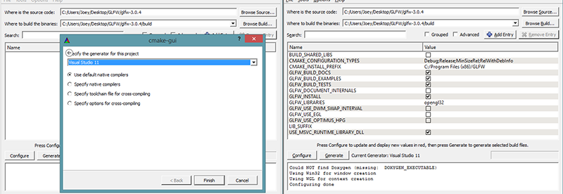

Once the source and destination folders have been set, click the Configure button so CMake can read the required settings and the source code. We then have to choose the generator for the project and since we're using Visual Studio 2015 we will choose the Visual Studio 14 option (Visual Studio 2015 is also known as Visual Studio 14). CMake will then display the possible build options to configure the resulting library. We can leave them to their default values and click Configure again to store the settings. Once the settings have been set, we can click Generate and the resulting project files will be generated in your build folder.

Compilation

In the build folder a file named GLFW.sln can be found and we open it with Visual Studio 2015. Since CMake generated a project file that already contains the proper configuration settings we can hit the Build Solution button and the resulting compiled library can be found in src/Debug named glfw3.lib (note, we're using version 3).

Once the library is generated we need to make sure the IDE knows where to find the library and the include files. There are two approaches in doing this:

1. We find the /lib and /include folders of the IDE/Compiler and add the content of GLFW's include folder to the IDE's /include folder and similarly add glfw3.lib to the IDE's /lib folder. This works, but this is not the recommended approach. It's hard to keep track of your library/include files and a new installation of your IDE/Compiler will result in lost files.
2. The recommended approach is to create a new set of directories at a location of your choice that contains all the header files/libraries from third parties to which you can refer to using your IDE/Compiler. I personally use a single folder that contains a Libs and Include folder where I store all my library and header files respectively for OpenGL projects. Now all my third party libraries are organized within a single location (that could be shared across multiple computers). The requirement is however, that each time we create a new project we have to tell the IDE where to find those directories.

Once the required files are stored at a location of your choice, we can start creating our first OpenGL project with GLFW!

*// я з усім гэтым павазіўся, але паспяхова выканаў //*

## Our first project

First, let's open up Visual Studio and create a new project. Choose Visual C++ if multiple options are given and take the Empty Project (don't forget to give your project a suitable name). We now have a workspace to create our very first OpenGL application!

### Linking

In order for the project to use GLFW we need to link the library with our project. This can be done by specifying we want to use glfw3.lib in the linker settings, but our project does not yet know where to find glfw3.lib since we pasted our third party libraries to different directories. We thus need to add those directories to the project first.

We can add those directories (where VS should search for libraries/include-files) by going to the project properties (right-click the project name in the solution explorer) and then go to VC++ Directories as can be seen in the image below:



From there on out you can add your own directories to let the project know where to search. This can be done by manually inserting it into the text or clicking the appropriate location string and selecting the <Edit..> option where you'll see the following image for the Include Directories case:



Here you can add as many extra directories as you'd like and from that point on the IDE will also search those directories when searching for header files, so as soon as your Include folder from GLFW is included, you will be able to find all the header files for GLFW by including <GLFW/..>. The same applies for the library directories.

Since VS can now find all the required files we can finally link GLFW to the project by going to the Linker tab and selecting input:

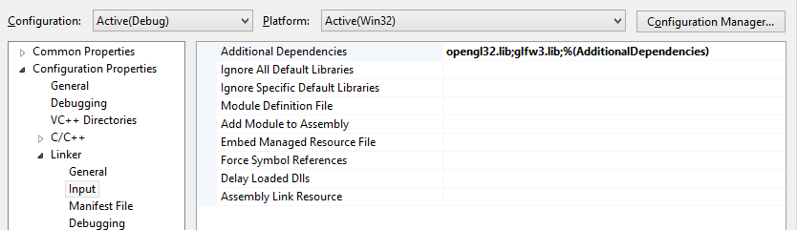

*// я паспяхова далучыў GLFW да сваёй сістэмы //*

To then link to a library you'd have to specify the name of the library to the linker. Since the library name is glfw3.lib, we add that to the Additional Dependencies field (either manually or using the <Edit..> option) and from that point on GLFW will be linked when we compile. Aside from GLFW you should also add a link entry to the OpenGL library, but this might differ per operating system:

### OpenGL library on Windows

If you're on Windows the OpenGL library opengl32.lib comes with the Microsoft SDK which is installed by default when you install Visual Studio. Since this tutorial uses the VS compiler and is on windows we add opengl32.lib to the linker settings. *// а я дабавіў бібліятэку з MinGW //*

#### OpenGL library on Linux

On Linux systems you need to link to the libGL.so library by adding -lGL to your linker settings. If you can't find the library you probably need to install any of the Mesa, NVidia or AMD dev packages, but I won't delve into the details since this is platform-specific (plus I'm not a Linux expert).

Then, once you've added both the GLFW and OpenGL library to the linker settings you can include the headers of GLFW as follows:

#include <GLFW\glfw3.h>

For Linux users compiling with GCC the following command line options might help you compile the project -lglfw3 -lGL -lX11 -lpthread -lXrandr -lXi. Not correctly linking the corresponding libraries will generate many undefined reference errors.

This concludes the setup and configuration of GLFW.

*// скончылі пра настройкі //*

## GLAD

We're still not quite there yet, since there is one other thing we still need to do. Since OpenGL is a standard/specification it is up to the driver manufacturer to implement the specification to a driver that the specific graphics card supports. Since there are many different versions of OpenGL drivers, the location of most of its functions is not known at compile-time and needs to be queried at run-time. It is then the task of the developer to retrieve the location of the functions he/she needs and store them in function pointers for later use. Retrieving those locations is [OS-specific](https://www.khronos.org/opengl/wiki/Load_OpenGL_Functions) and in Windows it looks something like this: *// intbu better this step //*

// define the function's prototype

**typedef** **void** (*GL_GENBUFFERS) (**GLsizei**, **GLuint**\*);

// find the function and assign it to a function pointer

GL_GENBUFFERS glGenBuffers = (GL_GENBUFFERS)wglGetProcAddress("glGenBuffers");

// function can now be called as normal

**unsigned** **int** buffer;

glGenBuffers(1, &buffer);

As you can see the code looks complex and it's a cumbersome process to do this for each function you might need that is not yet declared. Thankfully, there are libraries for this purpose as well where **GLAD** is a popular and up-to-date library.

### Setting up GLAD

GLAD is an [open source](https://github.com/Dav1dde/glad) library that manages all that cumbersome work we talked about. GLAD has a slightly different configuration setup than most common open source libraries. GLAD uses a [web service](http://glad.dav1d.de/) where we can tell GLAD for which version of OpenGL we'd like to define and load all relevant OpenGL functions according to that version.

Go to the [web service](http://glad.dav1d.de/), make sure the language is set to C++ and in the API section, select an OpenGL version of at least 3.3 (which is what we'll be using for these tutorials; higher versions are fine as well). Also make sure the profile is set to Core and that the Generate a loader option is ticked. Ignore the extensions (for now) and click Generate to produce the resulting library files.

GLAD by now should have provided you a zip file containing two include folders, and a single glad.c file. Copy both include folders (glad and KHR) into your include(s) directoy (or add an extra item pointing to these folders), and add the glad.c file to your project.

*// я так і зрабіў. Усё скампіліравалася. //*

After the previous steps, you should be able to add the following include directive above your file:

#include <glad/glad.h>

Hitting the compile button shouldn't give you any errors, at which point we're set to go for the [next](https://learnopengl.com/#!Getting-started/Hello-Window) tutorial where we'll discuss how we can actually use GLFW and GLAD to configure an OpenGL context and spawn a window. Be sure to check that all your include and library directories are correct and that the library names in the linker settings match with the corresponding libraries. If you're still stuck, check the comments, check any of the additional resources or ask your question below.

## Additional resources

* [GLFW: Window Guide](http://www.glfw.org/docs/latest/window_guide.html): official GLFW guide on setting up and configuring a GLFW window.
* [Building applications](http://www.opengl-tutorial.org/miscellaneous/building-your-own-c-application/): provides great info about the compilation/linking process of your application and a large list of possible errors (plus solutions) that might come up.
* [GLFW with Code::Blocks](http://wiki.codeblocks.org/index.php?title=Using_GLFW_with_Code::Blocks): building GLFW in Code::Blocks IDE.
* [Running CMake](http://www.cmake.org/runningcmake/): short overview of how to run CMake on both Windows and Linux.
* [Writing a build system under Linux](https://learnopengl.com/demo/autotools_tutorial.txt): an autotools tutorial by Wouter Verholst on how to write a build system in Linux, specifically targeted for these tutorials.
* [Polytonic/Glitter](https://github.com/Polytonic/Glitter): a simple boilerplate project that comes pre-configured with all relevant libraries; great for if you want a sample project for the LearnOpenGL tutorials without the hassle of having to compile all the libraries yourself.

### Want to help?

Enjoyed the tutorial? Consider becoming a [patron](https://www.patreon.com/learnopengl) of LearnOpenGL.  
  
Your support helps me create new and better tutorials, improve existing content and enables me to improve the website wherever I can. *// адваротная сувязь //*

[*https://learnopengl.com/#!Getting-started/Hello-Window*](https://learnopengl.com/#!Getting-started/Hello-Window)

## Hello Window

Let's see if we can get GLFW up and running. First, create a .cpp file and add the following includes to the top of your newly created file.

#include <glad/glad.h>

#include <GLFW/glfw3.h>

Be sure to include GLAD before GLFW. *// патрабаванне //* The include file for GLAD contains the correct OpenGL header includes (like GL/gl.h) so including GLAD before other header files that require OpenGL does the trick. *// абгрунтаванне //*

Next, we create the main function where we will instantiate the GLFW window:

**int** main()

{

glfwInit();

glfwWindowHint(GLFW_CONTEXT_VERSION_MAJOR, 3);

glfwWindowHint(GLFW_CONTEXT_VERSION_MINOR, 3);

glfwWindowHint(GLFW_OPENGL_PROFILE, GLFW_OPENGL_CORE_PROFILE);

//glfwWindowHint(GLFW_OPENGL_FORWARD_COMPAT, GL_TRUE);

**return** 0;

}

In the main function we first initialize GLFW with glfwInit, after which we can configure GLFW using glfwWindowHint. The first argument of glfwWindowHint tells us what option we want to configure, where we can select the option from a large enum of possible options prefixed with GLFW_. The second argument is an integer that sets the value of our option. A list of all the possible options and its corresponding values can be found at [GLFW's window handling](http://www.glfw.org/docs/latest/window.html#window_hints) documentation. If you try to run the application now and it gives a lot of undefined reference errors it means you didn't successfully link the GLFW library. *// у мяне ўсё ў парадку. Але што такое OpenGL профіль, я не вельмі зразумеў… //*

Since the focus of this website is on OpenGL version 3.3 we'd like to tell GLFW that 3.3 is the OpenGL version we want to use. This way GLFW can make the proper arrangements when creating the OpenGL context. This ensures that when a user does not have the proper OpenGL version GLFW fails to run. We set the major and minor version both to 3. We also tell GLFW we want to explicitly use the core-profile. Telling GLFW explicitly that we want to use the core-profile means we'll get access to a smaller subset of OpenGL features (without backwards-compatible features we no longer need). Note that on Mac OS X you need to add glfwWindowHint(GLFW_OPENGL_FORWARD_COMPAT, GL_TRUE); to your initialization code for it to work. *// лепей зразумець, якія фічы з’яўляюцца новымі і пашыранымі ў параўнанні з кор-профілем? //*

Make sure you have OpenGL versions 3.3 or higher installed on your system/hardware otherwise the application will crash or display undefined behavior. To find the OpenGL version on your machine either call **glxinfo** on Linux machines or use a utility like the [OpenGL Extension Viewer](http://download.cnet.com/OpenGL-Extensions-Viewer/3000-18487_4-34442.html) for Windows. If your supported version is lower try to check if your video card supports OpenGL 3.3+ (otherwise it's really old) and/or update your drivers. *// у мяне 4.0 – я паглядзеў дакументацыю для відэа-адаптэра // //*

Next we're required to create a window object. This window object holds all the windowing data and is used quite frequently by GLFW's other functions.

GLFWwindow* window = glfwCreateWindow(800, 600, "LearnOpenGL", NULL, NULL);

**if** (window == NULL)

{

std::cout << "Failed to create GLFW window" << std::endl;

glfwTerminate();

**return** -1;

}

glfwMakeContextCurrent(window);

The glfwCreateWindow function requires the window width and height as its first two arguments respectively. The third argument allows us to create a name for the window; for now we call it "LearnOpenGL" but you're allowed to name it however you like. We can ignore the last 2 parameters. The function returns a GLFWwindow object that we'll later need for other GLFW operations. After that we tell GLFW to make the context of our window the main context on the current thread. *// кантэкст патока і кантэкст акна – важныя паняцці OpenGL //*

### GLAD

In the previous tutorial we mentioned that GLAD manages function pointers for OpenGL so we want to initialize GLAD before we call any OpenGL function:

**if** (!gladLoadGLLoader((GLADloadproc)glfwGetProcAddress))

{

std::cout << "Failed to initialize GLAD" << std::endl;

**return** -1;

}

We pass GLAD the function to load the adress of the OpenGL function pointers which is OS-specific. GLFW gives us glfwGetProcAddress that defines the correct function based on which OS we're compiling for.

### Viewport

Before we can start rendering we have to do one last thing. We have to tell OpenGL the size of the rendering window so OpenGL knows how we want to display the data and coordinates with respect to the window. We can set those dimensions via the glViewport function:

glViewport(0, 0, 800, 600);

The first two parameters of glViewport set the location of the lower left corner of the window. The third and fourth parameter set the width and height of the rendering window in pixels, which we retrieve here from GLFW itself.

We could actually set the viewport dimensions at values smaller than GLFW's dimensions; then all the OpenGL rendering would be displayed in a smaller window and we could for example display other elements outside the OpenGL viewport.

Behind the scenes OpenGL uses the data specified via glViewport to transform the 2D coordinates it processed to coordinates on your screen. For example, a processed point of location (-0.5,0.5) would (as its final transformation) be mapped to (200,450) in screen coordinates. Note that processed coordinates in OpenGL are between -1 and 1 so we effectively map from the range (-1 to 1) to (0, 800) and (0, 600). *// рэалізацыя тэхналогіі //*

*// у мяне ўсё працуе без глада, а вось з гладам у мяне праблемы. Так што пакуль без яго. //*

However, the moment a user resizes the window the viewport should be adjusted as well. We can register a callback function on the window that gets called each time the window is resized. This resize callback function has the following prototype:

**void** framebuffer_size_callback(GLFWwindow* window, **int** width, **int** height);

The framebuffer size function takes a GLFWwindow as its first argument and two integers indicating the new window dimensions. Whenever the window changes in size, GLFW calls this function and fills in the proper arguments for you to process.

**void** framebuffer_size_callback(GLFWwindow* window, **int** width, **int** height)

{

glViewport(0, 0, width, height);

}

We do have to tell GLFW we want to call this function on every window resize by registering it:

glfwSetFramebufferSizeCallback(window, framebuffer_size_callback);

When the window is first displayed framebuffer_size_callback gets called as well with the resulting window dimensions. For retina displays width and height will end up significantly higher than the original input values.

There are many callbacks functions we can set to register our own functions. For example, we can make a callback function to process joystick input changes, process error messages etc. We register the callback functions after we've created the window and before the game loop is initiated. *// структура графічных прылажэнняў OpenGL //*

### Ready your engines

We don't want the application to draw a single image and then immediately quit and close the window. We want the application to keep drawing images and handling user input until the program has been explicitly told to stop. For this reason we have to create a while loop, that we now call the render loop, that keeps on running until we tell GLFW to stop. The following code shows a very simple render loop:

**while**(!glfwWindowShouldClose(window))

{

glfwSwapBuffers(window);

glfwPollEvents();

}

The glfwWindowShouldClose function checks at the start of each loop iteration if GLFW has been instructed to close, if so, the function returns true and the game loop stops running, after which we can close the application.  
The glfwPollEvents function checks if any events are triggered (like keyboard input or mouse movement events), updates the window state, and calls the corresponding functions (which we can set via callback methods). The glfwSwapBuffers will swap the color buffer (a large buffer that contains color values for each pixel in GLFW's window) that has been used to draw in during this iteration and show it as output to the screen.

#### **Double buffer**

When an application draws in a single buffer the resulting image might display flickering issues. This is because the resulting output image is not drawn in an instant, but drawn pixel by pixel and usually from left to right and top to bottom. Because these images are not displayed at an instant to the user, but rather via a step by step generation the result may contain quite a few artifacts. To circumvent these issues, windowing applications apply a double buffer for rendering. The **front** buffer contains the final output image that is shown at the screen, while all the rendering commands draw to the **back** buffer. As soon as all the rendering commands are finished we **swap** the back buffer to the front buffer so the image is instantly displayed to the user, removing all the aforementioned artifacts. *// тэхналогія малявання ў кампутарах і яе рэалізацыя //*

### One last thing

As soon as we exit the render loop we would like to properly clean/delete all resources that were allocated. We can do this via the glfwTerminate function that we call at the end of the main function.

glfwTerminate();

**return** 0;

This will clean up all the resources and properly exit the application. Now try to compile your application and if everything went well you should see the following output:

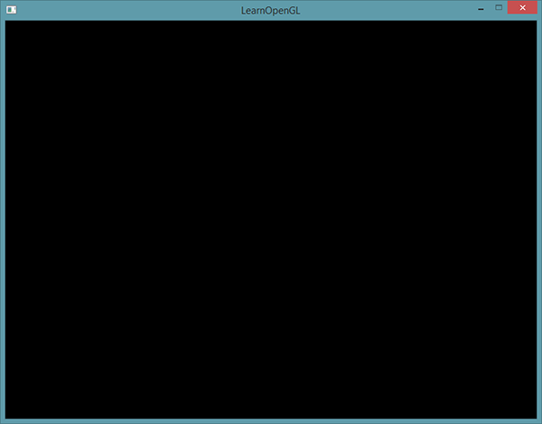

If it's a very dull and boring black image, you did things right! If you didn't get the right image or you're confused as to how everything fits together, check the full source code [here](https://learnopengl.com/code_viewer_gh.php?code=src/1.getting_started/1.1.hello_window/hello_window.cpp).

If you have issues compiling the application, first make sure all your linker options are set correctly and that you properly included the right directories in your IDE (as explained in the previous tutorial). Also make sure your code is correct; you can easily verify it by looking at the source code. If you still have any issues, post a comment below with your issue and me and/or the community will try to help you.

*// у мяне ўсё запусцілася і атрымалася. Толькі з рэндэрынгам пры рэсайзінгу не ўсё так гладка. Застаецца белая паласа, бывае. Потым паглядзець, у чым можа быць праблема //*

### Input

We also want to have some form of input control in GLFW and we can achieve this several of GLFW's input functions. We'll be using GLFW's glfwGetKey function that takes the window as input together with a key. The function returns whether this key is currently being pressed. We're creating a processInput function to keep all input code organized:

**void** processInput(GLFWwindow *window)

{

**if**(glfwGetKey(window, GLFW_KEY_ESCAPE) == GLFW_PRESS)

glfwSetWindowShouldClose(window, **true**);

}

Here we check whether the user has pressed the escape key (if it's not pressed, glfwGetKey returns GLFW_RELEASE). If the user did press the escape key, we close GLFW by setting its WindowShouldClose property to true using glfwSetwindowShouldClose. The next condition check of the main while loop will then fail and the application closes.

We then call processInput every iteration of the render loop:

**while** (!glfwWindowShouldClose(window))

{

processInput(window);

glfwSwapBuffers(window);

glfwPollEvents();

}

This gives us an easy way to check for specific key presses and react accordingly every frame.

*// усё цудоўна працуе //*

### Rendering

We want to place all the rendering commands in the render loop, since we want to execute all the rendering commands each iteration of the loop. This would look a bit like this:

// render loop

**while**(!glfwWindowShouldClose(window))

{

// input

processInput(window);

// rendering commands here

...

// check and call events and swap the buffers

glfwPollEvents();

glfwSwapBuffers(window);

}

Just to test if things actually work we want to clear the screen with a color of our choice. At the start of each render iteration we always want to clear the screen otherwise we would still see the results from the previous iteration *// важны аспект рэалізацыі графікі //* (this could be the effect you're looking for, but usually you don't). We can clear the screen's color buffer using the glClear function where we pass in buffer bits to specify which buffer we would like to clear. The possible bits we can set are GL_COLOR_BUFFER_BIT, GL_DEPTH_BUFFER_BIT and GL_STENCIL_BUFFER_BIT. Right now we only care about the color values so we only clear the color buffer.

glClearColor(0.2f, 0.3f, 0.3f, 1.0f);

glClear(GL_COLOR_BUFFER_BIT);

*// усё цудоўна работае, толькі qt не бачыць функцыі OpenGL. Але калі я дабавіў gl.h у інклюды, то і креатар пачаў бачыць усе функцыі OpenGL //*

Note that we also set a color via glClearColor to clear the screen with. Whenever we call glClear and clear the color buffer, the entire colorbuffer will be filled with the color as configured by glClearColor. This will result in a dark green-blueish color. *// рэалізацыя тэхналогіі //*

As you might recall from the OpenGL tutorial, the glClearColor function is a state-setting function and glClear is a state-using function in that it uses the current state to retrieve the clearing color from. *// структура тэхналогіі //*

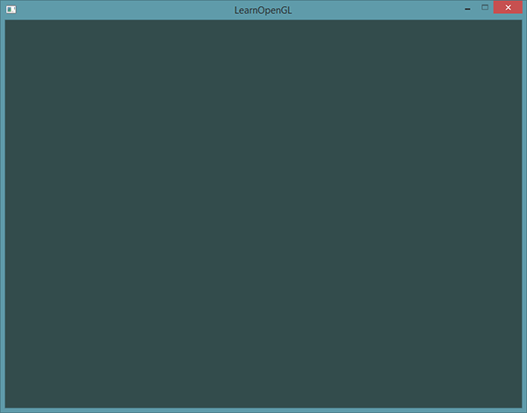

The full source code of the application can be found [here](https://learnopengl.com/code_viewer_gh.php?code=src/1.getting_started/1.2.hello_window_clear/hello_window_clear.cpp).

So right now we got everything ready to fill the game loop with lots of rendering calls, but that's for the [next](https://learnopengl.com/#!Getting-started/Hello-Triangle) tutorial. I think we've been rambling long enough here.

Want to help?

Enjoyed the tutorial? Consider becoming a [patron](https://www.patreon.com/learnopengl) of LearnOpenGL.  
  
Your support helps me create new and better tutorials, improve existing content and enables me to improve the website wherever I can.

[*https://learnopengl.com/#!Getting-started/Hello-Triangle*](https://learnopengl.com/#!Getting-started/Hello-Triangle)

## Hello Triangle

In OpenGL everything is in 3D space, but the screen and window are a 2D array of pixels so a large part of OpenGL's work is about transforming all 3D coordinates to 2D pixels that fit on your screen. *// структура тэхналогіі //* The process of transforming 3D coordinates to 2D coordinates is managed by the graphics pipeline of OpenGL. The graphics pipeline can be divided into two large parts: the first transforms your 3D coordinates into 2D coordinates and the second part transforms the 2D coordinates into actual colored pixels. *// структура тэхналогіі //* In this tutorial we'll briefly discuss the graphics pipeline and how we can use it to our advantage to create some fancy pixels.

There is a difference between a 2D coordinate and a pixel. A 2D coordinate is a very precise representation of where a point is in 2D space, while a 2D pixel is an approximation of that point limited by the resolution of your screen/window. *// розніца між паняццямі //*

The graphics pipeline takes as input a set of 3D coordinates and transforms these to colored 2D pixels on your screen. The graphics pipeline can be divided into several steps where each step requires the output of the previous step as its input. All of these steps are highly specialized (they have one specific function) and can easily be executed in parallel. Because of their parallel nature most graphics cards of today have thousands of small processing cores to quickly process your data within the graphics pipeline by running small programs on the GPU for each step of the pipeline. These small programs are called shaders. *// структура тэхналогіі і графічных картак //*

Some of these shaders are configurable by the developer which allows us to write our own shaders to replace the existing default shaders. This gives us much more fine-grained control over specific parts of the pipeline and because they run on the GPU, they can also save us valuable CPU time. Shaders are written in the OpenGL Shading Language (GLSL) and we'll delve more into that in the next tutorial. *// структура работы //*

Below you'll find an abstract representation of all the stages of the graphics pipeline. Note that the blue sections represent sections where we can inject our own shaders.

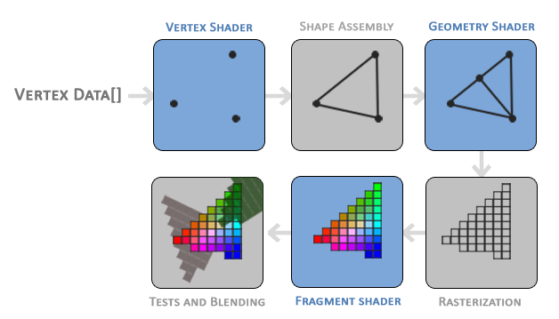

*// цудоўная рэпрэзентацыя структуры тэхналогіі //*

02.08.2017

As you can see the graphics pipeline contains a large number of sections that each handle one specific part of converting your vertex data to a fully rendered pixel. We will briefly explain each part of the pipeline in a simplified way to give you a good overview of how the pipeline operates. *// структура крыніцы //*

As input to the graphics pipeline we pass in a list of three 3D coordinates that should form a triangle in an array here called Vertex Data; this vertex data is a collection of vertices. A vertex is basically a collection of data per 3D coordinate. This vertex's data is represented using vertex attributes that can contain any data we'd like but for simplicity's sake let's assume that each vertex consists of just a 3D position and some color value. *// структура OpenGL //*

In order for OpenGL to know what to make of your collection of coordinates and color values OpenGL requires you to hint what kind of render types you want to form with the data. Do we want the data rendered as a collection of points, a collection of triangles or perhaps just one long line? Those hints are called primitives and are given to OpenGL while calling any of the drawing commands. Some of these hints are GL_POINTS, GL_TRIANGLES and GL_LINE_STRIP. *// структура тэхналогіі //*

The first part of the pipeline is the vertex shader that takes as input a single vertex. The main purpose of the vertex shader is to transform 3D coordinates into different 3D coordinates (more on that later) and the vertex shader allows us to do some basic processing on the vertex attributes. *// структура тэхналогіі //*

The primitive assembly stage takes as input all the vertices (or vertex if GL_POINTS is chosen) from the vertex shader that form a primitive and assembles all the point(s) in the primitive shape given; in this case a triangle. *// структура тэхналогіі //*

The output of the primitive assembly stage is passed to the geometry shader. The geometry shader takes as input a collection of vertices that form a primitive and has the ability to generate other shapes by emitting new vertices to form new (or other) primitive(s). In this example case, it generates a second triangle out of the given shape.

The output of the geometry shader is then passed on to the rasterization stage where it maps the resulting primitive(s) to the corresponding pixels on the final screen, resulting in fragments for the fragment shader to use. Before the fragment shaders runs, clipping is performed. Clipping discards all fragments that are outside your view, increasing performance. *// структура тэхналогіі //*

A fragment in OpenGL is all the data required for OpenGL to render a single pixel. *// вызначэнне //*

The main purpose of the fragment shader is to calculate the final color of a pixel and this is usually the stage where all the advanced OpenGL effects occur. Usually the fragment shader contains data about the 3D scene that it can use to calculate the final pixel color (like lights, shadows, color of the light and so on). *// структура тэхналогіі //*

After all the corresponding color values have been determined, the final object will then pass through one more stage that we call the alpha test and blending stage. This stage checks the corresponding depth (and stencil) value (we'll get to those later) of the fragment and uses those to check if the resulting fragment is in front or behind other objects and should be discarded accordingly. The stage also checks for alpha values (alpha values define the opacity of an object) and blends the objects accordingly. So even if a pixel output color is calculated in the fragment shader, the final pixel color could still be something entirely different when rendering multiple triangles. *// структура тэхналогіі //*

As you can see, the graphics pipeline is quite a complex whole and contains many configurable parts. However, for almost all the cases we only have to work with the vertex and fragment shader. The geometry shader is optional and usually left to its default shader. *// звычайная практыка //*

In Modern OpenGL we are **required** to define at least a vertex and fragment shader of our own (there are no default vertex/fragment shaders on the GPU). *// патрабаванне //* For this reason it is often quite difficult to start learning Modern OpenGL since a great deal of knowledge is required before being able to render your first triangle. *// разнавіднасць сістэмы ведаў, дзе асабліва палезны цьютаралы, у якіх вялікая колькасць работы зроблена настаўнікамі, а навучэнец факусіруе сваю ўвагу на пэўных фрагментах тэмы, паступова ахопліваючы яе ўсю. тнав //* Once you do get to finally render your triangle at the end of this chapter you will end up knowing a lot more about graphics programming. *// структура крыніцы ведаў //*

### Vertex input

To start drawing something we have to first give OpenGL some input vertex data. OpenGL is a 3D graphics library so all coordinates that we specify in OpenGL are in 3D (x, y and z coordinate). OpenGL doesn't simply transform **all** your 3D coordinates to 2D pixels on your screen; OpenGL only processes 3D coordinates when they're in a specific range between -1.0 and 1.0 on all 3 axes (x, y and z). All coordinates within this so called normalized device coordinates range will end up visible on your screen (and all coordinates outside this region won't). *// структура тэхналогіі //*

Because we want to render a single triangle we want to specify a total of three vertices with each vertex having a 3D position. We define them in normalized device coordinates (the visible region of OpenGL) in a float array:

**float** vertices[] = {

-0.5f, -0.5f, 0.0f,

0.5f, -0.5f, 0.0f,

0.0f, 0.5f, 0.0f

};

Because OpenGL works in 3D space we render a 2D triangle with each vertex having a z coordinate of 0.0. This way the depth of the triangle remains the same making it look like it's 2D.

### **Normalized Device Coordinates (NDC)**

Once your vertex coordinates have been processed in the vertex shader, they should be in normalized device coordinates which is a small space where the x, y and z values vary from -1.0 to 1.0. Any coordinates that fall outside this range will be discarded/clipped and won't be visible on your screen. Below you can see the triangle we specified within normalized device coordinates (ignoring the z axis):

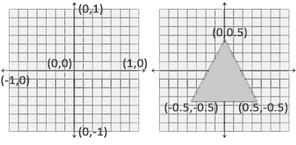

Unlike usual screen coordinates the positive y-axis points in the up-direction and the (0,0) coordinates are at the center of the graph, instead of top-left. Eventually you want all the (transformed) coordinates to end up in this coordinate space, otherwise they won't be visible.

Your NDC coordinates will then be transformed to screen-space coordinates via the viewport transform using the data you provided with glViewport. The resulting screen-space coordinates are then transformed to fragments as inputs to your fragment shader. *// структура тэхналогіі //*

With the vertex data defined we'd like to send it as input to the first process of the graphics pipeline: the vertex shader. This is done by creating memory on the GPU where we store the vertex data, configure how OpenGL should interpret the memory and specify how to send the data to the graphics card. The vertex shader then processes as much vertices as we tell it to from its memory. *// рэализацыя тэхналогіі і яе структура //*

We manage this memory via so called vertex buffer objects (VBO) that can store a large number of vertices in the GPU's memory. The advantage of using those buffer objects is that we can send large batches of data all at once to the graphics card without having to send data a vertex a time. *// перавагі буфераў. Структура тэхналогіі і яе значэнне //* Sending data to the graphics card from the CPU is relatively slow, so wherever we can we try to send as much data as possible at once. *// рэкамендацыя //* Once the data is in the graphics card's memory the vertex shader has almost instant access to the vertices making it extremely fast *// рэалізацыя тэхналогіі. Шэйдэр – гэта праграма для графічнай карткі //*

A vertex buffer object is our first occurrence of an OpenGL object as we've discussed in the [OpenGL](https://learnopengl.com/#!Getting-Started/OpenGL) tutorial. Just like any object in OpenGL this buffer has a unique ID corresponding to that buffer, so we can generate one with a buffer ID using the glGenBuffers function:

**unsigned** **int** VBO;

glGenBuffers(1, &VBO);

*// Вось тут мне прыйшлося раскаментаваць glad, бо інакш праграма не кампіліравалася, бо не было бачна функцыі glGenBuffer. Варта лепей зразумець, чаму? //*

*05.08.2017*

OpenGL has many types of buffer objects and the buffer type of a vertex buffer object is GL_ARRAY_BUFFER. *// структура тэхналогіі //* OpenGL allows us to bind to several buffers at once as long as they have a different buffer type. *// структура тэхналогіі //* We can bind the newly created buffer to the GL_ARRAY_BUFFER target with the glBindBuffer function:

glBindBuffer(GL_ARRAY_BUFFER, VBO);

From that point on any buffer calls we make (on the GL_ARRAY_BUFFER target) will be used to configure the currently bound buffer, which is VBO. Then we can make a call to glBufferData function that copies the previously defined vertex data into the buffer's memory: *// гэты метад капіруе дадзены ў відэакартку, наколькі я разумею. Шэйдэр – гэта код, які будзе выкананы з гэтымі дадзенамі на графічным працэсары //*

glBufferData(GL_ARRAY_BUFFER, **sizeof**(vertices), vertices, GL_STATIC_DRAW);

glBufferData is a function specifically targeted to copy user-defined data into the currently bound buffer. Its first argument is the type of the buffer we want to copy data into: the vertex buffer object currently bound to the GL_ARRAY_BUFFER target. The second argument specifies the size of the data (in bytes) we want to pass to the buffer; a simple sizeof of the vertex data suffices. The third parameter is the actual data we want to send.

The fourth parameter specifies how we want the graphics card to manage the given data. This can take 3 forms:

* GL_STATIC_DRAW: the data will most likely not change at all or very rarely.
* GL_DYNAMIC_DRAW: the data is likely to change a lot.
* GL_STREAM_DRAW: the data will change every time it is drawn.

The position data of the triangle does not change and stays the same for every render call so its usage type should best be GL_STATIC_DRAW. If, for instance, one would have a buffer with data that is likely to change frequently, a usage type of GL_DYNAMIC_DRAW or GL_STREAM_DRAW ensures the graphics card will place the data in memory that allows for faster writes. *// рэалізацыя тэхналогіі //*

As of now we stored the vertex data within memory on the graphics card as managed by a vertex buffer object named VBO. Next we want to create a vertex and fragment shader that actually processes this data, so let's start building those. *// структура спецыфікацыі //*

### Vertex shader

The vertex shader is one of the shaders that are programmable by people like us. Modern OpenGL requires that we at least set up a vertex and fragment shader if we want to do some rendering so we will briefly introduce shaders and configure two very simple shaders for drawing our first triangle. *// патрабаванне тэхналогіі і структура кнігі //* In the next tutorial we'll discuss shaders in more detail.

The first thing we need to do is write the vertex shader in the shader language GLSL (OpenGL Shading Language) and then compile this shader so we can use it in our application. Below you'll find the source code of a very basic vertex shader in GLSL:

#version 330 core

**layout** (location = 0) **in** vec3 aPos;

**void** main()

{

gl_Position = vec4(aPos.x, aPos.y, aPos.z, 1.0);

}

As you can see, GLSL looks similar to C. Each shader begins with a declaration of its version. Since OpenGL 3.3 and higher the version numbers of GLSL match the version of OpenGL (GLSL version 420 corresponds to OpenGL version 4.2 for example). We also explicitly mention we're using core profile functionality. *// glsl sturcture //*

Next we declare all the input vertex attributes in the vertex shader with the in keyword. Right now we only care about position data so we only need a single vertex attribute. GLSL has a vector datatype that contains 1 to 4 floats based on its postfix digit. Since each vertex has a 3D coordinate we create a vec3 input variable with the name aPos. We also specifically set the location of the input variable via layout (location = 0) and you'll later see that why we're going to need that location. *// структура кнігі. Арыентацыя чытача: тое, што не ясна зараз, будзе сказана потым. Аспекты трэпр //*

#### **Vector**

In graphics programming we use the mathematical concept of a vector quite often, since it neatly represents positions/directions in any space and has useful mathematical properties. A vector in GLSL has a maximum size of 4 and each of its values can be retrieved via vec.x,  vec.y, vec.z  and vec.w  respectively where each of them represents a coordinate in space. Note that the vec.w component is not used as a position in space (we're dealing with 3D, not 4D) but is used for something called perspective division. We'll discuss vectors in much greater depth in a later tutorial. *// пра вектары. Структура кнігі і арыентацыя чытача //*

To set the output of the vertex shader we have to assign the position data to the predefined gl_Position variable which is a vec4 behind the scenes. At the end of the main function, whatever we set gl_Position to will be used as the output of the vertex shader. Since our input is a vector of size 3 we have to cast this to a vector of size 4. We can do this by inserting the vec3 values inside the constructor of vec4 and set its w component to 1.0f (we will explain why in a later tutorial). *// вельмі цудоўна, што аўтар выяўна абазначае несказанную інфармацыю і арыентуе чытача ў тым, дзе яе можна будзе знайсці. Так нашмат лягчэй вывучаць і не ламаеш галаву, стоячы на месцы //*

The current vertex shader is probably the most simple vertex shader we can imagine because we did no processing whatsoever on the input data and simply forwarded it to the shader's output. In real applications the input data is usually not already in normalized device coordinates so we first have to transform the input data to coordinates that fall within OpenGL's visible region *// этапы работы па стварэнні графічных прылажэнняў //*

### Compiling a shader

We wrote the source code for the vertex shader (stored in a C string), but in order for OpenGL to use the shader it has to dynamically compile it at run-time from its source code.

The first thing we need to do is create a shader object, again referenced by an ID. *// сутнасць тэхналогіі //* So we store the vertex shader as a GLuint and create the shader with glCreateShader:

**unsigned** **int** vertexShader;

vertexShader = glCreateShader(GL_VERTEX_SHADER);

We provide the type of shader we want to create as an argument to glCreateShader. Since we're creating a vertex shader we pass in GL_VERTEX_SHADER.

Next we attach the shader source code to the shader object and compile the shader:

glShaderSource(vertexShader, 1, &vertexShaderSource, NULL);

glCompileShader(vertexShader);

The glShaderSource function takes the shader object to compile to as its first argument. The second argument specifies how many strings we're passing as source code, which is only one. The third parameter is the actual source code of the vertex shader and we can leave the 4th parameter to NULL.

You probably want to check if compilation was successful after the call to glCompileShader and if not, what errors were found so you can fix those. Checking for compile-time errors is accomplished as follows:

**int** success;

**char** infoLog[512];

glGetShaderiv(vertexShader, GL_COMPILE_STATUS, &success);

First we define an integer to indicate success and a storage container for the error messages (if any). Then we check if compilation was successful with glGetShaderiv. If compilation failed, we should retrieve the error message with glGetShaderInfoLog and print the error message.

**if**(!success)

{

glGetShaderInfoLog(vertexShader, 512, NULL, infoLog);

std::cout << "ERROR::SHADER::VERTEX::COMPILATION_FAILED\n" << infoLog << std::endl;

}

If no errors were detected while compiling the vertex shader it is now compiled.

### Fragment shader

The fragment shader is the second and final shader we're going to create for rendering a triangle. The fragment shader is all about calculating the color output of your pixels. To keep things simple the fragment shader will always output an orange-ish color. *// структура спецыфікацыі //*

Colors in computer graphics are represented as an array of 4 values: the red, green, blue and alpha (opacity) component, commonly abbreviated to RGBA. When defining a color in OpenGL or GLSL we set the strength of each component to a value between 0.0 and 1.0. If, for example, we would set red to 1.0f and green to 1.0f we would get a mixture of both colors and get the color yellow. Given those 3 color components we can generate over 16 million different colors!

#version 330 core

**out** vec4 FragColor;

**void** main()

{

FragColor = vec4(1.0f, 0.5f, 0.2f, 1.0f);

}

The fragment shader only requires one output variable and that is a vector of size 4 that defines the final color output that we should calculate ourselves. We can declare output values with the out keyword, that we here promptly named FragColor. Next we simply assign a vec4 to the color output as an orange color with an alpha value of 1.0 (1.0 being completely opaque).

The process for compiling a fragment shader is similar to the vertex shader, although this time we use the GL_FRAGMENT_SHADER constant as the shader type:

**unsigned** **int** fragmentShader;

fragmentShader = glCreateShader(GL_FRAGMENT_SHADER);

glShaderSource(fragmentShader, 1, &fragmentShaderSource, NULL);

glCompileShader(fragmentShader);

Both the shaders are now compiled and the only thing left to do is link both shader objects into a shader program that we can use for rendering.

#### Shader program

A shader program object is the final linked version of multiple shaders combined. *// структура тэхналогіі. Важная сутнасць тэхналогіі //* To use the recently compiled shaders we have to link them to a shader program object and then activate this shader program when rendering objects. The activated shader program's shaders will be used when we issue render calls. *// рэалізацыя тэхналогіі //*

When linking the shaders into a program it links the outputs of each shader to the inputs of the next shader. This is also where you'll get linking errors if your outputs and inputs do not match. *// рэалізацыя тэхналогіі. І тэхніка выканання тэхналогіі//*

Creating a program object is easy:

**unsigned** **int** shaderProgram;

shaderProgram = glCreateProgram();

The glCreateProgram function creates a program and returns the ID reference to the newly created program object. Now we need to attach the previously compiled shaders to the program object and then link them with glLinkProgram:

glAttachShader(shaderProgram, vertexShader);

glAttachShader(shaderProgram, fragmentShader);

glLinkProgram(shaderProgram);

The code should be pretty self-explanatory, we attach the shaders to the program and link them via glLinkProgram.

Just like shader compilation we can also check if linking a shader program failed and retrieve the corresponding log. However, instead of using glGetShaderiv and glGetShaderInfoLog we now use:

glGetProgramiv(shaderProgram, GL_LINK_STATUS, &success);

**if**(!success) {

glGetProgramInfoLog(shaderProgram, 512, NULL, infoLog);

...

}

The result is a program object that we can activate by calling glUseProgram with the newly created program object as its argument:

glUseProgram(shaderProgram);

Every shader and rendering call after glUseProgram will now use this program object (and thus the shaders). *// рэалізацыя тэхналогіі //*

Oh yeah, and don't forget to delete the shader objects once we've linked them into the program object; we no longer need them anymore:

glDeleteShader(vertexShader);

glDeleteShader(fragmentShader);

Right now we sent the input vertex data to the GPU and instructed the GPU how it should process the vertex data within a vertex and fragment shader. We're almost there, but not quite yet. OpenGL does not yet know how it should interpret the vertex data in memory and how it should connect the vertex data to the vertex shader's attributes. We'll be nice and tell OpenGL how to do that. *// этап распрацоўкі графічных прылажэнняў //*

### Linking Vertex Attributes

The vertex shader allows us to specify any input we want in the form of vertex attributes and while this allows for great flexibility, it does mean we have to manually specify what part of our input data goes to which vertex attribute in the vertex shader. This means we have to specify how OpenGL should interpret the vertex data before rendering. *// этап праектавання графічных прылажэнняў //*

Our vertex buffer data is formatted as follows: *// цудоўнейшая рэпрэзентацыя. Ёсць усе сутнасці і нават байты. //*

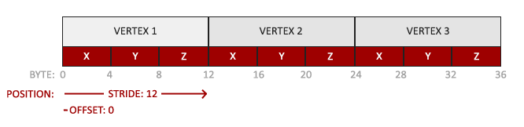

* The position data is stored as 32-bit (4 byte) floating point values.
* Each position is composed of 3 of those values.
* There is no space (or other values) between each set of 3 values. The values are tightly packed in the array.
* The first value in the data is at the beginning of the buffer.

*// гэта, я так разумею, характарыстыка канкрэтна гэтага прыклада //*

With this knowledge we can tell OpenGL how it should interpret the vertex data (per vertex attribute) using glVertexAttribPointer:

glVertexAttribPointer(0, 3, GL_FLOAT, GL_FALSE, 3 * **sizeof**(**float**), (**void**\*)0);

glEnableVertexAttribArray(0);

The function glVertexAttribPointer has quite a few parameters so let's carefully walk through them:

* The first parameter specifies which vertex attribute we want to configure. Remember that we specified the location of the position vertex attribute in the vertex shader with layout (location = 0). This sets the location of the vertex attribute to 0 and since we want to pass data to this vertex attribute, we pass in 0. *// злучэнне шэйдэра з праграмай //*
* The next argument specifies the size of the vertex attribute. The vertex attribute is a vec3 so it is composed of 3 values.
* The third argument specifies the type of the data which is GL_FLOAT (a vec* in GLSL consists of floating point values). *// структура glsl //*
* The next argument specifies if we want the data to be normalized. If we set this to GL_TRUE all the data that has a value not between 0 (or -1 for signed data) and 1 will be mapped to those values. We leave this at GL_FALSE.
* The fifth argument is known as the stride and tells us the space between consecutive vertex attribute sets. *// паняцце этрыбьют сет змяшчае некалькі атрыбутаў, якія характаразуюць канкрэтны вузел //* Since the next set of position data is located exactly 3 times the size of a float away we specify that value as the stride. Note that since we know that the array is tightly packed (there is no space between the next vertex attribute value) we could've also specified the stride as 0 to let OpenGL determine the stride (this only works when values are tightly packed). *// intbu //* Whenever we have more vertex attributes we have to carefully define the spacing between each vertex attribute but we'll get to see more examples of that later on.
* The last parameter is of type void* and thus requires that weird cast. This is the offset of where the position data begins in the buffer. Since the position data is at the start of the data array this value is just 0. We will explore this parameter in more detail later on *// арыентацыя чытача //*

*// вось зараз я значна лепей зразумеў гэту функцыю!!! Класны цьютарал! //*

Each vertex attribute takes its data from memory managed by a VBO and which VBO it takes its data from (one could have multiple VBOs) is determined by the VBO currently bound to GL_ARRAY_BUFFER when calling glVertexAttribPointer. *// важны аспект тэхналогіі. Для чаго можа спатрэбіцца некалькі ВБО? //* Since the previously defined VBO was bound before calling glVertexAttribPointer vertex attribute 0 is now associated with its vertex data. *// нагадаю, што кожны ВБО змяшчае канкрэтныя вертэксныя дадзены //*

Now that we specified how OpenGL should interpret the vertex data we should also enable the vertex attribute with glEnableVertexAttribArray giving the vertex attribute location as its argument; vertex attributes are disabled by default. *// структура тэхналогіі //* From that point on we have everything set up: we initialized the vertex data in a buffer using a vertex buffer object, set up a vertex and fragment shader and told OpenGL how to link the vertex data to the vertex shader's vertex attributes. *// этапы напісання графічнай праграмы //* Drawing an object in OpenGL would now look something like this:

// 0. copy our vertices array in a buffer for OpenGL to use

glBindBuffer(GL_ARRAY_BUFFER, VBO);

glBufferData(GL_ARRAY_BUFFER, **sizeof**(vertices), vertices, GL_STATIC_DRAW);

// 1. then set the vertex attributes pointers

glVertexAttribPointer(0, 3, GL_FLOAT, GL_FALSE, 3 * **sizeof**(**float**), (**void**\*)0);

glEnableVertexAttribArray(0);

// 2. use our shader program when we want to render an object

glUseProgram(shaderProgram);

// 3. now draw the object

someOpenGLFunctionThatDrawsOurTriangle();

We have to repeat this process every time we want to draw an object. It may not look like that much, but imagine if we have over 5 vertex attributes and perhaps 100s of different objects (which is not uncommon). Binding the appropriate buffer objects and configuring all vertex attributes for each of those objects quickly becomes a cumbersome process. What if there was some way we could store all these state configurations into an object and simply bind this object to restore its state? *// пастанощка задачы //*

#### Vertex Array Object

A vertex array object (also known as VAO) can be bound just like a vertex buffer object and any subsequent vertex attribute calls from that point on will be stored inside the VAO. This has the advantage that when configuring vertex attribute pointers you only have to make those calls once and whenever we want to draw the object, we can just bind the corresponding VAO. This makes switching between different vertex data and attribute configurations as easy as binding a different VAO. All the state we just set is stored inside the VAO.

Core OpenGL **requires** that we use a VAO so it knows what to do with our vertex inputs. If we fail to bind a VAO, OpenGL will most likely refuse to draw anything. *// патрабаванне тэхналогіі //*

A vertex array object stores the following:

* Calls to glEnableVertexAttribArray or glDisableVertexAttribArray.
* Vertex attribute configurations via glVertexAttribPointer.
* Vertex buffer objects associated with vertex attributes by calls to glVertexAttribPointer.

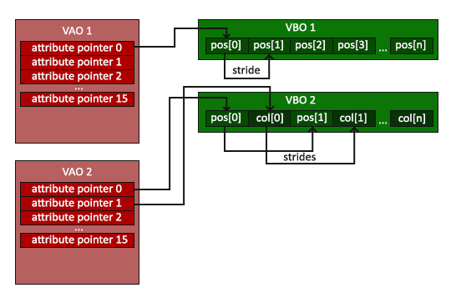

*// не магу пакуль сказаць, што добра ўлаўліваю ідэю ВАО і гэту схему… //*

The process to generate a VAO looks simliar to that of a VBO:

**unsigned** **int** VAO;

glGenVertexArrays(1, &VAO);

To use a VAO all you have to do is bind the VAO using glBindVertexArray. From that point on we should bind/configure the corresponding VBO(s) and attribute pointer(s) and then unbind the VAO for later use. As soon as we want to draw an object, we simply bind the VAO with the prefered settings before drawing the object and that is it. In code this would look a bit like this:

// ..:: Initialization code (done once (unless your object frequently changes)) :: ..

// 1. bind Vertex Array Object

glBindVertexArray(VAO);

// 2. copy our vertices array in a buffer for OpenGL to use

glBindBuffer(GL_ARRAY_BUFFER, VBO);

glBufferData(GL_ARRAY_BUFFER, **sizeof**(vertices), vertices, GL_STATIC_DRAW);

// 3. then set our vertex attributes pointers

glVertexAttribPointer(0, 3, GL_FLOAT, GL_FALSE, 3 * **sizeof**(**float**), (**void**\*)0);

glEnableVertexAttribArray(0);

[...]

// ..:: Drawing code (in render loop) :: ..

// 4. draw the object

glUseProgram(shaderProgram);

glBindVertexArray(VAO);

someOpenGLFunctionThatDrawsOurTriangle();

And that is it! Everything we did the last few million pages led up to this moment, a VAO that stores our vertex attribute configuration and which VBO to use. Usually when you have multiple objects you want to draw, you first generate/configure all the VAOs (and thus the required VBO and attribute pointers) and store those for later use. The moment we want to draw one of our objects, we take the corresponding VAO, bind it, then draw the object and unbind the VAO again. *// вось зараз для мяне стала зразумелай уся сутнасць гэтых ВАО. Гэта абстракцыя, якая робіць разуменне і напісанне кода ясней праз прынцып схавання Парнаса. Важнейшы прынцып траз //*

#### The triangle we've all been waiting for

To draw our objects of choice OpenGL provides us with the glDrawArrays function that draws primitives using the currently active shader, the previously defined vertex attribute configuration and with the VBO's vertex data (indirectly bound via the VAO). *// рэалізацыя тэхналогіі //*

glUseProgram(shaderProgram);

glBindVertexArray(VAO);

glDrawArrays(GL_TRIANGLES, 0, 3);

The glDrawArrays function takes as its first argument the OpenGL primitive type we would like to draw. Since we said at the start we wanted to draw a triangle and I don't like lying to you, we pass in GL_TRIANGLES. The second argument specifies the starting index of the vertex array we'd like to draw; we just leave this at 0. *// intbu this parameter //* The last argument specifies how many vertices we want to draw, which is 3 (we only render 1 triangle from our data, which is exactly 3 vertices long).

Now try to compile the code and work your way backwards if any errors popped up. As soon as your application compiles, you should see the following result:

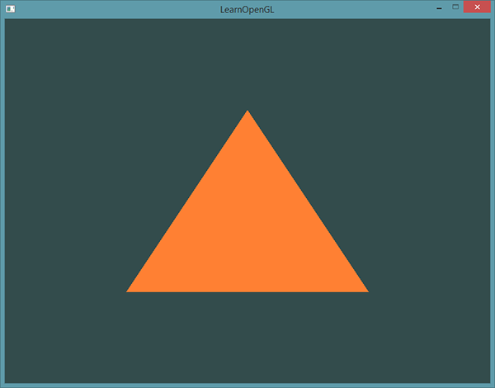

The source code for the complete program can be found [here](https://learnopengl.com/code_viewer_gh.php?code=src/1.getting_started/2.1.hello_triangle/hello_triangle.cpp) .

Modifying other VAOs requires a call to glBindVertexArray anyways so we generally don't unbind VAOs (nor VBOs) when it's not directly necessary.

*// гэта палезная вытрымка з кода //*

If your output does not look the same you probably did something wrong along the way so check the complete source code, see if you missed anything or ask below in the comments section.

*// У МЯНЕ ЎСЁ ПРАЦУЕ!!! //*

*06.08.2017*

### Element Buffer Objects

There is one last thing we'd like to discuss when rendering vertices and that is element buffer objects abbreviated to EBO. *// яшчэ адна сутнасць тэхналогіі //* To explain how element buffer objects work it's best to give an example: suppose we want to draw a rectangle instead of a triangle. We can draw a rectangle using two triangles (OpenGL mainly works with triangles *// структура тэхналогіі //*). This will generate the following set of vertices:

**float** vertices[] = {

// first triangle

0.5f, 0.5f, 0.0f, // top right

0.5f, -0.5f, 0.0f, // bottom right

-0.5f, 0.5f, 0.0f, // top left

// second triangle

0.5f, -0.5f, 0.0f, // bottom right

-0.5f, -0.5f, 0.0f, // bottom left

-0.5f, 0.5f, 0.0f // top left

};

As you can see, there is some overlap on the vertices specified. We specify bottom right and top left twice! This is an overhead of 50% since the same rectangle could also be specified with only 4 vertices, instead of 6. This will only get worse as soon as we have more complex models that have over 1000s of triangles where there will be large chunks that overlap. *// сапраўды, праблема //* What would be a better solution is to store only the unique vertices and then specify the order at which we want to draw these vertices in. In that case we would only have to store 4 vertices for the rectangle, and then just specify at which order we'd like to draw them. Wouldn't it be great if OpenGL provided us with a feature like that? *// вырашэнне праблемы //*

Thankfully, element buffer objects work exactly like that. An EBO is a buffer, just like a vertex buffer object, that stores indices that OpenGL uses to decide what vertices to draw. This so called indexed drawing is exactly the solution to our problem. To get started we first have to specify the (unique) vertices and the indices to draw them as a rectangle:

**float** vertices[] = {

0.5f, 0.5f, 0.0f, // top right

0.5f, -0.5f, 0.0f, // bottom right

-0.5f, -0.5f, 0.0f, // bottom left

-0.5f, 0.5f, 0.0f // top left

};

**unsigned** **int** indices[] = { // note that we start from 0!

0, 1, 3, // first triangle

1, 2, 3 // second triangle

};

You can see that, when using indices, we only need 4 vertices instead of 6. Next we need to create the element buffer object:

**unsigned** **int** EBO;

glGenBuffers(1, &EBO);

Similar to the VBO we bind the EBO and copy the indices into the buffer with glBufferData. Also, just like the VBO we want to place those calls between a bind and an unbind call, although this time we specify GL_ELEMENT_ARRAY_BUFFER as the buffer type.

glBindBuffer(GL_ELEMENT_ARRAY_BUFFER, EBO);

glBufferData(GL_ELEMENT_ARRAY_BUFFER, **sizeof**(indices), indices, GL_STATIC_DRAW);

Note that we're now giving GL_ELEMENT_ARRAY_BUFFER as the buffer target. The last thing left to do is replace the glDrawArrays call with glDrawElements to indicate we want to render the triangles from an index buffer. When using glDrawElements we're going to draw using indices provided in the element buffer object currently bound:

glBindBuffer(GL_ELEMENT_ARRAY_BUFFER, EBO);

glDrawElements(GL_TRIANGLES, 6, GL_UNSIGNED_INT, 0);

The first argument specifies the mode we want to draw in, similar to glDrawArrays. The second argument is the count or number of elements we'd like to draw. We specified 6 indices so we want to draw 6 vertices in total. The third argument is the type of the indices which is of type GL_UNSIGNED_INT. The last argument allows us to specify an offset in the EBO (or pass in an index array, but that is when you're not using element buffer objects), but we're just going to leave this at 0.

The glDrawElements function takes its indices from the EBO currently bound to the GL_ELEMENT_ARRAY_BUFFER target. This means we have to bind the corresponding EBO each time we want to render an object with indices which seems again a bit cumbersome. It just so happens that a vertex array object also keeps track of element buffer object bindings. The element buffer object currently bound while a VAO is bound, is stored as the VAO's element buffer object. Binding to a VAO thus also automatically binds its EBO. *// рэалізацыя і структура тэхналогіі //*

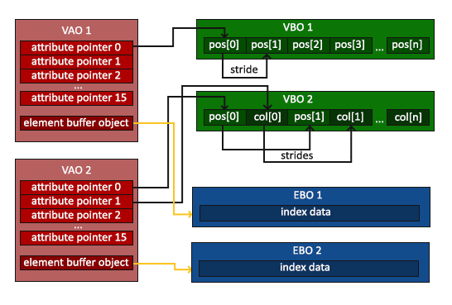

*// гэту цудоўную рэпрэзентацыю я зразумеў //*

A VAO stores the glBindBuffer calls when the target is GL_ELEMENT_ARRAY_BUFFER. This also means it stores its unbind calls so make sure you don't unbind the element array buffer before unbinding your VAO, otherwise it doesn't have an EBO configured. *// важная заўвага //*

The resulting initialization and drawing code now looks something like this:

// ..:: Initialization code :: ..

// 1. bind Vertex Array Object

glBindVertexArray(VAO);

// 2. copy our vertices array in a vertex buffer for OpenGL to use

glBindBuffer(GL_ARRAY_BUFFER, VBO);

glBufferData(GL_ARRAY_BUFFER, **sizeof**(vertices), vertices, GL_STATIC_DRAW);

// 3. copy our index array in a element buffer for OpenGL to use

glBindBuffer(GL_ELEMENT_ARRAY_BUFFER, EBO);

glBufferData(GL_ELEMENT_ARRAY_BUFFER, **sizeof**(indices), indices, GL_STATIC_DRAW);

// 4. then set the vertex attributes pointers

glVertexAttribPointer(0, 3, GL_FLOAT, GL_FALSE, 3 * **sizeof**(**float**), (**void**\*)0);

glEnableVertexAttribArray(0);

[...]

// ..:: Drawing code (in render loop) :: ..

glUseProgram(shaderProgram);

glBindVertexArray(VAO);

glDrawElements(GL_TRIANGLES, 6, GL_UNSIGNED_INT, 0)

glBindVertexArray(0);

Running the program should give an image as depicted below. The left image should look familiar and the right image is the rectangle drawn in wireframe mode. The wireframe rectangle shows that the rectangle indeed consists of two triangles.

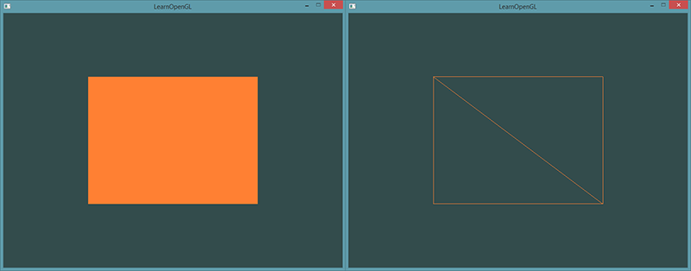**Wireframe mode**

To draw your triangles in wireframe mode, you can configure how OpenGL draws its primitives via glPolygonMode(GL_FRONT_AND_BACK, GL_LINE). The first argument says we want to apply it to the front and back of all triangles and the second line tells us to draw them as lines. Any subsequent drawing calls will render the triangles in wireframe mode until we set it back to its default using glPolygonMode(GL_FRONT_AND_BACK, GL_FILL).

If you have any errors, work your way backwards and see if you missed anything. Also, you can find the complete source code [here](https://learnopengl.com/code_viewer_gh.php?code=src/1.getting_started/2.2.hello_triangle_indexed/hello_triangle_indexed.cpp) and feel free to ask any question in the comments section below.

If you managed to draw a triangle or a rectangle just like we did then congratulations, you managed to make it past one of the hardest parts of modern OpenGL: drawing your first triangle. This is a difficult part since there is a large chunk of knowledge required before being able to draw your first triangle. Thankfully, we now made it past that barrier and the upcoming tutorials will hopefully be much easier to understand. *// тнав. Цудоўная арыентацыя чытача постфактум //*

### Additional resources

* [antongerdelan.net/hellotriangle](http://antongerdelan.net/opengl/hellotriangle.html): Anton Gerdelan's take on rendering the first triangle.
* [open.gl/drawing](https://open.gl/drawing): Alexander Overvoorde's take on rendering the first triangle.
* [antongerdelan.net/vertexbuffers](http://antongerdelan.net/opengl/vertexbuffers.html): some extra insights into vertex buffer objects.
* [learnopengl.com/#!In-Practice/Debugging](https://learnopengl.com/#!In-Practice/Debugging): there are a lot of steps involved in this tutorial; if you're stuck it might be worthwhile to read a bit on debugging in OpenGL (up until the debug output section). *// яшчэ адна цудоўная арыентацыя чытача. Гэта сіла дадзенага цьютарала //*

### Exercises

To really get a good grasp of the concepts discussed a few exercises were set up. It is advised to work through them before continuing to the next subject to make sure you get a good grasp of what's going on. *// арыентацыя чытача //*

1. Try to draw 2 triangles next to each other using glDrawArrays by adding more vertices to your data: [solution](https://learnopengl.com/code_viewer_gh.php?code=src/1.getting_started/2.3.hello_triangle_exercise1/hello_triangle_exercise1.cpp). *// выканаў //*
2. Now create the same 2 triangles using two different VAOs and VBOs for their data: [solution](https://learnopengl.com/code_viewer_gh.php?code=src/1.getting_started/2.4.hello_triangle_exercise2/hello_triangle_exercise2.cpp). *// выканаў //*
3. Create two shader programs where the second program uses a different fragment shader that outputs the color yellow; draw both triangles again where one outputs the color yellow: [solution](https://learnopengl.com/code_viewer_gh.php?code=src/1.getting_started/2.5.hello_triangle_exercise3/hello_triangle_exercise3.cpp). *// выканаў //*

Want to help?

Enjoyed the tutorial? Consider becoming a [patron](https://www.patreon.com/learnopengl) of LearnOpenGL.  
  
Your support helps me create new and better tutorials, improve existing content and enables me to improve the website wherever I can.

[*https://learnopengl.com/#!Getting-started/Shaders*](https://learnopengl.com/#!Getting-started/Shaders)

## Shaders

As mentioned in the [Hello Triangle](https://learnopengl.com/#!Getting-started/Hello-Triangle) tutorial, shaders are little programs that rest on the GPU. These programs are run for each specific section of the graphics pipeline. In a basic sense, shaders are nothing more than programs transforming inputs to outputs. Shaders are also very isolated programs in that they're not allowed to communicate with each other; the only communication they have is via their inputs and outputs. *// рэалізацыя і структура тэхналогіі //*

In the previous tutorial we briefly touched the surface of shaders and how to properly use them. We will now explain shaders, and specifically the OpenGL Shading Language, in a more general fashion. *// ступені разумення. Траз. Структура крыніцы і цудоўная арыентацыя чытача ў ёй. Тнав. трэпр //*

### GLSL

Shaders are written in the C-like language GLSL. GLSL is tailored for use with graphics and contains useful features specifically targeted at vector and matrix manipulation. *// структура тэхналогіі //*

Shaders always begin with a version declaration, followed by a list of input and output variables, uniforms and its mainfunction. Each shader's entry point is at its main function where we process any input variables and output the results in its output variables. Don't worry if you don't know what uniforms are, we'll get to those shortly.

A shader typically has the following structure:

#version version_number

**in** type in_variable_name;

**in** type in_variable_name;

**out** type out_variable_name;

**uniform** type uniform_name;

**void** main()

{

// process input(s) and do some weird graphics stuff

...

// output processed stuff to output variable

out_variable_name = weird_stuff_we_processed;

}

When we're talking specifically about the vertex shader each input variable is also known as a vertex attribute. There is a maximum number of vertex attributes we're allowed to declare limited by the hardware. *// абмежаванне тэхналогіі //* OpenGL guarantees there are always at least 16 4-component vertex attributes available, but some hardware might allow for more which you can retrieve by querying GL_MAX_VERTEX_ATTRIBS:

**int** nrAttributes;

glGetIntegerv(GL_MAX_VERTEX_ATTRIBS, &nrAttributes);

std::cout << "Maximum nr of vertex attributes supported: " << nrAttributes << std::endl;

This often returns the minimum of 16 which should be more than enough for most purposes.

### Types

GLSL has like any other programming language data types for specifying what kind of variable we want to work with. GLSL has most of the default basic types we know from languages like C: int, float, double, uint and bool. GLSL also features two container types that we'll be using a lot throughout the tutorials, namely vectors and matrices. We'll discuss matrices in a later tutorial. *// арыентацыя чытача //*

#### Vectors

A vector in GLSL is a 1, 2, 3 or 4 component container for any of the basic types just mentioned. They can take the following form (n represents the number of components):

* vecn: the default vector of n floats.
* bvecn: a vector of n booleans.
* ivecn: a vector of n integers.
* uvecn: a vector of n unsigned integers.
* dvecn: a vector of n double components.

Most of the time we will be using the basic vecn since floats are sufficient for most of our purposes.

Components of a vector can be accessed via vec.x where x is the first component of the vector. You can use .x, .y, .z and .w to access their first, second, third and fourth component respectively. GLSL also allows you to use rgba for colors or stpq for texture coordinates, accessing the same components.

The vector datatype allows for some interesting and flexible component selection called swizzling. Swizzling allows for the following syntax:

vec2 someVec;

vec4 differentVec = someVec.xyxx;

vec3 anotherVec = differentVec.zyw;

vec4 otherVec = someVec.xxxx + anotherVec.yxzy;

You can use any combination of up to 4 letters to create a new vector (of the same type) as long as the original vector has those components; it is not allowed to access the .z component of a vec2 for example. *// палезная і унікальная ўласцівасць мовы //*

We can also pass vectors as arguments to different vector constructor calls, reducing the number of arguments required:

vec2 vect = vec2(0.5, 0.7);

vec4 result = vec4(vect, 0.0, 0.0);

vec4 otherResult = vec4(result.xyz, 1.0);

*// яшчэ адна палезнасць //*

Vectors are thus a flexible datatype that we can use for all kinds of input and output. Throughout the tutorials you'll see plenty of examples of how we can creatively manage vectors. *// арыентацыя чытача тыпу: што нас чакае, ці тыпу: чым запоўнены цьютарал //*

### Ins and outs

Shaders are nice little programs on their own, but they are part of a whole and for that reason we want to have inputs and outputs on the individual shaders so that we can move stuff around. GLSL defined the in and out keywords specifically for that purpose. Each shader can specify inputs and outputs using those keywords and wherever an output variable matches with an input variable of the next shader stage they're passed along. *// структура тэхналогіі //* The vertex and fragment shader differ a bit though. *// адрозненне паняццяў //*

The vertex shader should receive some form of input otherwise it would be pretty ineffective. The vertex shader differs in its input, in that it receives its input straight from the vertex data. To define how the vertex data is organized we specify the input variables with location metadata so we can configure the vertex attributes on the CPU. We've seen this in the previous tutorial as layout (location = 0). The vertex shader thus requires an extra layout specification for its inputs so we can link it with the vertex data.

It is also possible to omit the layout (location = 0) specifier and query for the attribute locations in your OpenGL code via glGetAttribLocation, but I'd prefer to set them in the vertex shader. It is easier to understand and saves you (and OpenGL) some work. *// я згаджуся з цудоўным аўтарам гэтага цьютарала //*

The other exception is that the fragment shader requires a vec4 color output variable, since the fragment shaders needs to generate a final output color. If you'd fail to specify an output color in your fragment shader OpenGL will render your object black (or white). *// у маім выпадку – чорным //*

So if we want to send data from one shader to the other we'd have to declare an output in the sending shader and a similar input in the receiving shader. When the types and the names are equal on both sides OpenGL will link those variables together and then it is possible to send data between shaders (this is done when linking a program object). *// рэалізацыя тэхналогіі //* To show you how this works in practice we're going to alter the shaders from the previous tutorial to let the vertex shader decide the color for the fragment shader.

#### **Vertex shader**

#version 330 core

**layout** (location = 0) **in** vec3 aPos; // the position variable has attribute position 0

**out** vec4 vertexColor; // specify a color output to the fragment shader

**void** main()

{

gl_Position = vec4(aPos, 1.0); // see how we directly give a vec3 to vec4's constructor

vertexColor = vec4(0.5, 0.0, 0.0, 1.0); // set the output variable to a dark-red color

}

**Fragment shader**

#version 330 core

**out** vec4 FragColor;

**in** vec4 vertexColor; // the input variable from the vertex shader (same name and same type)

**void** main()

{

FragColor = vertexColor;

}

*// усё атрымалася проста цудоўна! //*

You can see we declared a vertexColor variable as a vec4 output that we set in the vertex shader and we declare a similar vertexColor input in the fragment shader. Since they both have the same type and name, the vertexColor in the fragment shader is linked to the vertexColor in the vertex shader. Because we set the color to a dark-red color in the vertex shader, the resulting fragments should be dark-red as well. The following image shows the output:

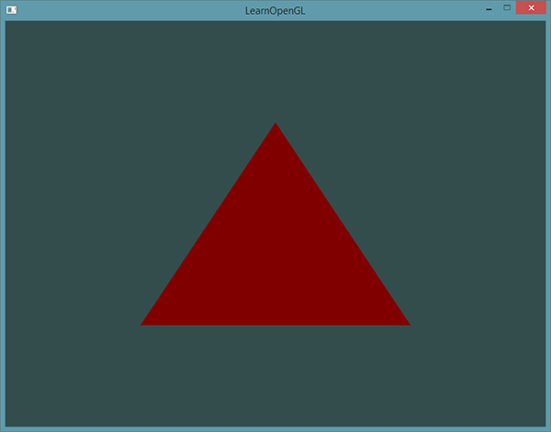

There we go! We just managed to send a value from the vertex shader to the fragment shader. Let's spice it up a bit and see if we can send a color from our application to the fragment shader! *// пастаноўка задачы. Структура цьютарала //*

### Uniforms

07.08.2017

Uniforms are another way to pass data from our application on the CPU to the shaders on the GPU, but uniforms are slightly different compared to vertex attributes. First of all, uniforms are global. Global, meaning that a uniform variable is unique per shader program object, and can be accessed from any shader at any stage in the shader program. Second, whatever you set the uniform value to, uniforms will keep their values until they're either reset or updated. *// а чым гэта адрозніваецца ад звычайных пераменных? //*

To declare a uniform in GLSL we simply add the uniform keyword to a shader with a type and a name. From that point on we can use the newly declared uniform in the shader. Let's see if this time we can set the color of the triangle via a uniform:

#version 330 core

**out** vec4 FragColor;

**uniform** vec4 ourColor; // we set this variable in the OpenGL code.

**void** main()

{

FragColor = ourColor;

}

We declared a uniform vec4 ourColor in the fragment shader and set the fragment's output color to the content of this uniform value. Since uniforms are global variables, we can define them in any shader we'd like so no need to go through the vertex shader again to get something to the fragment shader. We're not using this uniform in the vertex shader so there's no need to define it there.

If you declare a uniform that isn't used anywhere in your GLSL code the compiler will silently remove the variable from the compiled version which is the cause for several frustrating errors; keep this in mind! *// важны нюанс. Рэалізацыя тэхналогіі //*

The uniform is currently empty; we haven't added any data to the uniform yet so let's try that. We first need to find the index/location of the uniform attribute in our shader. Once we have the index/location of the uniform, we can update its values. Instead of passing a single color to the fragment shader, let's spice things up by gradually changing color over time:

**float** timeValue = glfwGetTime();

**float** greenValue = (sin(timeValue) / 2.0f) + 0.5f;

**int** vertexColorLocation = glGetUniformLocation(shaderProgram, "ourColor");

glUseProgram(shaderProgram);

glUniform4f(vertexColorLocation, 0.0f, greenValue, 0.0f, 1.0f);

*// усё працуе //*

First, we retrieve the running time in seconds via glfwGetTime(). Then we vary the color in the range of 0.0 - 1.0 by using the sin function and store the result in greenValue.

Then we query for the location of the ourColor uniform using glGetUniformLocation. We supply the shader program and the name of the uniform (that we want to retrieve the location from) to the query function. If glGetUniformLocation returns -1, it could not find the location. Lastly we can set the uniform value using the glUniform4f function. Note that finding the uniform location does not require you to use the shader program first, but updating a uniform **does** require you to first use the program (by calling glUseProgram), because it sets the uniform on the currently active shader program. *// рэалізацыя і патрабаванне тэхналогіі //*

Because OpenGL is in its core a C library it does not have native support for type overloading, so wherever a function can be called with different types OpenGL defines new functions for each type required; glUniform is a perfect example of this. The function requires a specific postfix for the type of the uniform you want to set. A few of the possible postfixes are:

* f: the function expects a float as its value
* i: the function expects an int as its value
* ui: the function expects an unsigned int as its value
* 3f: the function expects 3 floats as its value
* fv: the function expects a float vector/array as its value

*// рэалізацыя тэхналогіі і яе недахоп, як і мовы С у цэлым //*

Whenever you want to configure an option of OpenGL simply pick the overloaded function that corresponds with your type. In our case we want to set 4 floats of the uniform individually so we pass our data via glUniform4f(note that we also could've used the fv version).

Now that we know how to set the values of uniform variables, we can use them for rendering. If we want the color to gradually change, we want to update this uniform every game loop iteration (so it changes per-frame) otherwise the triangle would maintain a single solid color if we only set it once. So we calculate the greenValue and update the uniform each render iteration:

**while**(!glfwWindowShouldClose(window))

{

// input

processInput(window);

// render

// clear the colorbuffer

glClearColor(0.2f, 0.3f, 0.3f, 1.0f);

glClear(GL_COLOR_BUFFER_BIT);

// be sure to activate the shader

glUseProgram(shaderProgram);

// update the uniform color

**float** timeValue = glfwGetTime();

**float** greenValue = sin(timeValue) / 2.0f + 0.5f;

**int** vertexColorLocation = glGetUniformLocation(shaderProgram, "ourColor");

glUniform4f(vertexColorLocation, 0.0f, greenValue, 0.0f, 1.0f);

// now render the triangle

glBindVertexArray(VAO);

glDrawArrays(GL_TRIANGLES, 0, 3);

// swap buffers and poll IO events

glfwSwapBuffers(window);

glfwPollEvents();

}

The code is a relatively straightforward adaptation of the previous code. This time, we update a uniform value each iteration before drawing the triangle. If you update the uniform correctly you should see the color of your triangle gradually change from green to black and back to green.

Check out the source code [here](https://learnopengl.com/code_viewer_gh.php?code=src/1.getting_started/3.1.shaders_uniform/shaders_uniform.cpp) if you're stuck.

As you can see, uniforms are a useful tool for setting attributes that might change in render iterations, or for interchanging data between your application and your shaders, *// прызначэнне паняцця //* but what if we want to set a color for each vertex? *// пытанне кнігі //* In that case we'd have to declare as many uniforms as we have vertices. A better solution would be to include more data in the vertex attributes which is what we're going to do. *// структура цьютарала //*

### More attributes!

We saw in the previous tutorial how we can fill a VBO, configure vertex attribute pointers and store it all in a VAO. *// арыентацыя чытача //* This time, we also want to add color data to the vertex data. We're going to add color data as 3 floats to the vertices array. We assign a red, green and blue color to each of the corners of our triangle respectively:

**float** vertices[] = {

// positions // colors

0.5f, -0.5f, 0.0f, 1.0f, 0.0f, 0.0f, // bottom right

-0.5f, -0.5f, 0.0f, 0.0f, 1.0f, 0.0f, // bottom left

0.0f, 0.5f, 0.0f, 0.0f, 0.0f, 1.0f // top

};

Since we now have more data to send to the vertex shader, it is necessary to adjust the vertex shader to also receive our color value as a vertex attribute input. Note that we set the location of the aColor attribute to 1 with the layout specifier:

#version 330 core

**layout** (location = 0) **in** vec3 aPos; // the position variable has attribute position 0

**layout** (location = 1) **in** vec3 aColor; // the color variable has attribute position 1

**out** vec3 ourColor; // output a color to the fragment shader

**void** main()

{

gl_Position = vec4(aPos, 1.0);

ourColor = aColor; // set ourColor to the input color we got from the vertex data

}

Since we no longer use a uniform for the fragment's color, but now use the ourColor output variable we'll have to change the fragment shader as well:

#version 330 core

**out** vec4 FragColor;

**in** vec3 ourColor;

**void** main()

{

FragColor = vec4(ourColor, 1.0);

}

Because we added another vertex attribute and updated the VBO's memory we have to re-configure the vertex attribute pointers. The updated data in the VBO's memory now looks a bit like this:

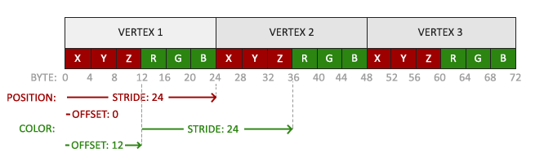

*// з гэтай рэпрэзентацыі я цудоўна зразумеў неясную мне калісьці функцыю //*

Knowing the current layout we can update the vertex format with glVertexAttribPointer:

// position attribute

glVertexAttribPointer(0, 3, GL_FLOAT, GL_FALSE, 6 * **sizeof**(**float**), (**void**\*)0);

glEnableVertexAttribArray(0);

// color attribute

glVertexAttribPointer(1, 3, GL_FLOAT, GL_FALSE, 6 * **sizeof**(**float**), (**void**\*)(3* **sizeof**(**float**)));

glEnableVertexAttribArray(1);

The first few arguments of glVertexAttribPointer are relatively straightforward. This time we are configuring the vertex attribute on attribute location 1. The color values have a size of 3 floats and we do not normalize the values.

Since we now have two vertex attributes we have to re-calculate the stride value. To get the next attribute value (e.g. the next x component of the position vector) in the data array we have to move 6 floats to the right, three for the position values and three for the color values. This gives us a stride value of 6 times the size of a float in bytes (= 24 bytes).   
Also, this time we have to specify an offset. For each vertex, the position vertex attribute is first so we declare an offset of 0. The color attribute starts after the position data so the offset is 3 * sizeof(float) in bytes (= 12 bytes).

Running the application should result in the following image:

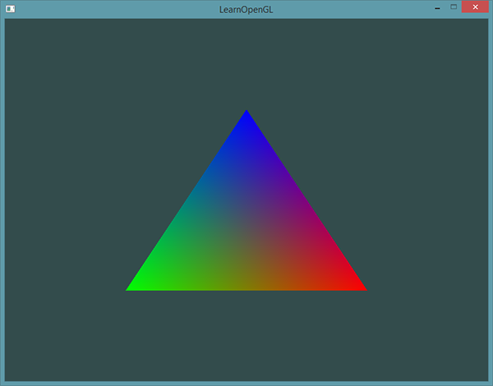

Check out the source code [here](https://learnopengl.com/code_viewer_gh.php?code=src/1.getting_started/3.2.shaders_interpolation/shaders_interpolation.cpp) if you're stuck.

*// УСЁ АТРЫМАЛАСЯ!!! //*

*13.08.2017*

The image might not be exactly what you would expect, since we only supplied 3 colors, not the huge color palette we're seeing right now. This is all the result of something called fragment interpolation in the fragment shader. When rendering a triangle the rasterization stage usually results in a lot more fragments than vertices originally specified. The rasterizer then determines the positions of each of those fragments based on where they reside on the triangle shape. *// рэалізацыя тэхналогіі //*  
Based on these positions, it interpolates all the fragment shader's input variables. Say for example we have a line where the upper point has a green color and the lower point a blue color. If the fragment shader is run at a fragment that resides around a position at 70% of the line its resulting color input attribute would then be a linear combination of green and blue; to be more precise: 30% blue and 70% green. *// алгарытм рэалізацыя градыента //*

This is exactly what happened at the triangle. We have 3 vertices and thus 3 colors and judging from the triangle's pixels it probably contains around 50000 fragments, where the fragment shader interpolated the colors among those pixels. If you take a good look at the colors you'll see it all makes sense: red to blue first gets to purple and then to blue. Fragment interpolation is applied to all the fragment shader's input attributes. *// рэалізацыя тэхналогіі //*

### Our own shader class

Writing, compiling and managing shaders can be quite cumbersome. As a final touch on the shader subject we're going to make our life a bit easier by building a shader class that reads shaders from disk, compiles and links them, checks for errors and is easy to use. This also gives you a bit of an idea how we can encapsulate some of the knowledge we learned so far into useful abstract objects. *// я зрабіў гэта самастойна!!! //*

We will create the shader class entirely in a header file, mainly for learning purposes and portability. Let's start by adding the required includes and by defining the class structure:

#ifndef SHADER_H

#define SHADER_H

#include <glad/glad.h> // include glad to get all the required OpenGL headers

#include <string>

#include <fstream>

#include <sstream>

#include <iostream>

**class** Shader

{

**public**:

// the program ID

**unsigned** **int** ID;

// constructor reads and builds the shader

Shader(**const** **GLchar**\* vertexPath, **const** **GLchar**\* fragmentPath);

// use/activate the shader

**void** use();

// utility uniform functions

**void** setBool(**const** std::string &name, **bool** value) **const**;

**void** setInt(**const** std::string &name, **int** value) **const**;

**void** setFloat(**const** std::string &name, **float** value) **const**;

};

#endif

We used several preprocessor directives at the top of the header file. Using these little lines of code informs your compiler to only include and compile this header file if it hasn't been included yet, even if multiple files include the shader header. This prevents linking conflicts.

The shader class holds the ID of the shader program. Its constructor requires the file paths of the source code of the vertex and fragment shader respectively that we can store on disk as simple text files. To add a little extra we also add several utility functions to ease our lifes a little: use activates the shader program, and all set... functions query a uniform location and set its value.

#### Reading from file

We're using C++ filestreams to read the content from the file into several string objects:

Shader(**const** **char**\* vertexPath, **const** **char**\* fragmentPath)

{

// 1. retrieve the vertex/fragment source code from filePath

std::string vertexCode;

std::string fragmentCode;

std::ifstream vShaderFile;

std::ifstream fShaderFile;

// ensure ifstream objects can throw exceptions:

vShaderFile.exceptions (std::ifstream::failbit | std::ifstream::badbit);

fShaderFile.exceptions (std::ifstream::failbit | std::ifstream::badbit);

**try**

{

// open files

vShaderFile.open(vertexPath);

fShaderFile.open(fragmentPath);

std::stringstream vShaderStream, fShaderStream;

// read file's buffer contents into streams

vShaderStream << vShaderFile.rdbuf();

fShaderStream << fShaderFile.rdbuf();

// close file handlers

vShaderFile.close();

fShaderFile.close();

// convert stream into string

vertexCode = vShaderStream.str();

fragmentCode = fShaderStream.str();

}

**catch**(std::ifstream::failure e)

{

std::cout << "ERROR::SHADER::FILE_NOT_SUCCESFULLY_READ" << std::endl;

}

**const** **char**\* vShaderCode = vertexCode.c_str();

**const** **char**\* fShaderCode = fragmentCode.c_str();

[...]

Next we need to compile and link the shaders. Note that we're also reviewing if compilation/linking failed and if so, print the compile-time errors which is extremely useful when debugging (you are going to need those error logs eventually):

// 2. compile shaders

**unsigned** **int** vertex, fragment;

**int** success;

**char** infoLog[512];

// vertex Shader

vertex = glCreateShader(GL_VERTEX_SHADER);

glShaderSource(vertex, 1, &vShaderCode, NULL);

glCompileShader(vertex);

// print compile errors if any

glGetShaderiv(vertex, GL_COMPILE_STATUS, &success);

**if**(!success)

{

glGetShaderInfoLog(vertex, 512, NULL, infoLog);

std::cout << "ERROR::SHADER::VERTEX::COMPILATION_FAILED\n" << infoLog << std::endl;

};

// similiar for Fragment Shader

[...]

// shader Program

ID = glCreateProgram();

glAttachShader(ID, vertex);

glAttachShader(ID, fragment);

glLinkProgram(ID);

// print linking errors if any

glGetProgramiv(ID, GL_LINK_STATUS, &success);

**if**(!success)

{

glGetProgramInfoLog(**this**->Program, 512, NULL, infoLog);

std::cout << "ERROR::SHADER::PROGRAM::LINKING_FAILED\n" << infoLog << std::endl;

}

// delete the shaders as they're linked into our program now and no longer necessery

glDeleteShader(vertex);

glDeleteShader(fragment);

The use function is straightforward:

**void** use()

{

glUseProgram(ID);

}

Similarly for any of the uniform setter functions:

**void** setBool(**const** std::string &name, **bool** value) **const**

{

glUniform1i(glGetUniformLocation(ID, name.c_str()), (**int**)value);

}

**void** setInt(**const** std::string &name, **int** value) **const**

{

glUniform1i(glGetUniformLocation(ID, name.c_str()), value);

}

**void** setFloat(**const** std::string &name, **float** value) **const**

{

glUniform1f(glGetUniformLocation(ID, name.c_str()), value);

}

And there we have it, a completed [shader class](https://learnopengl.com/code_viewer_gh.php?code=includes/learnopengl/shader_s.h). Using the shader class is fairly easy; we create a shader object once and from that point on simply start using it:

Shader ourShader("path/to/shaders/shader.vs", "path/to/shaders/shader.fs");

...

**while**(...)

{

ourShader.use();

ourShader.setFloat("someUniform", 1.0f);

DrawStuff();

}

Here we stored the vertex and fragment shader source code in two files called shader.vs and shader.fs. You're free to name your shader files however you like; I personally find the extensions .vs and .fs quite intuitive.

You can find the source code [here](https://learnopengl.com/code_viewer_gh.php?code=src/1.getting_started/3.3.shaders_class/shaders_class.cpp) using our newly created [shader class](https://learnopengl.com/code_viewer_gh.php?code=includes/learnopengl/shader_s.h). Note that you can click the shader file paths to find each shader's source code.

*// я скарыстаўся для счытвання файла націўнымі сродкамі Qt – QFile. //*

# Exercises

1. Adjust the vertex shader so that the triangle is upside down: [solution](https://learnopengl.com/code_viewer.php?code=getting-started/shaders-exercise1).
2. Specify a horizontal offset via a uniform and move the triangle to the right side of the screen in the vertex shader using this offset value: [solution](https://learnopengl.com/code_viewer.php?code=getting-started/shaders-exercise2).
3. Output the vertex position to the fragment shader using the out keyword and set the fragment's color equal to this vertex position (see how even the vertex position values are interpolated across the triangle). Once you managed to do this; try to answer the following question: why is the bottom-left side of our triangle black?: [solution](https://learnopengl.com/code_viewer.php?code=getting-started/shaders-exercise3).

*// не рабіў практыкаванняў… хаця трэцяе цікавае… //*

[*https://learnopengl.com/#!Getting-started/Textures*](https://learnopengl.com/#!Getting-started/Textures)

## ***Textures***

*We learned that to add more detail to our objects we can use colors for each vertex to create some interesting images. However, to get a fair bit of realism we'd have to have many vertices so we could specify a lot of colors. This takes up a considerable amount of extra overhead, since each models needs a lot more vertices and for each vertex a color attribute as well. // праблема графікі //*

*What artists and programmers generally prefer is to use a texture. A texture is a 2D image (even 1D and 3D textures exist) used to add detail to an object; think of a texture as a piece of paper with a nice brick image (for example) on it neatly folded over your 3D house so it looks like your house has a stone exterior. Because we can insert a lot of detail in a single image, we can give the illusion the object is extremely detailed without having to specify extra vertices. // перавага тэкстур і цудоўная аналогія для іх разумення //*

*Aside from images, textures can also be used to store a large collection of data to send to the shaders, but we'll leave that for a different topic. // арыентацыя чытача //*

*Below you'll see a texture image of a*[*brick wall*](https://learnopengl.com/img/textures/wall.jpg)*mapped to the triangle from the previous tutorial.*

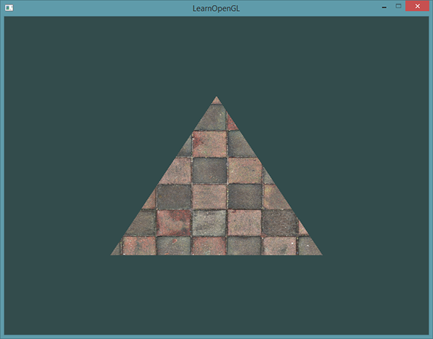

*In order to map a texture to the triangle we need to tell each vertex of the triangle which part of the texture it corresponds to. Each vertex should thus have a texture coordinate associated with them that specifies what part of the texture image to sample from. Fragment interpolation then does the rest for the other fragments. // выкарыстанне і рэалізацыя тэхналогіі. Фрагментная інтэрпаляцыя ў тэкстурах //*

*Texture coordinates range from 0 to 1 in the x and y axis (remember that we use 2D texture images). Retrieving the texture color using texture coordinates is called sampling. Texture coordinates start at (0,0) for the lower left corner of a texture image to (1,1) for the upper right corner of a texture image. The following image shows how we map texture coordinates to the triangle: // цудоўнейшая рэпрэзентацыя. Граматнейшы цьютарал //*

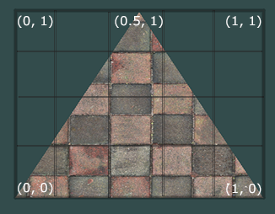

*We specify 3 texture coordinate points for the triangle. We want the bottom-left side of the triangle to correspond with the bottom-left side of the texture so we use the (0,0) texture coordinate for the triangle's bottom-left vertex. The same applies to the bottom-right side with a (1,0) texture coordinate. The top of the triangle should correspond with the top-center of the texture image so we take (0.5,1.0) as its texture coordinate. We only have to pass 3 texture coordinates to the vertex shader, which then passes those to the fragment shader that neatly interpolates all the texture coordinates for each fragment.*

*The resulting texture coordinates would then look like this:*

***float*** *texCoords[] = {*

*0.0f, 0.0f, // lower-left corner*

*1.0f, 0.0f, // lower-right corner*

*0.5f, 1.0f // top-center corner*

*};*

*Texture sampling has a loose interpretation and can be done in many different ways. It is thus our job to tell OpenGL how it should sample its textures. // задача ў графічных прылажэннях //*

### ***Texture Wrapping***

*Texture coordinates usually range from (0,0) to (1,1) but what happens if we specify coordinates outside this range? The default behavior of OpenGL is to repeat the texture images (we basically ignore the integer part of the floating point texture coordinate), but there are more options OpenGL offers: // рэалізацыя OpenGL //*

* *GL_REPEAT: The default behavior for textures. Repeats the texture image.*
* *GL_MIRRORED_REPEAT: Same as GL_REPEAT but mirrors the image with each repeat.*
* *GL_CLAMP_TO_EDGE: Clamps the coordinates between 0 and 1. The result is that higher coordinates become clamped to the edge, resulting in a stretched edge pattern.*
* *GL_CLAMP_TO_BORDER: Coordinates outside the range are now given a user-specified border color.*

*Each of the options have a different visual output when using texture coordinates outside the default range. Let's see what these look like on a sample texture image:*

*// з рэпрэзентацыя мне сталі зразумелыя гэтыя патэрны! //*

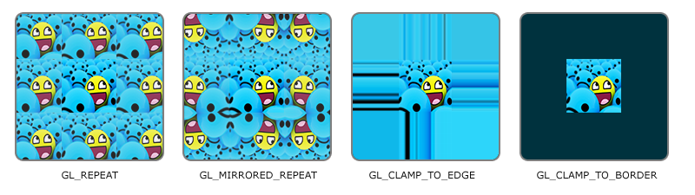

*Each of the aforementioned options can be set per coordinate axis (s, t (and r if you're using 3D textures) equivalent to x,y,z) with the glTexParameter* function:*

*glTexParameteri(GL_TEXTURE_2D, GL_TEXTURE_WRAP_S, GL_MIRRORED_REPEAT);*

*glTexParameteri(GL_TEXTURE_2D, GL_TEXTURE_WRAP_T, GL_MIRRORED_REPEAT);*

*The first argument specifies the texture target; we're working with 2D textures so the texture target is GL_TEXTURE_2D. The second argument requires us to tell what option we want to set and for which texture axis. We want to configure the WRAP option and specify it for both the S and T axis. The last argument requires us to pass in the texture wrapping mode we'd like and in this case OpenGL will set its texture wrapping option on the currently active texture with GL_MIRRORED_REPEAT.*

*If we choose the GL_CLAMP_TO_BORDER option we should also specify a border color. This is done using the fv equivalent of the glTexParameter function with GL_TEXTURE_BORDER_COLOR as its option where we pass in a float array of the border's color value:*

***float*** *borderColor[] = { 1.0f, 1.0f, 0.0f, 1.0f };*

*glTexParameterfv(GL_TEXTURE_2D, GL_TEXTURE_BORDER_COLOR, borderColor);*

### ***Texture Filtering***

*Texture coordinates do not depend on resolution but can be any floating point value, thus OpenGL has to figure out which texture pixel (also known as a texel ) to map the texture coordinate to. This becomes especially important if you have a very large object and a low resolution texture. You probably guessed by now that OpenGL has options for this texture filtering as well. There are several options available but for now we'll discuss the most important options: GL_NEAREST and GL_LINEAR.*

*GL_NEAREST (also known as nearest neighbor filtering) is the default texture filtering method of OpenGL. When set to GL_NEAREST, OpenGL selects the pixel which center is closest to the texture coordinate. // праблема ў тым, што выява на кампутары захавана як набор пікселаў, тады як каардынаты тэкстуры ў OpenGL мы задаем праз флоаты. І нам важна вызначыць з канкрэтнага флоата, які піксель выявы выкарыстоўваць // Below you can see 4 pixels where the cross represents the exact texture coordinate. The upper-left texel has its center closest to the texture coordinate and is therefore chosen as the sampled color: // цудоўная графічная рэпрэзентацыя дадзенай фільтрацыі //*

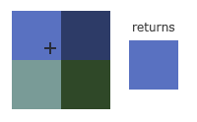

*GL_LINEAR (also known as (bi) linear filtering) takes an interpolated value from the texture coordinate's neighboring texels, approximating a color between the texels. The smaller the distance from the texture coordinate to a texel's center, the more that texel's color contributes to the sampled color. Below we can see that a mixed color of the neighboring pixels is returned: // цудоўная рэпрэзентацыя //*

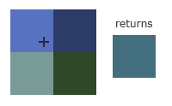

*But what is the visual effect of such a texture filtering method? Let's see how these methods work when using a texture with a low resolution on a large object (texture is therefore scaled upwards and individual texels are noticeable):*

**

*// вельмі цудоўная рэпрэзентацыя, якая тлумачыць розніцу //*

*GL_NEAREST results in blocked patterns where we can clearly see the pixels that form the texture while GL_LINEAR produces a smoother pattern where the individual pixels are less visible. GL_LINEAR produces a more realistic output, but some developers prefer a more 8-bit look and as a result pick the GL_NEAREST option.*

*Texture filtering can be set for magnifying and minifying operations (when scaling up or downwards) so you could for example use nearest neighbor filtering when textures are scaled downwards and linear filtering for upscaled textures. // кантэкст выкарыстання паняцця // We thus have to specify the filtering method for both options via glTexParameter*. The code should look similar to setting the wrapping method:*

*glTexParameteri(GL_TEXTURE_2D, GL_TEXTURE_MIN_FILTER, GL_NEAREST);*

*glTexParameteri(GL_TEXTURE_2D, GL_TEXTURE_MAG_FILTER, GL_LINEAR);*

### ***Mipmaps***

*Imagine if we had a large room with thousands of objects, each with an attached texture. There will be objects far away that have the same high resolution texture attached as the objects close to the viewer. Since the objects are far away and probably only produce a few fragments, OpenGL has difficulties retrieving the right color value for its fragment from the high resolution texture, since it has to pick a texture color for a fragment that spans a large part of the texture. // калі, напрыклад, выява захоўваецца з дазваленнем 1000*1000 пікселяў, а на экране яна займае толькі пару пікселяў. Праблема зразумела // This will produce visible artifacts on small objects, not to mention the waste of memory to use high resolution textures on small objects. // важная праблема OpenGL //*

*To solve this issue OpenGL uses a concept called mipmaps that is basically a collection of texture images where each subsequent texture is twice as small compared to the previous one. The idea behind mipmaps should be easy to understand: after a certain distance threshold from the viewer, OpenGL will use a different mipmap texture that best suits the distance to the object. Because the object is far away, the smaller resolution will not be noticeable to the user. Also, mipmaps have the added bonus feature that they're good for performance as well. Let's take a closer look at what a mipmapped texture looks like: // цудоўны прыклад праз рэпрэзентацыю //*

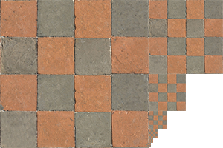

*Creating a collection of mipmapped textures for each texture image is cumbersome to do manually, but luckily OpenGL is able to do all the work for us with a single call to glGenerateMipmaps after we've created a texture. Later in the texture tutorial you'll see use of this function. // структура OpenGL //*

*When switching between mipmaps levels during rendering OpenGL might show some artifacts like sharp edges visible between the two mipmap layers. Just like normal texture filtering, it is also possible to filter between mipmap levels using NEAREST and LINEAR filtering for switching between mipmap levels. To specify the filtering method between mipmap levels we can replace the original filtering methods with one of the following four options:*

* *GL_NEAREST_MIPMAP_NEAREST: takes the nearest mipmap to match the pixel size and uses nearest neighbor interpolation for texture sampling.*
* *GL_LINEAR_MIPMAP_NEAREST: takes the nearest mipmap level and samples using linear interpolation.*
* *GL_NEAREST_MIPMAP_LINEAR: linearly interpolates between the two mipmaps that most closely match the size of a pixel and samples via nearest neighbor interpolation.*
* *GL_LINEAR_MIPMAP_LINEAR: linearly interpolates between the two closest mipmaps and samples the texture via linear interpolation. // мне было бы цікава ўбачыць гэтыя артэфакты пры пераключэнні між міпмапамі… //*

*Just like texture filtering we can set the filtering method to one of the 4 aforementioned methods using glTexParameteri:*

*glTexParameteri(GL_TEXTURE_2D, GL_TEXTURE_MIN_FILTER, GL_LINEAR_MIPMAP_LINEAR);*

*glTexParameteri(GL_TEXTURE_2D, GL_TEXTURE_MAG_FILTER, GL_LINEAR);*

*A common mistake is to set one of the mipmap filtering options as the magnification filter. This doesn't have any effect since mipmaps are primarily used for when textures get downscaled: texture magnification doesn't use mipmaps and giving it a mipmap filtering option will generate an OpenGL GL_INVALID_ENUM error code. // заўвага і патэнцыйная памылка //*

### ***Loading and creating textures***

*The first thing we need to do to actually use textures is to load them into our application. Texture images can be stored in dozens of file formats, each with their own structure and ordering of data, so how do we get those images in our application? One solution would be to choose a file format we'd like to use, say .PNG and write our own image loader to convert the image format into a large array of bytes. While it's not very hard to write your own image loader, it's still cumbersome and what if you want to support more file formats? You'd then have to write an image loader for each format you want to support.*

*Another solution, and probably a good one, is to use an image-loading library that supports several popular formats and does all the hard work for us. A library like stb_image.h.*

***stb_image.h***

*stb_image.h is a very popular single header image loading library by*[*Sean Barrett*](https://github.com/nothings)*that is able to load most popular file formats and is easy to integrate in your project(s). stb_image.h can be downloaded from*[*here*](https://github.com/nothings/stb/blob/master/stb_image.h)*. // яшчэ адзін інструмент // Simply download the single header file, add it to your project as stb_image.h and create an additional C++ file with the following code:*

*#define STB_IMAGE_IMPLEMENTATION*

*#include "stb_image.h"*

*By defining STB_IMAGE_IMPLEMENTATION the preprocessor modifies the header file such that it only contains the relevant definition source code, effectively turning the header file into a .cpp file, and that's about it. Now simply include stb_image.h somewhere in your program and compile.*

*For the following texture sections we're going to use an image of a*[*wooden container*](https://learnopengl.com/img/textures/container.jpg)*. To load an image using stb_image.hwe use its stbi_load function:*

***int*** *width, height, nrChannels;*

***unsigned******char*** *\*data = stbi_load("container.jpg", &width, &height, &nrChannels, 0);*

*The function first takes as input the location of an image file. It then expects you to give three ints as its second, third and fourth argument that stb_image.h will fill with the resulting image's width, height and number of color channels. We need the image's width and height for generating textures later on.*

### ***Generating a texture***

*Like any of the previous objects in OpenGL, textures are referenced with an ID; let's create one:*

***unsigned******int*** *texture;*

*glGenTextures(1, &texture);*

*The glGenTextures function first takes as input how many textures we want to generate and stores them in a unsigned int array given as its second argument (in our case just a single unsigned int). Just like other objects we need to bind it so any subsequent texture commands will configure the currently bound texture: // разнавіднасць аб’екта OpenGL. Паслядоўнасць работы з бібліятэкай. //*

*glBindTexture(GL_TEXTURE_2D, texture);*

*Now that the texture is bound, we can start generating a texture using the previously loaded image data. Textures are generated with glTexImage2D:*

*glTexImage2D(GL_TEXTURE_2D, 0, GL_RGB, width, height, 0, GL_RGB, GL_UNSIGNED_BYTE, data);*

*glGenerateMipmap(GL_TEXTURE_2D);*

*This is a large function with quite a few parameters so we'll walk through them step-by-step:*

* *The first argument specifies the texture target; setting this to GL_TEXTURE_2D means this operation will generate a texture on the currently bound texture object at the same target (so any textures bound to targets GL_TEXTURE_1D or GL_TEXTURE_3D will not be affected).*
* *The second argument specifies the mipmap level for which we want to create a texture for if you want to set each mipmap level manually, but we'll leave it at the base level which is 0.*
* *The third argument tells OpenGL in what kind of format we want to store the texture. Our image has only RGB values so we'll store the texture with RGB values as well.*
* *The 4th and 5th argument sets the width and height of the resulting texture. We stored those earlier when loading the image so we'll use the corresponding variables.*
* *The next argument should always be 0 (some legacy stuff). // не самы лепшы прыклад бібліятэкі //*
* *The 7th and 8th argument specify the format and datatype of the source image. We loaded the image with RGB values and stored them as chars (bytes) so we'll pass in the corresponding values.*
* *The last argument is the actual image data.*

*Once glTexImage2D is called, the currently bound texture object now has the texture image attached to it. However, currently it only has the base-level of the texture image loaded and if we want to use mipmaps we have to specify all the different images manually (by continually incrementing the second argument) or, we could call glGenerateMipmap after generating the texture. This will automatically generate all the required mipmaps for the currently bound texture.*

*After we're done generating the texture and its corresponding mipmaps, it is good practice to free the image memory:*

*stbi_image_free(data);*

*The whole process of generating a texture thus looks something like this:*

***unsigned******int*** *texture;*

*glGenTextures(1, &texture);*

*glBindTexture(GL_TEXTURE_2D, texture);*

*// set the texture wrapping/filtering options (on the currently bound texture object)*

*glTexParameteri(GL_TEXTURE_2D, GL_TEXTURE_WRAP_S, GL_REPEAT);*

*glTexParameteri(GL_TEXTURE_2D, GL_TEXTURE_WRAP_T, GL_REPEAT);*

*glTexParameteri(GL_TEXTURE_2D, GL_TEXTURE_MIN_FILTER, GL_LINEAR);*

*glTexParameteri(GL_TEXTURE_2D, GL_TEXTURE_MAG_FILTER, GL_LINEAR);*

*// load and generate the texture*

***int*** *width, height, nrChannels;*

***unsigned******char*** *\*data = stbi_load("container.jpg", &width, &height, &nrChannels, 0);*

***if*** *(data)*

*{*

*glTexImage2D(GL_TEXTURE_2D, 0, GL_RGB, width, height, 0, GL_RGB, GL_UNSIGNED_BYTE, data);*

*glGenerateMipmap(GL_TEXTURE_2D);*

*}*

***else***

*{*

*std::cout << "Failed to load texture" << std::endl;*

*}*

*stbi_image_free(data);*

### ***Applying textures***

*For the upcoming sections we will use the rectangle shape drawn with glDrawElements from the final part of the*[*Hello Triangle*](https://learnopengl.com/#!Getting-started/Hello-Triangle)*tutorial. We need to inform OpenGL how to sample the texture so we'll have to update the vertex data with the texture coordinates:*

***float*** *vertices[] = {*

*// positions // colors // texture coords*

*0.5f, 0.5f, 0.0f, 1.0f, 0.0f, 0.0f, 1.0f, 1.0f, // top right*

*0.5f, -0.5f, 0.0f, 0.0f, 1.0f, 0.0f, 1.0f, 0.0f, // bottom right*

*-0.5f, -0.5f, 0.0f, 0.0f, 0.0f, 1.0f, 0.0f, 0.0f, // bottom left*

*-0.5f, 0.5f, 0.0f, 1.0f, 1.0f, 0.0f, 0.0f, 1.0f // top left*

*};*

*Since we've added an extra vertex attribute we again have to notify OpenGL of the new vertex format:*

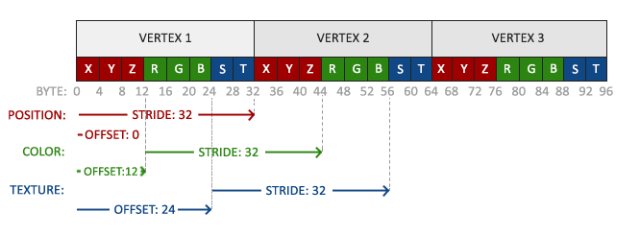

*// цудоўная рэпрэзентацыя, якая дазваляе добра зразумець тэхналогію //*

*glVertexAttribPointer(2, 2, GL_FLOAT, GL_FALSE, 8 \** ***sizeof****(****float****), (****void****\*)(6 \** ***sizeof****(****float****)));*

*glEnableVertexAttribArray(2);*

*Note that we have to adjust the stride parameter of the previous two vertex attributes to 8 * sizeof(float) as well.*

*Next we need to alter the vertex shader to accept the texture coordinates as a vertex attribute and then forward the coordinates to the fragment shader:*

*#version 330 core*

***layout*** *(location = 0)* ***in*** *vec3 aPos;*

***layout*** *(location = 1)* ***in*** *vec3 aColor;*

***layout*** *(location = 2)* ***in*** *vec2 aTexCoord;*

***out*** *vec3 ourColor;*

***out*** *vec2 TexCoord;*

***void*** *main()*

*{*

*gl_Position = vec4(aPos, 1.0);*

*ourColor = aColor;*

*TexCoord = aTexCoord;*

*}*

*The fragment shader should then accept the TexCoord output variable as an input variable.*

*The fragment shader should also have access to the texture object, but how do we pass the texture object to the fragment shader? GLSL has a built-in data-type for texture objects called a sampler that takes as a postfix the texture type we want e.g. sampler1D, sampler3D or in our case sampler2D. We can then add a texture to the fragment shader by simply declaring a uniform sampler2D that we later assign our texture to.*

*#version 330 core*

***out*** *vec4 FragColor;*

***in*** *vec3 ourColor;*

***in*** *vec2 TexCoord;*

***uniform*** *sampler2D ourTexture;*

***void*** *main()*

*{*

*FragColor = texture(ourTexture, TexCoord);*

*}*

*To sample the color of a texture we use GLSL's built-in texture function that takes as its first argument a texture sampler and as its second argument the corresponding texture coordinate. The texture function then samples the corresponding color value using the texture parameters we set earlier. // кантэкст выкарыстання і рэалізацыя тэхналогіі // The output of this fragment shader is then the (filtered) color of the texture at the (interpolated) texture coordinate.*

*All that's left to do now is to bind the texture before calling the glDrawElements and it will then automatically assign the texture to the fragment shader's sampler:*

*glBindTexture(GL_TEXTURE_2D, texture);*

*glBindVertexArray(VAO);*

*glDrawElements(GL_TRIANGLES, 6, GL_UNSIGNED_INT, 0);*

*If you did everything right you should see the following image:*

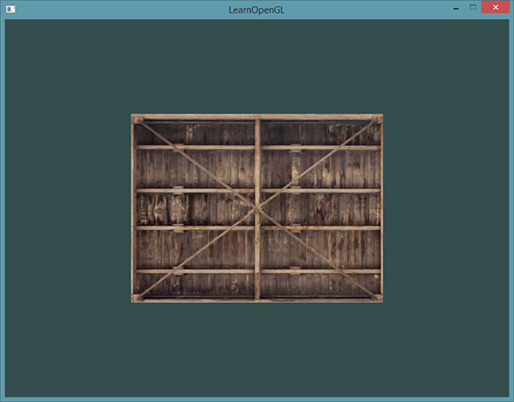

*If your rectangle is completely white or black you probably made an error along the way. Check your shader logs and try to compare your code with the application's*[*source code*](https://learnopengl.com/code_viewer_gh.php?code=src/1.getting_started/4.1.textures/textures.cpp)*.*

*// З ГОРАМ ДЫ ПАПАЛАМ У МЯНЕ ЎСЁ АТРЫМАЛАСЯ, АЛЕ ТОЛЬКІ З ВЫКАРЫСТАННЕМ СПАМПАВАНАЙ БІБЛІЯТЭКІ. ПРЫ ДАПАМОЗЕ QImage я не змог рэалізаваць задуманнае. Тэкстура атрымалася нейкай не такой… Трэба будзе лепей разбірацца ў гэтым класе //*

*If your texture code doesn't work or shows up as completely black, continue reading and work your way to the last example that****should****work. On some drivers it is always required to assign a texture unit to each sampler uniform which we'll discuss further in this tutorial.*

*To get a little funky we can also mix the resulting texture color with the vertex colors. We simply multiply the resulting texture color with the vertex color in the fragment shader to mix both colors:*

*FragColor = texture(ourTexture, TexCoord) * vec4(ourColor, 1.0);*

*The result should be a mixture of the vertex's color and the texture's color:*

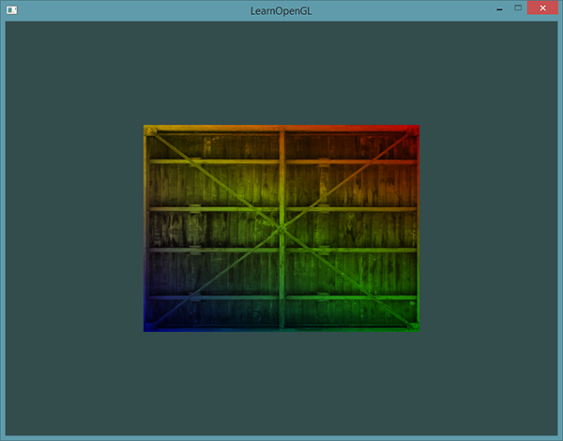

*I guess you could say our container likes to disco.*

### ***Texture Units***

*You probably wondered why the sampler2D variable is a uniform if we didn't even assign it some value with glUniform. Using glUniform1i we can actually assign a location value to the texture sampler so we can set multiple textures at once in a fragment shader. This location of a texture is more commonly known as a texture unit. The default texture unit for a texture is 0 which is the default active texture unit so we did not had to assign a location in the previous section; note that not all graphics drivers assign a default texture unit so the previous section might not've rendered for you. // нюанс розных графічных картак //*

*The main purpose of texture units is to allow us to use more than 1 texture in our shaders. By assigning texture units to the samplers, we can bind to multiple textures at once as long as we activate the corresponding texture unit first. Just like glBindTexture we can activate texture units using glActiveTexture passing in the texture unit we'd like to use:*

*glActiveTexture(GL_TEXTURE0); // activate the texture unit first before binding texture*

*glBindTexture(GL_TEXTURE_2D, texture);*

*After activating a texture unit, a subsequent glBindTexture call will bind that texture to the currently active texture unit. Texture unit GL_TEXTURE0 is always by default activated, so we didn't have to activate any texture units in the previous example when using glBindTexture.*

*OpenGL should have a at least a minimum of 16 texture units for you to use which you can activate using GL_TEXTURE0 to GL_TEXTURE15. They are defined in order so we could also get GL_TEXTURE8 via GL_TEXTURE0 + 8 for example, which is useful when we'd have to loop over several texture units. // рэалізацыя тэхналогіі і яе выкарыстанне // //*

*We still however need to edit the fragment shader to accept another sampler. This should be relatively straightforward now:*

*#version 330 core*

*...*

***uniform*** *sampler2D texture1;*

***uniform*** *sampler2D texture2;*

***void*** *main()*

*{*

*FragColor = mix(texture(texture1, TexCoord), texture(texture2, TexCoord), 0.2);*

*}*

*The final output color is now the combination of two texture lookups. GLSL's built-in mix function takes two values as input and linearly interpolates between them based on its third argument. If the third value is 0.0 it returns the first input; if it's 1.0 it returns the second input value. A value of 0.2 will return 80% of the first input color and 20% of the second input color, resulting in a mixture of both our textures.*

*We now want to load and create another texture; you should be familiar with the steps now. Make sure to create another texture object, load the image and generate the final texture using glTexImage2D. For the second texture we'll use an image of your*[*facial expression while learning OpenGL*](https://learnopengl.com/img/textures/awesomeface.png)*.*

*To use the second texture (and the first texture) we'd have to change the rendering procedure a bit by binding both textures to the corresponding texture unit:*

*glActiveTexture(GL_TEXTURE0);*

*glBindTexture(GL_TEXTURE_2D, texture1);*

*glActiveTexture(GL_TEXTURE1);*

*glBindTexture(GL_TEXTURE_2D, texture2);*

*glBindVertexArray(VAO);*

*glDrawElements(GL_TRIANGLES, 6, GL_UNSIGNED_INT, 0);*

*We also have to tell OpenGL to which texture unit each shader sampler belongs to by setting each sampler using glUniform1i. We only have to set this once, so we can do this before we enter the render loop:*

*ourShader.use(); // don't forget to activate the shader before setting uniforms!*

*glUniform1i(glGetUniformLocation(ourShader.ID, "texture1"), 0); // set it manually*

*ourShader.setInt("texture2", 1); // or with shader class*

***while****(...)*

*{*

*[...]*

*}*

*By setting the samplers via glUniform1i we make sure each uniform sampler corresponds to the proper texture unit. You should get the following result:*

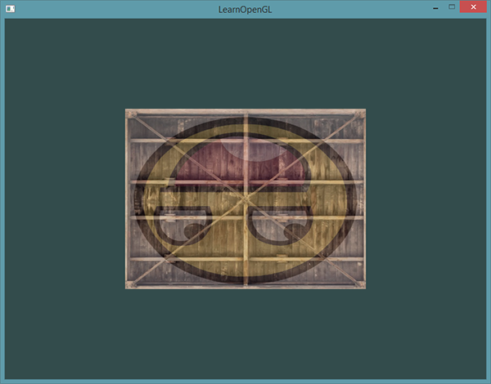

*You probably noticed that the texture is flipped upside-down! This happens because OpenGL expects the 0.0 coordinate on the y-axis to be on the bottom side of the image, but images usually have 0.0 at the top of the y-axis. Luckily for us, stb_image.h can flip the y-axis during image loading by adding the following statment before loading any image:*

*stbi_set_flip_vertically_on_load(****true****);*

*After telling stb_image.h to flip the y-axis when loading images you should get the following result:*

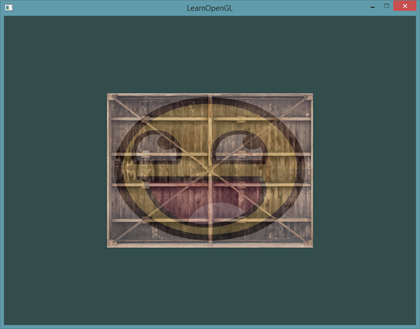

*If you see one happy container, you did things right. You can compare it with the*[*source code*](https://learnopengl.com/code_viewer_gh.php?code=src/1.getting_started/4.2.textures_combined/textures_combined.cpp)*.*

*// у мяне ўсё атрымалася! Але гэта было няпроста! //*

### ***Exercises***

*To get more comfortable with textures it is advised to work through these exercises before continuing.*

* *Make sure****only****the happy face looks in the other/reverse direction by changing the fragment shader:*[*solution*](https://learnopengl.com/code_viewer.php?code=getting-started/textures-exercise1)*. // я тут не зразумеў заданне //*
* *Experiment with the different texture wrapping methods by specifying texture coordinates in the range 0.0f to 2.0f instead of 0.0f to 1.0f. See if you can display 4 smiley faces on a single container image clamped at its edge:*[*solution*](https://learnopengl.com/code_viewer_gh.php?code=src/1.getting_started/4.3.textures_exercise2/textures_exercise2.cpp)*,*[*result*](https://learnopengl.com/img/getting-started/textures_exercise2.png)*. See if you can experiment with other wrapping methods as well. // пабалаваўся і павыконваў //*
* *Try to display only the center pixels of the texture image on the rectangle in such a way that the individual pixels are getting visible by changing the texture coordinates. Try to set the texture filtering method to GL_NEAREST to see the pixels more clearly:*[*solution*](https://learnopengl.com/code_viewer_gh.php?code=src/1.getting_started/4.4.textures_exercise3/textures_exercise3.cpp)*. // зроблена //*
* *Use a uniform variable as the mix function's third parameter to vary the amount the two textures are visible. Use the up and down arrow keys to change how much the container or the smiley face is visible:*[*solution*](https://learnopengl.com/code_viewer_gh.php?code=src/1.getting_started/4.5.textures_exercise4/textures_exercise4.cpp)*. // я вырашыў, але за адно націсканне стрэлкі ў мяне функцыя апрацоўкі інпута выклікаецца шмат разоў – каля ста. Так што прыйшлося паставіць вельмі малы інкрэмент. Дужа хутка працавала праграма. Такое ж самае вырашэнне прапанаваў і аўтар цьютарала. //*

[*https://learnopengl.com/#!Getting-started/Transformations*](https://learnopengl.com/#!Getting-started/Transformations)

*14.08.2017*

## ***Transformations***

*We now know how to create objects, color them and/or give them a detailed appearance using textures, but they're still not that interesting since they're all static objects. We could try and make them move by changing their vertices and re-configuring their buffers each frame, but that's cumbersome and costs quite some processing power. There are much better ways to transform an object and that's by using (multiple) matrix objects. This doesn't mean we're going to talk about kungfu and a large digital artificial world. // арыентацыя чытача. Перавага выкарыстання матрыц. Апошні сказ я не зразумеў… //*

*Matrices are very powerful mathematical constructs that seem scary at first, but once you'll grow accustomed to them they'll prove extremely useful. When discussing matrices, we'll have to make a small dive into some mathematics and for the more mathematically inclined readers I'll post additional resources for further reading.*

*However, to fully understand transformations we first have to delve a bit deeper into vectors before discussing matrices. The focus of this chapter is to give you a basic mathematical background in topics we will require later on. If the subjects are difficult, try to understand them as much as you can and come back to this page later to review the concepts whenever you need them. // фантастычная арыентацыя чытача. Тнав. //*

### ***Vectors***

*In its most basic definition, vectors are directions and nothing more. A vector has a direction and a magnitude (also known as its strength or length). You can think of vectors like directions on a treasure map: 'go left 10 steps, now go north 3 steps and go right 5 steps'; here 'left' is the direction and '10 steps' is the magnitude of the vector. The directions for the treasure map thus contains 3 vectors. Vectors can have any dimension, but we usually work with dimensions of 2 to 4. If a vector has 2 dimensions it represents a direction on a plane (think of 2D graphs) and when it has 3 dimensions it can represent any direction in a 3D world.*

*Below you'll see 3 vectors where each vector is represented with (x,y) as arrows in a 2D graph. Because it is more intuitive to display vectors in 2D (than in 3D) you can think of the 2D vectors as 3D vectors with a z coordinate of 0. Since vectors represent directions, the origin of the vector does not change its value. In the graph below we can see that the vectors v¯v¯ and w¯w¯ are equal even though their origin is different: // разнавіднасці вектараў //*

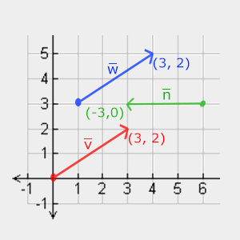

*When describing vectors mathematicians generally prefer to describe vectors as character symbols with a little bar over their head like v¯v¯. Also, when displaying vectors in formulas they are generally displayed as follows:*

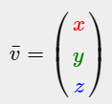

*Because vectors are specified as directions it is sometimes hard to visualize them as positions. What we basically visualize is we set the origin of the direction to (0,0,0) and then point towards a certain direction that specifies the point, making it a position vector (we could also specify a different origin and then say: 'this vector points to that point in space from this origin'). The position vector (3,5) would then point to (3,5) on the graph with an origin of (0,0). Using vectors we can thus describe directions****and****positions in 2D and 3D space.*

*Just like with normal numbers we can also define several operations on vectors (some of which you've already seen).*

#### **Scalar vector operations**

*A scalar is a single digit (or a vector with 1 component if you'd like stay in vector-land). When adding/subtracting/multiplying or dividing a vector with a scalar we simply add/subtract/multiply or divide each element of the vector by the scalar. For addition it would look like this:*

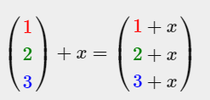

*Where ++ can be ++,−−,⋅⋅ or ÷÷ where ⋅⋅ is the multiplication operator. Keep in mind that for the −− and ÷÷ operator order the reverse order is not defined. // intbu better //*

#### **Vector negation**

*Negating a vector results in a vector in the reversed direction. A vector pointing north-east would point south-west after negation. To negate a vector we add a minus-sign to each component (you can also represent it as a scalar-vector multiplication with a scalar value of -1):*

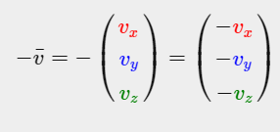

#### **Addition and subtraction**

*Addition of two vectors is defined as component-wise addition, that is each component of one vector is added to the same component of the other vector like so:*

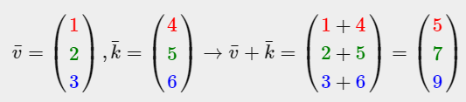

*Visually, it looks like this on vectors v=(4,2) and k=(1,2):*

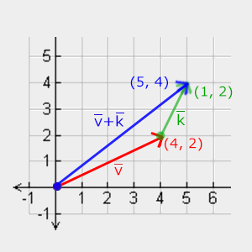

*Just like normal addition and subtraction, vector subtraction is the same as addition with a negated second vector:*

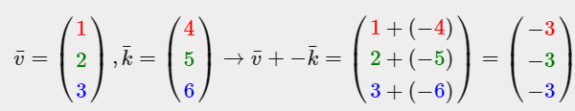

*// вельмі крута, што розныя кампаненты паказаны розным колерам. Тнав. //*

*Subtracting two vectors from each other results in a vector that's the difference of the positions both vectors are pointing at. This proves useful in certain cases where we need to retrieve a vector that's the difference between two points. // кантэкст выкарыстання аперацыі аднімання вектараў //*

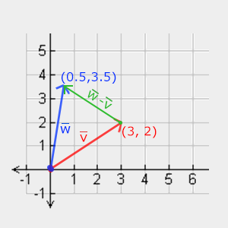

#### **Length**

*To retrieve the length/magnitude of a vector we use the Pythagoras theorem that you might remember from your math classes. A vector forms a triangle when you visualize its individual x and y component as two sides of a triangle:*

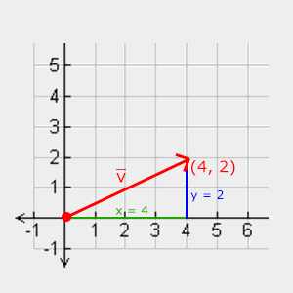

*Since the length of the two sides (x, y) are known and we want to know the length of the tilted side v¯v¯ we can calculate it using the Pythagoras theorem as:*

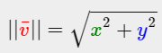

*Where ||v¯||||v¯|| is denoted as the length of vector v¯v¯. This is easily extended to 3D by adding z2z2 to the equation.*

*In this case the length of vector (4, 2) equals:*

**

*Which is 4.47.*

*There is also a special type of vector that we call a unit vector. A unit vector has one extra property and that is that its length is exactly 1. We can calculate a unit vector n^n^ from any vector by dividing each of the vector's components by its length:*

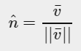

*We call this normalizing a vector. Unit vectors are displayed with a little roof over their head and are generally easier to work with, especially when we only care about their directions (the direction does not change if we change a vector's length).*

#### **Vector-vector multiplication**

*Multiplying two vectors is a bit of a weird case. Normal multiplication isn't really defined on vectors since it has no visual meaning, but we have two specific cases that we could choose from when multiplying: one is the dot product denoted as v¯⋅k¯v¯⋅k¯and the other is the cross product denoted as v¯×k¯v¯×k¯.*

##### ***Dot product***

*The dot product of two vectors is equal to the scalar product of their lengths times the cosine of the angle between them. If this sounds confusing take a look at its formula: // аўтар цьюторыяла – вялікі спец па навучанні! Тнав. //*

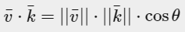

*Where the angle between them is represented as theta (θθ). Why is this interesting? Well, imagine if v¯v¯ and k¯k¯ are unit vectors then their length would be equal to 1. This would effectively reduce the formula to:*

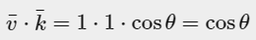

*Now the dot product****only****defines the angle between both vectors. You might remember that the cosine or cos function becomes 0 when the angle is 90 degrees or 1 when the angle is 0. This allows us to easily test if the two vectors are orthogonal or parallel to each other using the dot product (orthogonal means the vectors are at a right-angle to each other). In case you want to know more about the sin or the cosine functions I'd suggest the following*[*Khan Academy videos*](https://www.khanacademy.org/math/trigonometry/basic-trigonometry/basic_trig_ratios/v/basic-trigonometry)*about basic trigonometry. // цудоўная спасылка аўтара на адукацыйныя рэсурсы. Гэта фантастыка! //*

*You can also calculate the angle between two non-unit vectors, but then you'd have to divide the lengths of both vectors from the result to be left with cosθ.*

*So how do we calculate the dot product? The dot product is a component-wise multiplication where we add the results together. It looks like this with two unit vectors (you can verify that both their lengths are exactly 1):*

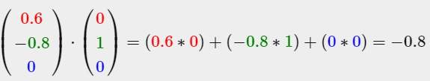

*To calculate the degree between both these unit vectors we use the inverse of the cosine function cos−1 and this results in 143.1 degrees. We now effectively calculated the angle between these two vectors. The dot product proves very useful when doing lighting calculations. // кантэкст выкарыстання паняцця //*

##### ***Cross product***

*The cross product is only defined in 3D space and takes two non-parallel vectors as input and produces a third vector that is orthogonal to both the input vectors. If both the input vectors are orthogonal to each other as well, a cross product would result in 3 orthogonal vectors. This will prove useful in the upcoming tutorials. The following image shows what this looks like in 3D space:*

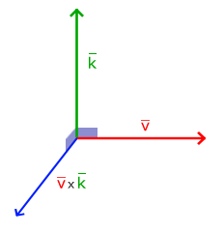

*Unlike the other operations, the cross product isn't really intuitive without delving into linear algebra so it's best to just memorize the formula and you'll be fine (or don't, you'll probably be fine as well). Below you'll see the cross product between two orthogonal vectors A and B:*

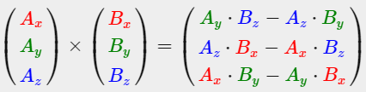

*As you can see, it doesn't really seem to make sense. However, if you just follow these steps you'll get another vector that is orthogonal to your input vectors.*

### ***Matrices***

*Now that we've discussed almost all there is to vectors it is time to enter the matrix! A matrix is basically a rectangular array of numbers, symbols and/or expressions. Each individual item in a matrix is called an element of the matrix. An example of a 2x3 matrix is shown below:*

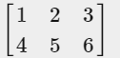

*Matrices are indexed by (i,j) where i is the row and j is the column, that is why the above matrix is called a 2x3 matrix (3 columns and 2 rows, also known as the dimensions of the matrix). This is the opposite of what you're used to when indexing 2D graphs as (x,y). To retrieve the value 4 we would index it as (2,1) (second row, first column).*

*Matrices are basically nothing more than that, just rectangular arrays of mathematical expressions. They do have a very nice set of mathematical properties and just like vectors we can define several operations on matrices, namely: addition, subtraction and multiplication.*

#### Addition and subtraction

*Addition and subtraction between a matrix and a scalar is defined as follows:*

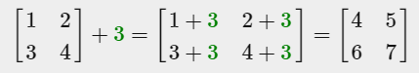

The scalar value is basically added to each individual element of the matrix. The same applies for matrix-scalar subtraction:

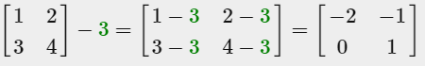

*Matrix addition and subtraction between two matrices is done on a per-element basis. So the same general rules apply that we're familiar with for normal numbers, but done on the elements of both matrices with the same index. This does mean that addition and subtraction is only defined for matrices of the same dimensions. A 3x2 matrix and a 2x3 matrix (or a 3x3 matrix and a 4x4 matrix) cannot be added or subtracted together. Let's see how matrix addition works on two 2x2 matrices:*

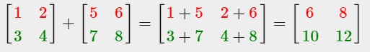

*The same rules apply for matrix subtraction:*

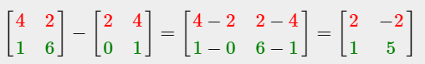

#### **Matrix-scalar products**

*Just like addition and subtraction, a matrix-scalar product multiples each element of the matrix by a scalar. The following example illustrates the multiplication:*

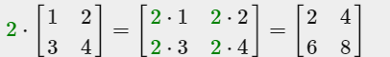

*Now it also makes sense as to why those single numbers are called scalars. A scalar basically scales all the elements of the matrix by its value. In the previous example, all elements were scaled by 2. // цудоўная этымалогія назвы. З разраду “ніколі не задумваўся” //*

*So far so good, all of our cases weren't really too complicated. That is, until we start on matrix-matrix multiplication.*

#### **Matrix-matrix multiplication**

*Multiplying matrices is not necessarily complex, but rather difficult to get comfortable with. Matrix multiplication basically means to follow a set of pre-defined rules when multiplying. There are a few restrictions though:*

1. *You can only multiply two matrices if the number of columns on the left-hand side matrix is equal to the number of rows on the right-hand side matrix.*
2. *Matrix multiplication is not commutative that is A⋅B≠B⋅A.*

*Let's get started with an example of a matrix multiplication of 2 2x2 matrices:*

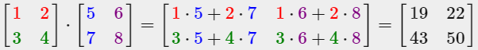

*Right now you're probably trying to figure out what the hell just happened? Matrix multiplication is a combination of normal multiplication and addition using the left-matrix's rows with the right-matrix's columns. Let's try discussing this with the following image:*

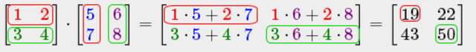

*We first take the upper row of the left matrix and then take a column from the right matrix. The row and column that we picked decides which output value of the resulting 2x2 matrix we're going to calculate. If we take the first row of the left matrix the resulting value will end up in the first row of the result matrix, then we pick a column and if it's the first column the result value will end up in the first column of the result matrix. This is exactly the case of the red pathway. To calculate the bottom-right result we take the bottom row of the first matrix and the rightmost column of the second matrix.*

*To calculate the resulting value we multiply the first element of the row and column together using normal multiplication, we do the same for the second elements, third, fourth etc. The results of the individual multiplications are then summed up and we have our result. Now it also makes sense that one of the requirements is that the size of the left-matrix's columns and the right-matrix's rows are equal, otherwise we can't finish the operations!*

*The result is then a matrix that has dimensions of (n,m) where n is equal to the number of rows of the left-hand side matrix and m is equal to the columns of the right-hand side matrix.*

*Don't worry if you have difficulties imagining the multiplications inside your head. Just keep trying to do the calculations by hand and return to this page whenever you have difficulties. Over time, matrix multiplication becomes second nature to you. // цудоўная арыентацыя чытача. Тнав. //*

*Let's finish the discussion of matrix-matrix multiplication with a larger example. Try to visualize the pattern using the colors. As a useful exercise, see if you can come up with your own answer of the multiplication and then compare them with the resulting matrix (once you try to do a matrix multiplication by hand you'll quickly get the grasp of them).*

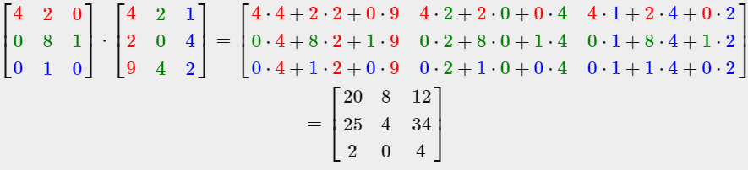

*As you can see, matrix-matrix multiplication is quite a cumbersome process and very prone to errors (which is why we usually let computers do this) and this gets problematic real quick when the matrices become larger. If you're still thirsty for more and you're curious about some more of the mathematical properties of matrices I strongly suggest you take a look at these*[*Khan Academy videos*](https://www.khanacademy.org/math/algebra2/algebra-matrices)*about matrices.*

*Anyways, now that we know how to multiply matrices together, we can start getting to the good stuff.*

#### **Matrix-Vector multiplication**

*Up until now we've had our fair share of vectors these tutorials. We used vectors to represent positions, colors and even texture coordinates. Let's move a bit further down the rabbit hole and tell you that a vector is basically a Nx1 matrix where Nis the vector's number of components (also known as an N-dimensional vector). If you think about it, it makes a lot of sense. Vectors are just like matrices an array of numbers, but with only 1 column. So, how does this new piece of information help us? Well, if we have a MxN matrix we can multiply this matrix by our Nx1 vector, since the columns of our matrix are equal to the number of rows of our vector, thus matrix multiplication is defined.*

*But why do we care if we can multiply matrices with a vector? // цудоўная арыентацыя чытача. Пытанні, якія ўзнікаюць у самога навучэнца. Тнав. // Well, it just so happens that there are lots of interesting 2D/3D transformations we can place inside a matrix and multiplying that matrix with our vector basically transforms our vector. In case you're still a bit confused, let's start with some examples and you'll soon see what we mean. // кантэкст выкарыстання тэхналогіі //*

##### ***Identity matrix***

*In OpenGL we usually work with 4x4 transformation matrices for several reasons and one of them is that most of the vectors are of size 4. // структура тэхналогіі // The most simple transformation matrix that we can think of is the identity matrix. The identity matrix is an NxNmatrix with only 0s except on its diagonal. As you'll see, this transformation matrix leaves a vector completely unharmed:*

*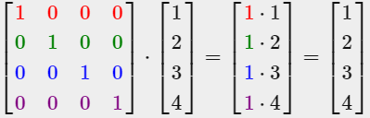  
The vector seems completely untouched. This becomes obvious from the rules of multiplication: the first result element is each individual element of the first row of the matrix multiplied with each element of the vector. Since each of the row's elements are 0 except the first one, we get: 1⋅1+0⋅2+0⋅3+0⋅4=11⋅1+0⋅2+0⋅3+0⋅4=1 and the same applies for the other 3 elements of the vector.*

*You might be wondering what the use is of a transformation matrix that does not transform? The identity matrix is usually a starting point for generating other transformation matrices and if we dig even deeper into linear algebra, a very useful matrix for proving theorems and solving linear equations.*

##### ***Scaling***

*When we're scaling a vector we are increasing the length of the arrow by amount we'd like to scale, keeping its direction the same. Since we're working in either 2 or 3 dimensions we can define scaling by a vector of 2 or 3 scaling variables, each scaling one axis (x, y or z).*

*Let's try scaling the vector v¯=(3,2). We will scale the vector along the x-axis by 0.5, thus making it twice as narrow; and we'll scale the vector by 2 along the y-axis, making it twice as high. Let's see what it looks like if we scale the vector by (0.5,2) as s¯:*

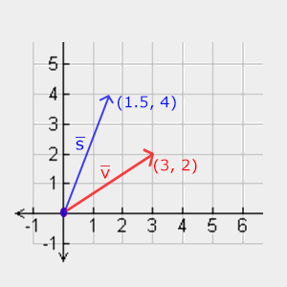

*// з гэтай рэпрэзентацыяй я не разабраўся, але тэма мне ясна. Тут пры скэйлінгу накірунак змяняецца… //*

*Keep in mind that OpenGL usually operates in 3D space so for this 2D case we could set the z-axis scale to 1 thus leaving it unharmed. The scaling operation we just performed is a non-uniform scale, because the scaling factor is not the same for each axis. If the scalar would be equal on all axes it would be called a uniform scale. // вось тут накірунак захоўваецца //*

*Let's start building a transformation matrix that does the scaling for us. We saw from the identity matrix that each of the diagonal elements were multiplied with its corresponding vector element. What if we were to change the 1s in the identity matrix to 3s? In that case, we would be multiplying each of the vector elements by a value of 3 and thus effectively scale the vector by 3. If we represent the scaling variables as (S1,S2,S3)(S1,S2,S3) we can define a scaling matrix on any vector (x,y,z)(x,y,z) as:*

*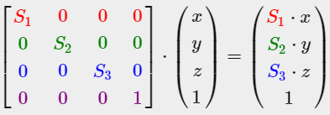  
Note that the 4th scaling vector stays 1, since it's undefined to scale the w component in a 3D space. The w component is used for other purposes as we'll see later on.*

*// матрыца маштабіравання мне зразумела //*

##### ***Translation***

*19.08.2017*

*Translation is the process of adding another vector on top of the original vector to return a new vector with a different position, thus moving the vector based on a translation vector. We've already discussed vector addition so this shouldn't be too new.*

*Just like the scaling matrix there are several locations on a 4-by-4 matrix that we can use to perform certain operations and for translation those are the top-3 values of the 4th column. If we represent the scaling vector as (Tx,Ty,Tz)(Tx,Ty,Tz) we can define the translation matrix by:*

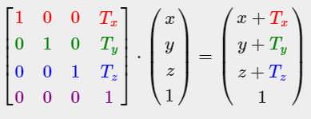

*This works because all of the translation values are multiplied by the vector's w column and added to the vector's original values (remember the matrix-multiplication rules). This wouldn't have been possible with a 3-by-3 matrix. // вось чаму у вектара ёсць чацвёртая каардыната //*

##### ***Homogeneous coordinates***

*The w component of a vector is also known as a homogeneous coordinate. To get the 3D vector from a homogeneous vector we divide the x, y and z coordinate by its w coordinate. We usually do not notice this since the w component is 1.0 most of the time. Using homogeneous coordinates has several advantages: it allows us to do translations on 3D vectors (without a w component we can't translate vectors) and in the next chapter we'll use the w value to create 3D visuals.  
  
Also, whenever the homogeneous coordinate is equal to 0 the vector is specifically known as a direction vector since a vector with a w coordinate of 0 cannot be translated.*

*With a translation matrix we could move objects in any of the 3 directions (x, y, z) we'd like, making it a very useful transformation matrix for our transformation toolkit.*

#### **Rotation**

*The last few transformations were relatively easy to understand and visualize in 2D or 3D space, but rotations are a bit trickier. If you want to know exactly how these matrices are constructed I'd recommend that you watch the rotation items of Khan Academy's*[*linear algebra*](https://www.khanacademy.org/math/linear-algebra/matrix_transformations)*videos. // складаная тэма і спасылка на тлумачэнне. Аспекты тнав. Выпадак, дзе грунтоўнае тлумачэнне з-за складанасці тэмы лепей апусціць //*

*First let's define what a rotation of a vector actually is // структура цьютарала //. A rotation in 2D or 3D is represented with an angle. An angle could be in degrees or radians where a whole circle has 360 degrees or 2*[*PI*](http://en.wikipedia.org/wiki/Pi)*radians. I personally prefer to work in degrees, since they seem to make more sense to me. Most rotation functions require an angle in radians, but luckily degrees are easily converted to radians:   
angle in degrees = angle in radians * (180.0f / PI)   
angle in radians = angle in degrees * (PI / 180.0f)   
Where PI equals (sort of) 3.14159265359. Rotating half a circle would rotate us 360/2 = 180 degrees and rotating 1/5th to the right means we rotate 360/5 = 72 degrees to the right. This is demonstrated for a basic 2D vector where v¯ is rotated 72 degrees to the right from k¯:*

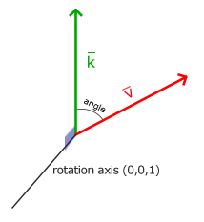

*Rotations in 3D are specified with an angle****and****a rotation axis. The angle specified will rotate the object along the rotation axis given. Try to visualize this by spinning your head a certain degree while continually looking down a single rotation axis. When rotating 2D vectors in a 3D world for example, we set the rotation axis to the z-axis (try to visualize this).*

*Using trigonometry it is possible to transform vectors to new rotated vectors given an angle. This is usually done via a smart combination of the sine and cosine function (commonly abbreviated to sin and cos). A discussion of how the transformation matrices are generated is out of the scope of this tutorial.*

*A rotation matrix is defined for each unit axis in 3D space where the angle is represented as the theta symbol θ.*

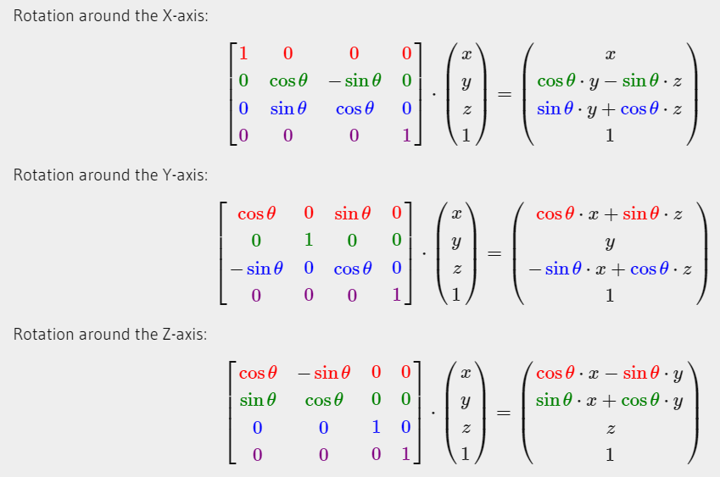

*Using the rotation matrices we can transform our position vectors around one of the three unit axes. It is also possible to combine them by first rotating around the X-axis and then the Y-axis for example. However, this quickly introduces a problem called Gimbal lock. // intbu this problem // We won't discuss the details, but a better solution is to rotate around an arbitrary unit axis e.g. (0.662, 0.2, 0.722) (note that this is a unit vector) right away instead of combining the rotation matrices. Such a (nasty) matrix exists and is given below with (Rx,Ry,Rz) as the arbitrary rotation axis:*

*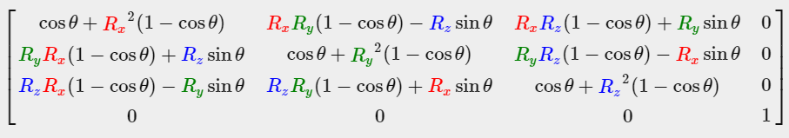  
A mathematical discussion of generating such a matrix is out of the scope of this tutorial. // тнав. Важна указваць, што выходзіць за рамкі таго ці іншага цьюторыяла // Keep in mind that even this matrix does not completely prevent gimbal lock (although it gets a lot harder). To truly prevent Gimbal locks we have to represent rotations using quaternions, that are not only safer, but also more computationally friendly. However, a discussion of quaternions is reserved for a later tutorial. // магчыма, там і пра гэту праблему скажуць //*

#### **Combining matrices**

*The true power from using matrices for transformations is that we can combine multiple transformations in a single matrix thanks to matrix-matrix multiplication. Let's see if we can generate a transformation matrix that combines several transformations. Say we have a vector (x,y,z) and we want to scale it by 2 and then translate it by (1,2,3). We need a translation and a scaling matrix for our required steps. The resulting transformation matrix would then look like:*

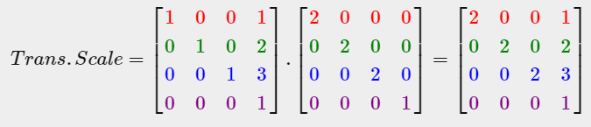

*Note that we first do a translation and then a scale transformation when multiplying matrices. Matrix multiplication is not commutative, which means their order is important. When multiplying matrices the right-most matrix is first multiplied with the vector so you should read the multiplications from right to left. It is advised to first do scaling operations, then rotations and lastly translations when combining matrices otherwise they might (negatively) affect each other. For example, if you would first do a translation and then scale, the translation vector would also scale!*

*Running the final transformation matrix on our vector results in the following vector:*

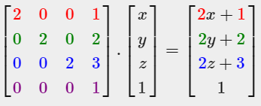

Great! The vector is first scaled by two and then translated by (1,2,3).

### *In practice*

*Now that we've explained all the theory behind transformations, it's time to see how we can actually use this knowledge to our advantage. // цудоўнейшая арыентацыя навучэнца. тнав // OpenGL does not have any form of matrix or vector knowledge built in, so we have to define our own mathematics classes and functions. In the tutorials we'd rather abstract from all the tiny mathematical details and simply use pre-made mathematics libraries. Luckily, there is an easy-to-use and tailored-for-OpenGL mathematics library called GLM.*

### *GLM*

**

*GLM stands for Open****GL******M****athematics and is a*header-only*library, which means that we only have to include the proper header files and we're done; // разнавіднасць бібліятэцы. Аспекты вылічальных тэхналогій // no linking and compiling necessary. GLM can be downloaded from their*[*website*](http://glm.g-truc.net/)*. Copy the root directory of the header files into your*includes*folder and let's get rolling. // цудоўная простасць тэхналогій для выкарыстання OpenGL //*

*Most of GLM's functionality that we need can be found in only 3 headers files that we'll include as follows:*

*#include <glm/glm.hpp>*

*#include <glm/gtc/matrix_transform.hpp>*

*#include <glm/gtc/type_ptr.hpp>*

*Let's see if we can put our transformation knowledge to good use by translating a vector of (1,0,0) by (1,1,0) (note that we define it as a glm::vec4 with its homogenous coordinate set to 1.0:*

*glm::vec4 vec(1.0f, 0.0f, 0.0f, 1.0f);*

*glm::mat4 trans;*

*trans = glm::translate(trans, glm::vec3(1.0f, 1.0f, 0.0f));*

*vec = trans * vec;*

*std::cout << vec.x << vec.y << vec.z << std::endl;*

*We first define a vector named vec using GLM's built-in vector class. Next we define a mat4 which is a 4-by-4 identity matrix by default. The next step is to create a transformation matrix by passing our identity matrix to the glm::translatefunction, together with a translation vector (the given matrix is then multiplied with a translation matrix and the resulting matrix is returned).   
Then we multiply our vector by the transformation matrix and output the result. If we still remember how matrix translation works then the resulting vector should be (1+1,0+1,0+0) which is (2,1,0). This snippet of code outputs 210 so the translation matrix did its job.*

*Let's do something more interesting and scale and rotate the container object from the previous tutorial. First we'll rotate the container by 90 degrees counter-clockwise. Then we scale it by 0.5, thus making it twice as small. Let's create the transformation matrix first:*

*glm::mat4 trans;*

*trans = glm::rotate(trans, glm::radians(90.0f), glm::vec3(0.0, 0.0, 1.0));*

*trans = glm::scale(trans, glm::vec3(0.5, 0.5, 0.5));*

*First we scale the container by 0.5 on each axis and then rotate the container 90 degrees around the Z-axis. GLM expects its angles in radians so we convert the degrees to radians using glm::radians. Note that the textured rectangle is on the XY plane so we want to rotate around the Z-axis. Because we pass the matrix to each of GLM's functions, GLM automatically multiples the matrices together, resulting in a transformation matrix that combines all the transformations.*

*The next big question is: how do we get the transformation matrix to the shaders? We shortly mentioned before that GLSL also has a mat4 type. So we'll adapt the vertex shader to accept a mat4 uniform variable and multiply the position vector by the matrix uniform:*

*#version 330 core*

***layout*** *(location = 0)* ***in*** *vec3 aPos;*

***layout*** *(location = 1)* ***in*** *vec2 aTexCoord;*

***out*** *vec2 TexCoord;*

***uniform*** *mat4 transform;*

***void*** *main()*

*{*

*gl_Position = transform * vec4(aPos, 1.0f);*

*TexCoord = vec2(aTexCoord.x, 1.0 - aTexCoord.y);*

*}*

*GLSL also has mat2 and mat3 types that allow for swizzling-like operations just like vectors. All the aforementioned math operations (like scalar-matrix multiplication, matrix-vector multiplication and matrix-matrix multiplication) are allowed on the matrix types. // glsl structure // Wherever special matrix operations are used we'll be sure to explain what's happening. // арыентацыя чытача. тнав //*

*We added the uniform and multiplied the position vector with the transformation matrix before passing it to*gl_Position*. Our container should now be twice as small and rotated 90 degrees (tilted to the left). We still need to pass the transformation matrix to the shader though:*

***unsigned******int*** *transformLoc = glGetUniformLocation(ourShader.ID, "transform");*

*glUniformMatrix4fv(transformLoc, 1, GL_FALSE, glm::value_ptr(trans));*

*We first query the location of the uniform variable and then send the matrix data to the shaders via glUniform function with Matrix4fv as its postfix. The first argument should be familiar by now which is the uniform's location. The second argument tells OpenGL how many matrices we'd like to send, which is 1. The third argument asks us if we want to transpose our matrix, that is to swap the columns and rows. OpenGL developers often use an internal matrix layout called column-major ordering which is the default matrix layout in GLM so there is no need to transpose the matrices; we can keep it at GL_FALSE. The last parameter is the actual matrix data, but GLM stores their matrices not in the exact way that OpenGL likes to receive them so we first transform them with GLM's built-in function value_ptr.*

*We created a transformation matrix, declared a uniform in the vertex shader and sent the matrix to the shaders where we transform our vertex coordinates. The result should look something like this:*

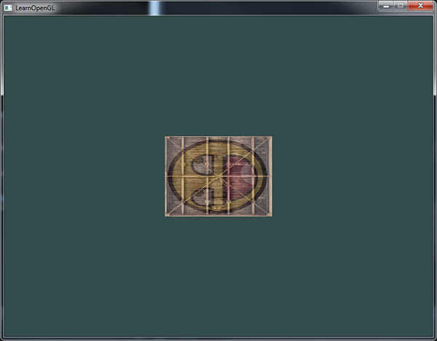

*// усё спрацавала //*

*Perfect! Our container is indeed tilted to the left and twice as small so the transformation was successful. Let's get a little more funky and see if we can rotate the container over time and for fun we'll also reposition the container at the bottom-right side of the window. To rotate the container over time we have to update the transformation matrix in the game loop because it needs to update each render iteration. We use GLFW's time function to get some angle over time:*

*glm::mat4 trans;*

*trans = glm::translate(trans, glm::vec3(0.5f, -0.5f, 0.0f));*

*trans = glm::rotate(trans, (****float****)glfwGetTime(), glm::vec3(0.0f, 0.0f, 1.0f));*

*Keep in mind that in the previous case we could declare the transformation matrix anywhere, but now we have to create it every iteration so we continuously update the rotation. This means we have to re-create the transformation matrix in each iteration of the game loop. Usually when rendering scenes we have several transformation matrices that are re-created with new values each render iteration. // тыповая практыка графічнага праектавання //*

*Here we first rotate the container around the origin (0,0,0) and once it's rotated, we translate its rotated version to the bottom-right corner of the screen. Remember that the actual transformation order should be read in reverse: even though in code we first translate and then later rotate, the actual transformations first apply a rotation and then a translation. Understanding all these combinations of transformations and how they apply to objects is difficult to understand. Try and experiment with transformations like these and you'll quickly get a grasp of it. // важнасць і складанасць задачы //*

*If you did things right you should get the following result:*

*And there you have it. A translated container that's rotated over time, all done by a single transformation matrix! Now you can see why matrices are such a powerful construct in graphics land. We can define an infinite amount of transformations and combine them all in a single matrix that we can re-use as often as we'd like. Using transformations like this in the vertex shader saves us the effort of re-defining the vertex data and saves us some processing time as well, since we don't have to re-send our data all the time (which is quite slow).*

*If you didn't get the right result or you're stuck somewhere else, take a look at the*[*source code*](https://learnopengl.com/code_viewer_gh.php?code=src/1.getting_started/5.1.transformations/transformations.cpp)*.*

*In the next tutorial we'll discuss how we can use matrices to define different coordinate spaces for our vertices. This will be our first step into real-time 3D graphics! // зацікаўліванне навучэнцаў наступным цьютаралам. Добрая практыка тнав. //*

### *Further reading*

* [*Essence of Linear Algebra*](https://www.youtube.com/playlist?list=PLZHQObOWTQDPD3MizzM2xVFitgF8hE_ab)*: great video tutorial series by Grant Sanderson about the underlying mathematics of transformations and linear algebra.*

### *Exercises*

* *Using the last transformation on the container, try switching the order around by first rotating and then translating. See what happens and try to reason why this happens:*[*solution*](https://learnopengl.com/code_viewer.php?code=getting-started/transformations-exercise1)*. // я трапіў на гэта па ходу выканання практыкавання… Мы фіксуем вось – і верцім адносна яе. Таму і не вельмі адэкватны вынік атрымліваецца. //*
* *Try drawing a second container with another call to glDrawElements but place it at a different position using transformations****only****. Make sure this second container is placed at the top-left of the window and instead of rotating, scale it over time (using the sin function is useful here; note that using sin will cause the object to invert as soon as a negative scale is applied):*[*solution*](https://learnopengl.com/code_viewer_gh.php?code=src/1.getting_started/5.2.transformations_exercise2/transformations_exercise2.cpp)*. // зроблена – і гэта цудоўна //*

[*https://learnopengl.com/#!Getting-started/Coordinate-Systems*](https://learnopengl.com/#!Getting-started/Coordinate-Systems)

## ***Coordinate Systems***

*In the last tutorial we learned how we can use matrices to our advantage by transforming all vertices with transformation matrices. OpenGL expects all the vertices, that we want to become visible, to be in normalized device coordinates after each vertex shader run. That is, the x, y and z coordinates of each vertex should be between -1.0 and 1.0; coordinates outside this range will not be visible. What we usually do, is specify the coordinates in a range we configure ourselves and in the vertex shader transform these coordinates to NDC. These NDC coordinates are then given to the rasterizer to transform them to 2D coordinates/pixels on your screen. // рэалізацыя тэхналогіі. Работа растэрайзэйшн шэйдэра. Звычайная практыка напісання праграм з выкарыстаннем OpenGL //*

*Transforming coordinates to NDC and then to screen coordinates is usually accomplished in a step-by-step fashion where we transform an object's vertices to several coordinate systems before finally transforming them to screen coordinates. The advantage of transforming them to several intermediate coordinate systems is that some operations/calculations are easier in certain coordinate systems as will soon become apparent. // канцэптуальнае значэнне розных каардынатных сістэм // There are a total of 5 different coordinate systems that are of importance to us:*

* *Local space (or Object space)*
* *World space*
* *View space (or Eye space)*
* *Clip space*
* *Screen space*

*Those are all a different state at which our vertices will be transformed in before finally ending up as fragments. // рэалізацыя тэхналогіі //*

*You're probably quite confused by now by what a space or coordinate system actually is so we'll explain them in a more understandable fashion by showing the total picture and what each specific space actually does.*

### ***The global picture***

*To transform the coordinates in one space to the next coordinate space we'll use several transformation matrices of which the most important are the model, view and projection matrix. Our vertex coordinates first start in local space as local coordinates and are then further processed to world coordinates, view coordinates, clip coordinates and eventually end up as screen coordinates. The following image displays the process and shows what each transformation does:*

**

1. *Local coordinates are the coordinates of your object relative to its local origin; they're the coordinates your object begins in.*
2. *The next step is to transform the local coordinates to world-space coordinates which are coordinates in respect of a larger world. These coordinates are relative to a global origin of the world, together with many other objects also placed relative to the world's origin.*
3. *Next we transform the world coordinates to view-space coordinates in such a way that each coordinate is as seen from the camera or viewer's point of view.*
4. *After the coordinates are in view space we want to project them to clip coordinates. Clip coordinates are processed to the -1.0 and 1.0 range and determine which vertices will end up on the screen.*
5. *And lastly we transform the clip coordinates to screen coordinates in a process we call viewport transform that transforms the coordinates from -1.0 and 1.0 to the coordinate range defined by glViewport. The resulting coordinates are then sent to the rasterizer to turn them into fragments. // рэалізацыя тэхналогіі //*

*You probably got a slight idea what each individual space is used for. // цудоўнейшая арыентацыя чытача. Тнав. // The reason we're transforming our vertices into all these different spaces is that some operations make more sense or are easier to use in certain coordinate systems. For example, when modifying your object it makes most sense to do this in local space, while calculating certain operations on the object with respect to the position of other objects makes most sense in world coordinates and so on. If we want, we could define one transformation matrix that goes from local space to clip space all in one go, but that leaves us with less flexibility.*

*We'll discuss each coordinate system in more detail below.*

### ***Local space***

*Local space is the coordinate space that is local to your object, i.e. where your object begins in. Imagine that you've created your cube in a modeling software package (like Blender). The origin of your cube is probably at (0,0,0) even though your cube might end up at a different location in your final application. Probably all the models you've created all have (0,0,0) as their initial position. All the vertices of your model are therefore in local space: they are all local to your object. // цудоўнае тлумачэнне на прыкладзе паняцця “лакальная прастора” //*

*The vertices of the container we've been using were specified as coordinates between -0.5 and 0.5 with 0.0 as its origin. These are local coordinates.*

### ***World space***

*If we would import all our objects directly in the application they would probably all be somewhere stacked on each other around the world's origin of (0,0,0) which is not what we want. We want to define a position for each object to position them inside a larger world. The coordinates in world space are exactly what they sound like: the coordinates of all your vertices relative to a (game) world. This is the coordinate space where you want your objects transformed to in such a way that they're all scattered around the place (preferably in a realistic fashion). The coordinates of your object are transformed from local to world space; this is accomplished with the model matrix.*

*The model matrix is a transformation matrix that translates, scales and/or rotates your object to place it in the world at a location/orientation they belong to. Think of it as transforming a house by scaling it down (it was a bit too large in local space), translating it to a suburbia town and rotating it a bit to the left on the y-axis so that it neatly fits with the neighboring houses. You could think of the matrix in the previous tutorial to position the container all over the scene as a sort of model matrix as well; we transformed the local coordinates of the container to some different place in the scene/world. // цудоўны патэрн тнав. Невыяўнае выкарыстанне новага паняцця раней: падыходзячы да разумення гэтага паняцця, мы яго ўжо ведаем //*

### ***View space***

*The view space is what people usually refer to as the camera of OpenGL (it is sometimes also known as the camera space or eye space). The view space is the result of transforming your world-space coordinates to coordinates that are in front of the user's view. The view space is thus the space as seen from the camera's point of view. This is usually accomplished with a combination of translations and rotations to translate/rotate the scene so that certain items are transformed to the front of the camera. These combined transformations are generally stored inside a view matrix that transforms world coordinates to view space. In the next tutorial we'll extensively discuss how to create such a view matrix to simulate a camera. // структура цьютарала //*

### ***Clip space***

*At the end of each vertex shader run, OpenGL expects the coordinates to be within a specific range and any coordinate that falls outside this range is clipped. Coordinates that are clipped are discarded, so the remaining coordinates will end up as fragments visible on your screen. This is also where clip space gets its name from. // рэалізацыя тэхналогіі //*

*Because specifying all the visible coordinates to be within the range -1.0 and 1.0 isn't really intuitive, we specify our own coordinate set to work in and convert those back to NDC as OpenGL expects them.*

*To transform vertex coordinates from view to clip-space we define a so called projection matrix that specifies a range of coordinates e.g. -1000 and 1000 in each dimension. The projection matrix then transforms coordinates within this specified range to normalized device coordinates (-1.0, 1.0). All coordinates outside this range will not be mapped between -1.0 and 1.0 and therefore be clipped. With this range we specified in the projection matrix, a coordinate of (1250, 500, 750) would not be visible, since the x coordinate is out of range and thus gets converted to a coordinate higher than 1.0 in NDC and is therefore clipped.*

*Note that if only a part of a primitive e.g. a triangle is outside the clipping volume OpenGL will reconstruct the triangle as one or more triangles to fit inside the clipping range. // рэалізацыя тэхналогіі. Дарагавізна кліпінга //*

*This viewing box a projection matrix creates is called a frustum and each coordinate that ends up inside this frustum will end up on the user's screen. The total process to convert coordinates within a specified range to NDC that can easily be mapped to 2D view-space coordinates is called projection since the projection matrix projects 3D coordinates to the easy-to-map-to-2D normalized device coordinates. // рэалізацыя тэхналогіі //*

*Once all the vertices are transformed to clip space a final operation called perspective division is performed where we divide the x, y and z components of the position vectors by the vector's homogeneous w component; perspective division is what transforms the 4D clip space coordinates to 3D normalized device coordinates. This step is performed automatically at the end of each vertex shader run. // рэалізацыя тэхналогіі //*

*It is after this stage where the resulting coordinates are mapped to screen coordinates (using the settings of glViewport) and turned into fragments.*

*The projection matrix to transform view coordinates to clip coordinates can take two different forms, where each form defines its own unique frustum. We can either create an orthographic projection matrix or a perspective projection matrix.*

#### **Orthographic projection**

*An orthographic projection matrix defines a cube-like frustum box that defines the clipping space where each vertex outside this box is clipped. When creating an orthographic projection matrix we specify the width, height and length of the visible frustum. All the coordinates that end up inside this frustum after transforming them to clip space with the orthographic projection matrix won't be clipped. The frustum looks a bit like a container:*

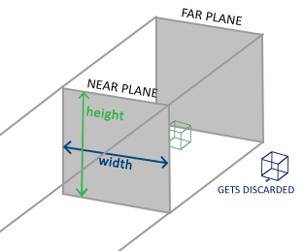

*The frustum defines the visible coordinates and is specified by a width, a height and a near and far plane. Any coordinate in front of the near plane is clipped and the same applies to coordinates behind the far plane. The orthographic frustum directly maps all coordinates inside the frustum to normalized device coordinates since the w component of each vector is untouched; if the w component is equal to 1.0 perspective division doesn't change the coordinates.*

*To create an orthographic projection matrix we make use of GLM's built-in function glm::ortho:*

*glm::ortho(0.0f, 800.0f, 0.0f, 600.0f, 0.1f, 100.0f);*

*The first two parameters specify the left and right coordinate of the frustum and the third and fourth parameter specify the bottom and top part of the frustum. With those 4 points we've defined the size of the near and far planes and the 5th and 6th parameter then define the distances between the near and far plane. This specific projection matrix transforms all coordinates between these x, y and z range values to normalized device coordinates.*

*An orthographic projection matrix directly maps coordinates to the 2D plane that is your screen, but in reality a direct projection produces unrealistic results since the projection doesn't take perspective into account. That is something the perspective projection matrix fixes for us. // недахоп паняцця //*

#### **Perspective projection**

*If you ever were to enjoy the graphics the real life has to offer you'll notice that objects that are farther away appear much smaller. This weird effect is something we call perspective. Perspective is especially noticeable when looking down the end of an infinite motorway or railway as seen in the following image:*

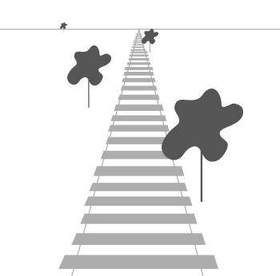

*As you can see, due to perspective the lines seem to coincide the farther they're away. This is exactly the effect perspective projection tries to mimic and it does so using a perspective projection matrix. The projection matrix maps a given frustum range to clip space, but also manipulates the w value of each vertex coordinate in such a way that the further away a vertex coordinate is from the viewer, the higher this w component becomes. Once the coordinates are transformed to clip space they are in the range -w to w (anything outside this range is clipped). OpenGL requires that the visible coordinates fall between the range -1.0 and 1.0 as the final vertex shader output, thus once the coordinates are in clip space, perspective division is applied to the clip space coordinates: // рэалізацыя тэхналогіі //*

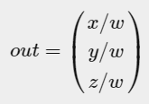

*Each component of the vertex coordinate is divided by its w component giving smaller vertex coordinates the further away a vertex is from the viewer. This is another reason why the w component is important, since it helps us with perspective projection. // важнасць паняцця: трансляцыі + матрыца перспектывы. Прыклад паняцця з дзвюма нязлучанымі палезнымі ўласцівасцямі // The resulting coordinates are then in normalized device space. If you're interested to figure out how the orthographic and perspective projection matrices are actually calculated (and aren't too scared of mathematics) I can recommend*[*this excellent article*](http://www.songho.ca/opengl/gl_projectionmatrix.html)*by Songho.*

*A perspective projection matrix can be created in GLM as follows:*

*glm::mat4 proj = glm::perspective(glm::radians(45.0f), (****float****)width/(****float****)height, 0.1f, 100.0f);*

*What glm::perspective does is again create a large frustum that defines the visible space, anything outside the frustum will not end up in the clip space volume and will thus become clipped. A perspective frustum can be visualized as a non-uniformly shaped box from where each coordinate inside this box will be mapped to a point in clip space. An image of a perspective frustum is seen below:*

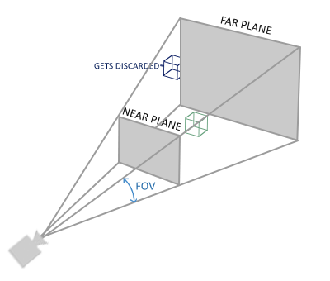

*Its first parameter defines the fov value, that stands for field of view and sets how large the viewspace is. For a realistic view it is usually set to 45 degrees, but for more doom-style results you could set it to a higher value. The second parameter sets the aspect ratio which is calculated by dividing the viewport's width by its height. The third and fourth parameter set the near and far plane of the frustum. We usually set the near distance to 0.1f and the far distance to 100.0f. All the vertices between the near and far plane and inside the frustum will be rendered.*

*Whenever the near value of your perspective matrix is set a bit too high (like 10.0f), OpenGL will clip all coordinates close to the camera (between 0.0f and 10.0f), which gives a familiar visual result in videogames in that you can see through certain objects if you move too close to them. // прыклад агульна вядомага артэфакта графічных праграм //*

*When using orthographic projection, each of the vertex coordinates are directly mapped to clip space without any fancy perspective division (it still does perspective division, but the w component is not manipulated (it stays 1) and thus has no effect). Because the orthographic projection doesn't use perspective projection, objects farther away do not seem smaller, which produces a weird visual output. For this reason the orthographic projection is mainly used for 2D renderings and for some architectural or engineering applications where we'd rather not have vertices distorted by perspective. Applications like Blender that are used for 3D modelling sometimes use orthographic projection for modelling, because it more accurately depicts each object's dimensions. Below you'll see a comparison of both projection methods in Blender: // прызначэнне кожнага з відаў праекцыйных матрыц //*

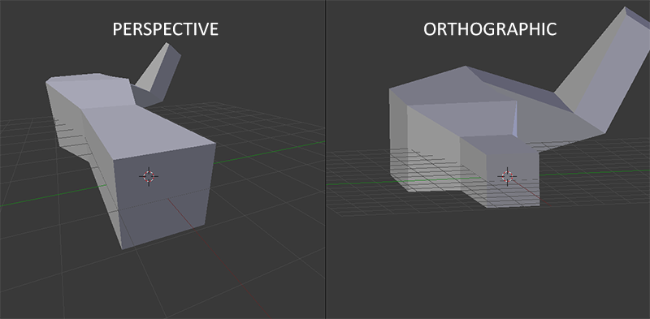

*You can see that with perspective projection, the vertices farther away appear much smaller, while in orthographic projection each vertex has the same distance to the user.*

### ***Putting it all together***

*We create a transformation matrix for each of the aforementioned steps: model, view and projection matrix. A vertex coordinate is then transformed to clip coordinates as follows:*

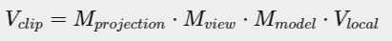

*Note that the order of matrix multiplication is reversed (remember that we need to read matrix multiplication from right to left). The resulting vertex should then be assigned to gl_Position in the vertex shader and OpenGL will then automatically perform perspective division and clipping. // рэалізацыя і выкарыстанне тэхналогіі //*

### ***And then?***

*The output of the vertex shader requires the coordinates to be in clip-space which is what we just did with the transformation matrices. OpenGL then performs perspective division on the clip-space coordinates to transform them to normalized-device coordinates. OpenGL then uses the parameters from glViewPort to map the normalized-device coordinates to screen coordinates where each coordinate corresponds to a point on your screen (in our case a 800x600 screen). This process is called the viewport transform.*

*This is a difficult topic to understand so if you're still not exactly sure about what each space is used for you don't have to worry. // Цудоўная арыентацыя чытача, якая супакойвае // Below you'll see how we can actually put these coordinate spaces to good use and enough examples will follow in these tutorials. // структура цьютарала //*

### ***Going 3D***

*Now that we know how to transform 3D coordinates to 2D coordinates we can start showing our objects as real 3D objects instead of a lame 2D plane we've been showing so far.*

*To start drawing in 3D we'll first create a model matrix. The model matrix consists of translations, scaling and/or rotations we'd like to apply to transform all object's vertices it to the global world space. Let's transform our plane a bit by rotating it on the x-axis so it looks like it's laying on the floor. The model matrix then looks like this:*

*glm::mat4 model;*

*model = glm::rotate(model, glm::radians(-55.0f), glm::vec3(1.0f, 0.0f, 0.0f));*

*By multiplying the vertex coordinates with this model matrix we're transforming the vertex coordinates to world coordinates. Our plane that is slightly on the floor thus represents the plane in the global world.*

*Next we need to create a view matrix. We want to move slightly backwards in the scene so the object becomes visible (when in world space we're located at the origin (0,0,0)). To move around the scene, think about the following:*

* *To move a camera backwards, is the same as moving the entire scene forward.*

*That is exactly what a view matrix does, we move the entire scene around inversed to where we want the camera to move.  
Because we want to move backwards and since OpenGL is a right-handed system we have to move in the positive z-axis. We do this by translating the scene towards the negative z-axis. This gives the impression that we are moving backwards. // рэалізацыя тэхналогіі //*

#### **Right-handed system**

*By convention, OpenGL is a right-handed system. What this basically says is that the positive x-axis is to your right, the positive y-axis is up and the positive z-axis is backwards. Think of your screen being the center of the 3 axes and the positive z-axis going through your screen towards you. The axes are drawn as follows: // структура тэхналогіі //*

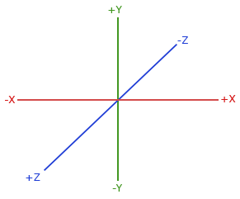

*To understand why it's called right-handed do the following:*

* *Stretch your right-arm along the positive y-axis with your hand up top.*
* *Let your thumb point to the right.*
* *Let your pointing finger point up.*
* *Now bend your middle finger downwards 90 degrees.*

*If you did things right, your thumb should point towards the positive x-axis, the pointing finger towards the positive y-axis and your middle finger towards the positive z-axis. If you were to do this with your left-arm you would see the z-axis is reversed. This is known as a left-handed system and is commonly used by DirectX. Note that in normalized device coordinates OpenGL actually uses a left-handed system (the projection matrix switches the handedness). // рэалізацыя тэхналогіі. Лепей зразумець //*

*We'll discuss how to move around the scene in more detail in the next tutorial. For now the view matrix looks like this:*

*glm::mat4 view;*

*// note that we're translating the scene in the reverse direction of where we want to move*

*view = glm::translate(view, glm::vec3(0.0f, 0.0f, -3.0f));*

*The last thing we need to define is the projection matrix. We want to use perspective projection for our scene so we'll declare the projection matrix like this:*

*glm::mat4 projection;*

*projection = glm::perspective(glm::radians(45.0f), screenWidth / screenHeight, 0.1f, 100.0f);*

*Now that we created the transformation matrices we should pass them to our shaders. First let's declare the transformation matrices as uniforms in the vertex shader and multiply them with the vertex coordinates:*

*#version 330 core*

***layout*** *(location = 0)* ***in*** *vec3 aPos;*

*...*

***uniform*** *mat4 model;*

***uniform*** *mat4 view;*

***uniform*** *mat4 projection;*

***void*** *main()*

*{*

*// note that we read the multiplication from right to left*

*gl_Position = projection * view * model * vec4(aPos, 1.0);*

*...*

*}*

*We should also send the matrices to the shader (this is usually done each render iteration since transformation matrices tend to change a lot):*

***int*** *modelLoc = glGetUniformLocation(ourShader.ID, "model"));*

*glUniformMatrix4fv(modelLoc, 1, GL_FALSE, glm::value_ptr(model));*

*... // same for View Matrix and Projection Matrix*

*Now that our vertex coordinates are transformed via the model, view and projection matrix the final object should be:*

* *Tilted backwards to the floor.*
* *A bit farther away from us.*
* *Be displayed with perspective (it should get smaller, the further its vertices are).*

*Let's check if the result actually does fulfill these requirements:*

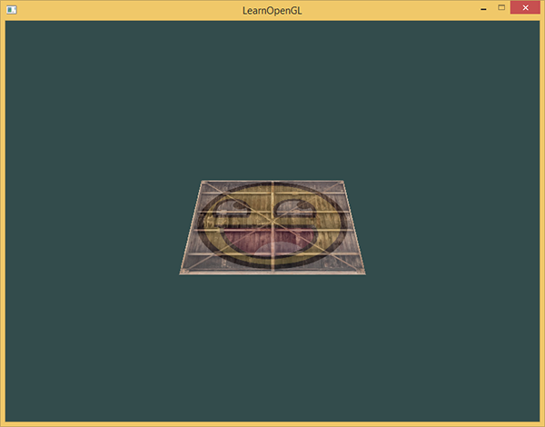

*It does indeed look like the plane is a 3D plane that's resting at some imaginary floor. If you're not getting the same result check the complete*[*source code*](https://learnopengl.com/code_viewer_gh.php?code=src/1.getting_started/6.1.coordinate_systems/coordinate_systems.cpp)*.*

*// у мяне ўсё атрымалася з першага разу! //*

### ***More 3D***

*So far we've been working with a 2D plane, even in 3D space, so let's take the adventurous route and extend our 2D plane to a 3D cube. To render a cube we need a total of 36 vertices (6 faces * 2 triangles * 3 vertices each). 36 vertices are a lot to sum up so you can retrieve them from*[*here*](https://learnopengl.com/code_viewer.php?code=getting-started/cube_vertices)*.*

*For fun, we'll let the cube rotate over time:*

*model = glm::rotate(model, (****float****)glfwGetTime() * glm::radians(50.0f), glm::vec3(0.5f, 1.0f, 0.0f));*

*And then we'll draw the cube using glDrawArrays, but this time with a count of 36 vertices.*

*glDrawArrays(GL_TRIANGLES, 0, 36);*

*You should get something similar to the following:*

*…*

*It does resemble a cube slightly but something's off. Some sides of the cubes are being drawn over other sides of the cube. This happens because when OpenGL draws your cube triangle-by-triangle, it will overwrite its pixels even though something else might've been drawn there before. Because of this, some triangles are drawn on top of each other while they're not supposed to overlap. // праблема оверлэпінга //*

*Luckily, OpenGL stores depth information in a buffer called the z-buffer that allows OpenGL to decide when to draw over a pixel and when not to. Using the z-buffer we can configure OpenGL to do depth-testing. // яшчэ адзін важны аб’ект тэхналогіі //*

### ***Z-buffer***

*OpenGL stores all its depth information in a z-buffer, also known as a depth buffer. GLFW automatically creates such a buffer for you (just like it has a color-buffer that stores the colors of the output image). The depth is stored within each fragment (as the fragment's z value) and whenever the fragment wants to output its color, OpenGL compares its depth values with the z-buffer and if the current fragment is behind the other fragment it is discarded, otherwise overwritten. This process is called depth testing and is done automatically by OpenGL. // рэалізацыя тэхналогіі //*

*However, if we want to make sure OpenGL actually performs the depth testing we first need to tell OpenGL we want to enable depth testing; it is disabled by default. We can enable depth testing using glEnable. The glEnable and glDisable functions allow us to enable/disable certain functionality in OpenGL. // структура тэхналогіі // That functionality is then enabled/disabled until another call is made to disable/enable it. Right now we want to enable depth testing by enabling GL_DEPTH_TEST:*

*glEnable(GL_DEPTH_TEST);*

*Since we're using a depth buffer we also want to clear the depth buffer before each render iteration (otherwise the depth information of the previous frame stays in the buffer). Just like clearing the color buffer, we can clear the depth buffer by specifying the DEPTH_BUFFER_BIT bit in the glClear function:*

*glClear(GL_COLOR_BUFFER_BIT | GL_DEPTH_BUFFER_BIT);*

*Let's re-run our program and see if OpenGL now performs depth testing:*

*There we go! A fully textured cube with proper depth testing that rotates over time. Check the source code*[*here*](https://learnopengl.com/code_viewer_gh.php?code=src/1.getting_started/6.2.coordinate_systems_depth/coordinate_systems_depth.cpp)*.*

### ***More cubes!***

*Say we wanted to display 10 of our cubes on screen. Each cube will look the same but will only differ in where it's located in the world with each a different rotation. The graphical layout of the cube is already defined so we don't have to change our buffers or attribute arrays when rendering more objects. The only thing we have to change for each object is its model matrix where we transform the cubes into the world.*

*First, let's define a translation vector for each cube that specifies its position in world space. We'll define 10 cube positions in a glm::vec3 array:*

*glm::vec3 cubePositions[] = {*

*glm::vec3( 0.0f, 0.0f, 0.0f),*

*glm::vec3( 2.0f, 5.0f, -15.0f),*

*glm::vec3(-1.5f, -2.2f, -2.5f),*

*glm::vec3(-3.8f, -2.0f, -12.3f),*

*glm::vec3( 2.4f, -0.4f, -3.5f),*

*glm::vec3(-1.7f, 3.0f, -7.5f),*

*glm::vec3( 1.3f, -2.0f, -2.5f),*

*glm::vec3( 1.5f, 2.0f, -2.5f),*

*glm::vec3( 1.5f, 0.2f, -1.5f),*

*glm::vec3(-1.3f, 1.0f, -1.5f)*

*};*

*Now, within the game loop we want to call the glDrawArrays function 10 times, but this time send a different model matrix to the vertex shader each time before we render. We will create a small loop within the game loop that renders our object 10 times with a different model matrix. Note that we also add a small rotation to each container.*

*glBindVertexArray(VAO);*

***for****(****unsigned******int*** *i = 0; i < 10; i++)*

*{*

*glm::mat4 model;*

*model = glm::translate(model, cubePositions[i]);*

***float*** *angle = 20.0f * i;*

*model = glm::rotate(model, glm::radians(angle), glm::vec3(1.0f, 0.3f, 0.5f));*

*ourShader.setMat4("model", model);*

*glDrawArrays(GL_TRIANGLES, 0, 36);*

*}*

*This snippet of code will update the model matrix each time a new cube is drawn and do this 10 times in total. Right now we should be looking into a world filled with 10 oddly rotated cubes:*

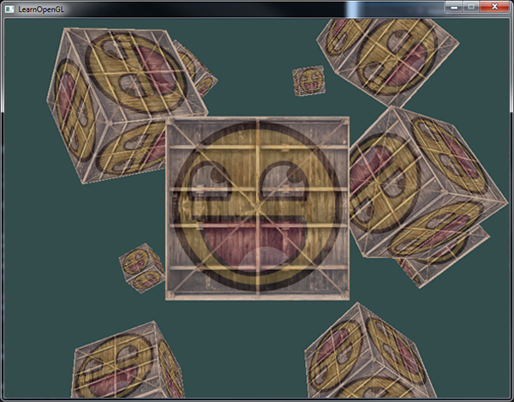

*Perfect! It looks like our container found some likeminded friends. If you're stuck see if you can compare your code with the* [*source code*](https://learnopengl.com/code_viewer_gh.php?code=src/1.getting_started/6.3.coordinate_systems_multiple/coordinate_systems_multiple.cpp)*.*

*// у кодзе напісана, што матрыца праекцыі часта не змяняецца і таму яе не імкнуцца стварыць унутры цыкла малявання //*

*// усё атрымалася проста цудоўна! //*

***Exercises***

* *Try experimenting with the FoV and aspect-ratio parameters of GLM's projection function. See if you can figure out how those affect the perspective frustum.*
* *Play with the view matrix by translating in several directions and see how the scene changes. Think of the view matrix as a camera object.*
* *Try to make every 3rd container (including the 1st) rotate over time, while leaving the other containers static using just the model matrix:*[*solution*](https://learnopengl.com/code_viewer.php?code=getting-started/coordinate_systems-exercise3)*.*

*// першыя два практыкаванні я выконваў і раней. Трэцяе – не буду, бо гэта лёгка робіцца даданнем спецыяльнай умовы ў целе цыкла //*

***Want to help?***

*Enjoyed the tutorial? Consider becoming a*[*patron*](https://www.patreon.com/learnopengl)*of LearnOpenGL.  
  
Your support helps me create new and better tutorials, improve existing content and enables me to improve the website wherever I can.*

[*https://learnopengl.com/#!Getting-started/Camera*](https://learnopengl.com/#!Getting-started/Camera)

*22.08.2017*

## ***Camera***

*In the previous tutorial we discussed the view matrix and how we can use the view matrix to move around the scene (we moved backwards a little). OpenGL by itself is not familiar with the concept of a camera, but we can try to simulate one by moving all objects in the scene in the reverse direction, giving the illusion that****we****are moving. // рэалізацыя тэхналогіі і праграміраванне на OpenGL //*

*In this tutorial we'll discuss how we can set up a camera in OpenGL. We will discuss an FPS-style camera that allows you to freely move around in a 3D scene. In this tutorial we'll also discuss keyboard and mouse input and finish with a custom camera class.*

### ***Camera/View space***

*26.08.2017*

*When we're talking about camera/view space we're talking about all the vertex coordinates as seen from the camera's perpective as the origin of the scene: the view matrix transforms all the world coordinates into view coordinates that are relative to the camera's position and direction. To define a camera we need its position in world space, the direction it's looking at, a vector pointing to the right and a vector pointing upwards from the camera. A careful reader might notice that we're actually going to create a coordinate system with 3 perpendicular unit axes with the camera's position as the origin.*

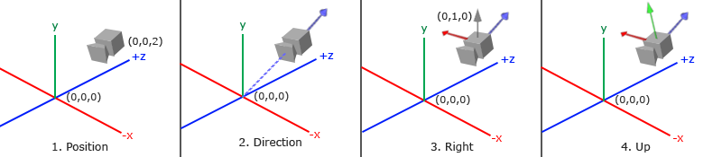

#### **1. Camera position**

*Getting a camera position is easy. The camera position is basically a vector in world space that points to the camera's position. We set the camera at the same position we've set the camera in the previous tutorial:*

*glm::vec3 cameraPos = glm::vec3(0.0f, 0.0f, 3.0f);*

*Don't forget that the positive z-axis is going through your screen towards you so if we want the camera to move backwards, we move along the positive z-axis.*

#### **2. Camera direction**

*The next vector required is the camera's direction e.g. at what direction it is pointing at. For now we let the camera point to the origin of our scene: (0,0,0). Remember that if we subtract two vectors from each other we get a vector that's the difference of these two vectors? Subtracting the camera position vector from the scene's origin vector thus results in the direction vector. Since we know that the camera points towards the negative z direction we want the direction vector to point towards the camera's positive z-axis. If we switch the subtraction order around we now get a vector pointing towards the camera's positive z-axis:*

*glm::vec3 cameraTarget = glm::vec3(0.0f, 0.0f, 0.0f);*

*glm::vec3 cameraDirection = glm::normalize(cameraPos - cameraTarget);*

*The name direction vector is not the best chosen name, since it is actually pointing in the reverse direction of what it is targeting. // я намаляваў – гэта, сапраўды, так //*

#### **3. Right axis**

*The next vector that we need is a right vector that represents the positive x-axis of the camera space. To get the right vector we use a little trick by first specifying an up vector that points upwards (in world space). Then we do a cross product on the up vector and the direction vector from step 2. Since the result of a cross product is a vector perpendicular to both vectors, we will get a vector that points in the positive x-axis's direction (if we would switch the vectors we'd get a vector that points in the negative x-axis):*

*glm::vec3 up = glm::vec3(0.0f, 1.0f, 0.0f);*

*glm::vec3 cameraRight = glm::normalize(glm::cross(up, cameraDirection)); // цудоўны кантэкст выкарыстання вектарнай алгебры //*

#### **4. Up axis**

*Now that we have both the x-axis vector and the z-axis vector, retrieving the vector that points in the camera's positive y-axis is relatively easy: we take the cross product of the right and direction vector:*

*glm::vec3 cameraUp = glm::cross(cameraDirection, cameraRight);*

*With the help of the cross product and a few tricks we were able to create all the vectors that form the view/camera space. For the more mathematically inclined readers, this process is known as the*[*Gram-Schmidt*](http://en.wikipedia.org/wiki/Gram%E2%80%93Schmidt_process)*process in linear algebra. Using these camera vectors we can now create a LookAt matrix that proves very useful for creating a camera.*

#### **Look At**

*A great thing about matrices is that if you define a coordinate space using 3 perpendicular (or non-linear) axes you can create a matrix with those 3 axes plus a translation vector and you can transform any vector to that coordinate space by multiplying it with this matrix. This is exactly what the LookAt matrix does and now that we have 3 perpendiclar axes and a position vector to define the camera space we can create our own LookAt matrix:*

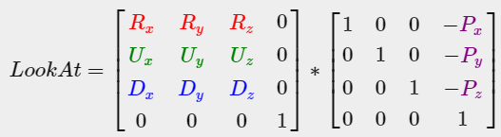

*Where R is the right vector, U is the up vector, D is the direction vector and P is the camera's position vector. Note that the position vector is inverted since we eventually want to translate the world in the opposite direction of where we want to move. Using this LookAt matrix as our view matrix effectively transforms all the world coordinates to the view space we just defined. The LookAt matrix then does exactly what it says: it creates a view matrix that looks at a given target.*

*Luckily for us, GLM already does all this work for us. We only have to specify a camera position, a target position and a vector that represents the up vector in world space (the up vector we used for calculating the right vector). GLM then creates the LookAt matrix that we can use as our view matrix:*

*glm::mat4 view;*

*view = glm::lookAt(glm::vec3(0.0f, 0.0f, 3.0f),*

*glm::vec3(0.0f, 0.0f, 0.0f),*

*glm::vec3(0.0f, 1.0f, 0.0f));*

*The glm::LookAt function requires a position, target and up vector respectively. This creates a view matrix that is the same as the one used in the previous tutorial.*

*Before delving into user input, let's get a little funky first by rotating the camera around our scene. We keep the target of the scene at (0,0,0).*

*We use a little bit of trigonometry to create an x and z coordinate each frame that represents a point on a circle and we'll use these for our camera position. By re-calculating the x and y coordinate we're traversing all the points in a circle and thus the camera rotates around the scene. We enlarge this circle by a pre-defined radius and create a new view matrix each render iteration using GLFW's glfwGetTime function:*

***float*** *radius = 10.0f;*

***float*** *camX = sin(glfwGetTime()) * radius;*

***float*** *camZ = cos(glfwGetTime()) * radius;*

*glm::mat4 view;*

*view = glm::lookAt(glm::vec3(camX, 0.0, camZ), glm::vec3(0.0, 0.0, 0.0), glm::vec3(0.0, 1.0, 0.0));*

*If you run this code you should get something like this:*

*…*

*// у мяне ўсё атрымалася //*

*With this little snippet of code the camera now circles around the scene over time. Feel free to experiment with the radius and position/direction parameters to get the feel of how this LookAt matrix works. Also, check the*[*source code*](https://learnopengl.com/code_viewer_gh.php?code=src/1.getting_started/7.1.camera_circle/camera_circle.cpp)*if you're stuck.*

### ***Walk around***

*Swinging the camera around a scene is fun, but it's more fun to do all the movement by ourselves! First we need to set up a camera system, so it is useful to define some camera variables at the top of our program:*

*glm::vec3 cameraPos = glm::vec3(0.0f, 0.0f, 3.0f);*

*glm::vec3 cameraFront = glm::vec3(0.0f, 0.0f, -1.0f);*

*glm::vec3 cameraUp = glm::vec3(0.0f, 1.0f, 0.0f);*

*The LookAt function now becomes:*

*view = glm::lookAt(cameraPos, cameraPos + cameraFront, cameraUp);*

*First we set the camera position to the previously defined cameraPos. The direction is the current position + the direction vector we just defined. This ensures that however we move, the camera keeps looking at the target direction. Let's play a bit with these variables by updating the cameraPos vector when we press some keys.*

*We already defined a processInput function to manage any of GLFW's keyboard input so let's add some new key commands to check for:*

***void*** *processInput(GLFWwindow *window)*

*{*

*...*

***float*** *cameraSpeed = 0.05f; // adjust accordingly*

***if*** *(glfwGetKey(window, GLFW_KEY_W) == GLFW_PRESS)*

*cameraPos += cameraSpeed * cameraFront;*

***if*** *(glfwGetKey(window, GLFW_KEY_S) == GLFW_PRESS)*

*cameraPos -= cameraSpeed * cameraFront;*

***if*** *(glfwGetKey(window, GLFW_KEY_A) == GLFW_PRESS)*

*cameraPos -= glm::normalize(glm::cross(cameraFront, cameraUp)) * cameraSpeed;*

***if*** *(glfwGetKey(window, GLFW_KEY_D) == GLFW_PRESS)*

*cameraPos += glm::normalize(glm::cross(cameraFront, cameraUp)) * cameraSpeed;*

*}*

*// цудоўнае выкарыстанне вектарнай алгебры //*

*Whenever we press one of the WASD keys, the camera's position is updated accordingly. If we want to move forward or backwards we add or subtract the direction vector from the position vector. If we want to move sidewards we do a cross product to create a right vector and we move along the right vector accordingly. This creates the familiar strafe effect when using the camera.*

*Note that we normalize the resulting right vector. If we wouldn't normalize this vector, the resulting cross product might return differently sized vectors based on the cameraFront variable. If we would not normalize the vector we would either move slow or fast based on the camera's orientation instead of at a consistent movement speed.*

*By now, you should already be able to move the camera somewhat, albeit at a speed that's system-specific at which you may need to adjust cameraSpeed.*

### ***Movement speed***

*Currently we used a constant value for movement speed when walking around. In theory this seems fine, but in practice people have different processing powers and the result of that is that some people are able to draw much more frames than others each second. Whenever a user draws more frames than another user he also calls processInput more often. The result is that some people move really fast and some really slow depending on their setup. When shipping your application you want to make sure it runs the same on all kinds of hardware. // лепей зразумець дадзены факт кнігі. і важнейшая задача пры распрацоўцы графічных прылажэнняў //*

*Graphics applications and games usually keep track of a deltatime variable that stores the time it takes to render the last frame. We then multiply all velocities with this deltaTime value. The result is that when we have a large deltaTime in a frame, meaning that the last frame took longer than average, the velocity for that frame will also be a bit higher to balance it all out. When using this approach it does not matter if you have a very fast or slow pc, the velocity of the camera will be balanced out accordingly so each user will have the same experience. // цудоўная практыка, якая забяспечвае плюс-мінус аднолькавую карцінку незалежна ад жалеза //*

*To calculate the deltaTime value we keep track of 2 global variables:*

***float*** *deltaTime = 0.0f; // Time between current frame and last frame*

***float*** *lastFrame = 0.0f; // Time of last frame*

*Within each frame we then calculate the new deltaTime value for later use:*

***float*** *currentFrame = glfwGetTime();*

*deltaTime = currentFrame - lastFrame;*

*lastFrame = currentFrame;*

*Now that we have deltaTime we can take it into account when calculating the velocities:*

***void*** *processInput(GLFWwindow *window)*

*{*

***float*** *cameraSpeed = 2.5f * deltaTime;*

*...*

*}*

*// усё атрымалася, але я злавіў баг. Калі я выдаляюся ад кубікаў вельмі-вельмі далёка, то яны знікаюць. Аднак, вяртаючыся назад, кубікі ўжо не адлюстроўваюцца з тэкстурай, але суцэльна белыя. Выява са смайлікам па-мінуламу прысутнічае //*

*Together with the previous section we should now have a much smoother and more consistent camera system for moving around the scene:*

*And now we have a camera that walks and looks equally fast on any system. Again, check the*[*source code*](https://learnopengl.com/code_viewer_gh.php?code=src/1.getting_started/7.2.camera_keyboard_dt/camera_keyboard_dt.cpp)*if you're stuck. We'll see the deltaTime value frequently return with anything movement related.*

### ***Look around***

*Only using the keyboard keys to move around isn't that interesting. Especially since we can't turn around making the movement rather restricted. That's where the mouse comes in!*

*To look around the scene we have to change the cameraFront vector based on the input of the mouse. However, changing the direction vector based on mouse rotations is a little complicated and requires some trigonemetry. If you do not understand the trigonemetry, don't worry. You can just skip to the code sections and paste them in your code; you can always come back later if you want to know more. // цудоўная арыентацыя чытача //*

#### **Euler angles**

*Euler angles are 3 values that can represent any rotation in 3D, defined by Leonhard Euler somewhere in the 1700s. There are 3 Euler angles: pitch, yaw and roll. The following image gives them a visual meaning:*

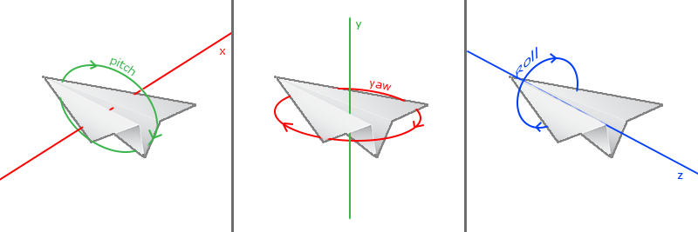

*The pitch is the angle that depicts how much we're looking up or down as seen in the first image. The second image shows the yaw value which represents the magnitude we're looking to the left or to the right. The roll represents how much we rollas mostly used in space-flight cameras. Each of the Euler angles are represented by a single value and with the combination of all 3 of them we can calculate any rotation vector in 3D.*

*For our camera system we only care about the yaw and pitch values so we won't discuss the roll value here. Given a pitch and a yaw value we can convert them into a 3D vector that represents a new direction vector. The process of converting yaw and pitch values to a direction vector requires a bit of trigonemetry and we start with a basic case:*

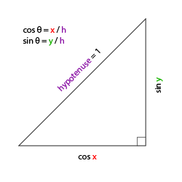

*If we define the hypotenuse to be of length 1 we know from trigonometry (soh cah toa) that the adjacant side's length is cos x/h=cos x/1=cos xcos⁡ x/h=cos⁡ x/1=cos⁡ x and that the opposing side's length is sin y/h=sin y/1=sin ysin⁡ y/h=sin⁡ y/1=sin⁡ y. This gives us some general formulas for retrieving the length in both the x and y directions, depending on the given angle. Let's use this to calculate the components of the direction vector:*

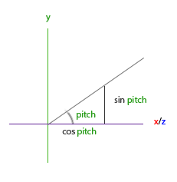

*This triangle looks similar to the previous triangle so if we visualize that we are sitting on the xz plane and look towards the y axis we can calculate the length / strength of the y direction (how much we're looking up or down) based on the first triangle. From the image we can see that the resulting y value for a given pitch equals sin θ:*

*direction.y = sin(glm::radians(pitch)); // Note that we convert the angle to radians first*

*Here we only update the y value is affected, but if you look carefully you can also that the x and z components are affected. From the triangle we can see that their values equal:*

*direction.x = cos(glm::radians(pitch));*

*direction.z = cos(glm::radians(pitch));*

*Let's see if we can find the required components for the yaw value as well:*

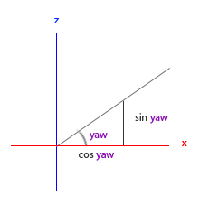

*Just like the pitch triangle we can see that the x component depends on the cos(yaw) value and the z value also depends on the sin of the yaw value. Adding this to the previous values results in a final direction vector based on the pitch and yaw values:*

*direction.x = cos(glm::radians(pitch)) * cos(glm::radians(yaw));*

*direction.y = sin(glm::radians(pitch));*

*direction.z = cos(glm::radians(pitch)) * sin(glm::radians(yaw));*

*This gives us a formula to convert yaw and pitch values to a 3-dimensional direction vector that we can use for looking around. You probably wondered by now: how do we get these yaw and pitch values?*

*// матэматыку зараз не зразумеў. Потым зразумею //*

### ***Mouse input***

*The yaw and pitch values are obtained from mouse (or controller/joystick) movement where horizontal mouse-movement affects the yaw and vertical mouse-movement affects the pitch. The idea is to store the last frame's mouse positions and in the current frame we calculate how much the mouse values changed in comparrison with last frame's value. The higher the horizontal/vertical difference, the more we update the pitch or yaw value and thus the more the camera should move.*

*First we will tell GLFW that it should hide the cursor and capture it. Capturing a cursor means that once the application has focus the mouse cursor stays within the window (unless the application loses focus or quits). We can do this with one simple configuration call:*

*glfwSetInputMode(window, GLFW_CURSOR, GLFW_CURSOR_DISABLED);*

*After this call, wherever we move the mouse it won't be visible and it should not leave the window. This is perfect for an FPS camera system.*

*To calculate the pitch and yaw values we need to tell GLFW to listen to mouse-movement events. We do this by creating a callback function with the following prototype:*

***void*** *mouse_callback(GLFWwindow* window,* ***double*** *xpos,* ***double*** *ypos);*

*Here xpos and ypos represent the current mouse positions. As soon as we register the callback function with GLFW each time the mouse moves, the mouse_callback function is called:*

*glfwSetCursorPosCallback(window, mouse_callback);*

*When handling mouse input for an FPS style camera there are several steps we have to take before eventually retrieving the direction vector:*

1. *Calculate the mouse's offset since the last frame.*
2. *Add the offset values to the camera's yaw and pitch values.*
3. *Add some constraints to the maximum/minimum yaw/pitch values*
4. *Calculate the direction vector*

*The first step is to calculate the offset of the mouse since the last frame. We first have to store the last mouse positions in the application, which we set to the center of the screen (screen size is 800 by 600) initially:*

***float*** *lastX = 400, lastY = 300;*

*Then in the mouse's callback function we calculate the offset movement between the last and current frame:*

***float*** *xoffset = xpos - lastX;*

***float*** *yoffset = lastY - ypos; // reversed since y-coordinates range from bottom to top*

*lastX = xpos;*

*lastY = ypos;*

***float*** *sensitivity = 0.05f;*

*xoffset *= sensitivity;*

*yoffset *= sensitivity;*

*Note that we multiply the offset values by a sensitivity value. If we omit this multiplication the mouse movement would be way too strong; fiddle around with the sensitivity value to your liking. // я з гэтай праблемай раней сутыкаўся неаднаразова //*

*Next we add the offset values to globally declared pitch and yaw values:*

*yaw += xoffset;*

*pitch += yoffset;*

*In the third step we'd like to add some constraints to the camera so users won't be able to make weird camera movements (also prevents a few weird issues). The pitch will be constrained in such a way that users won't be able to look higher than 89 degrees (at 90 degrees the view tends to reverse, so we stick to 89 as our limit) and also not below -89 degrees. This ensures the user will be able to look up to the sky and down to his feet but not further. The constraint works by just replacing the resulting value with its constraint value whenever it breaches the constraint:*

***if****(pitch > 89.0f)*

*pitch = 89.0f;*

***if****(pitch < -89.0f)*

*pitch = -89.0f;*

*Note that we set no constraint on the yaw value since we don't want to constrain the user in horizontal rotation. However, it's just as easy to add a constraint to the yaw as well if you feel like it.*

*The fourth and last step is to calculate the actual direction vector from the resulting yaw and pitch value as discussed in the previous section:*

*glm::vec3 front;*

*front.x = cos(glm::radians(pitch)) * cos(glm::radians(yaw));*

*front.y = sin(glm::radians(pitch));*

*front.z = cos(glm::radians(pitch)) * sin(glm::radians(yaw));*

*cameraFront = glm::normalize(front);*

*This computed direction vector then contains all the rotations calculated from the mouse's movement. Since the cameraFront vector is already included in glm's lookAt function we're set to go.*

*If you would now run the code you will notice that the camera makes a large sudden jump whenever the window first receives focus of your mouse cursor. The cause for the sudden jump is that as soon as your cursor enters the window the mouse callback function is called with an xpos and ypos position equal to the location your mouse entered the screen. This is usually a position that is quite a distance away from the center of the screen resulting in large offsets and thus a large movement jump. // тлумачэнне прычыны гэтага шкоднага эфекта // We can circumvent this issue by simply defining a global bool variable to check if this is the first time we receive mouse input and if so, we first update the initial mouse positions to the new xpos and ypos values; the resulting mouse movements will then use the entered mouse's position coordinates to calculate its offsets:*

***if****(firstMouse) // this bool variable is initially set to true*

*{*

*lastX = xpos;*

*lastY = ypos;*

*firstMouse =* ***false****;*

*}*

*The final code then becomes:*

***void*** *mouse_callback(GLFWwindow* window,* ***double*** *xpos,* ***double*** *ypos)*

*{*

***if****(firstMouse)*

*{*

*lastX = xpos;*

*lastY = ypos;*

*firstMouse =* ***false****;*

*}*

***float*** *xoffset = xpos - lastX;*

***float*** *yoffset = lastY - ypos;*

*lastX = xpos;*

*lastY = ypos;*

***float*** *sensitivity = 0.05;*

*xoffset *= sensitivity;*

*yoffset *= sensitivity;*

*yaw += xoffset;*

*pitch += yoffset;*

***if****(pitch > 89.0f)*

*pitch = 89.0f;*

***if****(pitch < -89.0f)*

*pitch = -89.0f;*

*glm::vec3 front;*

*front.x = cos(glm::radians(yaw)) * cos(glm::radians(pitch));*

*front.y = sin(glm::radians(pitch));*

*front.z = sin(glm::radians(yaw)) * cos(glm::radians(pitch));*

*cameraFront = glm::normalize(front);*

*}*

*There we go! Give it a spin and you'll see that we can now freely move through our 3D scene!*

*// усё працуе //*

### ***Zoom***

*As a little extra to the camera system we'll also implement a zooming interface. In the previous tutorial we said the Field of view or fov defines how much we can see of the scene. When the field of view becomes smaller the scene's projected space gets smaller giving the illusion of zooming in. // асноўная ідэя рэалізацыі зума. Зноў ілюзія // To zoom in, we're going to use the mouse's scroll-wheel. Similar to mouse movement and keyboard input we have a callback function for mouse-scrolling:*

***void*** *scroll_callback(GLFWwindow* window,* ***double*** *xoffset,* ***double*** *yoffset)*

*{*

***if****(fov >= 1.0f && fov <= 45.0f)*

*fov -= yoffset;*

***if****(fov <= 1.0f)*

*fov = 1.0f;*

***if****(fov >= 45.0f)*

*fov = 45.0f;*

*}*

*When scrolling, the yoffset value represents the amount we scrolled vertically. When the scroll_callback function is called we change the content of the globally declared fov variable. Since 45.0f is the default fov value we want to constrain the zoom level between 1.0f and 45.0f.*

*We now have to upload the perspective projection matrix to the GPU each render iteration but this time with the fov variable as its field of view:*

*projection = glm::perspective(glm::radians(fov), 800.0f / 600.0f, 0.1f, 100.0f);*

*And lastly don't forget to register the scroll callback function:*

*glfwSetScrollCallback(window, scroll_callback);*

*And there you have it. We implemented a simple camera system that allows for free movement in a 3D environment.*

*Feel free to experiment a little and if you're stuck compare your code with the*[*source code*](https://learnopengl.com/code_viewer_gh.php?code=src/1.getting_started/7.3.camera_mouse_zoom/camera_mouse_zoom.cpp)*.*

*Note that a camera system using Euler angles is still not a perfect system. Depending on your constraints and your setup you could still introduce a*[*Gimbal lock*](http://en.wikipedia.org/wiki/Gimbal_lock)*. The best camera system would be developed using quaternions but we'll leave that to a later topic. // недахоп дадзенай сістэмы камеры, які я пакуль што не вельмі добра адчуваю //*

*// усё працуе //*

### ***Camera class***

*In the upcoming tutorials we will always use a camera to easily look around the scenes and see the results from all angles. However, since a camera can take up quite some space on each tutorial we'll abstract a little from the details and create our own camera object that does most of the work for us with some neat little extras. Unlike the Shader tutorial we won't walk you through creating the camera class, but just provide you with the (fully commented) source code if you want to know the inner workings.*

*Just like the Shader object we create it entirely in a single header file. You can find the camera object*[*here*](https://learnopengl.com/code_viewer_gh.php?code=includes/learnopengl/camera.h)*. You should be able to understand all the code by now. It is advised to at least check the class out once to see how you could create a camera object like this.*

*The camera system we introduced is an FPS-like camera that suits most purposes and works well with Euler angles, but be careful when creating different camera systems like a flight simulation camera. Each camera system has its own tricks and quirks so be sure to read up on them. // характарыстыка дадзенай сістэмы ведаў // For example, this FPS camera doesn't allow for pitch values higher than 90 degrees and a static up vector of (0,1,0) doesn't work when we take roll values into account. // intbu better these limitations //*

*The updated version of the source code using the new camera object can be found*[*here*](https://learnopengl.com/code_viewer_gh.php?code=src/1.getting_started/7.4.camera_class/camera_class.cpp)*.*

***Exercises***

* *See if you can transform the camera class in such a way that it becomes a****true****fps camera where you cannot fly; you can only look around while staying on the xz plane:*[*solution*](https://learnopengl.com/code_viewer.php?code=getting-started/camera-exercise1)*. // трывіяльнае заданне, у якім трэба абясточыць пэўныя клавішы, здаецца. Хаця, шчыра сказаць, я грунтоўна гэта не вывучаў пакуль што //*
* *Try to create your own LookAt function where you manually create a view matrix as discussed at the start of this tutorial. Replace glm's LookAt function with your own implementation and see if it still acts the same:*[*solution*](https://learnopengl.com/code_viewer.php?code=getting-started/camera-exercise2)*. // таксама не выконваў, але заданне з большага не цяжкае //*

[*https://learnopengl.com/#!Getting-started/Review*](https://learnopengl.com/#!Getting-started/Review)

## *Review*

*Congratulations on reaching the end of the Getting started section. // добры тон у тнав // By now you should be able to create a window, create and compile shaders, send vertex data to your shaders via buffer objects or uniforms, draw objects, use textures, understand vectors and matrices and combine all that knowledge to create a full 3D scene with a camera to play around with. // цудоўнейшае абагульненне навыкаў, якія набыў навучэнец. Добрая практыка тнав //*

*Phew, that is a lot that we learned these last few chapters. Try to play around with the tutorials, experiment a bit or come up with your own ideas and solutions to some of the problems. // цудоўны прызыў да творчасці. Добрая практыка тнав // As soon as you feel you got the hang of all the materials we've discussed it's time to move on to the*[*next*](https://learnopengl.com/#!Lighting/Colors)*tutorials. // арыентацыя навучэнца тнав. Той выпадак, калі важна добра засвоіць ужо вывучанае, каб эфектыўна засваіваць наступнае. У такой сісвед, як гісторыя ці літаратура – гэта не так выяўна важна. Сувязь тсісвед і тнав – фундаментальная сувязь //*

### ***Glossary***

* *OpenGL: a formal specification of a graphics API that defines the layout and output of each function.*
* *GLAD: an extension loading library that loads and sets all OpenGL's function pointers for us so we can use all (modern) OpenGL's functions.*
* *Viewport: the window where we render to.*
* *Graphics Pipeline: the entire process a vertex has to walk through before ending up as a pixel on your screen.*
* *Shader: a small program that runs on the graphics card. Several stages of the graphics pipeline can use user-made shaders to replace existing functionality.*
* *Vertex: a collection of data that represent a single point.*
* *Normalized Device Coordinates: the coordinate system your vertices end up in after clipping and perspective division is performed on clip coordinates. All vertex positions in NDC between -1.0 and 1.0 will not be discarded and end up visible.*
* *Vertex Buffer Object: a buffer object that allocates memory and stores all the vertex data for the graphics card to use.*
* *Vertex Array Object: stores buffer and vertex attribute state information.*
* *Element Buffer Object: a buffer object that stores indices for indexed drawing.*
* *Uniform: a special type of GLSL variable that is global (each shader in a shader program can access this uniform variable) and only has to be set once.*
* *Texture: a special type of image wrapped around objects, giving the illusion an object is extremely detailed.*
* *Texture Wrapping: defines the mode that specifies how OpenGL should sample textures when texture coordinates are outside the range: (0, 1).*
* *Texture Filtering: defines the mode that specifies how OpenGL should sample the texture when there are several texels (texture pixels) to choose from. This usually occurs when a texture is magnified. // вось гэту тэму мне варта прыгадаць грунтоўней //*
* *Mipmaps: stored smaller versions of a texture where the appropriate sized version is chosen based on the distance to the viewer.*
* *stb_image: image loading library.*
* *Texture Units: allows for multiple textures on a single object by binding multiple textures each to a different texture unit.*
* *Vector: a mathematical entity that defines directions and/or positions in any dimension.*
* *Matrix: a rectangular array of mathematical expressions.*
* *GLM: a mathematics library tailored for OpenGL.*
* *Local Space: the space an object begins in. All coordinates relative to an object's origin.*
* *World Space: all coordinates relative to a global origin.*
* *View Space: all coordinates as viewed from a camera's perspective.*
* *Clip Space: all coordinates as viewed from the camera's perspective but with projection applied. This is the space the vertex coordinates should end up in, as output of the vertex shader. OpenGL does the rest (clipping/perspective division).*
* *Screen Space: all coordinates as viewed from the screen. Coordinates range from 0 to screen width/height.*
* *LookAt: a special type of view matrix that creates a coordinate system where all coordinates are rotated and translated in such a way that the user is looking at a given target from a given position.*
* *Euler Angles: defined as yaw, pitch and roll that allow us to form any 3D direction vector from these 3 values.*

# *Lightning*

[*https://learnopengl.com/#!Lighting/Colors*](https://learnopengl.com/#!Lighting/Colors)

## ***Colors***

*We briefly mentioned how to work with colors in OpenGL in the previous tutorials, but so far only touched the surface of colors. Here we'll extensively discuss what colors are and start building the scene for the upcoming lighting tutorials. // структура цьютарала. Цудоўная арыентацыя чытача. Тнав. //*

*In the real world, colors can take practically any known color value with each object having its own color(s). In the digital world we need to map the (infinite) real colors to (limited) digital values and therefore not all real-world colors can be represented digitally. We can however represent so many colors that you probably won't notice the difference anyways. Colors are digitally represented using a red, green and blue component commonly abbreviated as RGB. Using different combinations of just those 3 values we can represent almost any color there is. For example, to get a coral color we define a color vector as:*

*glm::vec3 coral(1.0f, 0.5f, 0.31f);*

*The colors we see in real life are not the colors the objects actually have, but are the colors reflected from the object; the colors that are not absorbed (rejected) by the objects are the colors we perceive of them. For example, the light of the sun is perceived as a white light that is the combined sum of many different colors (as you can see in the image). So if we would shine the white light on a blue toy, it absorbs all the white color's sub-colors except the blue color. Since the toy does not absorb the blue value, it is reflected and this reflected light enters our eye, making it look like the toy has a blue color. The following image shows this for a coral colored toy where it reflects several colors with varying intensity: // оптыка – аснова колераў. Сувязь фізікі і графічнага праграмавання. Канвергенцыя //*

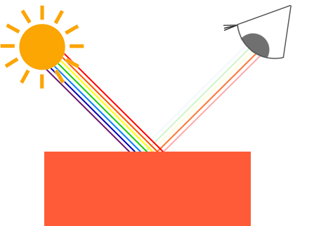

*You can see that the white sunlight is actually a collection of all the visible colors and the object absorbs a large portion of those colors. It only reflects those colors that represent the object's color and the combination of those is what we perceive (in this case a coral color).*

*These rules of color reflection apply directly in graphics-land. When we define a light source in OpenGL we want to give this light source a color. In the previous paragraph we had a white color so we'll give the light source a white color as well. If we would then multiply the light source's color with an object's color value, the resulting color is the reflected color of the object (and thus its perceived color). Let's revisit our toy (this time with a coral value) and see how we would calculate its perceivable color in graphics-land. We retrieve the resulting color vector by doing a component-wise multiplication on both color vectors: // чаму ў дадзеным выпадку працуе менавіта пакампанентнае перамнажэнне? //*

*// чым больш у святле, напрыклад, чырвонай кампаненты. Тым больш будзе адлюстроўвацца чырвонай кампаненты ад прадмета. Такім чынам, мы памножым яго чырвоную кампаненту на кампаненту святла. Рацыянальнае зерне тут ёсць. //*

*glm::vec3 lightColor(1.0f, 1.0f, 1.0f);*

*glm::vec3 toyColor(1.0f, 0.5f, 0.31f);*

*glm::vec3 result = lightColor * toyColor; // = (1.0f, 0.5f, 0.31f);*

*We can see that the toy's color absorbs a large portion of the white light, but reflects several red, green and blue values based on its own color value. This is a representation of how colors would work in real life. We can thus define an object's color as the amount of each color component it reflects from a light source. Now what would happen if we used a green light? // пытанне кнігі, якое я ўжо раней у сваіх развагах задаў ))) //*

*glm::vec3 lightColor(0.0f, 1.0f, 0.0f);*

*glm::vec3 toyColor(1.0f, 0.5f, 0.31f);*

*glm::vec3 result = lightColor * toyColor; // = (0.0f, 0.5f, 0.0f);*

*As we can see, the toy has no red and blue light to absorb and/or reflect The toy also absorbs half of the light's green value, but also still reflects half of the light's green value. The toy's color we perceive would then be a dark-greenish color. We can see that if we use a green light, only the green color components can be reflected and thus perceived; no red and blue colors are perceived. The result is that the coral object suddenly becomes a dark-greenish object. Let's try one more example with a dark olive-green light: // да тлумачэння таго, чаму чорны колер абазначаецца нулямі ў rgb-натацыі //*

*glm::vec3 lightColor(0.33f, 0.42f, 0.18f);*

*glm::vec3 toyColor(1.0f, 0.5f, 0.31f);*

*glm::vec3 result = lightColor * toyColor; // = (0.33f, 0.21f, 0.06f);*

*As you can see, we can get unexpected colors from objects by using different light colors. It's not hard to get creative with colors. // цікавая вобласць ведаў, дзе нецяжка быць крэатыўным //*

*But enough about colors, let's start building a scene where we can experiment in. // структура цьютарала //*

### ***A lighting scene***

*In the upcoming tutorials we'll be creating interesting visuals by simulating real-world lighting making extensive use of colors. Since now we'll be using light sources we want to display them as visual objects in the scene and add at least one object to simulate the lighting on. // структура цьютарала //*

*The first thing we need is an object to cast the light on and we'll use the infamous container cube from the previous tutorials. We will also be needing a light object to show where the light source is located in the 3D scene. For simplicity's sake we'll represent the light source with a cube as well (we already have the*[*vertex data*](https://learnopengl.com/code_viewer.php?code=getting-started/cube_vertices)*right?).*

*So, filling a vertex buffer object, setting vertex attribute pointers and all that weird stuff should be easy for you by now so we won't walk you through those steps. If you still have difficulties with those items I suggest you review the*[*previous tutorials*](https://learnopengl.com/#!Getting-started/Hello-Triangle) *and work through the exercises if possible before continuing. // вось чаму раілася раней грунтоўна вывучыць мінулыя цьютаралы //*

*So, the first thing we will actually need is a vertex shader to draw the container. The vertex positions of the container remain the same (although we won't be needing texture coordinates this time) so the code should be nothing new. We'll be using a stripped down version of the vertex shader from the last tutorials:*

*#version 330 core*

***layout*** *(location = 0)* ***in*** *vec3 aPos;*

***uniform*** *mat4 model;*

***uniform*** *mat4 view;*

***uniform*** *mat4 projection;*

***void*** *main()*

*{*

*gl_Position = projection * view * model * vec4(aPos, 1.0);*

*}*

*Make sure to update your vertex data and attribute pointers to correspond with the new vertex shader (if you want you can actually keep the texture data and attribute pointers active; we're just not using them right now, but it's not a bad idea to start from a fresh start).*

*Because we are also going to create a lamp cube, we want to generate a new VAO specifically for the lamp. We could also represent a lamp using the same VAO and then simply do some transformations on the model matrix, but in the upcoming tutorials we'll be changing the vertex data and attribute pointers of the container object quite often and we don't want these changes to propagate to the lamp object (we only care about the lamp's vertex positions), so we'll create a new VAO: // кантэкст выкарыстання VAO //*

***unsigned******int*** *lightVAO;*

*glGenVertexArrays(1, &lightVAO);*

*glBindVertexArray(lightVAO);*

*// we only need to bind to the VBO, the container's VBO's data already contains the correct data.*

*glBindBuffer(GL_ARRAY_BUFFER, VBO);*

*// set the vertex attributes (only position data for our lamp)*

*glVertexAttribPointer(0, 3, GL_FLOAT, GL_FALSE, 3 \** ***sizeof****(****float****), (****void****\*)0);*

*glEnableVertexAttribArray(0);*

*The code should be relatively straightforward. Now that we created both the container and the lamp cube there is one thing left to define and that is the fragment shader:*

*#version 330 core*

***out*** *vec4 FragColor;*

***uniform*** *vec3 objectColor;*

***uniform*** *vec3 lightColor;*

***void*** *main()*

*{*

*FragColor = vec4(lightColor * objectColor, 1.0);*

*}*

*// відаць, у GLSL па змоўчанні рэалізавана пакампанентнае перамнажэнне вектароў //*

*The fragment shader accepts both an object color and a light color from a uniform variable. Here we multiply the light's color with the object's (reflected) color just like we discussed at the beginning of this tutorial. Again, this shader should be easy to understand. Let's set the object's color to the last section's coral color with a white light:*

*// don't forget to 'use' the corresponding shader program first (to set the uniform)*

*lightingShader.use();*

*lightingShader.setVec3("objectColor", 1.0f, 0.5f, 0.31f);*

*lightingShader.setVec3("lightColor", 1.0f, 1.0f, 1.0f);*

*One thing left to note is that when we start to change the vertex and fragment shaders, the lamp cube will change as well and this is not what we want. We don't want the lamp object's color to be affected by the lighting calculations in the upcoming tutorials, but rather keep the lamp isolated from the rest. We want the lamp to have a constant bright color, unaffected by other color changes (this makes it look like the lamp really is the source of the light).*

*To accomplish this we actually need to create a second set of shaders that we will use to draw the lamp, thus being safe from any changes to the lighting shaders. // кантэкст выкарыстання розных шэйдэраў для розных графічных прымітываў // The vertex shader is the same as the current vertex shader so you can simply copy the source code for the lamp's vertex shader. The fragment shader of the lamp ensures the lamp's color stays bright by defining a constant white color on the lamp:*

*#version 330 core*

***out*** *vec4 FragColor;*

***void*** *main()*

*{*

*FragColor = vec4(1.0); // set all 4 vector values to 1.0*

*}*

*When we want to draw our objects, we want to draw the container object (or possibly many other objects) using the lighting shader we just defined and when we want to draw the lamp, we use the lamp's shaders. During the tutorials we'll gradually be updating the lighting shaders to slowly achieve more realistic results. // трэпр структура цьютарала. Трэпр, тнав. Выдатнейшы цьютарал //*

*The main purpose of the lamp cube is to show where the light comes from. We usually define a light source's position somewhere in the scene, but this is simply a position that has no visual meaning. To show the actual lamp we draw the lamp cube at the same location of the light source. This is accomplished by drawing the lamp object with the lamp shader, ensuring the lamp cube always stays white, regardless of the light conditions of the scene.*

*So let's declare a global vec3 variable that represents the light source's location in world-space coordinates:*

*glm::vec3 lightPos(1.2f, 1.0f, 2.0f);*

*We then want to translate the lamp's cube to the light source's position before drawing it and we'll also scale it down a bit to make sure the lamp isn't too dominant:*

*model = glm::mat4();*

*model = glm::translate(model, lightPos);*

*model = glm::scale(model, glm::vec3(0.2f));*

*The resulting drawing code for the lamp should then look something like this:*

*lampShader.use();*

*// set the model, view and projection matrix uniforms*

*...*

*// draw the lamp object*

*glBindVertexArray(lightVAO);*

*glDrawArrays(GL_TRIANGLES, 0, 36);*

*Injecting all the code fragments at their appropriate locations would then result in a clean OpenGL application properly configured for experimenting with lighting. If everything compiles it should look like this:*

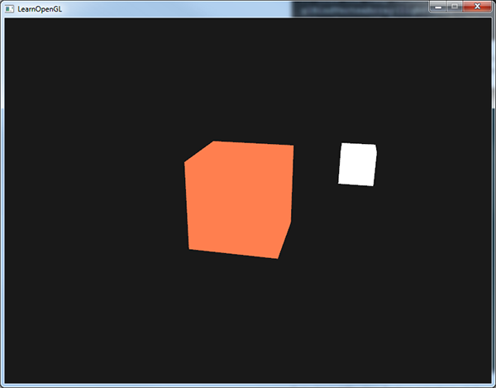

*Not really much to look at right now, but I'll promise it will get more interesting in the upcoming tutorials.*

*If you have difficulties finding out where all the code snippets fit together in the application as a whole, check the source code*[*here*](https://learnopengl.com/code_viewer_gh.php?code=src/2.lighting/1.colors/colors.cpp)*and carefully work your way through the code/comments.*

*// у мяне ўсё атрымалася //*

*Now that we have a fair bit of knowledge about colors and created a basic scene for some sexy lighting stuff we can jump to the*[*next*](https://learnopengl.com/#!Lighting/Basic-Lighting)*tutorial where the real magic begins. // і арыентацыя чытача, і яго эмацыянальнае інтрыгаванне. Усё ў адным флаконе. Гэта магія трэпр і тнав //*

[*https://learnopengl.com/#!Lighting/Basic-Lighting*](https://learnopengl.com/#!Lighting/Basic-Lighting)

## ***Basic Lighting***

*Lighting in the real world is extremely complicated and depends on way too many factors, something we can't afford to calculate on the limited processing power we have. Lighting in OpenGL is therefore based on approximations of reality using simplified models that are much easier to process and look relatively similar. These lighting models are based on the physics of light as we understand it. One of those models is called the Phong lighting model. // стан галіны і разнавіднасць мадэлі асвятлення // The major building blocks of the Phong model consist of 3 components: ambient, diffuse and specular lighting. Below you can see what these lighting components actually look like: // цудоўная рэпрэзентацыя для разумення //*

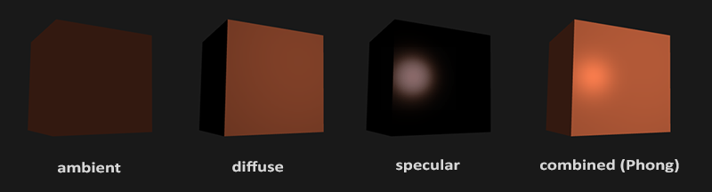

* *Ambient lighting: even when it is dark there is usually still some light somewhere in the world (the moon, a distant light) so objects are almost never completely dark. To simulate this we use an ambient lighting constant that always gives the object some color.*
* *Diffuse lighting: simulates the directional impact a light object has on an object. This is the most visually significant component of the lighting model. The more a part of an object faces the light source, the brighter it becomes.*
* *Specular lighting: simulates the bright spot of a light that appears on shiny objects. Specular highlights are often more inclined to the color of the light than the color of the object.*

*To create visually interesting scenes we want to at least simulate these 3 lighting components. We'll start with the simplest one: ambient lighting.*

### ***Ambient lighting***

*Light usually does not come from a single light source, but from many light sources scattered all around us, even when they're not immediately visible. One of the properties of light is that it can scatter and bounce in many directions reaching spots that aren't in its direct vicinity; light can thus reflect on other surfaces and have an indirect impact on the lighting of an object. Algorithms that take this into consideration are called global illumination algorithms, but these are expensive and/or complicated. // разнавіднасць алгарытмаў асвятлення і іх недахоп //*

*Since we're not big fans of complicated and expensive algorithms we'll start by using a very simplistic model of global illumination, namely ambient lighting. As you've seen in the previous section we use a small constant (light) color that we add to the final resulting color of the object's fragments, thus making it look like there is always some scattered light even when there's not a direct light source.*

*Adding ambient lighting to the scene is really easy. We take the light's color, multiply it with a small constant ambient factor, multiply this with the object's color and use it as the fragment's color:*

***void*** *main()*

*{*

***float*** *ambientStrength = 0.1;*

*vec3 ambient = ambientStrength * lightColor;*

*vec3 result = ambient * objectColor;*

*FragColor = vec4(result, 1.0);*

*}*

*If you'd now run your program, you'll notice that the first stage of lighting is now successfully applied to your object. The object is quite dark, but not completely since ambient lighting is applied (note that the light cube is unaffected because we use a different shader). It should look something like this:*

*// усё працуе //*

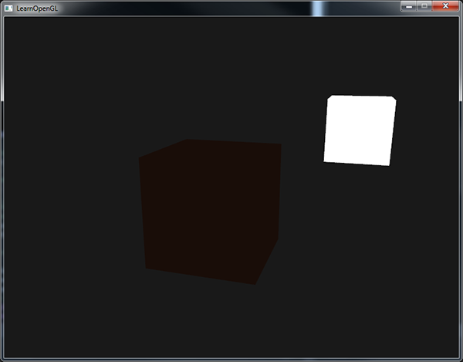

### ***Diffuse lighting***

*Ambient lighting by itself does not produce the most interesting results, but diffuse lighting will start to give a significant visual impact on the object. Diffuse lighting gives the object more brightness the closer its fragments are aligned to the light rays from a light source. To give you a better understanding of diffuse lighting take a look at the following image:*

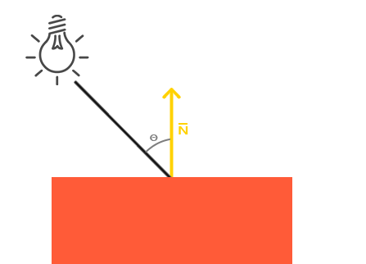

*To the left we find a light source with a light ray targeted at a single fragment of our object. We then need to measure at what angle the light ray touches the fragment. If the light ray is perpendicular to the object's surface the light has the greatest impact. To measure the angle between the light ray and the fragment we use something called a normal vector that is a vector perpendicular to the fragment's surface (here depicted as a yellow arrow); we'll get to that later. The angle between the two vectors can then easily be calculated with the dot product.*

*You might remember from the*[*transformations*](https://learnopengl.com/#!Getting-started/Transformations)*tutorial that the lower the angle between two unit vectors, the more the dot product is inclined towards a value of 1. When the angle between both vectors is 90 degrees, the dot product becomes 0. The same applies to θ: the larger θ becomes, the less of an impact the light should have on the fragment's color.*

*Note that to get (only) the cosine of the angle between both vectors we will work with unit vectors (vectors of length 1) so we need to make sure all the vectors are normalized, otherwise the dot product returns more than just the cosine (see*[*Transformations*](https://learnopengl.com/#!Getting-started/Transformations)*). // важнасць нармалізацыі //*

*The resulting dot product thus returns a scalar that we can use to calculate the light's impact on the fragment's color, resulting in differently lit fragments, based on their orientation towards the light. // структура мадэлі //*

*So, what do we need to calculate diffuse lighting?*

* *Normal vector: a vector that is perpendicular to the vertex' surface.*
* *The directed light ray: a direction vector that is the difference vector between the light's position and the fragment's position. To calculate this light ray we need the light's position vector and the fragment's position vector.*

#### **Normal vectors**

*A normal vector is a (unit) vector that is perpendicular to the surface of a vertex. Since a vertex by itself has no surface (it's just a single point in space) we retrieve a normal vector by using its surrounding vertices to figure out the surface of the vertex. We can use a little trick to calculate the normal vectors for all the cube's vertices by using the cross product, but since a 3D cube is not a complicated shape we can simply manually add them to the vertex data. The updated vertex data array can be found*[*here*](https://learnopengl.com/code_viewer.php?code=lighting/basic_lighting_vertex_data)*. Try to visualize that the normals are indeed vectors perpendicular to the plane's surfaces of the cube (a cube consists of 6 planes).*

*// нармалі ідуць як часткі вертэксаў //*

*Since we added extra data to the vertex array we should update the lighting's vertex shader:*

*#version 330 core*

***layout*** *(location = 0)* ***in*** *vec3 aPos;*

***layout*** *(location = 1)* ***in*** *vec3 aNormal;*

*...*

*02.09.2017*

*Now that we added a normal vector to each of the vertices and updated the vertex shader we should update the vertex attribute pointers as well. Note that the lamp object uses the same vertex array for its vertex data, but the lamp shader has no use of the newly added normal vectors. We don't have to update the lamp's shaders or attribute configurations, but we have to at least modify the vertex attribute pointers to reflect the new vertex array's size:*

*glVertexAttribPointer(0, 3, GL_FLOAT, GL_FALSE, 6 \** ***sizeof****(****float****), (****void****\*)0);*

*glEnableVertexAttribArray(0);*

*We only want to use the first 3 floats of each vertex and ignore the last 3 floats so we only need to update the strideparameter to 6 times the size of a float and we're done.*

*It may look inefficient using vertex data that is not completely used by the lamp shader, but the vertex data is already stored in the GPU's memory from the container object so we don't have to store new data into the GPU's memory. This actually makes it more efficient compared to allocating a new VBO specifically for the lamp. // аптымізацыя ў тэхналогіі //*

*All the lighting calculations are done in the fragment shader so we need to forward the normal vectors from the vertex shader to the fragment shader. Let's do that:*

***out*** *vec3 Normal;*

***void*** *main()*

*{*

*gl_Position = projection * view * model * vec4(aPos, 1.0);*

*Normal = aNormal;*

*}*

*What's left to do is declare the corresponding input variable in the fragment shader:*

***in*** *vec3 Normal;*

#### **Calculating the diffuse color**

*We now have the normal vector for each vertex, but we still need the light's position vector and the fragment's position vector. Since the light's position is just a single static variable we can simply declare it as a uniform in the fragment shader:*

***uniform*** *vec3 lightPos;*

*And then update the uniform in the game loop (or outside since it doesn't change). We use the lightPos vector declared in the previous tutorial as the location of the light source:*

*lightingShader.setVec3("lightPos", lightPos);*

*Then the last thing we need is the actual fragment's position. We're going to do all the lighting calculations in world space so we want a vertex position that is in world space. We can accomplish this by multiplying the vertex position attribute with the model matrix only (not the view and projection matrix) to transform it to world space coordinates. This can easily be accomplished in the vertex shader so let's declare an output variable and calculate its world space coordinates:*

***out*** *vec3 FragPos;*

***out*** *vec3 Normal;*

***void*** *main()*

*{*

*gl_Position = projection * view * model * vec4(aPos, 1.0);*

*FragPos = vec3(model * vec4(aPos, 1.0));*

*Normal = aNormal;*

*}*

*And lastly add the corresponding input variable to the fragment shader:*

***in*** *vec3 FragPos;*

*Now that all the required variables are set we can start with the lighting calculations in the fragment shader.*

*The first thing we need to calculate is the direction vector between the light source and the fragment's position. We mentioned that the light's direction vector is the difference vector between the light's position vector and the fragment's position vector. As you might remember from the*[*transformations*](https://learnopengl.com/#!Getting-started/Transformations)*tutorial we can easily calculate this difference by subtracting both vectors. We also want to make sure all the relevant vectors end up as unit vectors so we normalize both the normal and the resulting direction vector:*

*vec3 norm = normalize(Normal);*

*vec3 lightDir = normalize(lightPos - FragPos);*

*When calculating lighting we usually do not care about the magnitude of a vector or their position; we only care about their direction. Because we only care about their direction almost all the calculations are done with unit vectors since it simplifies most calculations (like the dot product). // перавага нармалізацыі // So when doing lighting calculations, make sure you always normalize the relevant vectors to ensure they're actual unit vectors. Forgetting to normalize a vector is a popular mistake. // рэкамендацыя і папулярныя памылкі //*

*Next we want to calculate the actual diffuse impact the light has on the current fragment by taking the dot product of the norm and lightDir vector. The resulting value is then multiplied with the light's color to get the diffuse component, resulting in a darker diffuse component the greater the angle is between both vectors:*

***float*** *diff = max(dot(norm, lightDir), 0.0);*

*vec3 diffuse = diff * lightColor;*

*If the angle between both vectors is greater than 90 degrees then the result of the dot product will actually become negative and we end up with a negative diffuse component. For that reason we use the max function that returns the highest of both its parameters to make sure the diffuse component (and thus the colors) never become negative. Lighting for negative colors is not really defined so it's best to stay away from that, unless you're one of those eccentric artists. // Лепей зразумець, якая праблема тут маецца на ўвазе??? //*

*Now that we have both an ambient and a diffuse component we add both colors to each other and then multiply the result with the color of the object to get the resulting fragment's output color:*

*vec3 result = (ambient + diffuse) * objectColor;*

*FragColor = vec4(result, 1.0);*

*If your application (and shaders) compiled successfully you should see something like this:*

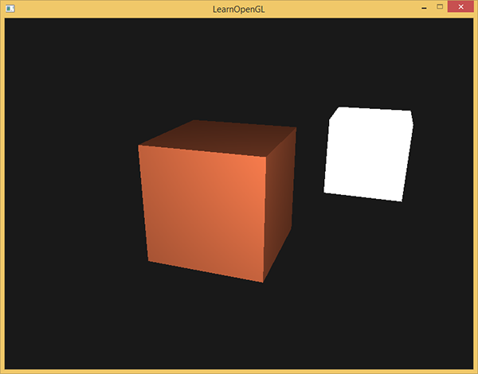

*You can see that with diffuse lighting the cube starts to look like an actual cube again. Try visualizing the normal vectors in your head and move around the cube to see that the larger the angle between them and the light's direction, the darker a fragment becomes.*

*// Доўга не атрымлівалася – і я не разумеў, у чым праблема. Аказалася, што забыў уключыць depth-тэст праз наступны радок:* glEnable(GL_DEPTH_TEST); *//*

*// зараз усё працуе //*

*Feel free to compare your source code with the complete source code*[*here*](https://learnopengl.com/code_viewer_gh.php?code=src/2.lighting/2.1.basic_lighting_diffuse/basic_lighting_diffuse.cpp)*if you're stuck.*

### ***One last thing***

*As of now we've been passing the normal vectors directly from the vertex shader to the fragment shader. However, the calculations we've been doing in the fragment shader are all done in world space coordinates, so shouldn't we transform the normal vectors to world space coordinates as well? Basically yes, but it's not as simple as simply multiplying it with a model matrix. // важная задача праектавання праграмных сістэм //*

*First of all, normal vectors are only direction vectors and do not represent a specific position in space. Also, normal vectors do not have a homogeneous coordinate (the w component of a vertex position). This means that translations do and should not have any effect on the normal vectors. // абгрунтаванне таго, чаму ў нармальных вектараў толькі тры каардынаты // So if we want to multiply the normal vectors with a model matrix we want to remove the translation part of the matrix by taking the upper-left 3x3 matrix of the model matrix (note that we could also set the wcomponent of a normal vector to 0 and multiply with the 4x4 matrix; this removes translation as well). The only transformations we want to apply to normal vectors are scale and rotation transformations.*

*Second, if the model matrix would perform a non-uniform scale, the vertices would be changed in such a way that the normal vector is not perpendicular to the surface anymore, so we can't transform the normal vectors with such a model matrix. The following image shows the effect such a model matrix (with non-uniform scaling) has on a normal vector: // важны нюанс //*

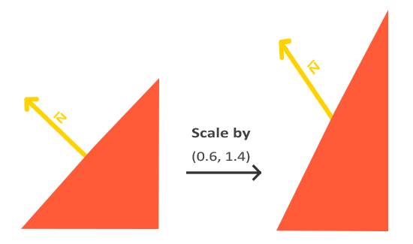

*Whenever we apply a non-uniform scale (note: uniform scales won't hurt the normals since their directions do not change, just their magnitude which is easily fixed by normalizing them) the normal vectors are not perpendicular to the corresponding surface anymore which distorts the lighting. // праблема графічнага праграмавання //*

*The trick of fixing this behavior is to use a different model matrix specifically tailored for normal vectors. This matrix is called the normal matrix and uses a few linear algebraic operations to remove the effect of wrongly scaling the normal vectors. If you want to know how this matrix is actually calculated I suggest the following*[*article*](http://www.lighthouse3d.com/tutorials/glsl-tutorial/the-normal-matrix/)*.*

*The normal matrix is defined as 'the transpose of the inverse of the upper-left corner of the model matrix'. Phew, that's a mouthful and if you don't really understand what that means, don't worry; we haven't discussed inverse and transpose matrices yet. // цудоўная арыентацыя чытача. Але я гэта ведаю. // Note that most resources define the normal matrix as these operations applied to the model-view matrix, but since we're working in world space (and not in view space) we only use the model matrix. // лепей зразумець сэнс апошняга сказу //*

*In the vertex shader we can generate this normal matrix ourselves by using the inverse and transpose functions in the vertex shader that work on any matrix type. Note that we also cast the matrix to a 3x3 matrix to ensure it loses its translation properties and that it can multiply with the vec3 normal vector:*

*Normal = mat3(transpose(inverse(model))) * aNormal;*

*In the diffuse lighting section the lighting was just fine because we did not perform any scaling operation on the object itself so there was not really a need to use a normal matrix and could've just multiplied the normals with the model matrix. If you are doing a non-uniform scale however, it is essential that you multiply your normal vector with the normal matrix.*

*Inversing matrices is a costly operation even for shaders so wherever possible, try to avoid doing inverse operations in shaders since they have to be done on each vertex of your scene. // рэкамендацыя. Праблема. // For learning purposes this is fine, but for an efficient application you'll likely want to calculate the normal matrix on the CPU and send it to the shaders via a uniform before drawing (just like the model matrix). // вырашэнне праблемы //*

### ***Specular Lighting***

*If you're not already exhausted by all the lighting calculations we can start finishing the Phong lighting model by adding specular highlights.*

*Just like diffuse lighting, specular lighting is based on the light's direction vector and the object's normal vectors, but this time it is also based on the view direction e.g. from what direction the player is looking at the fragment. Specular lighting is based on the reflective properties of light. If we think of the object's surface as a mirror, the specular lighting is the strongest wherever we would see the light reflected on the surface. You can see this effect in the following image:*

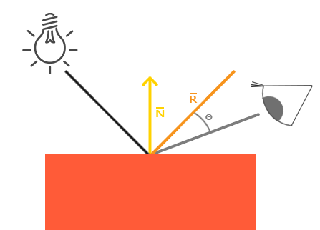

*// цудоўная рэпрэзентацыя //*

*We calculate a reflection vector by reflecting the light direction around the normal vector. Then we calculate the angular distance between this reflection vector and the view direction and the closer the angle between them, the greater the impact of the specular light. The resulting effect is that we see a bit of a highlight when we're looking at the light's direction reflected via the object.*

*The view vector is the one extra variable we need for specular lighting which we can calculate using the viewer's world space position and the fragment's position. Then we calculate the specular's intensity, multiply this with the light color and add this to the resulting ambient and diffuse components.*

*We chose to do the lighting calculations in world space, but most people tend to prefer doing lighting in view space. The added advantage of calculating in view space is that the viewer's position is always at (0,0,0) so you already got the position of the viewer for free. However, I find calculating lighting in world space more intuitive for learning purposes. If you still want to calculate lighting in view space you want to transform all the relevant vectors with the view matrix as well (don't forget to change the normal matrix too). // мне падабаецца варыянт аўтара, бо гэта інтуітыўна зразумелей //*

*To get the world space coordinates of the viewer we simply take the position vector of the camera object (which is the viewer of course). So let's add another uniform to the fragment shader and pass the corresponding camera position vector to the fragment shader:*

***uniform*** *vec3 viewPos;*

*lightingShader.setVec3("viewPos", camera.Position);*

*Now that we have all the required variables we can calculate the specular intensity. First we define a specular intensity value to give the specular highlight a medium-bright color so that it doesn't have too much of an impact:*

***float*** *specularStrength = 0.5;*

*If we would set this to 1.0f we'd get a really bright specular component which is a bit too much for a coral cube. In the*[*next*](https://learnopengl.com/#!Lighting/Materials) *tutorial we'll talk about properly setting all these lighting intensities and how they affect the objects. // структура цьютарала паступова раскрываецца. Гэта цудоўная перавага кнігі. Патэрн тнав. Чалавек усё лепей і лепей разумее структуру кнігі. Прычым загадзя раскрываюцца найбольш часта параграфы, якія будуць ісці не так далёка ад тэмы. Можна параўнаць з кнігай Дэмінга, які раскрывае, па крайняй меры імкнецца, раскрыць усе графавыя спасылкі // Next we calculate the view direction vector and the corresponding reflect vector along the normal axis:*

*vec3 viewDir = normalize(viewPos - FragPos);*

*vec3 reflectDir = reflect(-lightDir, norm);*

*Note that we negate the lightDir vector. The reflect function expects the first vector to point****from****the light source towards the fragment's position, but the lightDir vector is currently pointing the other way around from the fragment* ***towards****the light source (depends on the order of subtraction earlier on when we calculated the lightDir vector). // які цудоўны і грунтоўны цьютарал // To make sure we get the correct reflect vector we reverse its direction by negating the lightDir vector first. The second argument expects a normal vector so we supply the normalized norm vector.*

*Then what's left to do is to actually calculate the specular component. This is accomplished with the following formula:*

***float*** *spec = pow(max(dot(viewDir, reflectDir), 0.0), 32);*

*vec3 specular = specularStrength * spec * lightColor;*

*We first calculate the dot product between the view direction and the reflect direction (and make sure it's not negative) and then raise it to the power of 32. This 32 value is the shininess value of the highlight. The higher the shininess value of an object, the more it properly reflects the light instead of scattering it all around and thus the smaller the highlight becomes. Below you can see an image that shows the visual impact of different shininess values: // параметр тэхналогіі //*

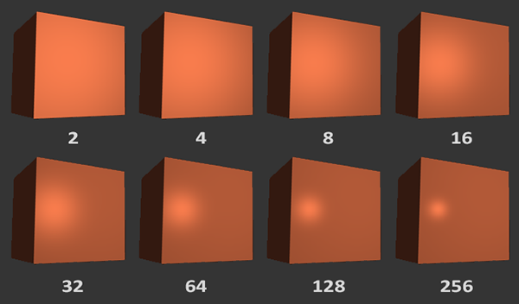

*We don't want the specular component to be too dominant so we keep the exponent at 32. The only thing left to do is to add it to the ambient and diffuse components and multiply the combined result with the object's color:*

*vec3 result = (ambient + diffuse + specular) * objectColor;*

*FragColor = vec4(result, 1.0);*

*We now calculated all the lighting components of the Phong lighting model. Based on your point of view you should see something like this:*

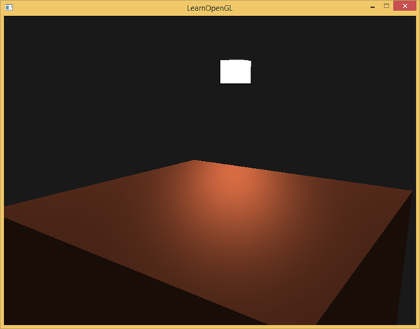

*You can find the complete source code of the application*[*here*](https://learnopengl.com/code_viewer_gh.php?code=src/2.lighting/2.2.basic_lighting_specular/basic_lighting_specular.cpp)*.*

*// усё атрымалася проста выдатнейшым чынам! Люблю такія цьютаралы //*

*In the earlier days of lighting shaders, developers used to implement the Phong lighting model in the vertex shader. The advantage of doing lighting in the vertex shader is that it is a lot more efficient since there are generally a lot less vertices than fragments, so the (expensive) lighting calculations are done less frequently. However, the resulting color value in the vertex shader is the resulting lighting color of that vertex only and the color values of the surrounding fragments are then the result of interpolated lighting colors. The result was that the lighting was not very realistic unless large amounts of vertices were used: // гісторыя тэхналогіі і менш якасная альтэрнатыва //*

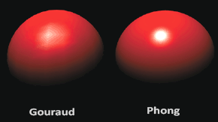

*When the Phong lighting model is implemented in the vertex shader it is called Gouraud shading instead of Phong shading. Note that due to the interpolation the lighting looks a bit off. The Phong shading gives much smoother lighting results. // параўнанне мадэляў асвятлення //*

*By now you should be starting to see just how powerful shaders are. With little information shaders are able to calculate how lighting affects the fragment's colors for all our objects. // моца тэхналогіі // In the*[*next*](https://learnopengl.com/#!Lighting/Materials)*tutorials we'll be delving much deeper into what we can do with the lighting model. // цудоўная арыентацыя чытачат тыпу “накірунак разумення без указання канкрэтнай семантыкі”. Даследваць. //*

### ***Exercises***

* *Right now the light source is a boring static light source that doesn't move. Try to move the light source around the scene over time using either sin or cos. Watching the lighting change over time gives you a good understanding of Phong's lighting model:*[*solution*](https://learnopengl.com/code_viewer.php?code=lighting/basic_lighting-exercise1)*. // вырашыў, змяняючы каардынаты лямпы ўручную. Нешта не атрымалася з матрыцай вярэчння glm //*

*// праўда, вырашэнне прапануецца падобнае //*

* *Play around with different ambient, diffuse and specular strengths and see how they impact the result. Also experiment with the shininess factor. Try to comprehend why certain values have a certain visual output. // потым займуся //*
* *Do Phong shading in view space instead of world space:*[*solution*](https://learnopengl.com/code_viewer.php?code=lighting/basic_lighting-exercise2)*. // пакуль што не рабіў, але вырашэнне зразумеў. Тут варта пераўтвараць каардынаты і нармалі ў вертэкс шэйдэры праз дзве матрыцы: model і view. //*

*// усё менавіта так, як я і сказаў. Код змяняецца толькі ў шэйдэрах //*

* *Implement Gouraud shading instead of Phong shading. If you did things right the lighting should*[*look a bit off*](https://learnopengl.com/img/lighting/basic_lighting_exercise3.png) *(especially the specular highlights) with the cube object. Try to reason why it looks so weird:*[*solution*](https://learnopengl.com/code_viewer.php?code=lighting/basic_lighting-exercise3)*. // не вырашаў. Шмат работы. А я хачу рухацца далей. //*

*// але вырашэнне атрымалася такім, як я і меркаваў. Проста для гэтага трэба шмат кода правіць. //*

[*https://learnopengl.com/#!Lighting/Materials*](https://learnopengl.com/#!Lighting/Materials)

## ***Materials***

*In the real world, each object reacts differently to light. Steel objects are often shinier than a clay vase for example and a wooden container does not react the same to light as a steel container. Each object also responds differently to specular highlights. Some objects reflect the light without too much scattering resulting in a small highlights and others scatter a lot giving the highlight a larger radius. If we want to simulate several types of objects in OpenGL we have to define material properties specific to each object.*

*In the previous tutorial we specified an object and light color to define the visual output of the object, combined with an ambient and specular intensity component. When describing objects we can define a material color for each of the 3 lighting components: ambient, diffuse and specular lighting. By specifying a color for each of the components we have fine-grained control over the color output of the object. Now add a shininess component to those 3 colors and we have all the material properties we need:*

*#version 330 core*

***struct*** *Material {*

*vec3 ambient;*

*vec3 diffuse;*

*vec3 specular;*

***float*** *shininess;*

*};*

***uniform*** *Material material; // юніформамі могуць быць уласна створаныя структуры //*

*In the fragment shader we create a struct to store the material properties of the object. We can also store them as individual uniform values, but storing them as a struct keeps it more organized. We first define the layout of the struct and then simply declare a uniform variable with the newly created struct as its type.*

*As you can see, we define a color vector for each of the Phong lighting's components. The ambient material vector defines what color this object reflects under ambient lighting; this is usually the same as the object's color. The diffuse material vector defines the color of the object under diffuse lighting. The diffuse color is (just like ambient lighting) set to the desired object's color. The specular material vector sets the color impact a specular light has on the object (or possibly even reflect an object-specific specular highlight color). Lastly, the shininess impacts the scattering/radius of the specular highlight.*

*With these 4 components that define an object's material we can simulate many real-world materials. A table as found at*[*devernay.free.fr*](http://devernay.free.fr/cours/opengl/materials.html)*shows several material properties that simulate real materials found in the outside world. // цудоўная табліца матэрыялаў для выкарыстання ў графічных прылажэннях // The following image shows the effect several of these real world materials have on our cube:*

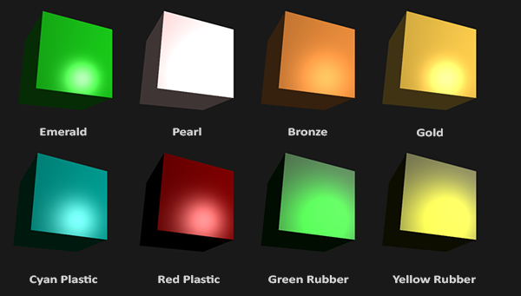

*// цудоўнейшая рэпрэзентацыя //*

*As you can see, by correctly specifying the material properties of an object it seems to change the perception we have of the object. The effects are clearly noticeable, but for the most realistic results we will eventually need more complicated shapes than a cube. In the*[*following tutorial sections*](https://learnopengl.com/#!Model-Loading/Assimp)*we'll discuss more complicated shapes. // важнасць матэрыялаў. Арыентацыя чытача. Тнав. Арыентацыя тыпу: “набліжэнне да вырашэння рэалістычных задач” //*

*Getting the right materials for an object is a difficult feat that mostly requires experimentation and a lot of experience so it's not that uncommon to completely destroy the visual quality of an object by a misplaced material. // складанасць задачы і крыніца частых памылак. Я ўжо спрабаваў займацца падборам колераў – вельмі складана //*

*Let's try implementing such a material system in the shaders. // пастаноўка задачы //*

### ***Setting materials***

*We created a uniform material struct in the fragment shader so next we want to change the lighting calculations to comply with the new material properties. Since all the material variables are stored in a struct we can access them from the material uniform:*

***void*** *main()*

*{*

*// ambient*

*vec3 ambient = lightColor * material.ambient; // тут ужо ўлічана яркасць амбіента? //*

*// diffuse*

*vec3 norm = normalize(Normal);*

*vec3 lightDir = normalize(lightPos - FragPos);*

***float*** *diff = max(dot(norm, lightDir), 0.0);*

*vec3 diffuse = lightColor * (diff * material.diffuse);*

*// specular*

*vec3 viewDir = normalize(viewPos - FragPos);*

*vec3 reflectDir = reflect(-lightDir, norm);*

***float*** *spec = pow(max(dot(viewDir, reflectDir), 0.0), material.shininess);*

*vec3 specular = lightColor * (spec * material.specular);*

*vec3 result = ambient + diffuse + specular;*

*FragColor = vec4(result, 1.0);*

*}*

*// мы фактычна замянілі адзін колер прадмета трыма колерамі і яскравасцю. Усе яны залежаць ад яго фізічнай структуры і аптычных уласцівасцяў, але разлічваць іх напрамую складана-складана. Гэта цудоўнейшы прыклад рэалістычнай імітацыі //*

*As you can see we now access all of the material struct's properties wherever we need them and this time calculate the resulting output color with the help of the material's colors. Each of the object's material attributes are multiplied with their respective lighting components.*

*We can set the material of the object in the application by setting the appropriate uniforms. A struct in GLSL however is not special in any regard when setting uniforms. A struct only acts as an encapsulation of uniform variables so if we want to fill the struct we still have to set the individual uniforms, but this time prefixed with the struct's name: // структура glsl //*

*lightingShader.setVec3("material.ambient", 1.0f, 0.5f, 0.31f);*

*lightingShader.setVec3("material.diffuse", 1.0f, 0.5f, 0.31f);*

*lightingShader.setVec3("material.specular", 0.5f, 0.5f, 0.5f);*

*lightingShader.setFloat("material.shininess", 32.0f);*

*We set the ambient and diffuse component to the color we'd like the object to have and set the specular component of the object to a medium-bright color; we don't want the specular component to be too strong on this specific object. We also keep the shininess at 32. We can now easily influence the object's material from the application.*

*Running the program gives you something like this:*

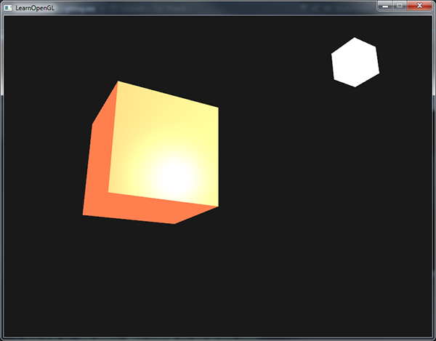

*It doesn't really look right though?*

*// нешта падобнае атрымалася і ў мяне зараз //*

### ***Light properties***

*The object is way too bright. The reason for the object being too bright is that the ambient, diffuse and specular colors are reflected with full force from any light source. Light sources also have different intensities for their ambient, diffuse and specular components respectively. In the previous tutorial we solved this by varying the ambient and specular intensities with a strength value. We want to do something similar, but this time by specifying intensity vectors for each of the lighting components. If we'd visualize lightColor as vec3(1.0) the code would look like this:*

*vec3 ambient = vec3(1.0) * material.ambient;*

*vec3 diffuse = vec3(1.0) * (diff * material.diffuse);*

*vec3 specular = vec3(1.0) * (spec * material.specular);*

*So each material property of the object is returned with full intensity for each of the light's components. These vec3(1.0) values can be influenced individually as well for each light source and this is usually what we want. Right now the ambient component of the object is fully influencing the color of the cube, but the ambient component shouldn't really have such a big impact on the final color so we can restrict the ambient color by setting the light's ambient intensity to a lower value:*

*vec3 ambient = vec3(0.1) * material.ambient;*

*We can influence the diffuse and specular intensity of the light source in the same way. This is closely similar to what we did in the previous*[*previous*](https://learnopengl.com/#!Lighting/Basic-Lighting)*tutorial; you could say we already created some light properties to influence each lighting component individually. We'll want to create something similar to the material struct for the light properties:*

***struct*** *Light {*

*vec3 position;*

*vec3 ambient;*

*vec3 diffuse;*

*vec3 specular;*

*};*

***uniform*** *Light light;*

*A light source has a different intensity for its ambient, diffuse and specular light. The ambient light is usually set to a low intensity because we don't want the ambient color to be too dominant. The diffuse component of a light source is usually set to the exact color we'd like a light to have; often a bright white color. The specular component is usually kept at vec3(1.0) shining at full intensity. Note that we also added the light's position vector to the struct. // тыповая практыка тэхналогіі //*

*Just like with the material uniform we need to update the fragment shader:*

*vec3 ambient = light.ambient * material.ambient;*

*vec3 diffuse = light.diffuse * (diff * material.diffuse);*

*vec3 specular = light.specular * (spec * material.specular);*

*We then want to set the light intensities in the application:*

*lightingShader.setVec3("light.ambient", 0.2f, 0.2f, 0.2f);*

*lightingShader.setVec3("light.diffuse", 0.5f, 0.5f, 0.5f); // darken the light a bit to fit the scene*

*lightingShader.setVec3("light.specular", 1.0f, 1.0f, 1.0f);*

*Now that we modulated how the light influences all the objects' materials we get a visual output that looks much like the output from the previous tutorial. This time however we got full control over the lighting and the material of the object:*

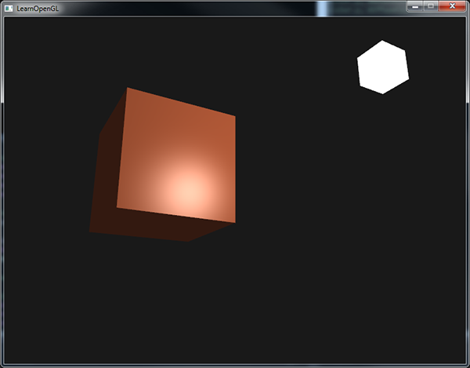

*// усё цудоўна атрымалася //*

*Changing the visual aspects of objects is relatively easy right now. Let's spice things up a bit!*

### ***Different light colors***

*So far we used light colors to only vary the intensity of their individual components by choosing colors that range from white to gray to black, not affecting the actual colors of the object (only its intensity). Since we now have easy access to the light's properties we can change their colors over time to get some really interesting effects. Since everything is already set up in the fragment shader, changing the light's colors is easy and immediately creates some funky effects: // перавага абстрагіравання ад шэйдэраў. Лепей зразумець гэты эфект //*

*As you can see, a different light color greatly influences the object's color output. Since the light color directly influences what colors the object can reflect (as you might remember from the*[*Colors*](https://learnopengl.com/#!Lighting/Colors)*tutorial) it has a significant impact on the visual output.*

*We can easily change the light's colors over time by changing the light's ambient and diffuse colors via sin and glfwGetTime:*

*glm::vec3 lightColor;*

*lightColor.x = sin(glfwGetTime() * 2.0f);*

*lightColor.y = sin(glfwGetTime() * 0.7f);*

*lightColor.z = sin(glfwGetTime() * 1.3f);*

*glm::vec3 diffuseColor = lightColor * glm::vec3(0.5f); // decrease the influence*

*glm::vec3 ambientColor = diffuseColor * glm::vec3(0.2f); // low influence*

*lightingShader.setVec3("light.ambient", ambientColor);*

*lightingShader.setVec3("light.diffuse", diffuseColor);*

*Try and experiment with several lighting and material values and see how they affect the visual output. You can find the source code of the application*[*here*](https://learnopengl.com/code_viewer_gh.php?code=src/2.lighting/3.1.materials/materials.cpp)*.*

*// клас! Усё працуе! //*

***Exercises***

* *Can you simulate some of the real-world objects by defining their respective materials like we've seen at the start of this tutorial? Note that the*[*table*](http://devernay.free.fr/cours/opengl/materials.html)*'s ambient values are not the same as the diffuse values; they didn't take light intensities into account. To correctly set their values you'd have to set all the light intensities to vec3(1.0) to get the same output:*[*solution*](https://learnopengl.com/code_viewer_gh.php?code=src/2.lighting/3.2.materials_exercise1/materials_exercise1.cpp)*of cyan plastic container. // я не вырашаў, але гэта задача не цяжкая //*

[*https://learnopengl.com/#!Lighting/Lighting-maps*](https://learnopengl.com/#!Lighting/Lighting-maps)

## ***Lighting maps***

*In the*[*previous*](https://learnopengl.com/#!Lighting/Materials)*tutorial we discussed the possibility of each object having a unique material of its own that reacts differently to light. // тнав. Арыентацыя чытача тыпу прыгадванне зместу // This is great for giving each object a unique look in comparison with other objects in a lighted scene, but still doesn't offer too much flexibility on the visual output of an object. // што маецца на ўвазе пад гінкасцю? //*

*In the previous tutorial we defined a material for an entire object as a whole, but objects in the real world usually do not consist of a single material, but consist of several materials. Think of a car: its exterior consists of a shiny fabric, it has windows that partly reflect the surrounding environment, its tires are all but shiny so they don't have specular highlights and it has rims that are super shiny (if you actually washed your car alright). // наступны крок ускладнення. Факт тэхналогіі і рэальнага свету // The car also has diffuse and ambient colors that are not the same for the entire object; a car displays many different ambient/diffuse colors. All by all, such an object has different material properties for each of its different parts.*

*So the material system in the previous tutorial isn't sufficient for all but the simplest models so we need to extend the previous system by introducing diffuse and specular maps. These allow us to influence the diffuse (and indirectly the ambient component since they're almost always the same anyways // цікавы факт цьютарала //) and the specular component of an object with much more precision. // пастаноўка задачы //*

***03.09.2017***

### ***Diffuse maps***

*What we want is some way to set the diffuse color of an object for each individual fragment. Some sort of system where we can retrieve a color value based on the fragment's position on the object? // intbu question //*

*This should probably all sound extremely familiar and to be honest we've been using such a system for a while now. This sounds a lot like textures we've extensively discussed in one of the*[*earlier*](https://learnopengl.com/#!Getting-started/Textures)*tutorials and it basically is just that: a texture. We're just using a different name for the same underlying principle: using an image wrapped around an object that we can index for unique color values per fragment. In lighted scenes this is usually called a diffuse map (this is generally how 3D artists call them) since a texture image represents all of the object's diffuse colors. // intbu better terminology difference //*

*To demonstrate diffuse maps we're going to use the*[*following image*](https://learnopengl.com/img/textures/container2.png)*of a wooden container with a steel border:*

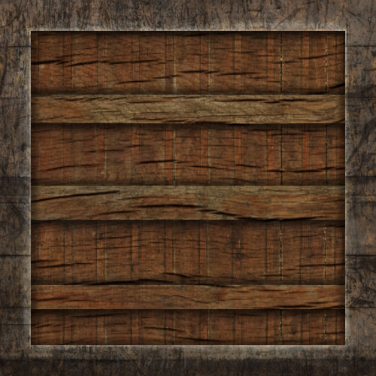

*Using a diffuse map in shaders is exactly the same as with the texture tutorials. // цудоўная аналогія // This time however we store the texture as a sampler2D inside the Material struct. We replace the earlier defined vec3 diffuse color vector with the diffuse map.*

*Keep in mind that sampler2D is a so called opaque type which means we can't instantiate these types, but only define them as uniforms. // лепей зразумець гэта паняцце: opaque type // If we would instantiate this struct other than as a uniform (like a function parameter) GLSL could throw strange errors; the same thus applies to any struct holding such opaque types. // лепей зразумець, што такое інстанцыраванне //*

*We also remove the ambient material color vector since the ambient color is in almost all cases equal to the diffuse color so there's no need to store it separately: // практыка тэхналогіі //*

***struct*** *Material {*

*sampler2D diffuse;*

*vec3 specular;*

***float*** *shininess;*

*};*

*...*

***in*** *vec2 TexCoords;*

*If you're a bit stubborn and still want to set the ambient colors to a different value (other than the diffuse value) you can keep the ambient vec3, but then the ambient colors would still remain the same for the entire object. To get different ambient values for each fragment you'd have to use another texture for ambient values alone.*

*Note that we are going to need texture coordinates again in the fragment shader, so we declared an extra input variable. Then we simply sample from the texture to retrieve the fragment's diffuse color value:*

*vec3 diffuse = light.diffuse * diff * vec3(texture(material.diffuse, TexCoords));*

*Also, don't forget to set the ambient material's color equal to the diffuse material's color as well:*

*vec3 ambient = light.ambient * vec3(texture(material.diffuse, TexCoords));*

*And that's all it takes to use a diffuse map. As you can see it is nothing new, but it does provide a dramatic increase in visual quality. To get it working we do need to update the vertex data with texture coordinates, transfer them as vertex attributes to the fragment shader, load the texture and bind the texture to the appropriate texture unit.*

*The updated vertex data can be found*[*here*](https://learnopengl.com/code_viewer.php?code=lighting/vertex_data_textures)*. The vertex data now includes vertex positions, normal vectors and texture coordinates for each of the cube's vertices. Let's update the vertex shader to accept texture coordinates as a vertex attribute and forward them to the fragment shader:*

*#version 330 core*

***layout*** *(location = 0)* ***in*** *vec3 aPos;*

***layout*** *(location = 1)* ***in*** *vec3 aNormal;*

***layout*** *(location = 2)* ***in*** *vec2 aTexCoords;*

*...*

***out*** *vec2 TexCoords;*

***void*** *main()*

*{*

*...*

*TexCoords = aTexCoords;*

*}*

*Be sure to update the vertex attribute pointers of both VAOs to match the new vertex data and load the container image as a texture. Before drawing the container we want to assign the preferred texture unit to the material.diffuse uniform sampler and bind the container texture to this texture unit:*

*lightingShader.setInt("material.diffuse", 0);*

*...*

*glActiveTexture(GL_TEXTURE0);*

*glBindTexture(GL_TEXTURE_2D, diffuseMap);*

*Now using a diffuse map we get an enormous boost in detail again and this time with added lighting the container really starts to shine (quite literally). Your container now probably looks something like this:*

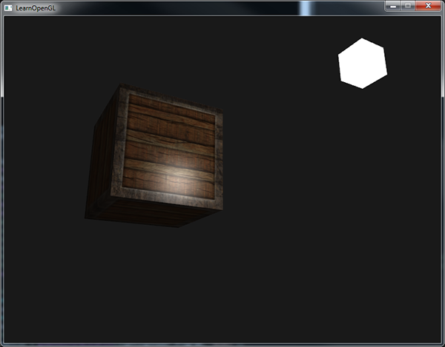

*You can find the full source code of the application*[*here*](https://learnopengl.com/code_viewer_gh.php?code=src/2.lighting/4.1.lighting_maps_diffuse_map/lighting_maps_diffuse.cpp)*.*

*// усё атрымалася, прычым самастойна //*

### ***Specular maps***

*You probably noticed that the specular highlight looks a bit off since our object is a container that mostly consists of wood and we know that wood doesn't give such specular highlights. We can fix this by setting the specular material of the object to vec3(0.0) but that would mean that the steel borders of the container would stop showing specular highlights as well and we also know that steel****should****show some specular highlights. Again, we would like to control what parts of the object should show a specular highlight with varying intensity. This is a problem that looks really familiar to the diffuse maps discussion. Coincidence? I think not. // пра важнасць спек’юлярных мапаў, бо розныя элемнеты прадметаў па-рознаму адлюстроўваюць святло //*

*We can also use a texture map just for specular highlights. This means we need to generate a black and white (or colors if you feel like it) texture that defines the specular intensities of each part of the object. An example of a*[*specular map*](https://learnopengl.com/img/textures/container2_specular.png)*is the following image:*

**

*The intensity of a specular highlight is retrieved by the brightness of each pixel in the image. Each pixel of the specular map can be displayed as a color vector where black represents the color vector vec3(0.0) and gray the color vector vec3(0.5) for example. In the fragment shader we then sample the corresponding color value and multiply this value with the light's specular intensity. The more 'white' a pixel thus is, the higher the result of the multiplication and thus the brighter the specular component of an object becomes. // рэалізацыя спек’юлярнага мэпа //*

*Because the container mostly consists of wood, and wood as a material should have no specular highlights, the entire wooden section of the diffuse texture was converted to black: black sections do not have any specular highlight. The steel border of the container has varying specular intensities with the steel itself being relatively susceptible to specular highlights while the cracks are not.*

*Technically wood also has specular highlights although with a much lower shininess value (more light scattering) and less impact, but for learning purposes we can just pretend wood doesn't have any reaction to specular light.*

*Using tools like Photoshop or Gimp it is relatively easy to transform a diffuse texture to a specular image like this by cutting out some parts, transforming it to black and white and increasing the brightness/contrast. // тэхніка стварэння спекьюлярных мапаў //*

### ***Sampling specular maps***

*A specular map is just like any other texture so the code is similar to the diffuse map code. Make sure to properly load the image and generate a texture object. Since we're using another texture sampler in the same fragment shader we have to use a different texture unit (see*[*Textures*](https://learnopengl.com/#!Getting-started/Textures)*) for the specular map so let's bind it to the appropriate texture unit before rendering:*

*lightingShader.setInt("material.specular", 1);*

*...*

*glActiveTexture(GL_TEXTURE1);*

*glBindTexture(GL_TEXTURE_2D, specularMap);*

*Then update the material properties of the fragment shader to accept a sampler2D as its specular component instead of a vec3:*

***struct*** *Material {*

*sampler2D diffuse;*

*sampler2D specular;*

***float*** *shininess;*

*};*

*And lastly we want to sample the specular map to retrieve the fragment's corresponding specular intensity:*

*vec3 ambient = light.ambient * vec3(texture(material.diffuse, TexCoords));*

*vec3 diffuse = light.diffuse * diff * vec3(texture(material.diffuse, TexCoords));*

*vec3 specular = light.specular * spec * vec3(texture(material.specular, TexCoords));*

*FragColor = vec4(ambient + diffuse + specular, 1.0);*

*By using a specular map we can specify with enormous detail what parts of an object actually have shiny properties and we can even set their corresponding intensity. Specular maps thus give us an added layer of control on top of the diffuse map. // слаі кантролю – важнае паняцце тэхналогіі і тстр. Паразважаць. Важная перавага спекьюлярных мапаў //*

*If you don't want to be too mainstream you could also use actual colors in the specular map to not only set the specular intensity of each fragment, but also the color of the specular highlight. Realistically, however, the color of the specular highlight is mostly (to completely) determined by the light source itself // факт тэхналогіі // so it wouldn't generate realistic visuals (that's why the images are usually black and white: we only care about the intensity). // тлумачэнне асаблівасцяў тэхналогіі //*

*If you would now run the application you can clearly see that the container's material now closely resembles that of an actual wooden container with steel frames:*

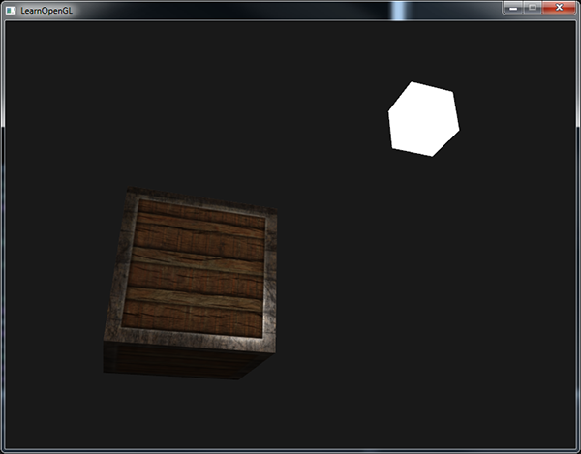

*You can find the full source code of the application*[*here*](https://learnopengl.com/code_viewer_gh.php?code=src/2.lighting/4.2.lighting_maps_specular_map/lighting_maps_specular.cpp)*.*

*// у мяне ўсё атрымалася, праўда, па-мойму, тэкстура дрэнная, бо стальныя рамкі выглядаюць не зусім так //*

*Using diffuse and specular maps we can really add an enormous amount of detail into relatively simple objects. We can even add more detail into the objects using other texture maps like normal/bump maps and/or reflection maps, but that is something we'll reserve for later tutorials. // арыентацыя чытача праз зацікаўліванне і прадусхваленне наступных тэмаў. Яшчэ два мапы тэхналогіі // Show your container to all your friends and family and be content with the fact that our container can one day become even prettier than it already is! // супер матывацыя навучэнца! Цудоўна, калі пасля практыкавання чалавек можа зрабіць штосьці, што сапраўды здаецца класным. Гэта мацнейшая матывацыя навучэнцаў. Паразважаць аб гэтым болей. //*

### ***Exercises***

* *Fool around with the light source's ambient, diffuse and specular vectors and see how they affect the visual output of the container. // паэксперыментуем потым //*
* *Try inverting the color values of the specular map in the fragment shader so that the wood shows specular highlights and the steel borders do not (note that due to the cracks in the steel border the borders still show some specular highlight, although with less intensity):*[*solution*](https://learnopengl.com/code_viewer.php?code=lighting/lighting_maps-exercise2)*. // гэта я змог хуценька зрабіць //*
* *Try creating a specular map from the diffuse texture that uses actual colors instead of black and white and see that the result doesn't look too realistic. You can use this*[*colored specular map*](https://learnopengl.com/img/lighting/lighting_maps_specular_color.png)*if you can't generate one yourself:*[*result*](https://learnopengl.com/img/lighting/lighting_maps_exercise3.png)*. // не займаўся пакуль… потым паспрабую… //*
* *Also add something they call an emission map which is a texture that stores emission values per fragment. Emission values are colors an object might emit as if it contains a light source itself; this way an object can glow regardless of the light conditions. Emission maps are often what you see when objects in a game glow (like*[*eyes of a robot*](http://www.witchbeam.com.au/unityboard/shaders_enemy.jpg)*, or*[*light strips on a container*](http://www.tomdalling.com/images/posts/modern-opengl-08/emissive.png)*). Add the*[*following*](https://learnopengl.com/img/textures/matrix.jpg)*texture (by creativesam) as an emission map onto the container as if the letters emit light:*[*solution*](https://learnopengl.com/code_viewer_gh.php?code=src/2.lighting/4.3.lighting_maps_exercise4/lighting_maps_exercise4.cpp)*;*[*result*](https://learnopengl.com/img/lighting/lighting_maps_exercise4.png)*. // разнавіднасць мапа. Практыкаванне пакуль не вырашаў. Потым вырашу. //*

[*https://learnopengl.com/#!Lighting/Light-casters*](https://learnopengl.com/#!Lighting/Light-casters)

## ***Light casters***

*09.09.2017*

*All the lighting we've used so far came from a single source that is a single point in space. It gives good results, but in the real world we have several types of light that each act different. // факт кнігі // A light source that casts light upon objects is called a light caster. In this tutorial we'll discuss several different types of light casters. Learning to simulate different light sources is yet another tool in your toolbox to further enrich your environments.*

*We'll first discuss a directional light, then a point light which is an extension of what we had before and lastly we'll discuss spotlights. In the*[*next*](https://learnopengl.com/#!Lighting/Multiple-lights)*tutorial we'll combine several of these different light types into one scene. // структура цьютарала і арыентацыя чытача. Цесна злучаныя цьютаралы. Тнав //*

### ***Directional Light***

*When a light source is far away the light rays coming from the light source are close to parallel to each other. It looks like all the light rays are coming from the same direction, regardless of where the object and/or the viewer is. When a light source is modeled to be infinitely far away it is called a directional light since all its light rays have the same direction; it is independent of the location of the light source.*

*A fine example of a directional light source is the sun as we know it. The sun is not infinitely far away from us, but it is so far away that we can perceive it as being infinitely far away in the lighting calculations. All the light rays from the sun are then modelled as parallel light rays as we can see in the following image:*

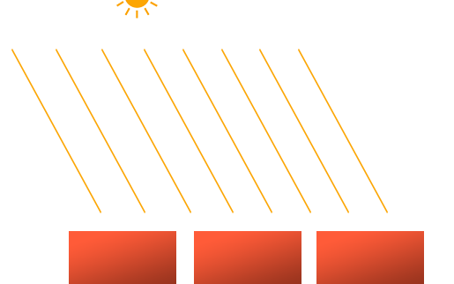

*Because all the light rays are parallel it does not matter how each object relates to the light source's position since the light direction remains the same for each object in the scene. Because the light's direction vector stays the same, the lighting calculations will be similar for each object in the scene.*

*We can model such a directional light by defining a light direction vector instead of a position vector. The shader calculations remain mostly the same except this time we directly use the light's direction vector instead of calculating the lightDirvector with the light's position vector:*

***struct*** *Light {*

*// vec3 position; // No longer necessery when using directional lights.*

*vec3 direction;*

*vec3 ambient;*

*vec3 diffuse;*

*vec3 specular;*

*};*

*...*

***void*** *main()*

*{*

*vec3 lightDir = normalize(-light.direction);*

*...*

*}*

*Note that we first negate the light.direction vector. The lighting calculations we used so far expect the light direction to be a direction from the fragment****towards****the light source, but people generally prefer to specify a directional light as a global direction pointing****from****the light source. Therefore we have to negate the global light direction vector to switch its direction; it's now a direction vector pointing towards the light source. Also, be sure to normalize the vector since it is unwise to assume the input vector to be a unit vector.*

*The resulting lightDir vector is then used as before in the diffuse and specular computations.*

*To clearly demonstrate that a directional light has the same effect on all multiple objects we revisit the container party scene from the end of the*[*Coordinate systems*](https://learnopengl.com/#!Getting-started/Coordinate-Systems)*tutorial. In case you missed the party we first defined 10 different*[*container positions*](https://learnopengl.com/code_viewer.php?code=lighting/light_casters_container_positions) *and generated a different model matrix per container where each model matrix contained the appropriate local-to-world transformations:*

***for****(****unsigned******int*** *i = 0; i < 10; i++)*

*{*

*glm::mat4 model;*

*model = glm::translate(model, cubePositions[i]);*

***float*** *angle = 20.0f * i;*

*model = glm::rotate(model, glm::radians(angle), glm::vec3(1.0f, 0.3f, 0.5f));*

*lightingShader.setMat4("model", model);*

*glDrawArrays(GL_TRIANGLES, 0, 36);*

*}*

*Also, don't forget to actually specify the direction of the light source (note that we define the direction as a direction****from****the light source; you can quickly see the light's direction is pointing downwards):*

*lightingShader.setVec3("light.direction", -0.2f, -1.0f, -0.3f);*

*We've been passing the light's position and direction vectors as vec3s for a while now, but some people tend to prefer to keep all the vectors defined as vec4. When defining position vectors as a vec4 it is important to set the w component to 1.0 so translation and projections are properly applied. However, when defining a direction vector as a vec4 we don't want translations to have an effect (since they just represent directions, nothing more) so then we define the w component to be 0.0.*

*Direction vectors are then represented like: vec4(0.2f, 1.0f, 0.3f, 0.0f). This can also function as an easy check for light types: you could check if the w component is equal to 1.0 to see that we now have a light's position vector and if w is equal to 0.0 we have a light's direction vector so adjust the calculations based on that:*

***if****(lightVector.w == 0.0) // note: be careful for floating point errors*

*// do directional light calculations*

***else******if****(lightVector.w == 1.0)*

*// do light calculations using the light's position (like last tutorial)*

*Fun fact: this is actually how the old OpenGL (fixed-functionality) determined if a light source was a directional light or a positional light source and adjusted its lighting based on that. // гісторыя тэхналогіі //*

*If you'd now compile the application and fly through the scene it looks like there is a sun-like light source casting light on all the objects. Can you see that the diffuse and specular components all react as if there was a light source somewhere in the sky? It'll look something like this:*

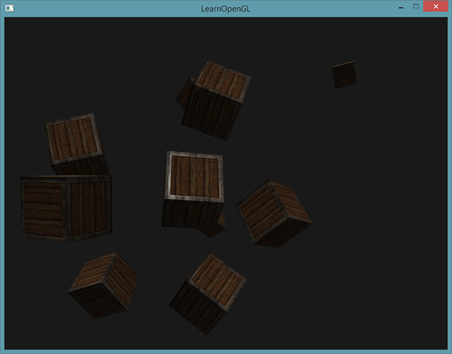

*You can find the full source code of the application*[*here*](https://learnopengl.com/code_viewer_gh.php?code=src/2.lighting/5.1.light_casters_directional/light_casters_directional.cpp)*.*

*// у мяне не ўсё атрымалася. Пры абыходзе вакол кубікаў пачынаюць ззяць некаторыя заднія грані. Хаця яны ўвесь час павінны заставацца цёмнымі. Але гэта мы разгледзем потым. Зараз рухаемся далей. //*

### ***Point lights***

*Directional lights are great for global lights that illuminate the entire scene, but aside from a directional light we usually also want several point lights scattered throughout the scene. A point light is a light source with a given position somewhere in a world that illuminates in all directions where the light rays fade out over distance. Think of light bulbs and torches as light casters that act as a point light.*

**

*In the earlier tutorials we've been working with a (simplistic) point light all along. We had a light source at a given position that scatters light in all directions from that given light position. However, the light source we defined simulated light rays that never fade out thus making it look like the light source is extremely strong. // не ўлічваецца затуханне? // In most 3D simulations we'd like to simulate a light source that only illuminates a certain area close to the light source and not the entire scene. // пастаноўка задачы. Факт цьютарала //*

*If you'd add the 10 containers to the lighting scene of the previous tutorial you'd notice that the container all the way in the back is lit with the same intensity as the container in front of the lamp; there is no formula defined that diminishes light over distance. We want the container in the back to only be slightly lit in comparison to the containers close to the light source.*

#### **Attenuation**

*To reduce the intensity of light, over the distance a light ray travels, is generally called attenuation. One way to reduce the light intensity over distance is to simply use a linear equation. Such an equation would linearly reduce the light intensity over the distance thus making sure that objects at a distance are less bright. However, such a linear function tends to look a bit fake. In the real world, lights are generally quite bright standing close by, but the brightness of a light source diminishes quickly at the start and the remaining light intensity more slowly diminishes over distance. We are thus in need of a different formula for reducing the light's intensity.*

*Luckily some smart people already figured this out for us. The following formula calculates an attenuation value based on a fragment's distance to the light source which we later multiply with the light's intensity vector:*

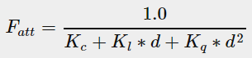

*Here d represents the distance from the fragment to the light source. Then to calculate the attenuation value we define 3 (configurable) terms: a constant term Kc, a linear term Kl and a quadratic term Kq.*

* *The constant term is usually kept at 1.0 which is mainly there to make sure the resulting denominator never gets smaller than 1 since it would otherwise boost the intensity with certain distances, which is not the effect we're looking for.*
* *The linear term is multiplied with the distance value that reduces the intensity in a linear fashion.*
* *The quadratic term is multiplied with the quadrant of the distance and sets a quadratic decrease of intensity for the light source. The quadratic term will be less significant compared to the linear term when the distance is small, but gets much larger than the linear term as the distance grows.*

*Due to the quadratic term the light will diminish mostly at a linear fashion until the distance becomes large enough for the quadratic term to surpass the linear term and then the light intensity will decrease a lot faster. The resulting effect is that the light is quite intense when at a close range, but quickly loses it brightness over distance and eventually loses its brightness at a more slower pace. The following graph shows the effect such an attenuation has over a distance of 100:*

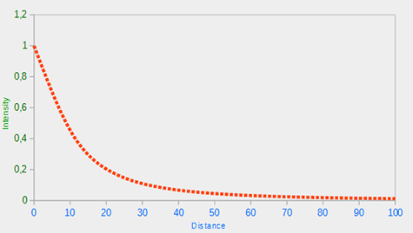

*// апісанне мадэлі затухання святла //*

*You can see that the light has the highest intensity when the distance is small, but as soon as the distance grows its intensity is significantly reduced and slowly reaches 0 intensity at around a distance of 100. This is exactly what we want.*

#### **Choosing the right values**

*10.09.2017*

*But at what values do we set those 3 terms? Setting the right values depends on many factors: the environment, the distance you want a light to cover, the type of light etc. In most cases, it simply is a question of experience and a moderate amount of tweaking. // яшчэ адна сімуляцыя ў графіцы // The following table shows some of the values these terms could take to simulate a realistic (sort of) light source that covers a specific radius (distance). The first column specifies the distance a light will cover with the given terms. These values are good starting points for most lights, with courtesy of*[*Ogre3D's wiki*](http://www.ogre3d.org/tikiwiki/tiki-index.php?page=-Point+Light+Attenuation)*:*

|  |  |  |  |
| --- | --- | --- | --- |
| ***Distance*** | ***Constant*** | ***Linear*** | ***Quadratic*** |
| *7* | *1.0* | *0.7* | *1.8* |
| *13* | *1.0* | *0.35* | *0.44* |
| *20* | *1.0* | *0.22* | *0.20* |
| *32* | *1.0* | *0.14* | *0.07* |
| *50* | *1.0* | *0.09* | *0.032* |
| *65* | *1.0* | *0.07* | *0.017* |
| *100* | *1.0* | *0.045* | *0.0075* |
| *160* | *1.0* | *0.027* | *0.0028* |
| *200* | *1.0* | *0.022* | *0.0019* |
| *325* | *1.0* | *0.014* | *0.0007* |
| *600* | *1.0* | *0.007* | *0.0002* |
| *3250* | *1.0* | *0.0014* | *0.000007* |

*As you can see, the constant term Kc is kept at 1.0 in all cases. The linear term Kl is usually quite small to cover larger distances and the quadratic term Kq is even smaller. Try to experiment a bit with these values to see their effect in your implementation. In our environment a distance of 32 to 100 is generally enough for most lights.*

#### **Implementing attenuation**

*To implement attenuation we'll be needing 3 extra values in the fragment shader: namely the constant, linear and quadratic terms of the formula. These are best stored in the Light struct we defined earlier. Note that we calculate lightDir as we did in the previous tutorial and not as in the earlier Directional Light section.*

***struct*** *Light {*

*vec3 position;*

*vec3 ambient;*

*vec3 diffuse;*

*vec3 specular;*

***float*** *constant;*

***float*** *linear;*

***float*** *quadratic;*

*};*

*Then we set the terms in OpenGL: we want the light to cover a distance of 50 so we'll use the appropriate constant, linear and quadratic terms from the table:*

*lightingShader.setFloat("light.constant", 1.0f);*

*lightingShader.setFloat("light.linear", 0.09f);*

*lightingShader.setFloat("light.quadratic", 0.032f);*

*Implementing attenuation in the fragment shader is relatively straightforward: we simply calculate an attenuation value based on the formula and multiply this with the ambient, diffuse and specular components.*

*We do need the distance to the light source for the formula to work though; remember how we can calculate the length of a vector? We can retrieve the distance term by retrieving the difference vector between the fragment and the light source and take the resulting vector's length. We can use GLSL's built-in length function for that purpose:*

***float*** *distance = length(light.position - FragPos);*

***float*** *attenuation = 1.0 / (light.constant + light.linear * distance +*

*light.quadratic * (distance * distance));*

*Then we include this attenuation value in the lighting calculations by multiplying the attenuation value with the ambient, diffuse and specular colors.*

*We could leave the ambient component alone so ambient lighting is not decreased over distance, but if we were to use more than 1 light source all the ambient components will start to stack up so in that case we want to attenuate ambient lighting as well. Simply play around with what's best for your environment.*

*ambient *= attenuation;*

*diffuse *= attenuation;*

*specular *= attenuation;*

*If you'd run the application you'd get something like this:*

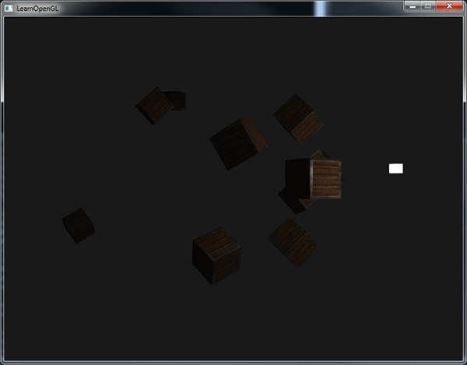

*// акрамя засветкі задніх граняў усё астатняе працуе годна. Пакуль што не буду разбірацца, у чым праблема. Потым разбяруся падрабязней //*

*You can see that right now only the front containers are lit with the closest container being the brightest. The containers in the back are not lit at all since they're too far from the light source. You can find the source code of the application*[*here*](https://learnopengl.com/code_viewer_gh.php?code=src/2.lighting/5.2.light_casters_point/light_casters_point.cpp)*.*

*A point light is thus a light source with a configurable location and attenuation applied to its lighting calculations. Yet another type of light for our lighting arsenal.*

### ***Spotlight***

*The last type of light we're going to discuss is a spotlight. A spotlight is a light source that is located somewhere in the environment that, instead of shooting light rays in all directions, only shoots them in a specific direction. The result is that only the objects within a certain radius of the spotlight's direction are lit and everything else stays dark. A good example of a spotlight would be a street lamp or a flashlight.*

*A spotlight in OpenGL is represented by a world-space position, a direction and a cutoff angle that specifies the radius of the spotlight. For each fragment we calculate if the fragment is between the spotlight's cutoff directions (thus in its cone) and if so, we lit the fragment accordingly. The following image gives you an idea of how a spotlight works: // апісанне святла і прызначэнне графікі. трэпр //*

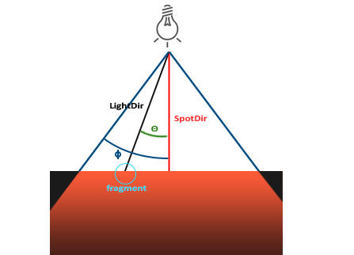

* *LightDir: the vector pointing from the fragment to the light source.*
* *SpotDir: the direction the spotlight is aiming at.*
* *Phi ϕ: the cutoff angle that specifies the spotlight's radius. Everything outside this angle is not lit by the spotlight.*
* *Theta θ: the angle between the LightDir vector and the SpotDir vector. The θ value should be smaller than the Φ value to be inside the spotlight.*

*So what we basically need to do, is calculate the dot product (returns the cosine of the angle between two unit vectors remember?) between the LightDir vector and the SpotDir vector and compare this with the cutoff angle ϕ. Now that you (sort of) understand what a spotlight is all about we're going to create one in the form of a flashlight.*

#### **Flashlight**

*A flashlight is a spotlight located at the viewer's position and usually aimed straight ahead from the player's perspective. Basically a flashlight is a normal spotlight, but with its position and direction continually updated based on the player's position and orientation. // разнавіднасць крыніцы святла //*

*So, the values we're going to need for the fragment shader are the spotlight's position vector (to calculate the light's direction vector), the spotlight's direction vector and the cutoff angle. We can store these values in the Light struct:*

***struct*** *Light {*

*vec3 position;*

*vec3 direction;*

***float*** *cutOff;*

*...*

*};*

*Next we pass the appropriate values to the shaders:*

*lightingShader.setVec3("light.position", camera.Position);*

*lightingShader.setVec3("light.direction", camera.Front);*

*lightingShader.setFloat("light.cutOff", glm::cos(glm::radians(12.5f)));*

*As you can see we're not setting an angle for the cutoff value but calculate the cosine value based on an angle and pass the cosine result to the fragment shader. The reason for this is that in the fragment shader we're calculating the dot product between the LightDir and the SpotDir vector and the dot product returns a cosine value and not an angle so we can't directly compare an angle with a cosine value. To retrieve the angle we then have to calculate the inverse cosine of the dot product's result which is an expensive operation. So to save some performance we calculate the cosine value of a given cutoff angle and pass this result to the fragment shader. Since both angles are now represented as cosines, we can directly compare between them without any expensive operations. // аспекты вытворчаснасці і аптымізацыі //*

*Now what's left to do is calculate the theta θ value and compare this with the cutoff ϕ value to determine if we're in or outside the spotlight:*

***float*** *theta = dot(lightDir, normalize(-light.direction));*

***if****(theta > light.cutOff)*

*{*

*// do lighting calculations*

*}*

***else*** *// else, use ambient light so scene isn't completely dark outside the spotlight.*

*color = vec4(light.ambient * vec3(texture(material.diffuse, TexCoords)), 1.0);*

*We first calculate the dot product between the lightDir vector and the negated direction vector (negated, because we want the vectors to point towards the light source, instead of from). Be sure to normalize all the relevant vectors.*

*You might be wondering why there is a > sign instead of a < sign in the if guard. Shouldn't theta be smaller than the light's cutoff value to be inside the spotlight? That is right, but don't forget angle values are represented as cosine values and an angle of 0 is represented as the cosine value of 1.0 while an angle of 90 degrees is represented as the cosine value of 0.0 as you can see here: // аўтар удакладняе, што мы параўноўваем вуглы праз косінусы //*

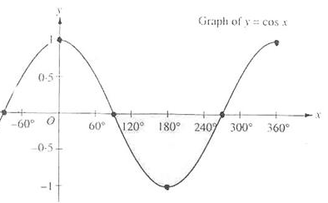

*You can now see that the closer the cosine value is to 1.0 the smaller its angle. Now it makes sense why theta needs to be larger than the cutoff value. The cutoff value is currently set at the cosine of 12.5 which is equal to 0.9978 so a cosine theta value between 0.9979 and 1.0 would result in the fragment being lit as inside the spotlight.*

*Running the application results in a spotlight that only lights the fragments that are directly inside the cone of the spotlight. It'll look something like this:*

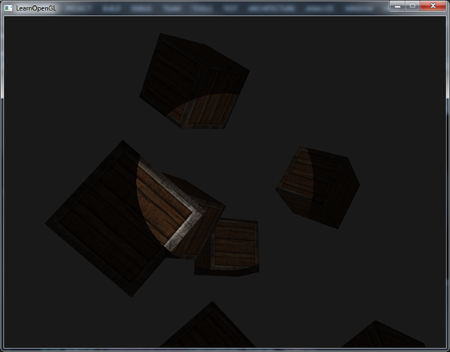

*You can find the full source code*[*here*](https://learnopengl.com/code_viewer_gh.php?code=src/2.lighting/5.3.light_casters_spot/light_casters_spot.cpp)*.*

*// усё атрымалася, але, сапраўды, края светлавой плямы даволі рэзкія, што не рэалістычна. Акрамя гэтага, здаецца, блікі і таму падобнае бачныя не там, дзе трэба. Потым разабрацца ў прычыне. Але, здаецца, трэба пэўным чынам падбіраць скалярныя памнажэнні і вуглы ў шэйдэрах //*

*It still looks a bit fake though, mostly because the spotlight has hard edges. Wherever a fragment reaches the edge of the spotlight's cone it is shut down completely instead of with a nice smooth fade. A realistic spotlight would reduce the light gradually around its edges. // факт кнігі //*

#### **Smooth/Soft edges**

*To create the effect of a smoothly-edged spotlight we want to simulate a spotlight having an inner and an outer cone. We can set the inner cone as the cone defined in the previous section, but we also want an outer cone that gradually dims the light from the inner to the edges of the outer cone. // асноўная ідэя мадэлі асвятлення //*

*To create an outer cone we simply define another cosine value that represents the angle between the spotlight's direction vector and the outer cone's vector (equal to its radius). Then, if a fragment is between the inner and the outer cone it should calculate an intensity value between 0.0 and 1.0. If the fragment is inside the inner cone its intensity is equal to 1.0 and 0.0 if the fragment is outside the outer cone.*

*We can calculate such a value using the following formula:*

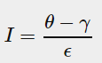

*Here ϵ (epsilon) is the cosine difference between the inner (ϕ) and the outer cone (γ) (ϵ=ϕ−γ). The resulting I value is then the intensity of the spotlight at the current fragment.*

*It is a bit hard to visualize how this formula actually works so let's try it out with a few sample values: // прыклад, калі табліца аказваецца больш інфарматыўнай, чым графіка //*

|  |  |  |  |  |  |  |  |
| --- | --- | --- | --- | --- | --- | --- | --- |
| *θ* | *θ****in degrees*** | *ϕ****(inner cutoff)*** | *ϕ****in degrees*** | *γ****(outer cutoff)*** | *γ****in degrees*** | *ϵ* | *I* |
| *0.87* | *30* | *0.91* | *25* | *0.82* | *35* | *0.91 - 0.82 = 0.09* | *0.87 - 0.82 / 0.09 = 0.56* |
| *0.9* | *26* | *0.91* | *25* | *0.82* | *35* | *0.91 - 0.82 = 0.09* | *0.9 - 0.82 / 0.09 = 0.89* |
| *0.97* | *14* | *0.91* | *25* | *0.82* | *35* | *0.91 - 0.82 = 0.09* | *0.97 - 0.82 / 0.09 = 1.67* |
| *0.83* | *34* | *0.91* | *25* | *0.82* | *35* | *0.91 - 0.82 = 0.09* | *0.83 - 0.82 / 0.09 = 0.11* |
| *0.64* | *50* | *0.91* | *25* | *0.82* | *35* | *0.91 - 0.82 = 0.09* | *0.64 - 0.82 / 0.09 = -2.0* |
| *0.966* | *15* | *0.9978* | *12.5* | *0.953* | *17.5* | *0.966 - 0.953 = 0.0448* | *0.966 - 0.953 / 0.0448 = 0.29* |

*As you can see we're basically interpolating between the outer cosine and the inner cosine based on the θ value. If you still don't really see what's going on, don't worry, you can simply take the formula for granted and return here when you're much older and wiser. // цудоўная арыентацыя чытача. Сувязь тнав і псіхалогіі. Псіхалогія навучання – важная тэма //*

*Since we now have an intensity value that is either negative when outside the spotlight, higher than 1.0 when inside the inner cone and somewhere in between around the edges. If we properly clamp the values we don't need an if-else in the fragment shader anymore and we can simply multiply the light components with the calculated intensity value:*

***float*** *theta = dot(lightDir, normalize(-light.direction));*

***float*** *epsilon = light.cutOff - light.outerCutOff;*

***float*** *intensity = clamp((theta - light.outerCutOff) / epsilon, 0.0, 1.0);*

*...*

*// we'll leave ambient unaffected so we always have a little light.*

*diffuse *= intensity;*

*specular *= intensity;*

*...*

*Note that we use the clamp function that clamps its first argument between the values 0.0 and 1.0. This makes sure the intensity values won't end up outside the [0, 1] interval.*

*Make sure you add the outerCutOff value to the Light struct and set its uniform value in the application. For the following image an inner cutoff angle of 12.5 and an outer cutoff angle of 17.5 was used:*

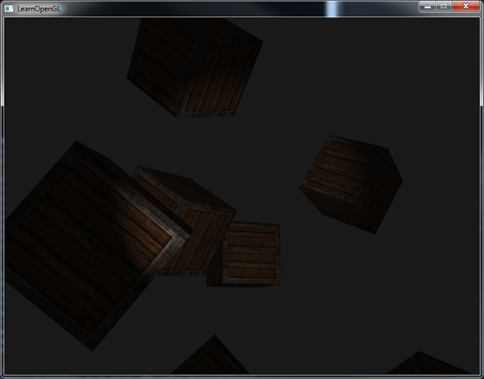

*Ahhh, that's much better. Play around with the inner and outer cutoff angles and try to create a spotlight that better suits your needs. You can find the source code of the application*[*here*](https://learnopengl.com/code_viewer_gh.php?code=src/2.lighting/5.4.light_casters_spot_soft/light_casters_spot_soft.cpp)*.*

*// усё атрымалася за выключэннем невялікіх недалікаў, пра якія я ўзгадваў раней //*

*Such a flashlight/spotlight type of lamp is perfect for horror games and combined with directional and point lights the environment will really start to light up. // прызначэнне і кантэкст выкарыстання паняцця // In the*[*next*](https://learnopengl.com/#!Lighting/Multiple-lights)*tutorial we'll combine all the lights and tricks we've discussed so far. // структура цьютарала. Не ведаю чаму, але напрыканцы дадзенага цьютарала мне ясна, што будзе далей //*

### ***Exercises***

* *Try experimenting with all the different light types and their fragment shaders. Try inverting some vectors and/or using < instead of >. Try to explain the different visual outcomes. // разнавіднасць практыкаванняў – эксперыментаваць на варыяцыях. Гэта цудоўна. Паразважаць. Тнав. //*

[*https://learnopengl.com/#!Lighting/Multiple-lights*](https://learnopengl.com/#!Lighting/Multiple-lights)

## ***Multip******le lights***

*18.09.2017*

*In the previous tutorials we learned quite a lot about lighting in OpenGL. We learned about Phong shading, materials, lighting maps and different types of light casters. In this tutorial we're going to combine all the previously obtained knowledge by creating a fully lit scene with 6 active light sources. We are going to simulate a sun-like light as a directional light source, 4 point lights scattered throughout the scene and we'll be adding a flashlight as well.*

*To use more than one light source in the scene we want to encapsulate the lighting calculations into GLSL functions. The reason for that is that the code quickly gets nasty when we want to do lighting computations with multiple lights with each light type requiring different computations. If we were to do all these calculations in the main function only, the code quickly becomes difficult to understand. // тыповая практыка праектавання //*

*Functions in GLSL are just like C-functions. We have a function name, a return type and we'd have to declare a prototype at the top of the code file if the function hasn't been declared before the main function yet. We'll create a different function for each of the light types: directional lights, point lights and spotlights. // GLSL structure //*

*When using multiple lights in a scene the approach is usually as follows: we have a single color vector that represents the fragment's output color. For each light, the light's contribution color of the fragment is added to the fragment's output color vector. So each light in the scene will calculate its individual impact on the aforementioned fragment and contribute to the final output color. A general structure would look something like this:*

***out*** *vec4 FragColor;*

***void*** *main()*

*{*

*// define an output color value*

*vec3 output = vec3(0.0);*

*// add the directional light's contribution to the output*

*output += someFunctionToCalculateDirectionalLight();*

*// do the same for all point lights*

***for****(****int*** *i = 0; i < nr_of_point_lights; i++)*

*output += someFunctionToCalculatePointLight();*

*// and add others lights as well (like spotlights)*

*output += someFunctionToCalculateSpotLight();*

*FragColor = vec4(output, 1.0);*

*}*

*The actual code will likely differ per implementation, but the general structure remains the same. We define several functions that calculate the impact per light source and add its resulting color to an output color vector. If for example two light sources are close to the fragment, their combined contribution would result in a more brightly lit fragment than the fragment being lit by a single light source.*

### ***Directional light***

*What we want to do is define a function in the fragment shader that calculates the contribution a directional light has on the corresponding fragment: a function that takes a few parameters and returns the calculated directional lighting color.*

*First we need to set the required variables that we minimally need for a directional light source. We can store the variables in a struct called DirLight and define it as a uniform. The required variables should be familiar from the*[*previous*](https://learnopengl.com/#!Lighting/Light-casters)*tutorial:*

***struct*** *DirLight {*

*vec3 direction;*

*vec3 ambient;*

*vec3 diffuse;*

*vec3 specular;*

*};*

***uniform*** *DirLight dirLight;*

*We can then pass the dirLight uniform to a function with the following prototype:*

*vec3 CalcDirLight(DirLight light, vec3 normal, vec3 viewDir);*

*Just like C and C++ if we want to call a function (in this case inside the main function) the function should be defined somewhere before the caller's line number. In this case we'd prefer to define the functions below the main function so this requirement doesn't hold. Therefore we declare the function's prototypes somewhere above the main function, just like we would in C.*

*You can see that the function requires a DirLight struct and two other vectors required for its computation. If you successfully completed the previous tutorial then the content of this function should come as no surprise:*

*vec3 CalcDirLight(DirLight light, vec3 normal, vec3 viewDir)*

*{*

*vec3 lightDir = normalize(-light.direction);*

*// diffuse shading*

***float*** *diff = max(dot(normal, lightDir), 0.0);*

*// specular shading*

*vec3 reflectDir = reflect(-lightDir, normal);*

***float*** *spec = pow(max(dot(viewDir, reflectDir), 0.0), material.shininess);*

*// combine results*

*vec3 ambient = light.ambient * vec3(texture(material.diffuse, TexCoords));*

*vec3 diffuse = light.diffuse * diff * vec3(texture(material.diffuse, TexCoords));*

*vec3 specular = light.specular * spec * vec3(texture(material.specular, TexCoords)); // трошку не памятаю, што робіць гэта функцыя //*

***return*** *(ambient + diffuse + specular);*

*}*

*We basically copied the code from the previous tutorial and used the vectors given as function arguments to calculate the directional light's contribution vector. The resulting ambient, diffuse and specular contributions are then returned as a single color vector.*

### ***Point light***

*Just like with directional lights we also want to define a function that calculates the contribution a point light has on the given fragment, including its attenuation. Just like directional lights we want to define a struct that specifies all the variables required for a point light:*

***struct*** *PointLight {*

*vec3 position;*

***float*** *constant;*

***float*** *linear;*

***float*** *quadratic;*

*vec3 ambient;*

*vec3 diffuse;*

*vec3 specular;*

*};*

*#define NR_POINT_LIGHTS 4*

***uniform*** *PointLight pointLights[NR_POINT_LIGHTS];*

*As you can see we used a pre-processor directive in GLSL // GLSL structure // to define the number of point lights we want to have in our scene. We then use this NR_POINT_LIGHTS constant to create an array of PointLight structs. Arrays in GLSL are just like C arrays and can be created by the use of two square brackets. // GLSL structure // Right now we have 4 PointLight structs to fill with data.*

*We could also simply define****one****large struct (instead of different structs per light type) that contains all the necessary variables for****all****the different light types and use that struct for each function, and simply ignore the variables we don't need. However, I personally find the current approach more intuitive and aside from a few extra lines of code it could save up some memory since not all light types need all variables. // я згодны з аўтарам – гэта больш зразумела і больш ясна //*

*The prototype of the point light's function is as follows:*

*vec3 CalcPointLight(PointLight light, vec3 normal, vec3 fragPos, vec3 viewDir);*

*The function takes all the data it needs as its arguments and returns a vec3 that represents the color contribution that this specific point light has on the fragment. Again, some intelligent copy-and-pasting results in the following function:*

*vec3 CalcPointLight(PointLight light, vec3 normal, vec3 fragPos, vec3 viewDir)*

*{*

*vec3 lightDir = normalize(light.position - fragPos);*

*// diffuse shading*

***float*** *diff = max(dot(normal, lightDir), 0.0);*

*// specular shading*

*vec3 reflectDir = reflect(-lightDir, normal);*

***float*** *spec = pow(max(dot(viewDir, reflectDir), 0.0), material.shininess);*

*// attenuation*

***float*** *distance = length(light.position - fragPos);*

***float*** *attenuation = 1.0 / (light.constant + light.linear * distance +*

*light.quadratic * (distance * distance));*

*// combine results*

*vec3 ambient = light.ambient * vec3(texture(material.diffuse, TexCoords));*

*vec3 diffuse = light.diffuse * diff * vec3(texture(material.diffuse, TexCoords));*

*vec3 specular = light.specular * spec * vec3(texture(material.specular, TexCoords));*

*ambient *= attenuation;*

*diffuse *= attenuation;*

*specular *= attenuation;*

***return*** *(ambient + diffuse + specular);*

*}*

*Abstracting this functionality away in a function like this has the advantage that we can easily calculate the lighting for multiple point lights without the need for nasty duplicated code. In the main function we simply create a loop that iterates over the point light array that calls CalcPointLight for each point light.*

### ***Putting it all together***

*Now that we defined both a function for directional lights and a function for point lights we can put it all together in the main function.*

***void*** *main()*

*{*

*// properties*

*vec3 norm = normalize(Normal);*

*vec3 viewDir = normalize(viewPos - FragPos);*

*// phase 1: Directional lighting*

*vec3 result = CalcDirLight(dirLight, norm, viewDir);*

*// phase 2: Point lights*

***for****(****int*** *i = 0; i < NR_POINT_LIGHTS; i++)*

*result += CalcPointLight(pointLights[i], norm, FragPos, viewDir);*

*// phase 3: Spot light*

*//result += CalcSpotLight(spotLight, norm, FragPos, viewDir);*

*FragColor = vec4(result, 1.0);*

*}*

*Each light type adds its contribution to the resulting output color until all light sources are processed. The resulting color contains the color impact of all the light sources in the scene combined. If you want you could also implement a spotlight and add its effect to the output color as well. We leave the CalcSpotLight function as an exercise for the reader.*

*Setting the uniforms for the directional light struct shouldn't be too unfamiliar, but you might be wondering how we could set the uniform values of the point lights since the point light uniform is now an array of PointLight structs. This isn't something we've discussed before.*

*Luckily for us, it isn't too complicated. To set the uniform of an array of structs works just like setting the uniforms of a single struct, although this time we also have to define the appropriate index when querying the uniform's location:*

*lightingShader.setFloat("pointLights[0].constant", 1.0f);*

*Here we index the first PointLight struct in the pointLights array and retrieve the location of its constant variable. This does mean unfortunately that we have to manually set all the uniforms for each of the 4 point lights, which leads up to 28 uniform calls for the point lights alone which is a bit tedious. You could try to abstract a bit away from this by defining a point light class that sets the uniforms for you, but in the end you'd still have to set the all the lights' uniform values this way.*

*Let's not forget that we also need to define a position vector for each of the point lights so let's spread them up a bit around the scene. We'll define another glm::vec3 array that contains the pointlights' positions:*

*glm::vec3 pointLightPositions[] = {*

*glm::vec3( 0.7f, 0.2f, 2.0f),*

*glm::vec3( 2.3f, -3.3f, -4.0f),*

*glm::vec3(-4.0f, 2.0f, -12.0f),*

*glm::vec3( 0.0f, 0.0f, -3.0f)*

*};*

*Then index the corresponding PointLight struct from the pointLights array and set its position attribute as one of the positions we just defined. Also be sure to now draw 4 light cubes instead of just 1. Simply create a different model matrix for each of the light objects just like we did with the containers.*

*If you'd also use a flashlight the result of all the combined lights looks something like this:*

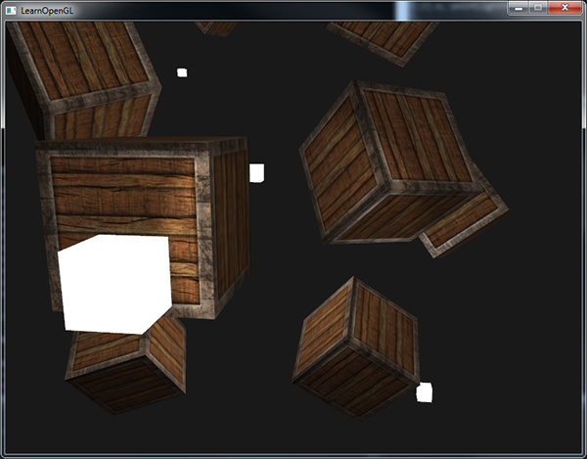

*As you can see there appears to be some form of a global light (like a sun) somewhere in the sky, we have 4 lights scattered throughout the scene and a flashlight is visible from the player's perspective. Looks pretty neat doesn't it?*

*You can find the full source code of the final application*[*here*](https://learnopengl.com/code_viewer_gh.php?code=src/2.lighting/6.multiple_lights/multiple_lights.cpp)*.*

*23.09.2017*

*// у мяне не вельмі атрымалася гэтая праграма. Старая праблема, злучаная асветленымі заднімі гранямі, відаць, мае прычынай тое, што пры вярчэнні вектары нармаляў верцяцца не зусім правільна… А яшчэ праблема ўзнікла з атэньюэйшн. Калі лічу без яго, то ўсё добра, а калі з ім – то не. Паразважаць потым. Што будзе калі колер складваецца і перавышае адзінку? //*

*The image shows all the light sources set with the default light properties we've used in all the previous tutorials, but if you'd play around with these values you can get pretty interesting results. Artists and level editors generally tweak all these lighting variables in a large editor to make sure the lighting matches the environment. Using the simple lighted environment we just created you can create some interesting visuals by simply tweaking the lights their attributes: // аспекты падрыхтоўкі дызайну гульняў //*

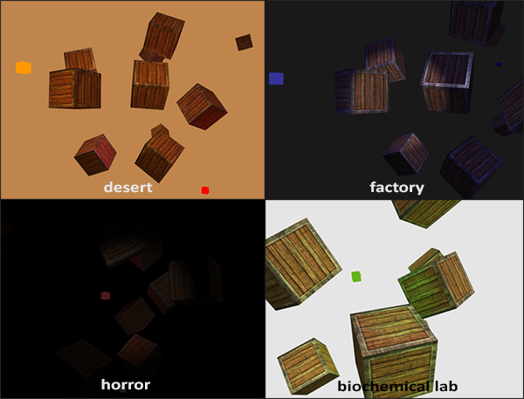

*We also changed the clear color to better reflect the lighting. You can see that by simply adjusting some of the lighting parameters you can create completely different atmospheres. // аспекты трэпр. Уплыў лайтнінга на атмасферу графікі //*

*By now you should have a pretty good understanding of lighting in OpenGL. With the knowledge so far we can already create interesting and visually rich environments and atmospheres. Try playing around with all the different values to create your own atmospheres.*

### ***Exercises***

* *Can you (sort of) re-create the different atmospheres of the last image by tweaking the light's attribute values?*[*solution*](https://learnopengl.com/code_viewer.php?code=lighting/multiple_lights-exercise2)*. // не вырашаў, бо дужа застраў на гэтым прыкладзе //*

***Want to help?***

*Enjoyed the tutorial? Consider becoming a*[*patron*](https://www.patreon.com/learnopengl)*of LearnOpenGL.  
  
Your support helps me create new and better tutorials, improve existing content and enables me to improve the website wherever I can.*

[*https://learnopengl.com/#!Lighting/Review*](https://learnopengl.com/#!Lighting/Review)

## ***Review***

*Congratulations on making it this far! I'm not sure if you noticed, but over all the lighting tutorials we basically learned nothing new about OpenGL itself except a few minor items like accessing uniform arrays. All of the tutorials so far were all about manipulating shaders using techniques and formulas to achieve realistic lighting results. This again shows you the power of shaders. Shaders are extremely flexible and you witnessed firsthand that with just a few 3D vectors and some configurable variables we were able to create amazing graphics with just that!*

*The last few tutorials you learned about colors, the Phong lighting model (that includes ambient, diffuse and specular lighting), object materials, configurable light properties, diffuse and specular maps, different types of lights and how to combine all the knowledge into a single application. Be sure to experiment with different lights, material colors, light properties and try to create your own environments with the help of a little bit of creativity.*

*In the next tutorials we'll be adding more advanced shapes to our scene that look really well in the lighting models we've discussed.*

### ***Glossary***

* *Color vector: a vector portraying most of the real world colors via a combination of red, green and blue components (abbreviated to RGB). The color of an object is actually the reflected color components that an object did not absorb.*
* *Phong lighting model: a model for approximating real-world lighting by computing an ambient, diffuse and specular component.*
* *Ambient lighting: approximation of global illumination by giving each object a small brightness so that objects aren't completely dark if not lit.*
* *Diffuse shading: lighting that gets stronger the more a vertex/fragment is aligned to a light source. Makes use of normal vectors to calculate the angles.*
* *Normal vector: a (unit) vector that is perpendicular to a surface.*
* *Normal matrix: a 3x3 matrix that is the model (or model-view) matrix without translation. It is also modified in such a way (inverse-transpose) that it keeps normal vectors facing in the correct direction when applying non-uniform scaling. Otherwise normal vectors get distorted when using non-uniform scaling.*
* *Specular lighting: sets a specular highlight the closer the viewer is looking at the reflection of a light source on a surface. Based on the viewer's direction, the light's direction and a shininess value that sets the amount of scattering of the highlight.*
* *Phong shading: the Phong lighting model applied in the fragment shader.*
* *Gouraud shading: the Phong lighting model applied in the vertex shader. Produces noticeable artifacts when using a small number of vertices. Gains efficiency for loss of visual quality.*
* *GLSL struct: a C-like struct that acts as a container for shader variables. Mostly used for organizing input/output/uniforms. // структура GLSL //*
* *Material: the ambient, diffuse and specular color an object reflects. These set the colors an object has.*
* *Light (properties): the ambient, diffuse and specular intensity of a light. These can take any color value and define at what color/intensity a light source shines for each specific Phong component.*
* *Diffuse map: a texture image that sets the diffuse color per fragment.*
* *Specular map: a texture map that sets the specular intensity/color per fragment. Allows for specular highlights only on certain areas of an object.*
* *Directional light: a light source with only a direction. It is modeled to be at an infinite distance which has the effect that all its light rays seem parallel and its direction vector thus stays the same over the entire scene.*
* *Point light: a light source with a location in a scene with light that fades out over distance.*
* *Attenuation: the process of light reducing its intensity over distance, used in point lights and spotlights.*
* *Spotlight: a light source that is defined by a cone in one specific direction.*
* *Flashlight: a spotlight positioned from the viewer's perspective.*
* *GLSL uniform array: an array of uniform values. Work just like a C-array, except that they can't be dynamically allocated.*

# *Model Loading*

[*https://learnopengl.com/#!Model-Loading/Assimp*](https://learnopengl.com/#!Model-Loading/Assimp)

## ***Assimp***

*In all the scenes so far we've been extensively abusing our little container friend in many ways, but over time even our best friends could get a little boring. In practical graphics applications there are usually lots of complicated and interesting models that are much prettier to look at than a static container. However, unlike the container object, we can't really manually define all the vertices, normals and texture coordinates of complicated shapes like houses, vehicles or human-like characters. What we want instead is to import these models into the application; models that were carefully designed by 3D artists in tools like*[*Blender*](http://www.blender.org/)*,*[*3DS Max*](http://www.autodesk.nl/products/3ds-max/overview)*or*[*Maya*](http://www.autodesk.com/products/autodesk-maya/overview)*.*

*These so called 3D modeling tools allow artists to create complicated shapes and apply textures to them via a process called uv-mapping. The tools then automatically generate all the vertex coordinates, vertex normals and texture coordinates while exporting them to a model file format. This way, artists have an extensive toolkit to create high quality models without having to care too much about the technical details. // прыклад павышэння якасці праз ізаліраванне спецыялістаў за кошт змяншэння ведаў кожнага і павышэння іх вузкай спецыялізацыі. Павыяўляць з пункту гледжання атс, якія гэта дае перавагі // All the technical aspects are hidden in the exported model file. We, as graphics programmers,****do****have to care about these technical details though.*

*It is thus our job to parse these exported model files and extract all the relevant information so we can store them in a format that OpenGL understands. A common issue is however that there are dozens of different file formats where each exports the model data in its own unique way. Model formats like the*[*Wavefront .obj*](http://en.wikipedia.org/wiki/Wavefront_.obj_file)*only contains model data with minor material information like model colors and diffuse/specular maps, while model formats like the XML-based*[*Collada file format*](http://en.wikipedia.org/wiki/COLLADA)*are extremely extensive and contain models, lights, many types of materials, animation data, cameras, complete scene information and much more. The wavefront object format is generally considered to be an easy-to-parse model format. It is recommended to visit the Wavefront's wiki page at least once to see how such a file format's data is structured. This should give you a basic perception of how model file formats are generally structured.*

*All by all, there are many different file formats where a common general structure between them usually does not exist. So if we want to import a model from these file formats we'd have to write an importer ourselves for each of the file formats we want to import. Luckily for us, there just happens to be a library for this.*

### ***A model loading library***

*A very popular model importing library out there is called*[*Assimp*](http://assimp.org/)*that stands for Open Asset Import Library. Assimp is able to import dozens of different model file formats (and export to some as well) by loading all the model's data into Assimp's generalized data structures. As soon as Assimp has loaded the model, we can retrieve all the data we need from Assimp's data structures. Because the data structure of Assimp stays the same, regardless of the type of file format we imported, it abstracts us from all the different file formats out there.*

*When importing a model via Assimp it loads the entire model into a scene object that contains all the data of the imported model/scene. Assimp then has a collection of nodes where each node contains indices to data stored in the scene object where each node can have any number of children. A (simplistic) model of Assimp's structure is shown below:*

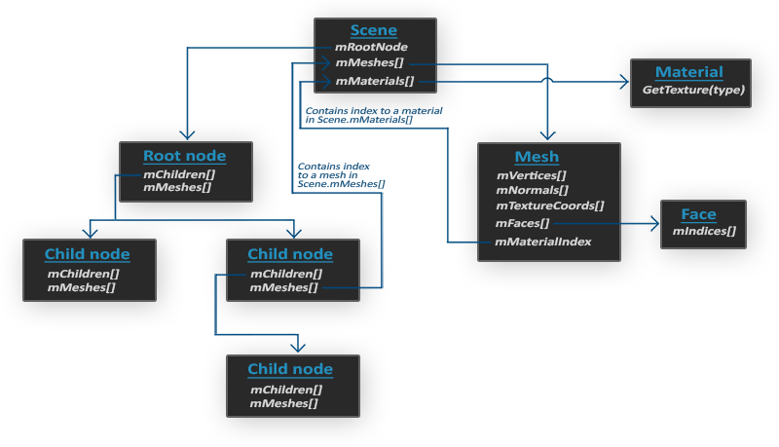

*// не сказаць, што с ходу схема ясна… //*

* *All the data of the scene/model is contained in the Scene object like all the materials and the meshes. It also contains a reference to the root node of the scene.*
* *The Root node of the scene may contain children nodes (like all other nodes) and could have a set of indices that point to mesh data in the scene object's mMeshes array. The root node's mMeshes array contains the actual Mesh objects, the values in the mMeshes array of a node are only indices for the scene's meshes array.*
* *A Mesh object itself contains all the relevant data required for rendering, think of vertex positions, normal vectors, texture coordinates, faces and the material of the object.*
* *A mesh contains several faces. A Face represents a render primitive of the object (triangles, squares, points). A face contains the indices of the vertices that form a primitive. Because the vertices and the indices are separated, this makes it easy for us to render via an index buffer (see*[*Hello Triangle*](https://learnopengl.com/#!Getting-started/Hello-Triangle)*).*
* *Finally a mesh also contains a Material object that hosts several functions to retrieve the material properties of an object. Think of colors and/or texture maps (like diffuse and specular maps).*

*So what we want to do is first load an object into a Scene object, recursively retrieve the corresponding Mesh objects from each of the nodes (we recursively search each node's children) and process each Mesh object to retrieve the vertex data, indices and its material properties. The result is then a collection of mesh data that we want to contain in a single Model object.*

#### **Mesh**

*When modelling objects in modelling toolkits, artists generally do not create an entire model out of a single shape. Usually each model has several sub-models/shapes that it consists of. Each of those single shapes that a model is composed of is called a mesh. Think of a human-like character: artists usually model the head, limbs, clothes, weapons all as separate components and the combined result of all these meshes represents the final model. A single mesh is the minimal representation of what we need to draw an object in OpenGL (vertex data, indices and material properties). A model (usually) consists of several meshes.*

*In the*[*next*](https://learnopengl.com/#!Model-Loading/Mesh)*tutorials we'll create our own Model and Mesh class that load and store the imported models using the structure we've just described. // цудоўная арыентацыя чытача пра тое, што будзе наперадзе // If we then want to draw a model we do not render the model as a whole but we render all of the individual meshes that the model is composed of. However, before we can start importing models we first need to actually include Assimp in our project.*

### ***Building Assimp***

*You can download Assimp from their*[*download*](http://assimp.org/main_downloads.html)*page and choose the corresponding version. As of this writing the newest Assimp version used was version 3.1.1. It is advised to compile the libraries by yourself, since their pre-compiled libraries aren't working on most systems. Review the*[*Creating a window*](https://learnopengl.com/#!Getting-started/Creating-a-window)*tutorial if you forgot how to compile a library by yourself via CMake.*

*A few issues came up though while building Assimp so I'll note them down here with their solutions in case any of you get the same errors:*

* *CMake continually gave errors while retrieving the configuration list about DirectX libraries missing, messages like:*

*Could not locate DirectX*

*CMake Error at cmake-modules/FindPkgMacros.cmake:110 (message):*

*Required library DirectX not found! Install the library (including dev packages)*

*and* ***try*** *again. If the library is already installed, set the missing variables*

*manually* ***in*** *cmake.*

*The solution here is to install the DirectX SDK in case you haven't installed this before. You can download the SDK from*[*here*](http://www.microsoft.com/en-us/download/details.aspx?id=6812)*.*

* *While installing the DirectX SDK a possible error code of s1023 could pop up. In that case you first want to de-install the C++ Redistributable package(s) before installing the SDK as explained*[*here*](http://blogs.msdn.com/b/chuckw/archive/2011/12/09/known-issue-directx-sdk-june-2010-setup-and-the-s1023-error.aspx)*.*
* *Once the configuration is completed you can generate a solution file, open it and compile the libraries (either as a release version or a debug version, whatever floats your boat).*
* *The default configuration builds Assimp as a dynamic library so we need to include the resulting DLL named assimp.dll alongside the application's binaries. You can simply copy the DLL to the same folder where your application's executable is located.*
* *After compilation of Assimp the resulting library and DLL file are located in the code/Debug or code/Release folder.*
* *Then simply move the lib and DLL to their appropriate locations, link them from your solution and be sure not to forget to copy Assimp's headers to your include directory as well (the header files are found in the include folder in the files downloaded from Assimp).*

*If you still received any unreported error, feel free to ask for help in the comments below.*

*If you want Assimp to use multi-threading for faster performance you could compile Assimp with Boost. You can find the full installation instructions at their*[*installation page*](http://assimp.org/lib_html/install.html)*. // буду мець на ўвазе, але ўстанаўліваць пакуль што не буду //*

*By now you should have compiled Assimp and linked it to your application. Next step:*[*importing*](https://learnopengl.com/#!Model-Loading/Mesh)*fancy 3D stuff!*

[*https://learnopengl.com/#!Model-Loading/Mesh*](https://learnopengl.com/#!Model-Loading/Mesh)

## ***Mesh***

*Using Assimp we can load many different models into the application, but once loaded they're all stored in Assimp's data structures. What we eventually want is transform that data to a format that OpenGL understands so that we can render the objects. We learned from the previous tutorial that a mesh represents a single drawable entity so let's start by defining a mesh class of our own.*

*Let's review a bit of what we've learned so far to think about what a mesh should minimally have as its data. A mesh should at least need a set of vertices where each vertex contains a position vector, a normal vector and a texture coordinate vector. A mesh should also contain indices for indexed drawing and material data in the form of textures (diffuse/specular maps).*

*Now that we set the minimal requirements for a mesh class we can define a vertex in OpenGL:*

***struct*** *Vertex {*

*glm::vec3 Position;*

*glm::vec3 Normal;*

*glm::vec2 TexCoords;*

*};*

*We store each of the required vectors in a struct called Vertex that we can use to index each of the vertex attributes. Aside from a Vertex struct we also want to organize the texture data in a Texture struct:*

***struct*** *Texture {*

***unsigned******int*** *id;*

*string type;*

*};*

*We store the id of the texture and its type e.g. a diffuse texture or a specular texture.*

*Knowing the actual representation of a vertex and a texture we can start defining the structure of the mesh class:*

***class*** *Mesh {*

***public****:*

*/* Mesh Data */*

*vector<Vertex> vertices;*

*vector<****unsigned******int****> indices;*

*vector<Texture> textures;*

*/* Functions */*

*Mesh(vector<Vertex> vertices, vector<****unsigned******int****> indices, vector<Texture> textures);*

***void*** *Draw(Shader shader);*

***private****:*

*/* Render data */*

***unsigned******int*** *VAO, VBO, EBO;*

*/* Functions */*

***void*** *setupMesh();*

*};*

*// не самы лепшы клас з пункту гледжання ООП //*

*As you can see the class isn't too complicated. In the constructor we give the mesh all the necessary data, we initialize the buffers in the setupMesh function and finally draw the mesh via the Draw function. Note that we give a shader to the Draw function; by passing the shader to the mesh we can set several uniforms before drawing (like linking samplers to texture units).*

*The function content of the constructor is pretty straightforward. We simply set the class's public variables with the constructor's corresponding argument variables. We also call the setupMesh function in the constructor:*

*Mesh(vector<Vertex> vertices, vector<****unsigned******int****> indices, vector<Texture> textures)*

*{*

***this****->vertices = vertices;*

***this****->indices = indices;*

***this****->textures = textures;*

*setupMesh();*

*}*

*Nothing special going on here. Let's delve right into the setupMesh function now.*

### ***Initialization***

*Thanks to the constructor we now have large lists of mesh data that we can use for rendering. We do need to setup the appropriate buffers though and specify the vertex shader layout via vertex attribute pointers. By now you should have no trouble with these concepts, but we've spiced it up a bit this time with the introduction of vertex data in structs:*

***void*** *setupMesh()*

*{*

*glGenVertexArrays(1, &VAO);*

*glGenBuffers(1, &VBO);*

*glGenBuffers(1, &EBO);*

*glBindVertexArray(VAO);*

*glBindBuffer(GL_ARRAY_BUFFER, VBO);*

*glBufferData(GL_ARRAY_BUFFER, vertices.size() \** ***sizeof****(Vertex), &vertices[0], GL_STATIC_DRAW);*

*glBindBuffer(GL_ELEMENT_ARRAY_BUFFER, EBO);*

*glBufferData(GL_ELEMENT_ARRAY_BUFFER, indices.size() \** ***sizeof****(****unsigned******int****),*

*&indices[0], GL_STATIC_DRAW);*

*// vertex positions*

*glEnableVertexAttribArray(0);*

*glVertexAttribPointer(0, 3, GL_FLOAT, GL_FALSE,* ***sizeof****(Vertex), (****void****\*)0);*

*// vertex normals*

*glEnableVertexAttribArray(1);*

*glVertexAttribPointer(1, 3, GL_FLOAT, GL_FALSE,* ***sizeof****(Vertex), (****void****\*)offsetof(Vertex, Normal));*

*// vertex texture coords*

*glEnableVertexAttribArray(2);*

*glVertexAttribPointer(2, 2, GL_FLOAT, GL_FALSE,* ***sizeof****(Vertex), (****void****\*)offsetof(Vertex, TexCoords));*

*glBindVertexArray(0);*

*}*

*The code is not much different than what you'd expect, but a few little tricks were used with the help of the Vertex struct.*

*Structs have a great property in C++ that their memory layout is sequential. That is if we were to represent a struct as an array of data it would only contain the struct's variables in sequential order which directly translates to a float (actually byte) array that we want for an array buffer. For example, if we have a filled Vertex struct its memory layout would be equal to:*

*Vertex vertex;*

*vertex.Position = glm::vec3(0.2f, 0.4f, 0.6f);*

*vertex.Normal = glm::vec3(0.0f, 1.0f, 0.0f);*

*vertex.TexCoords = glm::vec2(1.0f, 0.0f);*

*// = [0.2f, 0.4f, 0.6f, 0.0f, 1.0f, 0.0f, 1.0f, 0.0f];*

*Thanks to this useful property we can directly pass a pointer to a large list of Vertex structs as the buffer's data and they translate perfectly to what glBufferData expects as its argument:*

*glBufferData(GL_ARRAY_BUFFER, vertices.size() \** ***sizeof****(Vertex), vertices[0], GL_STATIC_DRAW);*

*Naturally the sizeof operator can also be used on the struct for the appropriate size in bytes. This should be 32 bytes (8floats * 4 bytes each).*

*Another great use of structs is a preprocessor directive called offsetof(s,m) that takes as its first argument a struct and as its second argument a variable name of the struct. The macro returns the byte offset of that variable from the start of the struct. This is perfect for defining the offset parameter of the glVertexAttribPointer function:*

*glVertexAttribPointer(1, 3, GL_FLOAT, GL_FALSE,* ***sizeof****(Vertex), (****void****\*)offsetof(Vertex, Normal));*

*The offset is now defined using the offsetof macro that, in this case, sets the byte offset of the normal vector equal to the byte offset of the normal vector in the struct which is 3 floats and thus 12 bytes. Note that we also set the stride parameter equal to the size of the Vertex struct.*

*Using a struct like this does not only provide more readable code but also allows us to easily extend the structure. If we want another vertex attribute we can simply add it to the struct and due to its flexible nature, the rendering code won't break. // перавагі ў гінкасці пры выкарыстанні дадзенага падыхода //*

### ***Rendering***

*The last function we need to define for the Mesh class to be complete is its Draw function. Before actually rendering the mesh though we first want to bind the appropriate textures before calling glDrawElements. However, this is actually slightly difficult since we don't know from the start how many (if any) textures the mesh has and what type they might have. So how do we set the texture units and samplers in the shaders?*

*To solve the issue we're going to assume a certain naming convention: each diffuse texture is named texture_diffuseN and each specular texture should be named texture_specularN where N is any number ranging from 1 to the maximum number of texture samplers allowed. Let's say we have 3 diffuse textures and 2 specular textures for a particular mesh, their texture samplers should then be called:*

***uniform*** *sampler2D texture_diffuse1;*

***uniform*** *sampler2D texture_diffuse2;*

***uniform*** *sampler2D texture_diffuse3;*

***uniform*** *sampler2D texture_specular1;*

***uniform*** *sampler2D texture_specular2;*

*By this convention we can define as many texture samplers as we want in the shaders and if a mesh actually does contain (so many) textures we know what their names are going to be. By this convention we can process any amount of textures on a single mesh and the developer is free to use as many of those as he wants by simply defining the proper samplers (although defining less would be a bit of a waste of bind and uniform calls).*

*There are many solutions to problems like this and if you don't like this particular solution it is up to you to get creative and come up with your own solution.*

*The resulting drawing code then becomes:*

***void*** *Draw(Shader shader)*

*{*

***unsigned******int*** *diffuseNr = 1;*

***unsigned******int*** *specularNr = 1;*

***for****(****unsigned******int*** *i = 0; i < textures.size(); i++)*

*{*

*glActiveTexture(GL_TEXTURE0 + i); // activate proper texture unit before binding*

*// retrieve texture number (the N in diffuse_textureN)*

*stringstream ss;*

*string number;*

*string name = textures[i].type;*

***if****(name == "texture_diffuse")*

*ss << diffuseNr++; // transfer unsigned int to stream*

***else******if****(name == "texture_specular")*

*ss << specularNr++; // transfer unsigned int to stream*

*number = ss.str();*

*shader.setFloat(("material." + name + number).c_str(), i);*

*glBindTexture(GL_TEXTURE_2D, textures[i].id);*

*}*

*glActiveTexture(GL_TEXTURE0);*

*// draw mesh*

*glBindVertexArray(VAO);*

*glDrawElements(GL_TRIANGLES, indices.size(), GL_UNSIGNED_INT, 0);*

*glBindVertexArray(0);*

*}*

*It's not the most beautiful code but that is partly to blame to how ugly C++ is when*[*converting*](http://www.cplusplus.com/articles/D9j2Nwbp/)*types like ints to strings. We first calculate the N-component per texture type and concatenate it to the texture's type string to get the appropriate uniform name. // я хачу нагадаць, што шмат тэкстур нам патрэбна тады, калі мы іх накладываем адначасова адна на адну, як калі рабілі са смайлікамі ці калі ўлічвалі па розных тэкстурах, дзе дрэва, а дзе метал // We then locate the appropriate sampler, give it the location value to correspond with the currently active texture unit and bind the texture. This is also the reason we need the shader in the Draw function.   
We also added "material." to the resulting uniform name because we usually store the textures in a material struct (this might differ per implementation).*

*Note that we increment the diffuse and specular counters the moment we transfer them to the stringstream. In C++ the increment call: variable++ returns the variable as is and****then****increments the variable while ++variable****first****increments the variable and then returns it. In our case we first pass the original counter value to the stringstream and****then****increment it for the next round.*

*You can find the full source code of the Mesh class*[*here*](https://learnopengl.com/code_viewer_gh.php?code=includes/learnopengl/mesh.h)*.*

*The Mesh class we just defined is a neat abstraction for many of the topics we've discussed in the early tutorials. In the*[*next*](https://learnopengl.com/#!Model-Loading/Model) *tutorial we'll create a model that acts as a container for several mesh objects and actually implement Assimp's loading interface.*

[*https://learnopengl.com/#!Model-Loading/Model*](https://learnopengl.com/#!Model-Loading/Model)

## ***Model***

*Now it is time to get our hands dirty with Assimp and start creating the actual loading and translation code. The goal of this tutorial is to create another class that represents a model in its entirety, that is, a model that contains multiple meshes, possibly with multiple objects. A house, that contains a wooden balcony, a tower and perhaps a swimming pool could still be loaded as a single model. We'll load the model via Assimp and translate it to multiple Mesh objects we've created in the*[*last*](https://learnopengl.com/#!Model-Loading/Mesh) *tutorial.*

*Without further ado, I present you the class structure of the Model class:*

***class*** *Model*

*{*

***public****:*

*/* Functions */*

*Model(****char*** *\*path)*

*{*

*loadModel(path);*

*}*

***void*** *Draw(Shader shader);*

***private****:*

*/* Model Data */*

*vector<Mesh> meshes;*

*string directory;*

*/* Functions */*

***void*** *loadModel(string path);*

***void*** *processNode(aiNode *node,* ***const*** *aiScene *scene);*

*Mesh processMesh(aiMesh *mesh,* ***const*** *aiScene *scene);*

*vector<Texture> loadMaterialTextures(aiMaterial *mat, aiTextureType type,*

*string typeName);*

*};*

*The Model class contains a vector of Mesh objects and requires us to give it a file location in its constructor. It then loads the file right away via the loadModel function that is called in the constructor. The private functions are all designed to process a part of Assimp's import routine and we'll cover them shortly. We also store the directory of the file path that we'll later need when loading textures.*

*The Draw function is nothing special and basically loops over each of the meshes to call their respective Draw function:*

***void*** *Draw(Shader shader)*

*{*

***for****(****unsigned******int*** *i = 0; i < meshes.size(); i++)*

*meshes[i].Draw(shader);*

*}*

### ***Importing a 3D model into OpenGL***

*To import a model and translate it to our own structure we first need to include the appropriate headers of Assimp so the compiler won't complain to us:*

*#include <assimp/Importer.hpp>*

*#include <assimp/scene.h>*

*#include <assimp/postprocess.h>*

*The first function we're calling is loadModel that's directly called from the constructor. Within loadModel we use Assimp to load the model into a data structure of Assimp called a scene object. You might remember from the*[*first*](https://learnopengl.com/#!Model-Loading/Assimp)*tutorial of the model loading series that this is the root object of Assimp's data interface. Once we have the scene object we can access all the data we need from the loaded model.*

*The great thing about Assimp is that it neatly abstracts from all the technical details of loading all the different file formats and does all this with a single one-liner:*

*Assimp::Importer importer;*

***const*** *aiScene *scene = importer.ReadFile(path, aiProcess_Triangulate | aiProcess_FlipUVs);*

*We first declare an actual Importer object from Assimp's namespace and then call its ReadFile function. The function expects a file path and as its second argument several post-processing options. Aside from simply loading the file, Assimp allows us to specify several options that forces Assimp to do some extra calculations/operations on the imported data. By setting aiProcess_Triangulate we tell Assimp that if the model does not (entirely) consist of triangles it should transform all the model's primitive shapes to triangles. The aiProcess_FlipUVs flips the texture coordinates on the y-axis where necessary during processing (you might remember from the*[*Textures*](https://learnopengl.com/#!Getting-started/Textures)*tutorial that most images in OpenGL were reversed around the y-axis so this little postprocessing option fixes that for us). A few other useful options are:*

* *aiProcess_GenNormals : actually creates normals for each vertex if the model didn't contain normal vectors.*
* *aiProcess_SplitLargeMeshes : splits large meshes into smaller sub-meshes which is useful if your rendering has a maximum number of vertices allowed and can only process smaller meshes.*
* *aiProcess_OptimizeMeshes : actually does the reverse by trying to join several meshes into one larger mesh, reducing drawing calls for optimization.*

*Assimp provides a great set of postprocessing instructions and you can find all of them*[*here*](http://assimp.sourceforge.net/lib_html/postprocess_8h.html)*. Actually loading a model via Assimp is (as you can see) surprisingly easy. The hard work lies in using the returned scene object to translate the loaded data to an array of Mesh objects.*

*The complete loadModel function is listed here:*

***void*** *loadModel(string path)*

*{*

*Assimp::Importer import;*

***const*** *aiScene *scene = import.ReadFile(path, aiProcess_Triangulate | aiProcess_FlipUVs);*

***if****(!scene || scene->mFlags & AI_SCENE_FLAGS_INCOMPLETE || !scene->mRootNode)*

*{*

*cout << "ERROR::ASSIMP::" << import.GetErrorString() << endl;*

***return****;*

*}*

*directory = path.substr(0, path.find_last_of('/'));*

*processNode(scene->mRootNode, scene);*

*}*

*After we load the model, we check if the scene and the root node of the scene are not null and check one of its flags to see if the returned data is incomplete. If any of these error conditions are met, we report an error via the importer's GetErrorString function and return. We also retrieve the directory path of the given file path.*

*If nothing went wrong we want to process al of the scene's nodes so we pass the first node (root node) to the recursive processNode function. Because each node (possibly) contains a set of children we want to first process the node in question, and then continue processing all the node's children and so on. This fits a recursive structure so we'll be defining a recursive function. A recursive function is a function that does some processing and recursively calls the same function with different parameters until a certain condition is met. In our case the exit condition is met when all nodes have been processed.*

*As you might remember from Assimp's structure each node contains a set of mesh indices where each index points to a specific mesh located in the scene object. We thus want to retrieve these mesh indices, retrieve each mesh, process each mesh and then do this all again for each of the node's children nodes. The content of the processNode function is shown below:*

***void*** *processNode(aiNode *node,* ***const*** *aiScene *scene)*

*{*

*// process all the node's meshes (if any)*

***for****(****unsigned******int*** *i = 0; i < node->mNumMeshes; i++)*

*{*

*aiMesh *mesh = scene->mMeshes[node->mMeshes[i]];*

*meshes.push_back(processMesh(mesh, scene));*

*}*

*// then do the same for each of its children*

***for****(****unsigned******int*** *i = 0; i < node->mNumChildren; i++)*

*{*

*processNode(node->mChildren[i], scene);*

*}*

*}*

*We first check each of the node's mesh indices and retrieve the corresponding mesh by indexing the scene's mMeshes array. The returned mesh is then passed to the processMesh function that returns a Mesh object that we can store in the meshes list/vector.*

*Once all the meshes have been processed we iterate through all of the node's children and call the same processNode function for each of the node's children. Once a node no longer has any children the function stops executing.*

*A careful reader might've noticed that we could basically forget about processing any of the nodes and simply loop through all of the scene's meshes directly without doing all this complicated stuff with indices. The reason we're doing this is that the initial idea for using nodes like this is that it defines a parent-child relation between meshes. By recursively iterating through these relations we can actually define certain meshes to be parents of other meshes. // трошачку не вельмі ўлавіў сэнс гэтага абзаца //  
A use case for such a system is where you want to translate a car mesh and make sure that all its children (like an engine mesh, a steering wheel mesh and its tire meshes) translate as well; such a system is easily created using parent-child relations.  
Right now however we're not using such a system, but it is generally recommended to stick with this approach for whenever you want extra control over your mesh data. These node-like relations are after all defined by the artists who created the models. // лепей зразумець, што маецца на ўвазе //*

*The next step is to actually process Assimp's data into the Mesh class we created last tutorial.*

### ***Assimp to Mesh***

*Translating an aiMesh object to a mesh object of our own is not too difficult. All we need to do is access each of the mesh's relevant properties and store them in our own object. The general structure of the processMesh function then becomes:*

*Mesh processMesh(aiMesh *mesh,* ***const*** *aiScene *scene)*

*{*

*vector<Vertex> vertices;*

*vector<****unsigned******int****> indices;*

*vector<Texture> textures;*

***for****(****unsigned******int*** *i = 0; i < mesh->mNumVertices; i++)*

*{*

*Vertex vertex;*

*// process vertex positions, normals and texture coordinates*

*...*

*vertices.push_back(vertex);*

*}*

*// process indices*

*...*

*// process material*

***if****(mesh->mMaterialIndex >= 0)*

*{*

*...*

*}*

***return*** *Mesh(vertices, indices, textures);*

*}*

*Processing a mesh basically consists of 3 sections: retrieving all the vertex data, retrieving the mesh's indices and finally retrieving the relevant material data. The processed data is stored in one of the 3 vectors and from those a Mesh is created and returned to the function's caller.*

*Retrieving the vertex data is pretty simple: we define a Vertex struct that we add to the vertices array after each iteration. We loop for as much vertices there exist within the mesh (retrieved via mesh->mNumVertices). Within the iteration we then want to fill this struct with all the relevant data. For vertex positions this is done as follows:*

*glm::vec3 vector;*

*vector.x = mesh->mVertices[i].x;*

*vector.y = mesh->mVertices[i].y;*

*vector.z = mesh->mVertices[i].z;*

*vertex.Position = vector;*

*Note that we define a placeholder vec3 for transferring Assimp's data to. We need the placeholder since Assimp maintains its own data types for vector, matrices, strings etc. and they don't convert really well to glm's data types.*

*Assimp calls their vertex position array mVertices which isn't really too intuitive.*

*The procedure for normals should come as no surprise now:*

*vector.x = mesh->mNormals[i].x;*

*vector.y = mesh->mNormals[i].y;*

*vector.z = mesh->mNormals[i].z;*

*vertex.Normal = vector;*

*Texture coordinates are roughly the same, but Assimp allows a model to have up to 8 different texture coordinates per vertex which we're not going to use so we only care about the first set of texture coordinates. // а для чаго могуць спатрэбіцца цэлых восем? // We'll also want to check if the mesh actually contains texture coordinates (which might not be always the case):*

***if****(mesh->mTextureCoords[0]) // does the mesh contain texture coordinates?*

*{*

*glm::vec2 vec;*

*vec.x = mesh->mTextureCoords[0][i].x;*

*vec.y = mesh->mTextureCoords[0][i].y;*

*vertex.TexCoords = vec;*

*}*

***else***

*vertex.TexCoords = glm::vec2(0.0f, 0.0f);*

*The vertex struct is now completely filled with the required vertex attributes and we can push it to the back of the vertices vector at the end of the iteration. This process is repeated for each of the mesh's vertices.*

#### **Indices**

*Assimp's interface defined each mesh having an array of faces where each face represents a single primitive, which in our case (due to the aiProcess_Triangulate option) are always triangles. A face contains the indices that define which vertices we need to draw in what order for each primitive so if we iterate over all the faces and store all the face's indices in the indices vector we're all set:*

***for****(****unsigned******int*** *i = 0; i < mesh->mNumFaces; i++)*

*{*

*aiFace face = mesh->mFaces[i];*

***for****(****unsigned******int*** *j = 0; j < face.mNumIndices; j++)*

*indices.push_back(face.mIndices[j]);*

*}*

*After the outer loop has finished we now have a complete set of vertices and index data for drawing the mesh via glDrawElements. However, to finish the discussion and to add some detail to the mesh we want to process the mesh's material as well.*

#### **Material**

*Just like with nodes, a mesh only contains an index to a material object and to retrieve the actual material of a mesh we need to index the scene's mMaterials array. The mesh's material index is set in its mMaterialIndex property which we can also query to check if the mesh actually contains a material or not:*

***if****(mesh->mMaterialIndex >= 0)*

*{*

*aiMaterial *material = scene->mMaterials[mesh->mMaterialIndex];*

*vector<Texture> diffuseMaps = loadMaterialTextures(material,*

*aiTextureType_DIFFUSE, "texture_diffuse");*

*textures.insert(textures.end(), diffuseMaps.begin(), diffuseMaps.end());*

*vector<Texture> specularMaps = loadMaterialTextures(material,*

*aiTextureType_SPECULAR, "texture_specular");*

*textures.insert(textures.end(), specularMaps.begin(), specularMaps.end());*

*}*

*We first retrieve the aiMaterial object from the scene's mMaterials array. Then we want to load the mesh's diffuse and/or specular textures. A material object internally stores an array of texture locations for each texture type. The different texture types are all prefixed with aiTextureType_. We use a helper function called loadMaterialTextures to retrieve the textures from the material. The function returns a vector of Texture structs that we then store at the end of the model's textures vector.*

*The loadMaterialTextures function iterates over all the texture locations of the given texture type, retrieves the texture's file location and then loads and generates the texture and stores the information in a Vertex struct. It looks like this:*

*vector<Texture> loadMaterialTextures(aiMaterial *mat, aiTextureType type, string typeName)*

*{*

*vector<Texture> textures;*

***for****(****unsigned******int*** *i = 0; i < mat->GetTextureCount(type); i++)*

*{*

*aiString str;*

*mat->GetTexture(type, i, &str);*

*Texture texture;*

*texture.id = TextureFromFile(str.C_Str(), directory);*

*texture.type = typeName;*

*texture.path = str;*

*textures.push_back(texture);*

*}*

***return*** *textures;*

*}*

*We first check the amount of textures stored in the material via its GetTextureCount function that expects one of the texture types we've given. We then retrieve each of the texture's file locations via the GetTexture function that stores the result in an aiString. We then use another helper function called TextureFromFile that loads a texture (with SOIL) for us and returns the texture's ID. You can check the complete code listing at the end for its content if you're not sure how such a function is written.*

*Note that we make the assumption that texture file paths in model files are local to the actual model object e.g. in the same directory as the location of the model itself. We can then simply concatenate the texture location string and the directory string we retrieved earlier (in the loadModel function) to get the complete texture path (that's why the GetTexture function also needs the directory string).  
Some models found over the internet still use absolute paths for their texture locations which won't work on each machine. In that case you probably want to manually edit the file to use local paths for the textures (if possible).*

*And that is all there is to importing a model using Assimp.*

### ***A large optimization***

*We're not completely done yet, since there is still a large (but not completely necessary) optimization we want to make. Most scenes re-use several of their textures onto several meshes; think of a house again that has a granite texture for its walls. This texture could also be applied to the floor, its ceilings, the staircase, perhaps a table and maybe even a small well close by. Loading textures is not a cheap operation and in our current implementation a new texture is loaded and generated for each mesh even though the exact same texture has been loaded several times before. This quickly becomes the bottleneck of your model loading implementation.*

*So we're going to add one small tweak to the model code by storing all of the loaded textures globally and wherever we want to load a texture we first check if it hasn't been loaded already. If so, we take that texture and skip the entire loading routine saving us lots of processing power. To be able to actually compare textures we need to store their path as well:*

***struct*** *Texture {*

***unsigned******int*** *id;*

*string type;*

*aiString path; // we store the path of the texture to compare with other textures*

*};*

*Then we store all the loaded textures in another vector declared at the top of the model's class file as a private variable:*

*vector<Texture> textures_loaded;*

*Then in the loadMaterialTextures function we want to compare the texture path with all the textures in the textures_loaded vector to see if the current texture path is similar to any of those. If so, we skip the texture loading/generation part and simply use the located texture struct as the mesh's texture. The (updated) function is shown below:*

*vector<Texture> loadMaterialTextures(aiMaterial *mat, aiTextureType type, string typeName)*

*{*

*vector<Texture> textures;*

***for****(****unsigned******int*** *i = 0; i < mat->GetTextureCount(type); i++)*

*{*

*aiString str;*

*mat->GetTexture(type, i, &str);*

***bool*** *skip =* ***false****;*

***for****(****unsigned******int*** *j = 0; j < textures_loaded.size(); j++)*

*{*

***if****(std::strcmp(textures_loaded[j].path.C_Str(), str.C_Str()) == 0)*

*{*

*textures.push_back(textures_loaded[j]);*

*skip =* ***true****;*

***break****;*

*}*

*}*

***if****(!skip)*

*{ // if texture hasn't been loaded already, load it*

*Texture texture;*

*texture.id = TextureFromFile(str.C_Str(), directory);*

*texture.type = typeName;*

*texture.path = str;*

*textures.push_back(texture);*

*textures_loaded.push_back(texture); // add to loaded textures*

*}*

*}*

***return*** *textures;*

*}*

*So now we do not only have a versatile model loading system, but we also have an optimized one that loads objects quite fast.*

*Some versions of Assimp tend to load models quite slow when using the debug version and/or the debug mode of your IDE so be sure to test it out with release versions as well if you run into slow loading times.*

*You can find the complete source code of the optimized Model class*[*here*](https://learnopengl.com/code_viewer_gh.php?code=includes/learnopengl/model.h)*.*

*21.10.2017*

*// у qt усё ніяк не мог падключыць Асімп. Перайшоў на Віжуал Студыю – і ўсё атрымалася! //*

### ***No more containers!***

*So let's give our implementation a spin by actually importing a model created by genuine artists, not something done by the creative genius that I am (you got to admit, those containers were probably one of the most beautiful cubical shapes you've seen). Because I don't want to give myself too much credit I'll occasionally allow some other artists to join the ranks and this time we're going to load the original*[*nanosuit*](http://tf3dm.com/3d-model/crysis-2-nanosuit-2-97837.html)*used by Crytek's game Crysis (as downloaded from tf3dm.com for this example; any other model could've been used). The model is exported as a .obj file together with a .mtl file that contains the model's diffuse, specular and normal maps (more about those later). You can download the (slightly modified) model*[*here*](https://learnopengl.com/data/models/nanosuit.rar)*, note that all the textures and the model files should be located in the same directory for the textures to load.*

*The version you can download from this website is a modified version where each texture file path was modified to a local relative path instead of an absolute path if downloaded from the original source.*

*Now in the code, declare a Model object and pass in the model's file location. The model should then automatically load and (if there were no errors) draw the object in the game loop using its Draw function and that is it. No more buffer allocations, attribute pointers and render commands, just a simple one-liner. Then if you create a simple set of shaders where the fragment shader only outputs the object's diffuse texture color the result looks a bit like this:*

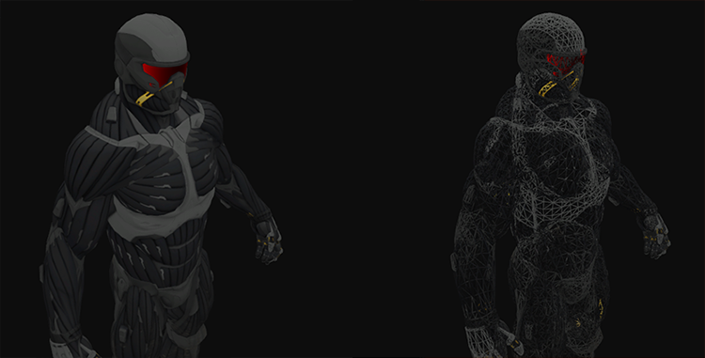

*You can find the complete source code*[*here*](https://learnopengl.com/code_viewer_gh.php?code=src/3.model_loading/1.model_loading/model_loading.cpp)*.*

*We could also get more creative and introduce two point lights to the render equation as we learned from the*[*Lighting*](https://learnopengl.com/#!Lighting/Light-casters)*tutorials and together with specular maps get amazing results:*

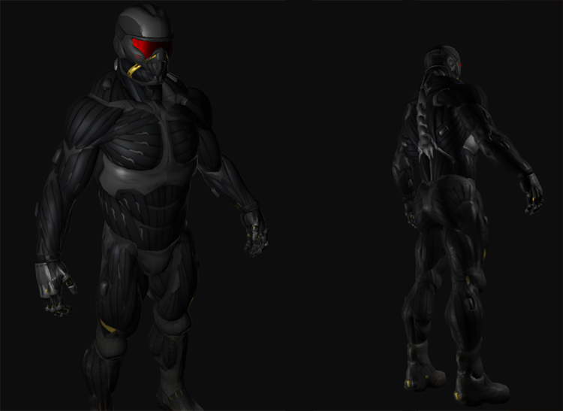

*Even I have to admit that this is maybe a bit more fancy than the containers we've used so far. Using Assimp you can load tons of models found over the internet. There are quite a few resource websites that offer free 3D models for you to download in several file formats. Do note that some models still won't load properly, have texture paths that won't work or might simply be exported in a format even Assimp can't read.*

# *Advanced OpenGL*

[*https://learnopengl.com/#!Advanced-OpenGL/Depth-testing*](https://learnopengl.com/#!Advanced-OpenGL/Depth-testing)

## ***Depth testing***

*In the*[*coordinate systems*](https://learnopengl.com/#!Getting-started/Coordinate-Systems)*tutorial we've rendered a 3D container and made use of a depth buffer to prevent faces rendering to the front while they're behind other faces. In this tutorial we're going to elaborate a bit more on these depth values the depth buffer (or z-buffer) is storing and how it actually determines if a fragment is indeed behind other fragments.*

*The depth-buffer is a buffer that, just like the color buffer (that stores all the fragment colors: the visual output), stores information per fragment and (usually) has the same width and height as the color buffer. The depth buffer is automatically created by the windowing system and stores its depth values as 16, 24 or 32 bit floats. In most systems you'll see a depth buffer with a precision of 24 bits.*

*When depth testing is enabled OpenGL tests the depth value of a fragment against the content of the depth buffer. OpenGL performs a depth test and if this test passes, the depth buffer is updated with the new depth value. If the depth test fails, the fragment is discarded.*

*Depth testing is done in screen space after the fragment shader has run (and after stencil testing has run which we'll discuss in the*[*next*](https://learnopengl.com/#!Advanced-OpenGL/Stencil-testing)*tutorial). The screen space coordinates relate directly to the viewport defined by OpenGL's glViewport function and can be accessed via GLSL's built-in gl_FragCoord variable in the fragment shader. // структура GLSL // The x and y components of gl_FragCoord represent the fragment's screen-space coordinates (with (0,0) being the bottom-left corner). The gl_FragCoord also contains a z-component which contains the actual depth value of the fragment. This z value is the value that is compared to the depth buffer's content.*

*Today most GPUs support a hardware feature called early depth testing. Early depth testing allows the depth test to run before the fragment shader runs. Wherever it is clear a fragment is never going to be visible (it is behind other objects) we can prematurely discard the fragment.   
  
Fragment shaders are usually quite expensive so wherever we can avoid running them we should. A restriction on the fragment shader for early depth testing is that you shouldn't write to the fragment's depth value. If a fragment shader would write to its depth value, early depth testing is impossible; OpenGL won't be able to figure out the depth value before hand.*

*Depth testing is disabled by default so to enable depth testing we need to enable it with the GL_DEPTH_TEST option:*

*glEnable(GL_DEPTH_TEST);*

*Once enabled OpenGL automatically stores fragments their z-values in the depth buffer if they passed the depth test and discards fragments if they failed the depth test accordingly. If you have depth testing enabled you should also clear the depth buffer before each render iteration using the GL_DEPTH_BUFFER_BIT, otherwise you're stuck with the written depth values from last render iteration:*

*glClear(GL_COLOR_BUFFER_BIT | GL_DEPTH_BUFFER_BIT);*

*There are certain scenarios imaginable where you want to perform the depth test on all fragments and discard them accordingly, but****not****update the depth buffer. Basically, you're using a read-only depth buffer. OpenGL allows us to disable writing to the depth buffer by setting its depth mask to GL_FALSE:*

*glDepthMask(GL_FALSE); // спецыяльны сцэнар, дзе мы не хочам абнаўляць буфер глыбінь, але хочам проста правесці тэст на глыбіні //*

*Note that this only has effect if depth testing is enabled.*

### ***Depth test function***

*OpenGL allows us to modify the comparison operators it uses for the depth test. This allows us to control when OpenGL should pass or discard fragments and when to update the depth buffer. We can set the comparison operator (or depth function) by calling glDepthFunc:*

*glDepthFunc(GL_LESS);*

*The function accepts several comparison operators that are listed in the table below:*

|  |  |
| --- | --- |
| ***Function*** | ***Description*** |
| *GL_ALWAYS* | *The depth test always passes.* |
| *GL_NEVER* | *The depth test never passes.* |
| *GL_LESS* | *Passes if the fragment's depth value is less than the stored depth value.* |
| *GL_EQUAL* | *Passes if the fragment's depth value is equal to the stored depth value.* |
| *GL_LEQUAL* | *Passes if the fragment's depth value is less than or equal to the stored depth value.* |
| *GL_GREATER* | *Passes if the fragment's depth value is greater than the stored depth value.* |
| *GL_NOTEQUAL* | *Passes if the fragment's depth value is not equal to the stored depth value.* |
| *GL_GEQUAL* | *Passes if the fragment's depth value is greater than or equal to the stored depth value.* |

*By default the depth function GL_LESS is used that discards all the fragments that have a depth value higher than or equal to the current depth buffer's value.*

*Let's show the effect that changing the depth function has on the visual output. We'll use a fresh code setup that displays a basic scene with two textured cubes sitting on a textured floor with no lighting. You can find the source code*[*here*](https://learnopengl.com/code_viewer_gh.php?code=src/4.advanced_opengl/1.1.depth_testing/depth_testing.cpp)*.*

*Within the source code we changed the depth function to GL_ALWAYS:*

*glEnable(GL_DEPTH_TEST);*

*glDepthFunc(GL_ALWAYS);*

*This simulates the same behavior we get if we didn't enable depth testing. The depth test simply always passes so the fragments that are drawn last are rendered in front of the fragments that were drawn before, even though they should've been at the front. Since we've drawn the floor plane as last the plane's fragments overwrite each of the container's fragments:*

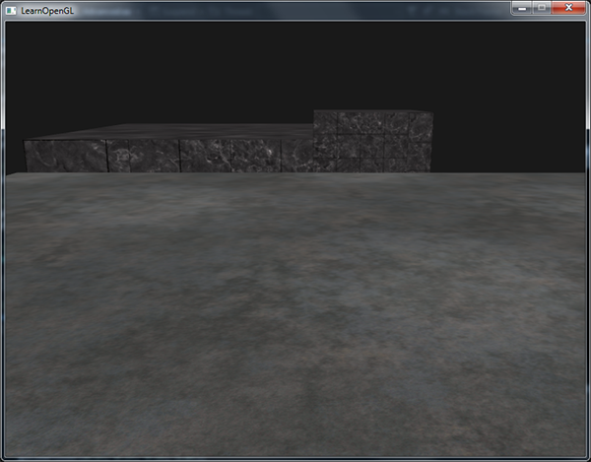

*Setting it all back to GL_LESS gives us the type of scene we're used to:*

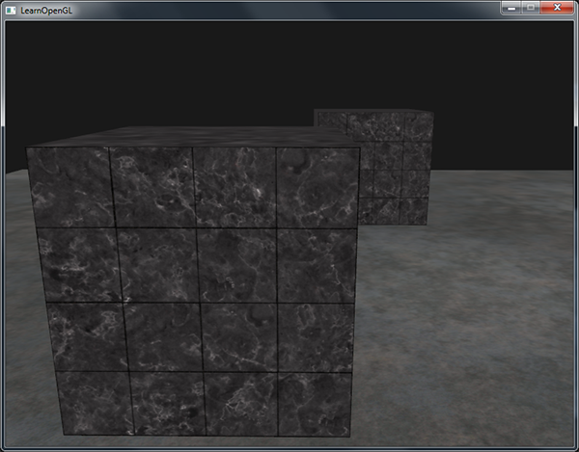

*// зараз мне стала ўсё зразумела. Усё менавіта так. Толькі тэкстуру нешта не атрымалася нарамальна запампаваць. //*

### ***Depth value precision***

*The depth buffer contains depth values between 0.0 and 1.0 and it compares its content with z-value of all the objects in the scene as seen from the viewer. These z-values in view space can be any value between the projection frustum's near and far value. We thus need some way to transform these view-space z-values to the range of [0,1] and one way is to linearly transform them to the [0,1] range. The following (linear) equation then transforms the z-value to a depth value between 0.0 and 1.0:*

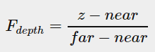

*Here near and far are the near and far values we used to provide to the projection matrix to set the visible frustum (see*[*coordinate Systems*](https://learnopengl.com/#!Getting-started/Coordinate-Systems)*). The equation takes a depth value z within the frustum and transforms it to the range [0,1]. The relation between the z-value and its corresponding depth value is presented in the following graph:*

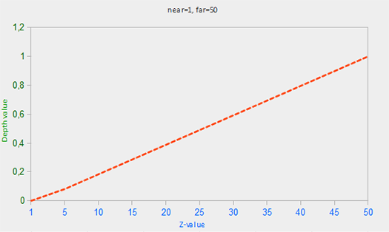

*Note that all equations give a depth value close to 0.0 when the object is close by and a depth value close to 1.0 when the object is close to the far plane.*

*In practice however, a linear depth buffer like this is almost never used. For correct projection properties a non-linear depth equation is used that is proportional to 1/z. What this basically does is give us enormous precision when z is small and much less precision when z is far away. Think about this for a second: do we really want the depth values that are 1000 units away to have the same precision as highly-detailed objects at a distance of 1? The linear equation doesn't take this into account.*

*Since the non-linear function is proportional to 1/z, z-values between 1.0 and 2.0 for example would result in depth values between 1.0 and 0.5 which is half of the precision a float provides us, giving us enormous precision at small z-values. Z-values between 50.0 and 100.0 would account for only 2% of the float's precision, this is exactly what we want. Such an equation, that also takes near and far distances into account, is given below:*

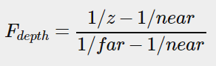

*Don't worry if you don't know exactly what is going on with this equation. The important thing to remember is that the values in the depth buffer are not linear in screen-space (they are linear in view-space before the projection matrix is applied). A value of 0.5 in the depth buffer does not mean the object's z-values are halfway in the frustum; the z-value of the vertex is actually quite close to the near plane! You can see the non-linear relation between the z-value and the resulting depth buffer's value in the following graph:*

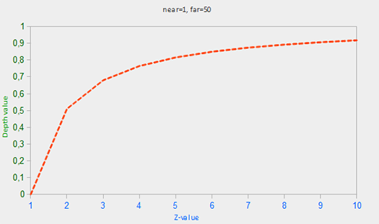

*As you can see, the depth values are greatly determined by the small z-values thus giving us enormous depth precision to the objects close by. The equation to transform z-values (from the viewer's perspective) is embedded within the projection matrix so when we transform vertex coordinates from view to clip and then to screen-space the non-linear equation is applied. If you're curious as to what the projection matrix actually does in detail I suggest the following*[*great article*](http://www.songho.ca/opengl/gl_projectionmatrix.html)

*The effect of this non-linear equation quickly becomes apparent when we try to visualize the depth buffer.*

### ***Visualizing the depth buffer***

*We know that the z-value of the built-in gl_FragCoord vector in the fragment shader contains the depth value of that particular fragment. If we were to output this depth value of the fragment as a color we could display the depth values of all the fragments in the scene. We can do this by returning a color vector based on the fragment's depth value:*

***void*** *main()*

*{*

*FragColor = vec4(vec3(gl_FragCoord.z), 1.0);*

*}*

*If you'd then run the same program again you'll probably notice that everything is white, making it look like all of our depth values are 1.0 which is the maximum depth value. So why aren't any of the depth values closer to 0.0 and thus darker? // менавіта так. Усё белае-белае //*

*You might remember from the previous section that the depth values in screen space are non-linear e.g. they have a very high precision for small z-values and a low precision for large z-values. The depth value of the fragment increases rapidly over distance so almost all the vertices have values close to 1.0. If we were to carefully move really close to objects you might eventually see the colors getting darker, showing that their z-values are becoming smaller: // усё цудоўна атрымалася! //*

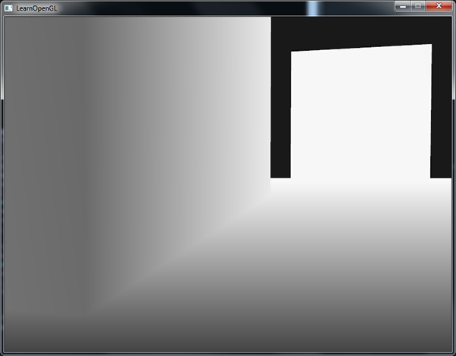

*This clearly shows the non-linearity of the depth value. Objects close by have a much larger effect on the depth value than objects far away. Only moving a few inches results in the colors going from dark to completely white.*

*We can however, transform the non-linear depth values of the fragment back to their linear siblings. To achieve this we basically need to reverse the process of projection for the depth values alone. This means we have to first re-transform the depth values from the range [0,1] to normalized device coordinates in the range [-1,1] (clip space). Then we want to reverse the non-linear equation (equation 2) as done in the projection matrix and apply this inversed equation to the resulting depth value. The result is then a linear depth value. Sounds do-able right?*

*First we want to transform the depth value to NDC which is not too difficult:*

***float*** *z = depth * 2.0 - 1.0; // перавод дыяпазону (0,1) у (-1,1) //*

*We then take the resulting z value and apply the inverse transformation to retrieve the linear depth value:*

***float*** *linearDepth = (2.0 * near * far) / (far + near - z * (far - near));*

*This equation is derived from the projection matrix that again uses equation 2 to non-linearize the depth values returning depth values between near and far. This*[*math-heavy article*](http://www.songho.ca/opengl/gl_projectionmatrix.html)*explains the projection matrix in enormous detail for the interested reader; it also shows where the equations come from.*

*The complete fragment shader that transforms the non-linear depth in screen-space to a linear depth value is then as follows:*

*#version 330 core*

***out*** *vec4 FragColor;*

***float*** *near = 0.1;*

***float*** *far = 100.0;*

***float*** *LinearizeDepth(****float*** *depth)*

*{*

***float*** *z = depth * 2.0 - 1.0; // back to NDC*

***return*** *(2.0 * near * far) / (far + near - z * (far - near));*

*}*

***void*** *main()*

*{*

***float*** *depth = LinearizeDepth(gl_FragCoord.z) / far; // divide by far for demonstration*

*FragColor = vec4(vec3(depth), 1.0);*

*}*

*Because the linearized depth values range from near to far most of its values will be above 1.0 and displayed as completely white. By dividing the linear depth value by far in the main function we convert the linear depth value to roughly the range [0, 1]. This way we can gradually see the scene become brighter the closer the fragments are to the projection frustum's far plane, which is better suited for demonstration purposes.*

*If we'd now run the application we get depth values that are actually linear over distance. Try moving around the scene to see the depth values change in a linear fashion.*

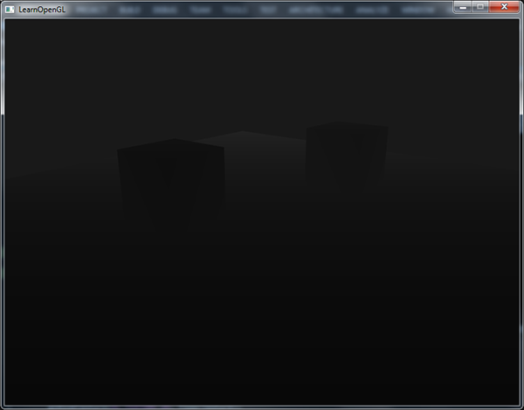

*// усё так. Зараз добра бачна, наколькі неэфектыўная лінейная мадэля z-буфера //*

*The colors are mostly black because the depth values range linearly from the near plane which is 0.1 to the far plane which is 100 that is still quite far away from us. The result is that we're relatively close to the near plane and thus get lower (darker) depth values.*

### ***Z-fighting***

*A common visual artifact might occur when two planes or triangles are so closely aligned to each other that the depth buffer does not have enough precision to figure out which one of the two shapes is in front of the other. The result is that the two shapes continually seem to switch order which causes weird glitchy patterns. This is called z-fighting, because it looks like the shapes are fighting over who gets on top. // шкодны візуальны артэфакт //*

*In the scene we've been using so far there are a few spots where z-fighting is quite noticeable. The containers were placed at the exact height that the floor was placed which means the bottom plane of the container is coplanar with the floor plane. The depth values of both planes are then the same so the resulting depth test has no way of figuring out which is the right one.*

*If you move the camera inside one of the containers the effects are clearly visible, the bottom part of the container is constantly switching between the container's plane and the floor's plane in a zigzag pattern:*

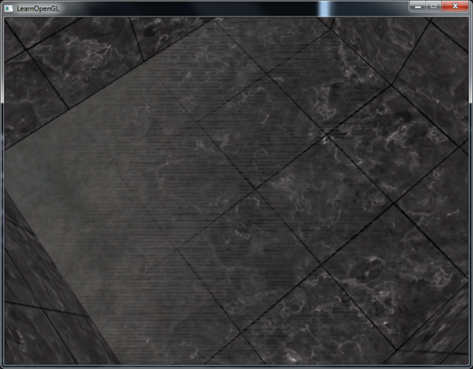

*// ёсць такі эфект! //*

*Z-fighting is a common problem with depth buffers and is generally stronger when objects are at a further distance (because the depth buffer has less precision at larger z-values). Z-fighting can't be completely prevented, but there are generally a few tricks that will help to mitigate or completely prevent z-fighting in your scene.*

#### **Prevent z-fighting**

*The first and most important trick is never place objects too close to each other in a way that some of their triangles closely overlap. By creating a small offset between two objects that is hardly noticeable by a user you'll completely remove z-fighting between the two objects. In the case of the containers and the plane we could've easily moved the containers slightly in the positive y direction. The small change of the container's positions would probably not be noticeable at all and completely reduce the z-fighting. However, this requires manual intervention of each of the objects and thorough testing to make sure no objects in a scene produce z-fighting.*

*A second trick is to set the near plane as far as possible. In one of the previous sections we've discussed that precision is extremely large when close to the near plane so if we move the near plane farther from the viewer, we'll have significantly greater precision over the entire frustum range. However, setting the near plane too far could cause clipping of near objects so it is usually a matter of tweaking and experimentation to figure out the best near distance for your scene. // не да канца зразмеў гэты другі падыход //*

*Another great trick at the cost of some performance is to use a higher precision depth buffer. Most depth buffers have a precision of 24 bits, but most cards nowadays support 32 bit depth buffers which increases the precision by a significant amount. So at the cost of some performance you'll get much more precision with depth testing, reducing z-fighting. // а як гэта робіцца? //*

*The 3 techniques we've discussed are the most common and easy-to-implement anti z-fighting techniques. There are some other techniques out there that require a lot more work and still won't completely disable z-fighting. Z-fighting is a common issue, but if you use the proper combination of the listed techniques you probably won't really need to deal with z-fighting.*

[*https://learnopengl.com/#!Advanced-OpenGL/Stencil-testing*](https://learnopengl.com/#!Advanced-OpenGL/Stencil-testing)

## ***Stencil testing***

*22.10.2017*

*Once the fragment shader has processed the fragment a so called stencil test is executed that, just like the depth test, has the possibility of discarding fragments. Then the remaining fragments get passed to the depth test that could possibly discard even more fragments. The stencil test is based on the content of yet another buffer called the stencil buffer that we're allowed to update during rendering to achieve interesting effects.*

*A stencil buffer (usually) contains 8 bits per stencil value that amounts to a total of 256 different stencil values per pixel/fragment. We can then set these stencil values to values of our liking and then we can discard or keep fragments whenever a particular fragment has a certain stencil value.*

*Each windowing library needs to set up a stencil buffer for you. GLFW does this automatically so we don't have to tell GLFW to create one, but other windowing libraries might not create a stencil library by default so be sure to check your library's documentation.*

*A simple example of a stencil buffer is shown below:*

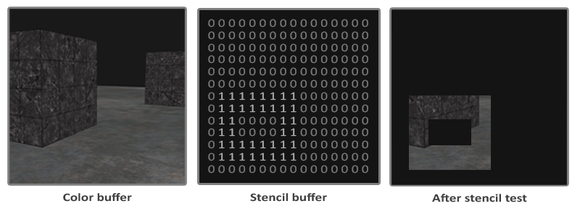

*The stencil buffer is first cleared with zeros and then an open rectangle of 1s is set in the stencil buffer. The fragments of the scene are then only rendered (the others are discarded) wherever the stencil value of that fragment contains a 1.*

*Stencil buffer operations allow us to set the stencil buffer at specific values wherever we're rendering fragments. By changing the content of the stencil buffer while we're rendering, we're writing to the stencil buffer. In the same (or following) render iteration(s) we can then read these values to discard or pass certain fragments. When using stencil buffers you can get as crazy as you like, but the general outline is usually as follows:*

* *Enable writing to the stencil buffer.*
* *Render objects, updating the content of the stencil buffer.*
* *Disable writing to the stencil buffer.*
* *Render (other) objects, this time discarding certain fragments based on the content of the stencil buffer.*

*By using the stencil buffer we can thus discard certain fragments based on the fragments of other drawn objects in the scene.*

*You can enable stencil testing by enabling GL_STENCIL_TEST. From that point on, all rendering calls will influence the stencil buffer in one way or another.*

*glEnable(GL_STENCIL_TEST);*

*Note that you also need to clear the stencil buffer each iteration just like the color and depth buffer:*

*glClear(GL_COLOR_BUFFER_BIT | GL_DEPTH_BUFFER_BIT | GL_STENCIL_BUFFER_BIT);*

*Also, just like the depth testing's glDepthMask function, there is an equivalent function for the stencil buffer. The function glStencilMask allows us to set a bitmask that is ANDed with the stencil value about to be written to the buffer. By default this is set to a bitmask of all 1s unaffecting the output, but if we were to set this to 0x00 all the stencil values written to the buffer end up as 0s. This is equivalent to depth testing's glDepthMask(GL_FALSE):*

*glStencilMask(0xFF); // each bit is written to the stencil buffer as is*

*glStencilMask(0x00); // each bit ends up as 0 in the stencil buffer (disabling writes)*

*Most of the cases you'll just be writing 0x00 or 0xFF as the stencil mask, but it's good to know there are options to set custom bit-masks.*

### ***Stencil functions***

*Just like with depth testing, we have a certain amount of control over when a stencil test should pass or fail and how it should affect the stencil buffer. There are a total of two functions we can use to configure stencil testing: glStencilFunc and glStencilOp.*

*The glStencilFunc(GLenum func, GLint ref, GLuint mask) has three parameters:*

* *func: sets the stencil test function. This test function is applied to the stored stencil value and the glStencilFunc's ref value. Possible options are: GL_NEVER, GL_LESS, GL_LEQUAL, GL_GREATER, GL_GEQUAL, GL_EQUAL, GL_NOTEQUAL and GL_ALWAYS. The semantic meaning of these is similar to the depth buffer's functions.*
* *ref: specifies the reference value for the stencil test. The stencil buffer's content is compared to this value.*
* *mask: specifies a mask that is ANDed with both the reference value and the stored stencil value before the test compares them. Initially set to all 1s. // intbu //*

*So in the case of the simple stencil example we've shown at the start the function would be set to:*

*glStencilFunc(GL_EQUAL, 1, 0xFF)*

*This tells OpenGL that whenever the stencil value of a fragment is equal (GL_EQUAL) to the reference value 1 the fragment passes the test and is drawn, otherwise discarded.*

*But glStencilFunc only described what OpenGL should do with the content of the stencil buffer, not how we can actually update the buffer. That is where glStencilOp comes in.*

*The glStencilOp(GLenum sfail, GLenum dpfail, GLenum dppass) contains three options of which we can specify for each option what action to take:*

* *sfail: action to take if the stencil test fails.*
* *dpfail: action to take if the stencil test passes, but the depth test fails.*
* *dppass: action to take if both the stencil and the depth test pass.*

*Then for each of the options you can take any of the following actions:*

|  |  |
| --- | --- |
| ***Action*** | ***Description*** |
| *GL_KEEP* | *The currently stored stencil value is kept.* |
| *GL_ZERO* | *The stencil value is set to 0.* |
| *GL_REPLACE* | *The stencil value is replaced with the reference value set with glStencilFunc.* |
| *GL_INCR* | *The stencil value is increased by 1 if it is lower than the maximum value.* |
| *GL_INCR_WRAP* | *Same as GL_INCR, but wraps it back to 0 as soon as the maximum value is exceeded.* |
| *GL_DECR* | *The stencil value is decreased by 1 if it is higher than the minimum value.* |
| *GL_DECR_WRAP* | *Same as GL_DECR, but wraps it to the maximum value if it ends up lower than 0.* |
| *GL_INVERT* | *Bitwise inverts the current stencil buffer value.* |

*By default the glStencilOp function is set to (GL_KEEP, GL_KEEP, GL_KEEP) so whatever the outcome of any of the tests, the stencil buffer keeps its values. The default behavior does not update the stencil buffer, so if you want to write to the stencil buffer you need to specify at least one different action for any of the options.*

*So using glStencilFunc and glStencilOp we can precisely specify when and how we want to update the stencil buffer and we can also specify when the stencil test should pass or not e.g. when fragments should be discarded.*

### ***Object outlining***

*It would be unlikely if you completely understood how stencil testing works from the previous sections alone so we're going to demonstrate a particular useful feature that can be implemented with stencil testing alone called object outlining.*

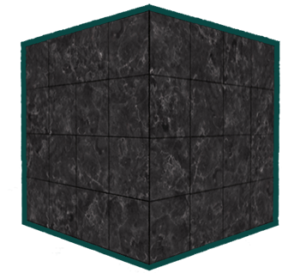

*Object outlining does exactly what it says it does. For each object (or only one) we're creating a small colored border around the (combined) objects. This is a particular useful effect when you want to select units in a strategy game for example and need to show the user which of the units were selected. The routine for outlining your objects is as follows:*

1. *Set the stencil func to GL_ALWAYS before drawing the (to be outlined) objects, updating the stencil buffer with 1s wherever the objects' fragments are rendered.*
2. *Render the objects.*
3. *Disable stencil writing and depth testing.*
4. *Scale each of the objects by a small amount.*
5. *Use a different fragment shader that outputs a single (border) color.*
6. *Draw the objects again, but only if their fragments' stencil values are not equal to 1.*
7. *Enable stencil writing and depth testing again.*

*This process sets the content of the stencil buffer to 1s for each of the object's fragments and when we want to draw the borders, we basically draw scaled-up versions of the objects and wherever the stencil test passes, the scaled-up version is drawn which is around the borders of the object. We're basically discarding all the fragments of the scaled-up versions that are part of the original objects' fragments using the stencil buffer.*

*So we're first going to create a very basic fragment shader that outputs a border color. We simply set a hardcoded color value and call the shader shaderSingleColor:*

***void*** *main()*

*{*

*FragColor = vec4(0.04, 0.28, 0.26, 1.0);*

*}*

*We're only going to add object outlining to the two containers so we'll leave the floor out of it. We thus want to first draw the floor, then the two containers (while writing to the stencil buffer) and then we draw the scaled-up containers (while discarding the fragments that write over the previously drawn container fragments).*

*We first want to enable stencil testing and set the actions to take whenever any of the tests succeed or fail:*

*glEnable(GL_DEPTH_TEST);*

*glStencilOp(GL_KEEP, GL_KEEP, GL_REPLACE);*

*If any of the tests fail we do nothing, we simply keep the currently stored value that is in the stencil buffer. If both the stencil test and the depth test succeed however, we want to replace the stored stencil value with the reference value set via glStencilFunc which we later set to 1.*

*We clear the stencil buffer to 0s and for the containers we update the stencil buffer to 1 for each fragment drawn:*

*glStencilFunc(GL_ALWAYS, 1, 0xFF); // all fragments should update the stencil buffer*

*glStencilMask(0xFF); // enable writing to the stencil buffer*

*normalShader.use();*

*DrawTwoContainers();*

*By using the GL_ALWAYS stencil testing function we make sure that each of the containers' fragments update the stencil buffer with a stencil value of 1. Because the fragments always pass the stencil test, the stencil buffer is updated with the reference value wherever we've drawn them.*

*Now that the stencil buffer is updated with 1s where the containers were drawn we're going to draw the upscaled containers, but this time disabling writes to the stencil buffer:*

*glStencilFunc(GL_NOTEQUAL, 1, 0xFF);*

*glStencilMask(0x00); // disable writing to the stencil buffer*

*glDisable(GL_DEPTH_TEST);*

*shaderSingleColor.use();*

*DrawTwoScaledUpContainers();*

*We set the stencil function to GL_NOTEQUAL which makes sure that we're only drawing parts of the containers that are not equal to 1 thus only draw the part of the containers that are outside the previously drawn containers. Note that we also disable depth testing so the scaled up containers e.g. the borders do not get overwritten by the floor.*

*Also make sure to enable the depth buffer again once you're done.*

*The total object outlining routine for our scene will then look something like this:*

*glEnable(GL_DEPTH_TEST);*

*glStencilOp(GL_KEEP, GL_KEEP, GL_REPLACE);*

*glClear(GL_COLOR_BUFFER_BIT | GL_DEPTH_BUFFER_BIT | GL_STENCIL_BUFFER_BIT);*

*glStencilMask(0x00); // make sure we don't update the stencil buffer while drawing the floor*

*normalShader.use();*

*DrawFloor()*

*glStencilFunc(GL_ALWAYS, 1, 0xFF);*

*glStencilMask(0xFF);*

*DrawTwoContainers();*

*glStencilFunc(GL_NOTEQUAL, 1, 0xFF);*

*glStencilMask(0x00);*

*glDisable(GL_DEPTH_TEST);*

*shaderSingleColor.use();*

*DrawTwoScaledUpContainers();*

*glStencilMask(0xFF);*

*glEnable(GL_DEPTH_TEST);*

*As long as you understand the general idea behind stencil testing this fragment of code shouldn't be too hard to understand. Otherwise try to carefully read the previous sections again and try to completely understand what each of the functions does now that you've seen an example of its usage. // цудоўная арыентацыя чытача //*

*The result of this outlining algorithm, in the scene from the*[*depth testing*](https://learnopengl.com/#!Advanced-OpenGL/Depth-testing)*tutorial, then looks like this:*

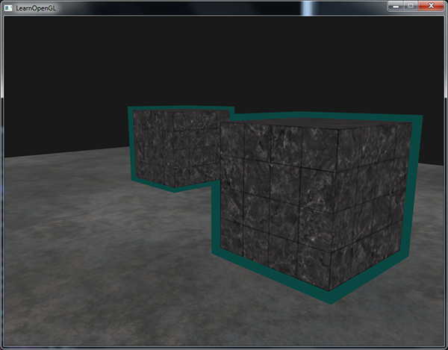

*Check the source code*[*here*](https://learnopengl.com/code_viewer_gh.php?code=src/4.advanced_opengl/2.stencil_testing/stencil_testing.cpp)*to see the complete code of the object outlining algorithm.*

*// у мяне ўсё атрымалася //*

*23/10/2017*

*You can see that the borders overlap between both containers which is usually the effect that we want (think of strategy games where we want to select 10 units; merging borders is usually what we want). If you want a complete border per object you'd have to clear the stencil buffer per object and get a little creative with the depth buffer.*

*The object outlining algorithm you've seen is quite commonly used in several games to visualize selected objects (think of strategy games) and such an algorithm can easily be implemented within a model class. You could then simply set a boolean flag within the model class to draw with borders or without. If you want to be creative you could even give the borders a more natural look with the help of post-processing filters like Gaussian Blur.*

*Stencil testing has many more purposes, beside outlining objects, like drawing textures inside a rear-view mirror so it neatly fits into the mirror shape or rendering real-time shadows with a stencil buffer technique called shadow volumes. Stencil buffers provide us with yet another nice tool in our already extensive OpenGL toolkit.*

[*https://learnopengl.com/#!Advanced-OpenGL/Blending*](https://learnopengl.com/#!Advanced-OpenGL/Blending)

## ***Blending***

*Blending in OpenGL is also commonly known as the technique to implement transparency within objects. Transparency is all about objects (or parts of them) not having a solid color, but having a combination of colors from the object itself and any other object behind it with varying intensity. A colored glass window is a transparent object; the glass has a color of its own, but the resulting color contains the colors of all the objects behind the glass as well. This is also where the name blending comes from, since we blend several colors (of different objects) to a single color. Transparency thus allows us to see through objects.*

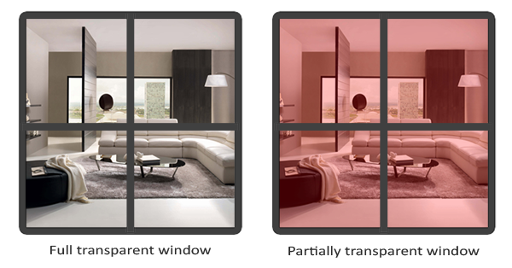

*Transparent objects can be completely transparent (it lets all colors through) or partially transparent (it lets colors through, but also shows some of its own colors). The amount of transparency of an object is defined by its color's alpha value. The alpha color value is the 4th component of a color vector that you've probably seen quite often now. Until this tutorial, we've always kept this 4th component at a value of 1.0 giving the object 0.0 transparency, while an alpha value of 0.0 would result in the object having complete transparency. An alpha value of 0.5 tells us the object's color consist of 50% of its own color and 50% of the colors behind the object.*

*The textures we've used so far all consisted of 3 color components: red, green and blue, but some textures also have an embedded alpha channel that contains an alpha value per texel. This alpha value tells us exactly which parts of the texture have transparency and by how much. For example, the following*[*window texture*](https://learnopengl.com/img/advanced/blending_transparent_window.png)*has an alpha value of 0.25 at its glass part (it would normally be completely red, but since it has 75% transparency it largely shows the website's background through it, making it seem a lot less red) and an alpha value of 0.0 at its corners:*

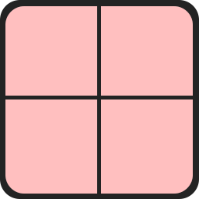

*We'll soon be adding this windowed texture to the scene, but first we'll discuss an easier technique to implement transparency for textures that are either fully transparent or fully opaque.*

### ***Discarding fragments***

*Some images do not care about partial transparency, but either want to show something or nothing at all based on the color value of a texture. Think of grass; to create something like grass with little effort you generally paste a grass texture onto a 2D quad and place that quad into your scene. However, grass isn't exactly shaped like a 2D square so you only want to display some parts of the grass texture and ignore the others.*

*The following texture is exactly such a texture where it either is full opaque (an alpha value of 1.0) or it is fully transparent (an alpha value of 0.0) and nothing in between. You can see that wherever there is no grass, the image shows the website's background color instead of its own.*

**

*So when adding vegetation like grass to your scene we don't want to see a square image of grass, but rather only show the actual grass and be able to see through the rest of the image. We want to discard the fragments that show the transparent parts of the texture, not storing the fragment into the color buffer. Before we get into that we first need to learn how to load a transparent texture.*

*To load textures with alpha values there's not much we need to change. stb_image automatically loads an image's alpha channel if it's available, but we do need to tell OpenGL our texture now uses an alpha channel in the texture generation procedure:*

*glTexImage2D(GL_TEXTURE_2D, 0, GL_RGBA, width, height, 0, GL_RGBA, GL_UNSIGNED_BYTE, data);*

*Also make sure that you retrieve all 4 color components of the texture in the fragment shader, not just the RGB components:*

***void*** *main()*

*{*

*// FragColor = vec4(vec3(texture(texture1, TexCoords)), 1.0);*

*FragColor = texture(texture1, TexCoords);*

*}*

*Now that we know how to load transparent textures it's time to put it to the test by adding several of these leaves of grass throughout the basic scene introduced in the*[*depth testing*](https://learnopengl.com/#!Advanced-OpenGL/Depth-testing)*tutorial.*

*We create a small vector where we add several glm::vec3 variables to represent the location of the grass leaves:*

*vector<glm::vec3> vegetation;*

*vegetation.push_back(glm::vec3(-1.5f, 0.0f, -0.48f));*

*vegetation.push_back(glm::vec3( 1.5f, 0.0f, 0.51f));*

*vegetation.push_back(glm::vec3( 0.0f, 0.0f, 0.7f));*

*vegetation.push_back(glm::vec3(-0.3f, 0.0f, -2.3f));*

*vegetation.push_back(glm::vec3( 0.5f, 0.0f, -0.6f));*

*Each of the grass objects is rendered as a single quad with the grass texture attached to it. It's not a perfect 3D representation of grass, but it's a lot more efficient than actually loading complex models. With a few tricks, like adding several more rotated grass quads at the same position, you can still get good results.*

*Because the grass texture is added to a quad object we'll need to create another VAO again, fill the VBO and set the appropriate vertex attribute pointers. Then after we've drawn the floor and the two cubes we're going to draw the grass leaves:*

*glBindVertexArray(vegetationVAO);*

*glBindTexture(GL_TEXTURE_2D, grassTexture);*

***for****(****unsigned******int*** *i = 0; i < vegetation.size(); i++)*

*{*

*model = glm::mat4();*

*model = glm::translate(model, vegetation[i]);*

*shader.setMat4("model", model);*

*glDrawArrays(GL_TRIANGLES, 0, 6);*

*}*

*Running your application will now probably look a bit like this:*

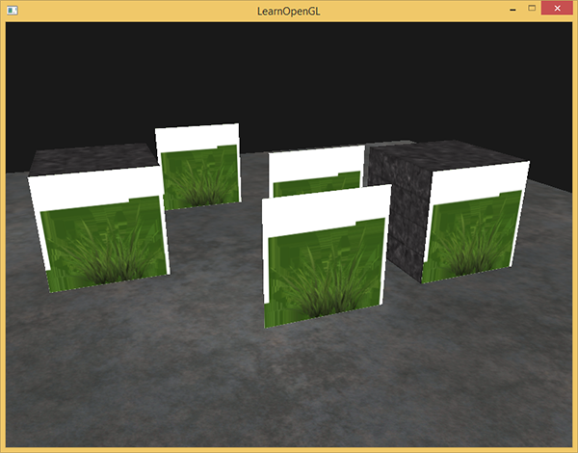

*This happens because OpenGL by default does not know what to do with alpha values, nor when to discard them. We have to manually do this ourselves. Luckily this is quite easy thanks to the use of shaders. GLSL gives us the discard command that (once called) ensures the fragment will not be further processed and thus not end up into the color buffer. Thanks to this command we can check in the fragment shader whether a fragment shader gets an alpha value below a certain threshold and if so, discard the fragment as if it had never been processed:*

*#version 330 core*

***out*** *vec4 FragColor;*

***in*** *vec2 TexCoords;*

***uniform*** *sampler2D texture1;*

***void*** *main()*

*{*

*vec4 texColor = texture(texture1, TexCoords);*

***if****(texColor.a < 0.1)*

*discard;*

*FragColor = texColor;*

*}*

*Here we check if the sampled texture color contains an alpha value lower than a threshold of 0.1 and if so, discard the fragment. This fragment shader ensures us that it only renders fragments that are not (almost) completely transparent. Now it'll look like it should:*

*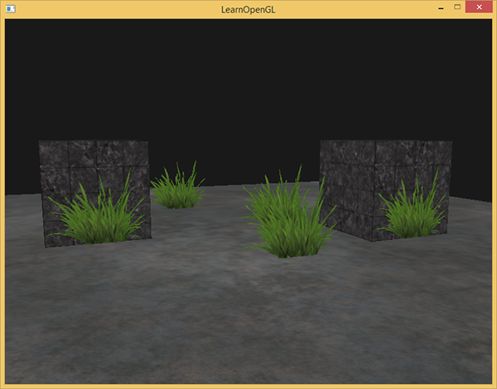Note that when sampling textures at their borders, OpenGL interpolates the border values with the next repeated value of the texture (because we set its wrapping parameters to GL_REPEAT). This is usually okay, but since we're using transparent values, the top of the texture image gets its transparent value interpolated with the bottom border's solid color value. The result is then a slightly semi-transparent colored border you might see wrapped around your textured quad. // intbu problem // To prevent this, set the texture wrapping method to GL_CLAMP_TO_EDGE whenever you use alpha textures:*

*glTexParameteri( GL_TEXTURE_2D, GL_TEXTURE_WRAP_S, GL_CLAMP_TO_EDGE);*

*glTexParameteri( GL_TEXTURE_2D, GL_TEXTURE_WRAP_T, GL_CLAMP_TO_EDGE);*

*You can find the source code*[*here*](https://learnopengl.com/code_viewer_gh.php?code=src/4.advanced_opengl/3.1.blending_discard/blending_discard.cpp)*.*

### ***Blending***

*While discarding fragments is great and all, it doesn't give us the flexibility to render semi-transparent images; we either render the fragment or completely discard it. To render images with different levels of transparency we have to enable blending. Like most of OpenGL's functionality we can enable blending by enabling GL_BLEND:*

*glEnable(GL_BLEND);*

*28.10.2017*

*Now that we've enabled blending we need to tell OpenGL****how****it should actually blend.*

*Blending in OpenGL is done with the following equation:*

**

* *C¯source: the source color vector. This is the color vector that originates from the texture.*
* *C¯destination: the destination color vector. This is the color vector that is currently stored in the color buffer.*
* *Fsource: the source factor value. Sets the impact of the alpha value on the source color.*
* *Fdestination: the destination factor value. Sets the impact of the alpha value on the destination color.*

*After the fragment shader has run and all the tests have passed, this blend equation is let loose on the fragment's color output and with whatever is currently in the color buffer (previous fragment color stored before the current fragment). The source and destination colors will automatically be set by OpenGL, but the source and destination factor can be set to a value of our choosing. Let's start with a simple example:*

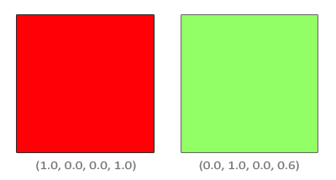

*We have two squares where we want to draw the semi-transparent green square on top of the red square. The red square will be the destination color (and thus should be first in the color buffer) and we are now going to draw the green square over the red square.*

*The question then arises: what do we set the factor values to? Well, we at least want to multiply the green square with its alpha value so we want to set the Fsrc equal to the alpha value of the source color vector which is 0.6. Then it makes sense to let the destination square have a contribution equal to the remainder of the alpha value. If the green square contributes 60% to the final color we want the red square to contribute 40% of the final color e.g. 1.0 - 0.6. So we set the Fdestination equal to one minus the alpha value of the source color vector. The equation thus becomes:*

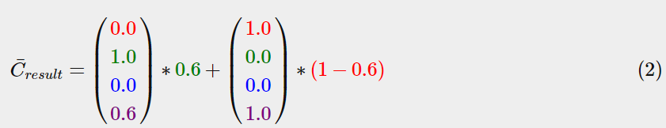

*The result is that the combined square fragments contain a color that is 60% green and 40% red giving a dirty color:*

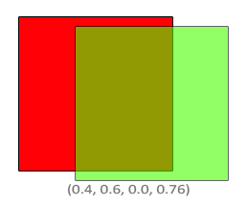

*The resulting color is then stored in the color buffer, replacing the previous color.*

*So this is great and all, but how do we actually tell OpenGL to use factors like these? Well it just so happens that there is a function for this called glBlendFunc.*

*The glBlendFunc(GLenum sfactor, GLenum dfactor) function expects two parameters that set the option for the source and destination factor. OpenGL defined quite a few options for us to set of which we'll list the most common options below. Note that the constant color vector C¯constant can be separately set via the glBlendColor function.*

|  |  |
| --- | --- |
| ***Option*** | ***Value*** |
| *GL_ZERO* | *Factor is equal to 0.* |
| *GL_ONE* | *Factor is equal to 1.* |
| *GL_SRC_COLOR* | *Factor is equal to the source color vector C¯source.* |
| *GL_ONE_MINUS_SRC_COLOR* | *Factor is equal to 1 minus the source color vector: 1−C¯source.* |
| *GL_DST_COLOR* | *Factor is equal to the destination color vector C¯destination* |
| *GL_ONE_MINUS_DST_COLOR* | *Factor is equal to 1 minus the destination color vector: 1−C¯destination.* |
| *GL_SRC_ALPHA* | *Factor is equal to the alpha component of the source color vector C¯source.* |
| *GL_ONE_MINUS_SRC_ALPHA* | *Factor is equal to 1−alpha of the source color vector C¯source.* |
| *GL_DST_ALPHA* | *Factor is equal to the alpha component of the destination color vector C¯destination.* |
| *GL_ONE_MINUS_DST_ALPHA* | *Factor is equal to 1−alpha of the destination color vector C¯destination.* |
| *GL_CONSTANT_COLOR* | *Factor is equal to the constant color vector C¯constant.* |
| *GL_ONE_MINUS_CONSTANT_COLOR* | *Factor is equal to 11 - the constant color vector C¯constant.* |
| *GL_CONSTANT_ALPHA* | *Factor is equal to the alpha component of the constant color vector C¯constant.* |
| *GL_ONE_MINUS_CONSTANT_ALPHA* | *Factor is equal to 1−alpha of the constant color vector C¯constant.* |

*To get the blending result we had from the two squares earlier, we want to take the alpha of the source color vector for the source factor and 1−alpha for the destination factor. This translates to the glBlendFunc as follows:*

*glBlendFunc(GL_SRC_ALPHA, GL_ONE_MINUS_SRC_ALPHA);*

*It is also possible to set different options for the RGB and alpha channel individually using glBlendFuncSeparate:*

*glBlendFuncSeparate(GL_SRC_ALPHA, GL_ONE_MINUS_SRC_ALPHA, GL_ONE, GL_ZERO);*

*This function sets the RGB components as we've set them previously, but only lets the resulting alpha component be influenced by the source's alpha value.*

*OpenGL gives us even more flexibility by allowing us to change the operator between the source and destination part of the equation. Right now, the source and destination components are added together, but we could also subtract them if we want. glBlendEquation(GLenum mode) allows us to set this operation and has 3 possible options:*

* *GL_FUNC_ADD: the default, adds both components to each other: C¯result=Src+Dst.*
* *GL_FUNC_SUBTRACT: subtracts both components from each other: C¯result=Src−Dst.*
* *GL_FUNC_REVERSE_SUBTRACT: subtracts both components, but reverses order: C¯result=Dst−Src.*

*Usually we can simply omit a call to glBlendEquation because GL_FUNC_ADD is the preferred blending equation for most operations, but if you're really trying your best to break the mainstream circuit any of the other equations might suit your needs.*

### ***Rendering semi-transparent textures***

*Now that we know how OpenGL works with regards to blending it's time to put our knowledge to the test by adding several semi-transparent windows. We'll be using the same scene as in the start of this tutorial, but instead of rendering a grass texture we're now going to use the*[*transparent window*](https://learnopengl.com/img/advanced/blending_transparent_window.png)*texture from the start of this tutorial.*

*First, during initialization we enable blending and set the appropriate blending function:*

*glEnable(GL_BLEND);*

*glBlendFunc(GL_SRC_ALPHA, GL_ONE_MINUS_SRC_ALPHA);*

*Since we enabled blending there is no need to discard fragments so we'll reset the fragment shader to its original version:*

*#version 330 core*

***out*** *vec4 FragColor;*

***in*** *vec2 TexCoords;*

***uniform*** *sampler2D texture1;*

***void*** *main()*

*{*

*FragColor = texture(texture1, TexCoords);*

*}*

*// вось у чым заключаецца аўтаматызм блендзінга //*

*This time (whenever OpenGL renders a fragment) it combines the current fragment's color with the fragment color currently in the color buffer based on its alpha value. Since the glass part of the window texture is semi-transparent we should be able to see the rest of the scene by looking through this window.*

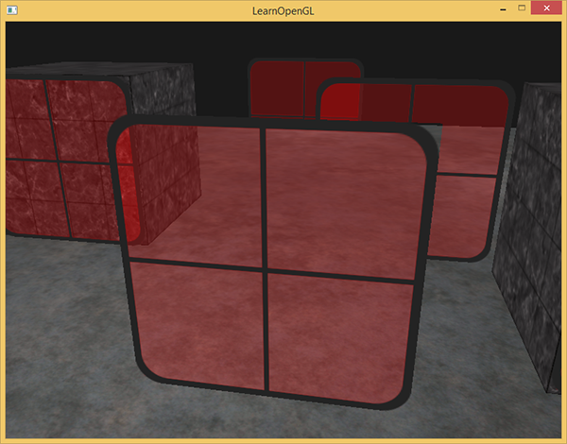

*If you take a closer look however, you might notice something is off. The transparent parts of the front window are occluding the windows in the background. Why is this happening?*

*The reason for this is that depth testing works a bit tricky combined with blending. When writing to the depth buffer, the depth test does not care if the fragment has transparency or not so the transparent parts are written to the depth buffer as any other value. The result is that the entire quad of the window is checked for depth testing regardless of transparency. Even though the transparent part should show the windows behind it, the depth test discards them.*

*So we cannot simply render the windows however we want and expect the depth buffer to solve all our issues for us; this is also where blending gets a little nasty. To make sure the windows show the windows behind them, we have to draw the windows in the background first. This means we have to manually sort the windows from furthest to nearest and draw them accordingly ourselves.*

*Note that with fully transparent objects like the grass leaves we have the option to simply discard the transparent fragments instead of blending them, saving us a few of these headaches (no depth issues).*

### ***Don't break the order***

*To make blending work for multiple objects we have to draw the farthest object first and the closest object as last. The normal non-blended objects can still be drawn as normal using the depth buffer so they don't have to be sorted. We do have to make sure those are drawn first before drawing the (sorted) transparent objects. When drawing a scene with non-transparent and transparent objects the general outline is usually as follows:*

1. *Draw all opaque objects first.*
2. *Sort all the transparent objects.*
3. *Draw all the transparent objects in sorted order.*

*One way of sorting the transparent objects is to retrieve the distance of an object from the viewer's perspective. This can be achieved by taking the distance between the camera's position vector and the object's position vector. We then store this distance together with the corresponding position vector in a map data structure from the STL library. A map automatically sorts its values based on its keys, so once we've added all positions with their distance as the key they're automatically sorted on their distance value:*

*std::map<****float****, glm::vec3> sorted;*

***for*** *(****unsigned******int*** *i = 0; i < windows.size(); i++)*

*{*

***float*** *distance = glm::length(camera.Position - windows[i]);*

*sorted[distance] = windows[i];*

*}*

*The result is a sorted container object that stores each of the window positions based on their distance key value from lowest to highest distance.*

*Then, this time when rendering, we take each of the map's values in reverse order (from farthest to nearest) and then draw the corresponding windows in correct order:*

***for****(std::map<****float****,glm::vec3>::reverse_iterator it = sorted.rbegin(); it != sorted.rend(); ++it)*

*{*

*model = glm::mat4();*

*model = glm::translate(model, it->second);*

*shader.setMat4("model", model);*

*glDrawArrays(GL_TRIANGLES, 0, 6);*

*}*

*We take a reverse iterator from the map to iterate through each of the items in reverse order and then translate each window quad to the corresponding window position. This relatively simple approach to sorting transparent objects fixes the previous problem and now the scene looks like this:*

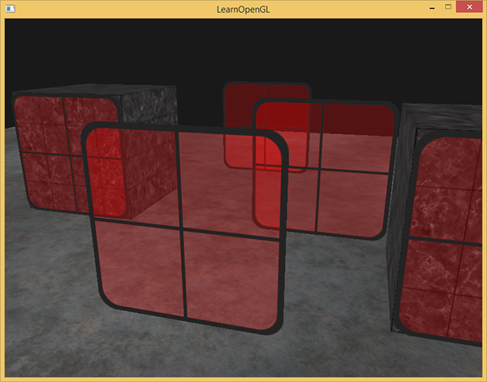

*You can find the complete source code with sorting*[*here*](https://learnopengl.com/code_viewer_gh.php?code=src/4.advanced_opengl/3.2.blending_sort/blending_sorted.cpp)*.*

*While this approach of sorting the objects by their distance works well for this specific scenario, it doesn't take rotations, scaling or any other transformation into account and weirdly shaped objects need a different metric than simply a position vector.*

*Sorting objects in your scene is a difficult feat that depends greatly on the type of scene you have, let alone the extra processing power it costs. Completely rendering a scene with solid and transparent objects isn't all that easy. There are more advanced techniques like order independent transparency but these are out of the scope of this tutorial. For now you'll have to live with normally blending your objects, but if you're careful and know the limitations you can still get fairly decent blending implementations.*

*// кропка пашырэння ведаў з цьютарала //*

[*https://learnopengl.com/#!Advanced-OpenGL/Face-culling*](https://learnopengl.com/#!Advanced-OpenGL/Face-culling)

## ***Face culling***

*Try mentally visualizing a 3D cube and count the maximum number of faces you'll be able to see from any direction. If your imagination is not too creative you probably ended up with a maximum number of 3. You can view a cube from any position and/or direction, but you would never be able to see more than 3 faces. So why would we waste the effort of actually drawing those other 3 faces that we can't even see. If we could discard those in some way we would save more than 50% of fragment shader runs!*

*We say more than 50% instead of 50%, because from certain angles only 2 or even 1 face could be visible. In that case we'd save****more****than 50%.*

*This is a really great idea, but there's one problem we need to solve: how do we know if a face of an object is not visible from the viewer's point of view?   
If we imagine any closed shape, each of its faces has two sides. Each side would either face the user or show its back to the user. What if we could only render the faces that are facing the viewer?*

*This is exactly what face culling does. OpenGL checks all the faces that are front facing towards the viewer and renders those while discarding all the faces that are back facing saving us a lot of fragment shader calls (those are expensive!). We do need to tell OpenGL which of the faces we use are actually the front faces and which faces are the back faces. OpenGL uses a clever trick for this by analyzing the winding order of the vertex data.*

### ***Winding order***

*When we define a set of triangle vertices we're defining them in a certain winding order that is either clockwise or counter-clockwise. Each triangle consists of 3 vertices and we specify those 3 vertices in a winding order as seen from the center of the triangle.*

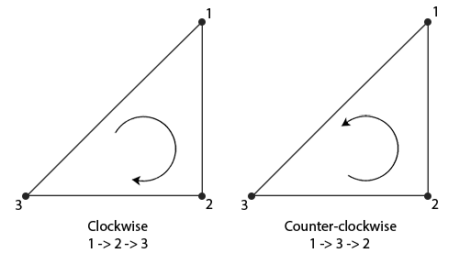

*As you can see in the image we first define the vertex 1 and then we can either define vertex 2 or 3 and this choice defines the winding order of this triangle. The following code illustrates this:*

***float*** *vertices[] = {*

*// clockwise*

*vertices[0], // vertex 1*

*vertices[1], // vertex 2*

*vertices[2], // vertex 3*

*// counter-clockwise*

*vertices[0], // vertex 1*

*vertices[2], // vertex 3*

*vertices[1] // vertex 2*

*};*

*Each set of 3 vertices that form a triangle primitive thus contain a winding order. OpenGL uses this information when rendering your primitives to determine if a triangle is a front-facing or a back-facing triangle. By default, triangles defined with counter-clockwise vertices are processed as front-facing triangles.*

*When defining your vertex order you visualize the corresponding triangle as if it was facing you, so each triangle that you're specifying should be counter-clockwise as if you're directly facing that triangle. The cool thing about specifying all your vertices like this is that the actual winding order is calculated at the rasterization stage, so when the vertex shader has already run. The vertices are then seen as from the****viewer's point of view****.*

*All the triangle vertices that the viewer is then facing are indeed in the correct winding order as we specified them, but the vertices of the triangles at the other side of the cube are now rendered in such a way that their winding order becomes reversed. The result is that the triangles we're facing are seen as front-facing triangles and the triangles at the back are seen as back-facing triangles. The following image shows this effect:*

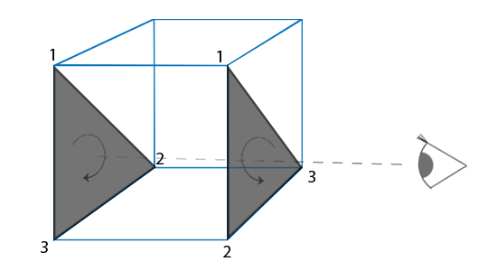

*In the vertex data we would've defined both triangles in counter-clockwise order (the front triangle as 1, 2, 3 and the back triangle as 1, 2 and 3 as well (if we'd see the triangle from the front)). However, from the viewer's direction the back triangle is rendered clockwise if we draw it in the order of 1, 2 and 3 from the viewer's current point of view. Even though we specified the back triangle in counter-clockwise order, it is now rendered in a clockwise order. This is exactly what we want to cull (discard) non-visible faces!*

### ***Face culling***

*At the start of the tutorial we said that OpenGL is able to discard triangle primitives if they're rendered as back-facing triangles. Now that we know how to set the winding order of the vertices we can start using OpenGL's face culling option which is disabled by default.*

*The cube vertex data we used in the last tutorials wasn't defined with the counter-clockwise winding order in mind, so I updated the vertex data to reflect a counter-clockwise winding order which you can copy from*[*here*](https://learnopengl.com/code_viewer.php?code=advanced/faceculling_vertexdata)*. It's a good practice to try and visualize that these vertices are indeed all defined in a counter-clockwise order for each triangle.*

*To enable face culling we only have to enable OpenGL's GL_CULL_FACE option:*

*glEnable(GL_CULL_FACE);*

*From this point on, all the faces that are not front-faces are discarded (try flying inside the cube to see that all inner faces are indeed discarded). Currently we save over 50% of performance on rendering fragments, but do note that this only works with closed shapes like a cube. We'll have to disable face culling again when we draw the grass leaves from the*[*previous*](https://learnopengl.com/#!Advanced-OpenGL/Blending)*tutorial for example, since their front****and****back face should be visible.*

*OpenGL allows us to change the type of face we want to cull as well. What if we want to cull front faces and not the back faces? We can define this behavior by calling glCullFace:*

*glCullFace(GL_FRONT);*

*The glCullFace function has three possible options:*

* *GL_BACK: Culls only the back faces.*
* *GL_FRONT: Culls only the front faces.*
* *GL_FRONT_AND_BACK: Culls both the front and back faces.*

*The initial value of glCullFace is GL_BACK. Aside from the faces to cull we can also tell OpenGL we'd rather prefer clockwise faces as the front-faces instead of counter-clockwise faces via glFrontFace:*

*glFrontFace(GL_CCW);*

*The default value is GL_CCW that stands for counter-clockwise ordering with the other option being GL_CW which (obviously) stands for clockwise ordering.*

*As a simple test we could reverse the winding order by telling OpenGL that the front-faces are now determined by a clockwise ordering instead of a counter-clockwise ordering:*

*glEnable(GL_CULL_FACE);*

*glCullFace(GL_BACK);*

*glFrontFace(GL_CW);*

*The result is that only the back faces are rendered:*

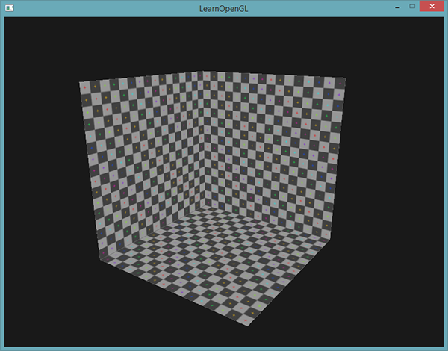

*Note that you can create the same effect by culling front faces with the default counter-clockwise winding order:*

*glEnable(GL_CULL_FACE);*

*glCullFace(GL_FRONT);*

*As you can see, face culling is a great tool for increasing performance of your OpenGL applications with minimal effort. You do have to keep track of which objects will actually benefit from face culling and which objects shouldn't be culled.*

***Exercises***

* *Can you re-define the vertex data by specifying each triangle in clockwise order and then render the scene with clockwise triangles set as the front faces:*[*solution*](https://learnopengl.com/code_viewer.php?code=advanced/faceculling-exercise1)

*// сапраўды, калі робіш кулінг, то грані ўнутры не малююцца //*

[*https://learnopengl.com/#!Advanced-OpenGL/Framebuffers*](https://learnopengl.com/#!Advanced-OpenGL/Framebuffers)

## ***Framebuffers***

*So far we've used several types of screen buffers: a color buffer for writing color values, a depth buffer to write depth information and finally a stencil buffer that allows us to discard certain fragments based on some condition. The combination of these buffers is called a framebuffer and is stored somewhere in memory. OpenGL gives us the flexibility to define our own framebuffers and thus define our own color and optionally a depth and stencil buffer.*

*The rendering operations we've done so far were all done on top of the render buffers attached to the default framebuffer. The default framebuffer is created and configured when you create your window (GLFW does this for us). By creating our own framebuffer we can get an additional means to render to.*

*The application of framebuffers might not immediately make sense, but rendering your scene to a different framebuffer allows us to create mirrors in a scene or do cool post-processing effects for example. First we'll discuss how they actually work and then we'll use them by implementing those cool post-processing effects. // важнае паняцце OpenGL //*

### ***Creating a framebuffer***

*Just like any other object in OpenGL we can create a framebuffer object (abbreviated to FBO) by using a function called glGenFramebuffers:*

***unsigned******int*** *fbo;*

*glGenFramebuffers(1, &fbo);*

*This pattern of object creation and usage is something we've seen dozens of times now so their usage functions are similar to all the other object's we've seen; first we create a framebuffer object, bind it as the active framebuffer, do some operations and unbind the framebuffer. To bind the framebuffer we use glBindFramebuffer:*

*glBindFramebuffer(GL_FRAMEBUFFER, fbo);*

*By binding to the GL_FRAMEBUFFER target all the next read and write framebuffer operations will affect the currently bound framebuffer. It is also possible to bind a framebuffer to a read or write target specifically by binding to GL_READ_FRAMEBUFFER or GL_DRAW_FRAMEBUFFER respectively. The framebuffer bound to GL_READ_FRAMEBUFFER is then used for all read operations like glReadPixels and the framebuffer bound to GL_DRAW_FRAMEBUFFER is used as the destination for rendering, clearing and other write operations. Most of the times you won't need to make this distinction though and you generally bind to both with GL_FRAMEBUFFER.*

*Unfortunately, we can't use our framebuffer yet because it is not complete. For a framebuffer to be complete the following requirements have to be satisfied:*

* *We have to attach at least one buffer (color, depth or stencil buffer).*
* *There should be at least one color attachment.*
* *All attachments should be complete as well (reserved memory). // intbu //*
* *Each buffer should have the same number of samples.*

*Don't worry if you don't know what samples are, we'll get to those in a*[*later*](https://learnopengl.com/#!Advanced-OpenGL/Anti-Aliasing)*tutorial.*

*From the requirements it should be clear that we need to create some kind of attachment for the framebuffer and attach this attachment to the framebuffer. After we've completed all requirements we can check if we actually successfully completed the framebuffer by calling glCheckFramebufferStatus with GL_FRAMEBUFFER. It then checks the currently bound framebuffer and returns any of*[*these*](https://www.khronos.org/registry/OpenGL-Refpages/gl4/html/glCheckFramebufferStatus.xhtml)*values found in the specification. If it returns GL_FRAMEBUFFER_COMPLETE we're good to go:*

***if****(glCheckFramebufferStatus(GL_FRAMEBUFFER) == GL_FRAMEBUFFER_COMPLETE)*

*// execute victory dance*

*All subsequent rendering operations will now render to the attachments of the currently bound framebuffer. Since our framebuffer is not the default framebuffer, the rendering commands will have no impact on the visual output of your window. For this reason it is called off-screen rendering while rendering to a different framebuffer. To make sure all rendering operations will have a visual impact on the main window we need to make the default framebuffer active again by binding to 0:*

*glBindFramebuffer(GL_FRAMEBUFFER, 0);*

*When we're done with all framebuffer operations, do not forget to delete the framebuffer object:*

*glDeleteFramebuffers(1, &fbo);*

*Now before the completeness check is executed we need to attach one or more attachments to the framebuffer. An attachment is a memory location that can act as a buffer for the framebuffer, think of it as an image. When creating an attachment we have two options to take: textures or render buffer objects.*

### ***Texture attachments***

*When attaching a texture to a framebuffer, all rendering commands will write to the texture as if it was a normal color/depth or stencil buffer. The advantage of using textures is that the result of all rendering operations will be stored as a texture image that we can then easily use in our shaders.*

*Creating a texture for a framebuffer is roughly the same as a normal texture:*

***unsigned******int*** *texture;*

*glGenTextures(1, &texture);*

*glBindTexture(GL_TEXTURE_2D, texture);*

*glTexImage2D(GL_TEXTURE_2D, 0, GL_RGB, 800, 600, 0, GL_RGB, GL_UNSIGNED_BYTE, NULL);*

*glTexParameteri(GL_TEXTURE_2D, GL_TEXTURE_MIN_FILTER, GL_LINEAR);*

*glTexParameteri(GL_TEXTURE_2D, GL_TEXTURE_MAG_FILTER, GL_LINEAR);*

*The main differences here is that we set the dimensions equal to the screen size (although this is not required) and we pass NULL as the texture's data parameter. For this texture, we're only allocating memory and not actually filling it. Filling the texture will happen as soon as we render to the framebuffer. Also note that we do not care about any of the wrapping methods or mipmapping since we won't be needing those in most cases.*

*If you want to render your whole screen to a texture of a smaller or larger size you need to call glViewport again (before rendering to your framebuffer) with the new dimensions of your texture, otherwise only a small part of the texture or screen would be drawn onto the texture.*

*Now that we've created a texture the last thing we need to do is actually attach it to the framebuffer:*

*glFramebufferTexture2D(GL_FRAMEBUFFER, GL_COLOR_ATTACHMENT0, GL_TEXTURE_2D, texture, 0);*

*The glFrameBufferTexture2D has the following parameters:*

* *target: the framebuffer type we're targeting (draw, read or both).*
* *attachment: the type of attachment we're going to attach. Right now we're attaching a color attachment. Note that the 0 at the end suggests we can attach more than 1 color attachment. We'll get to that in a later tutorial.*
* *textarget: the type of the texture you want to attach.*
* *texture: the actual texture to attach.*
* *level: the mipmap level. We keep this at 0.*

*Aside from the color attachments we can also attach a depth and a stencil texture to the framebuffer object. To attach a depth attachment we specify the attachment type as GL_DEPTH_ATTACHMENT. Note that the texture's format and internal format type should then become GL_DEPTH_COMPONENT to reflect the depth buffer's storage format. To attach a stencil buffer you use GL_STENCIL_ATTACHMENT as the second argument and specify the texture's formats as GL_STENCIL_INDEX.*

*It is also possible to attach both a depth buffer and a stencil buffer as a single texture. Each 32 bit value of the texture then consists for 24 bits of depth information and 8 bits of stencil information. To attach a depth and stencil buffer as one texture we use the GL_DEPTH_STENCIL_ATTACHMENT type and configure the texture's formats to contain combined depth and stencil values. An example of attaching a depth and stencil buffer as one texture to the framebuffer is given below:*

*glTexImage2D(*

*GL_TEXTURE_2D, 0, GL_DEPTH24_STENCIL8, 800, 600, 0,*

*GL_DEPTH_STENCIL, GL_UNSIGNED_INT_24_8, NULL*

*);*

*glFramebufferTexture2D(GL_FRAMEBUFFER, GL_DEPTH_STENCIL_ATTACHMENT, GL_TEXTURE_2D, texture, 0);*

### ***Renderbuffer object attachments***

*Renderbuffer objects were introduced to OpenGL after textures as a possible type of framebuffer attachments, so textures were the only attachments used in the good old days. Just like a texture image, a renderbuffer object is an actual buffer e.g. an array of bytes, integers, pixels or whatever. A renderbuffer object has the added advantage though that it stores its data in OpenGL's native rendering format making it optimized for off-screen rendering to a framebuffer.*

*Renderbuffer objects store all the render data directly into their buffer without any conversions to texture-specific formats, thus making them faster as a writeable storage medium. However, renderbuffer objects are generally write-only, thus you cannot read from them (like with texture-access). It is possible to read from them via glReadPixels though that returns a specified area of pixels from the currently bound framebuffer, but not directly from the attachment itself.*

*Because their data is already in its native format they are quite fast when writing data or simply copying their data to other buffers. Operations like switching buffers are thus quite fast when using renderbuffer objects. The glfwSwapBuffers function we've been using at the end of each render iteration might as well be implemented with renderbuffer objects: we simply write to a renderbuffer image, and swap to the other one at the end. Renderbuffer objects are perfect for these kind of operations. // intbu what kinds of operations //*

*Creating a renderbuffer object looks similar to the framebuffer's code:*

***unsigned******int*** *rbo;*

*glGenRenderbuffers(1, &rbo);*

*And similarly we want to bind the renderbuffer object so all subsequent renderbuffer operations affect the current rbo:*

*glBindRenderbuffer(GL_RENDERBUFFER, rbo);*

*Since renderbuffer objects are generally write-only they are often used as depth and stencil attachments, since most of the time we don't really need to read values from the depth and stencil buffers but still care about depth and stencil testing. We****need****the depth and stencil values for testing, but don't need to sample these values so a renderbuffer object suits this perfectly. When we're not sampling from these buffers, a renderbuffer object is generally preferred since it's more optimized.*

*Creating a depth and stencil renderbuffer object is done by calling the glRenderbufferStorage function:*

*glRenderbufferStorage(GL_RENDERBUFFER, GL_DEPTH24_STENCIL8, 800, 600);*

*Creating a renderbuffer object is similar to texture objects, the difference being that this object is specifically designed to be used as an image, instead of a general purpose data buffer like a texture. Here we've chosen the GL_DEPTH24_STENCIL8 as the internal format, which holds both the depth and stencil buffer with 24 and 8 bits respectively.*

*Last thing left to do is actually attach the renderbuffer object:*

*glFramebufferRenderbuffer(GL_FRAMEBUFFER, GL_DEPTH_STENCIL_ATTACHMENT, GL_RENDERBUFFER, rbo);*

*Renderbuffer objects could provide some optimizations in your framebuffer projects, but it is important to realize when to use renderbuffer objects and when to use textures. The general rule is that if you never need to sample data from a specific buffer, it is wise to use a renderbuffer object for that specific buffer. If you need to someday sample data from a specific buffer like colors or depth values, you should use a texture attachment instead. Performance-wise it doesn't have an enormous impact though.*

### ***Rendering to a texture***

*Now that we know how framebuffers (sort of) work it's time to put them to good use. We're going to render the scene into a color texture attached to a framebuffer object we created and then draw this texture over a simple quad that spans the whole screen. The visual output is then exactly the same as without a framebuffer, but this time it's all printed on top of a single quad. Now why is this useful? In the next section we'll see why.*

*First thing to do is to create an actual framebuffer object and bind it, this is all relatively straightforward:*

***unsigned******int*** *framebuffer;*

*glGenFramebuffers(1, &framebuffer);*

*glBindFramebuffer(GL_FRAMEBUFFER, framebuffer);*

*Next we create a texture image that we attach as a color attachment to the framebuffer. We set the texture's dimensions equal to the width and height of the window and keep its data uninitialized:*

*// generate texture*

***unsigned******int*** *texColorBuffer;*

*glGenTextures(1, &texColorBuffer);*

*glBindTexture(GL_TEXTURE_2D, texColorBuffer);*

*glTexImage2D(GL_TEXTURE_2D, 0, GL_RGB, 800, 600, 0, GL_RGB, GL_UNSIGNED_BYTE, NULL);*

*glTexParameteri(GL_TEXTURE_2D, GL_TEXTURE_MIN_FILTER, GL_LINEAR );*

*glTexParameteri(GL_TEXTURE_2D, GL_TEXTURE_MAG_FILTER, GL_LINEAR);*

*glBindTexture(GL_TEXTURE_2D, 0);*

*// attach it to currently bound framebuffer object*

*glFramebufferTexture2D(GL_FRAMEBUFFER, GL_COLOR_ATTACHMENT0, GL_TEXTURE_2D, texColorBuffer, 0);*

*We also want to make sure OpenGL is able to do depth testing (and optionally stencil testing if you're into that) so we have to make sure to add a depth (and stencil) attachment to the framebuffer as well. Since we'll only be sampling the color buffer and not the other buffers we can create a renderbuffer object for this purpose. Remember that they're a good choice when you're not going to sample from the specific buffer(s)?*

*Creating a renderbuffer object isn't too hard. The only thing we have to remember is that we're creating it as a depth****and*** *stencil attachment renderbuffer object. We set its internal format to GL_DEPTH24_STENCIL8 which is enough precision for our purposes.*

***unsigned******int*** *rbo;*

*glGenRenderbuffers(1, &rbo);*

*glBindRenderbuffer(GL_RENDERBUFFER, rbo);*

*glRenderbufferStorage(GL_RENDERBUFFER, GL_DEPTH24_STENCIL8, 800, 600);*

*glBindRenderbuffer(GL_RENDERBUFFER, 0);*

*Once we've allocated enough memory for the renderbuffer object we can unbind the renderbuffer.*

*Then, as a final step before we can complete the framebuffer, we attach the renderbuffer object to the depth****and****stencil attachment of the framebuffer:*

*glFramebufferRenderbuffer(GL_FRAMEBUFFER, GL_DEPTH_STENCIL_ATTACHMENT, GL_RENDERBUFFER, rbo);*

*Then as a final measure we want to check if the framebuffer is actually complete and if it's not, we print an error message.*

***if****(glCheckFramebufferStatus(GL_FRAMEBUFFER) != GL_FRAMEBUFFER_COMPLETE)*

*std::cout << "ERROR::FRAMEBUFFER:: Framebuffer is not complete!" << std::endl;*

*glBindFramebuffer(GL_FRAMEBUFFER, 0);*

*Then also be sure to unbind the framebuffer to make sure we're not accidentally rendering to the wrong framebuffer.*

*Now that the framebuffer is complete all we need to do to render to the framebuffer's buffers instead of the default framebuffers is simply bind to the framebuffer object. All subsequent rendering commands will then influence the currently bound framebuffer. All the depth and stencil operations will also read from the currently bound framebuffer's depth and stencil attachments if they're available. If you were to omit a depth buffer for example, all depth testing operations will no longer work, because there's not a depth buffer present in the currently bound framebuffer.*

*So, to draw the scene to a single texture we'll have to take the following steps:*

1. *Render the scene as usual with the new framebuffer bound as the active framebuffer.*
2. *Bind to the default framebuffer.*
3. *Draw a quad that spans the entire screen with the new framebuffer's color buffer as its texture.*

*We'll draw the same scene we've used in the*[*depth testing*](https://learnopengl.com/#!Advanced-OpenGL/Depth-testing)*tutorial, but this time with the old-school*[*container*](https://learnopengl.com/img/textures/container.jpg)*texture.*

*To draw the quad we're going to create a fresh set of simple shaders. We're not going to include any fancy matrix transformations since we'll just be supplying the*[*vertex coordinates as normalized device coordinates*](https://learnopengl.com/code_viewer.php?code=advanced/framebuffers_quad_vertices)*so we can directly specify them as the output of the vertex shader. The vertex shader looks like this:*

*#version 330 core*

***layout*** *(location = 0)* ***in*** *vec2 aPos;*

***layout*** *(location = 1)* ***in*** *vec2 aTexCoords;*

***out*** *vec2 TexCoords;*

***void*** *main()*

*{*

*gl_Position = vec4(aPos.x, aPos.y, 0.0, 1.0);*

*TexCoords = aTexCoords;*

*}*

*Nothing too fancy. The fragment shader will be even more basic since the only thing we have to do is sample from a texture:*

*#version 330 core*

***out*** *vec4 FragColor;*

***in*** *vec2 TexCoords;*

***uniform*** *sampler2D screenTexture;*

***void*** *main()*

*{*

*FragColor = texture(screenTexture, TexCoords);*

*}*

*It is then up to you to create and configure a VAO for the screen quad. A render iteration of the framebuffer procedure then has the following structure:*

*// first pass*

*glBindFramebuffer(GL_FRAMEBUFFER, framebuffer);*

*glClearColor(0.1f, 0.1f, 0.1f, 1.0f);*

*glClear(GL_COLOR_BUFFER_BIT | GL_DEPTH_BUFFER_BIT); // we're not using the stencil buffer now*

*glEnable(GL_DEPTH_TEST);*

*DrawScene();*

*// second pass*

*glBindFramebuffer(GL_FRAMEBUFFER, 0); // back to default*

*glClearColor(1.0f, 1.0f, 1.0f, 1.0f);*

*glClear(GL_COLOR_BUFFER_BIT);*

*screenShader.use();*

*glBindVertexArray(quadVAO);*

*glDisable(GL_DEPTH_TEST);*

*glBindTexture(GL_TEXTURE_2D, textureColorbuffer);*

*glDrawArrays(GL_TRIANGLES, 0, 6);*

*There are a few things to note. First, since each framebuffer we're using has its own set of buffers, we want to clear each of those buffers with the appropriate bits set by calling glClear. Second, when drawing the quad, we're disabling depth testing since we don't really care about depth testing because we're drawing a simple quad; we'll have to enable depth testing again when we draw the normal scene though.*

*There are quite some steps that could go wrong here, so if you have no output, try to debug where possible and re-read the relevant sections of the tutorial. If everything did work out successfully you'll get a visual result that looks like this:*

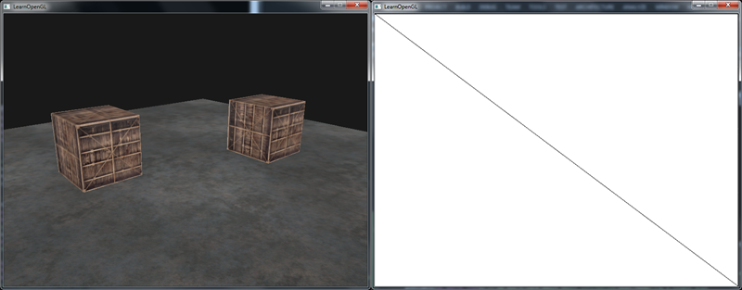

*The left shows the visual output which is exactly the same as we've seen in the*[*depth testing*](https://learnopengl.com/#!Advanced-OpenGL/Depth-testing)*tutorial, but this time, rendered to a simple quad. If we render the scene in wireframe it becomes obvious we've only drawn a single quad in the default framebuffer. // intbu this better //*

*You can find the source code of the application*[*here*](https://learnopengl.com/code_viewer_gh.php?code=src/4.advanced_opengl/5.1.framebuffers/framebuffers.cpp)*.*

*So what was the use of this again? Well, because we can now freely access each of the pixels of the completely rendered scene as a single texture image, we can create some interesting effects in the fragment shader. The combination of all these interesting effects are called post-processing effects.*

*// як я разумею, фрэйм-буфер дае нам тую магчымасць, што мы малюем на сіне цалкам выяву, ане набор трохмерных аб’ектаў. Выяву іх следаў //*

### ***Post-processing***

*Now that the entire scene is rendered to a single texture we can create some interesting effects simply by manipulating the texture data. In this section we'll show you some of the more popular post-processing effects and how you might create your own with some added creativity.*

*Let's start with one of the simplest post-processing effects.*

#### **Inversion**

*// гэтыя эфекты, як я разумею, будуць змяшчацца ў кодзе шэйдэраў //*

*We have access to each of the colors of the render output so it's not so hard to return the inverse of these colors in the fragment shader. We're taking the color of the screen texture and inverse it by subtracting it from 1.0:*

***void*** *main()*

*{*

*FragColor = vec4(vec3(1.0 - texture(screenTexture, TexCoords)), 1.0);*

*}*

*While inversion is a relatively simple post-processing effect it already creates funky results:*

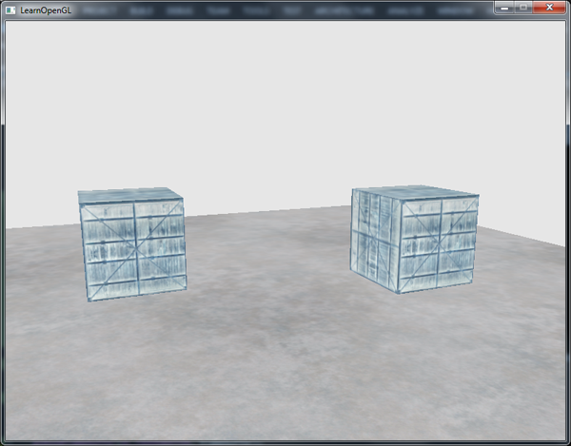

*The entire scene now has all its colors inversed with a single line of code in the fragment shader. Pretty cool huh?*

#### **Grayscale**

*Another interesting effect is to remove all colors from the scene except the white, gray and black colors effectively grayscaling the entire image. An easy way to do this is simply by taking all the color components and averaging their results:*

***void*** *main()*

*{*

*FragColor = texture(screenTexture, TexCoords);*

***float*** *average = (FragColor.r + FragColor.g + FragColor.b) / 3.0;*

*FragColor = vec4(average, average, average, 1.0);*

*}*

*This already creates pretty good results, but the human eye tends to be more sensitive to green colors and the least to blue, so to get the most physically accurate results we'll need to use weighted channels:*

***void*** *main()*

*{*

*FragColor = texture(screenTexture, TexCoords);*

***float*** *average = 0.2126 * FragColor.r + 0.7152 * FragColor.g + 0.0722 * FragColor.b;*

*FragColor = vec4(average, average, average, 1.0);*

*}*

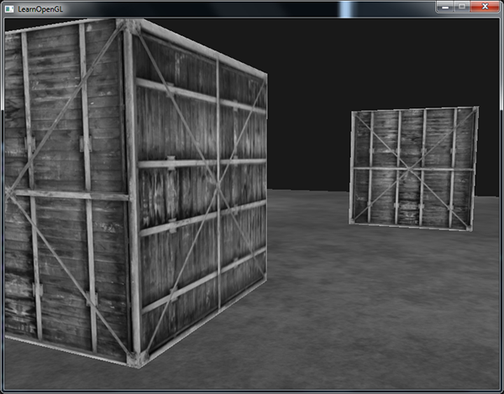

*You probably won't notice the difference right away, but with more complicated scenes, such a weighted grayscaling effect tends to be more realistic.*

### ***Kernel effects***

*Another advantage about doing post-processing on a single texture image is that we can actually sample color values from other parts of the texture. We could for example take a small area around the current texture coordinate and sample multiple texture values around the current texture value. We can then create interesting effects by combining them in creative ways.*

*A kernel (or convolution matrix) is a small matrix-like array of values centered on the current pixel that multiplies surrounding pixel values by its kernel values and adds them all together to form a single value. So basically we're adding a small offset to the texture coordinates in surrounding directions of the current pixel and combine the results based on the kernel. An example of a kernel is given below:*

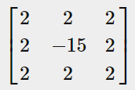

*This kernel takes 8 surrounding pixel values and multiplies them by 2 and the current pixel by -15. This example kernel basically multiplies the surrounding pixels by a weight determined in the kernel and balances the result by multiplying the current pixel by a large negative weight.*

*Most kernels you'll find over the internet all sum up to 1 if you add all the weights together. If they don't add up to 1 it means that the resulting texture color ends brighter or darker than the original texture value.*

*Kernels are an extremely useful tool for post-processing since they're quite easy to use, experiment with and a lot of examples can be found online. We do have to slightly adapt the fragment shader a bit to actually support kernels. We make the assumption that each kernel we'll be using is a 3x3 kernel (which most kernels are):*

***const******float*** *offset = 1.0 / 300.0;*

***void*** *main()*

*{*

*vec2 offsets[9] = vec2[](*

*vec2(-offset, offset), // top-left*

*vec2( 0.0f, offset), // top-center*

*vec2( offset, offset), // top-right*

*vec2(-offset, 0.0f), // center-left*

*vec2( 0.0f, 0.0f), // center-center*

*vec2( offset, 0.0f), // center-right*

*vec2(-offset, -offset), // bottom-left*

*vec2( 0.0f, -offset), // bottom-center*

*vec2( offset, -offset) // bottom-right*

*);*

***float*** *kernel[9] =* ***float****[](*

*-1, -1, -1,*

*-1, 9, -1,*

*-1, -1, -1*

*);*

*vec3 sampleTex[9];*

***for****(****int*** *i = 0; i < 9; i++)*

*{*

*sampleTex[i] = vec3(texture(screenTexture, TexCoords.st + offsets[i]));*

*}*

*vec3 col = vec3(0.0);*

***for****(****int*** *i = 0; i < 9; i++)*

*col += sampleTex[i] * kernel[i];*

*FragColor = vec4(col, 1.0);*

*}*

*In the fragment shader we first create an array of 9 vec2 offsets for each surrounding texture coordinate. The offset is simply a constant value that you could customize to your liking. Then we define the kernel, which in this case is a sharpen kernel that sharpens each color value by sampling all surrounding pixels in an interesting way. Lastly, we add each offset to the current texture coordinate when sampling and then multiply these texture values with the weighted kernel values that we add together.*

*This particular sharpen kernel looks like this:*

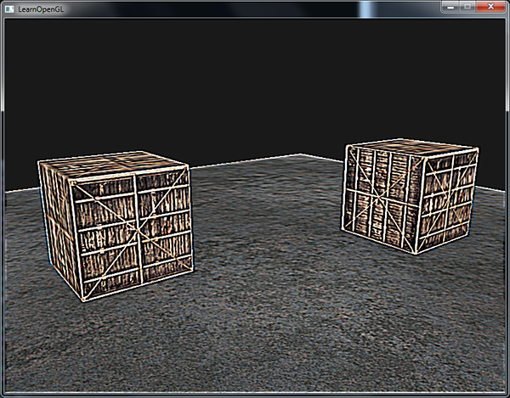

*This could create some interesting effects of where your player might be on a narcotic adventure.*

#### **Blur**

*A kernel that creates a blur effect is defined as follows:*

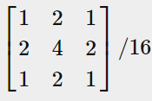

*Because all values add up to 16, simply returning the combined sampled colors would result in an extremely bright color so we have to divide each value of the kernel by 16. The resulting kernel array would then become:*

***float*** *kernel[9] =* ***float****[](*

*1.0 / 16, 2.0 / 16, 1.0 / 16,*

*2.0 / 16, 4.0 / 16, 2.0 / 16,*

*1.0 / 16, 2.0 / 16, 1.0 / 16*

*);*

*By changing the kernel float array in the fragment shader we're completely changing the post-processing effect we're after. It now looks something like this:*

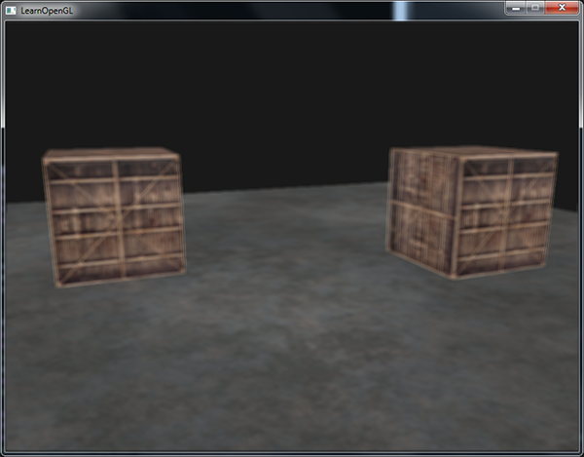

*Such a blur effect creates interesting possibilities. We could vary the blur amount over time for example to create the effect of someone being drunk, or increase the blur whenever the main character is not wearing glasses. Blurring also give us a useful utility to smooth color values which we will use in later tutorials.*

*You can see that once we have such a little kernel implementation in place it is quite easy to create cool post-processing effects. Let's show you a last popular effect to finish this discussion.*

#### **Edge detection**

*Below you can find an edge-detection kernel that is similar to the sharpen kernel:*

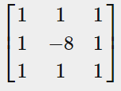

*This kernel highlights all edges and darkens the rest, which is quite useful when we only care about edges in an image.*

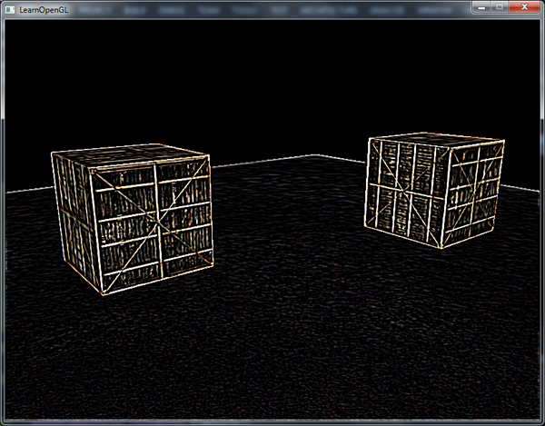

*It probably does not come as a surprise that kernels like this are used as image-manipulating tools/filters in tools like Photoshop. Because of a graphic card's ability to process fragments with extreme parallel capabilities, we can manipulate images on a per-pixel basis in real-time with relative ease. // адметныя рысы графічных картак // Image-editing tools therefore tend to use graphics cards more often for image-processing.*

*// я вывучыў код і магу распавесці паслядоўнасць работы з фрэймбуферам. Мы далучаем да яго тэкстуру, а таксама два другіх буфера. Праводзячы маляванне, мы запаўняем гэту тэкстуру. А потым мы звязваем яе з экранным фрэймбуферам. Пры гэтым і ў першым, і ў другім маляванні мы выкарыстоўваем асобныя VAO, VBO і г.д. //*

[*https://learnopengl.com/#!Advanced-OpenGL/Cubemaps*](https://learnopengl.com/#!Advanced-OpenGL/Cubemaps)

## ***Cubemaps***

*We've been using 2D textures for a while now, but there are even more texture types we haven't explored yet and in this tutorial we'll discuss a texture type that is actually a combination of multiple textures mapped into a single texture: a cube map.*

*A cubemap is basically a texture that contains 6 individual 2D textures that each form one side of a cube: a textured cube. You might be wondering what's the point of such a cube? Why bother with combining 6 individual textures into a single entity instead of just using 6 individual textures? Well, cube maps have the useful property that they can be indexed/sampled using a direction vector. Imagine we have a 1x1x1 unit cube with the origin of a direction vector residing at its center. Sampling a texture value from the cube map with an orange direction vector looks a bit like this:*

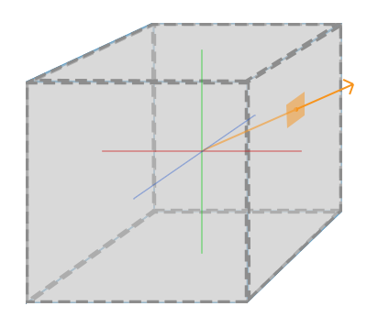

*The magnitude of the direction vector doesn't matter. As long as a direction is supplied, OpenGL retrieves the corresponding texels that the direction hits (eventually) and returns the properly sampled texture value.*

*If we imagine we have a cube shape that we attach such a cubemap to, the direction vector to sample the cubemap would be similar to the (interpolated) vertex position of the cube. This way we can sample the cubemap using the cube's actual position vectors as long as the cube is centered on the origin. We can then retrieve the texture coordinates of all vertices as the vertex positions of the cube. The result is a texture coordinate that accesses the proper individual face texture of the cubemap.*

### ***Creating a cubemap***

*A cubemap is a texture like any other texture so to create one we generate a texture and bind it to the proper texture target before we do any further texture operations. This time binding to GL_TEXTURE_CUBE_MAP:*

***unsigned******int*** *textureID;*

*glGenTextures(1, &textureID);*

*glBindTexture(GL_TEXTURE_CUBE_MAP, textureID);*

*Because a cubemap consists of 6 textures, one for each face, we have to call glTexImage2D six times with their parameters set to values similar to the previous tutorials. This time however, we have to set the texture target parameter to a specific face of the cubemap, basically telling OpenGL which side of the cubemap we're creating a texture for. This means we have to call glTexImage2D once for each face of the cubemap.*

*Since we have 6 faces OpenGL provides us with 6 special texture targets specifically for targeting a face of the cubemap:*

|  |  |
| --- | --- |
| ***Texture target*** | ***Orientation*** |
| *GL_TEXTURE_CUBE_MAP_POSITIVE_X* | *Right* |
| *GL_TEXTURE_CUBE_MAP_NEGATIVE_X* | *Left* |
| *GL_TEXTURE_CUBE_MAP_POSITIVE_Y* | *Top* |
| *GL_TEXTURE_CUBE_MAP_NEGATIVE_Y* | *Bottom* |
| *GL_TEXTURE_CUBE_MAP_POSITIVE_Z* | *Back* |
| *GL_TEXTURE_CUBE_MAP_NEGATIVE_Z* | *Front* |

*Like many of OpenGL's enums, their behind-the-scenes int value is linearly incremented so if we were to have an array or vector of texture locations we could loop over them by starting // структура OpenGL //*

*with GL_TEXTURE_CUBE_MAP_POSITIVE_X and incrementing the enum by 1 each iteration, effectively looping through all the texture targets:*

***int*** *width, height, nrChannels;*

***unsigned******char*** *\*data;*

***for****(****GLuint*** *i = 0; i < textures_faces.size(); i++)*

*{*

*data = stbi_load(textures_faces[i].c_str(), &width, &height, &nrChannels, 0);*

*glTexImage2D(*

*GL_TEXTURE_CUBE_MAP_POSITIVE_X + i,*

*0, GL_RGB, width, height, 0, GL_RGB, GL_UNSIGNED_BYTE, data*

*);*

*}*

*Here we have a vector called textures_faces that contain the locations of all the textures required for the cubemap in the order as given in the table. This generates a texture for each face of the currently bound cubemap.*

*Because a cubemap is a texture like any other texture we will also specify its wrapping and filtering methods:*

*glTexParameteri(GL_TEXTURE_CUBE_MAP, GL_TEXTURE_MAG_FILTER, GL_LINEAR);*

*glTexParameteri(GL_TEXTURE_CUBE_MAP, GL_TEXTURE_MIN_FILTER, GL_LINEAR);*

*glTexParameteri(GL_TEXTURE_CUBE_MAP, GL_TEXTURE_WRAP_S, GL_CLAMP_TO_EDGE);*

*glTexParameteri(GL_TEXTURE_CUBE_MAP, GL_TEXTURE_WRAP_T, GL_CLAMP_TO_EDGE);*

*glTexParameteri(GL_TEXTURE_CUBE_MAP, GL_TEXTURE_WRAP_R, GL_CLAMP_TO_EDGE);*

*Don't be scared by the GL_TEXTURE_WRAP_R, this simply sets the wrapping method for the texture's R coordinate which corresponds to the texture's 3rd dimension (like the z for positions). We set the wrapping method to GL_CLAMP_TO_EDGE since texture coordinates that are exactly between two faces might not hit an exact face (due to some hardware limitations) so by using GL_CLAMP_TO_EDGE OpenGL always return their edge values whenever we sample between faces. // лепей зразумець дадзеную праблему //*

*Then before drawing the objects that will use the cubemap, we activate the corresponding texture unit and bind the cubemap before rendering, not much of a difference compared to normal 2D textures.*

*Within the fragment shader we also have to use a different sampler of the type samplerCube that we sample from using the texture function, but this time using a vec3 direction vector instead of a vec2. An example of fragment shader using a cubemap looks like this: // структура GLSL //*

***in*** *vec3 textureDir; // direction vector representing a 3D texture coordinate*

***uniform*** *samplerCube cubemap; // cubemap texture sampler*

***void*** *main()*

*{*

*FragColor = texture(cubemap, textureDir);*

*}*

*That is still great and all, but why bother? Well, it just so happens that there are quite a few interesting techniques that are a lot easier to implement with a cubemap. One of those techniques is creating a skybox.*

### ***Skybox***

*A skybox is a (large) cube that encompasses the entire scene and contains 6 images of a surrounding environment, giving the player the illusion that the environment he's in is actually much larger than it actually is. Some examples of skyboxes used in videogames are images of mountains, of clouds or of a starry night sky. An example of a skybox, using starry night sky images, can be seen in the following screenshot of the third elder scrolls game:*

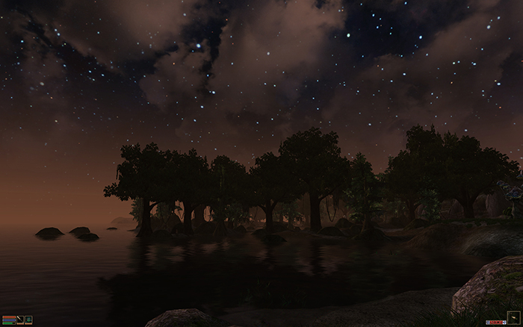

*You probably guessed by now that skyboxes like this suit cubemaps perfectly: we have a cube that has 6 faces and needs to be textured per face. In the previous image they used several images of a night sky to give the illusion the player is in some large universe while he's actually inside a tiny little box.*

*There are usually enough resources online where you could find skyboxes like these. This*[*website*](http://www.custommapmakers.org/skyboxes.php)*for example has plenty of skyboxes. These skybox images usually have the following pattern:*

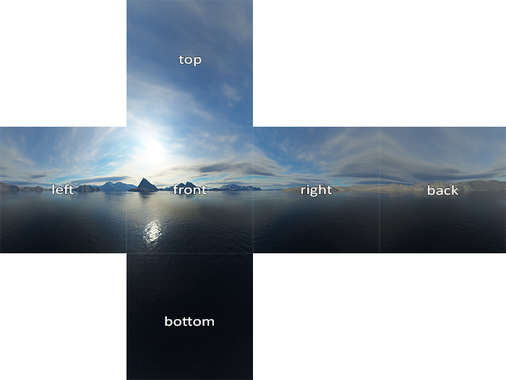

*If you would fold those 6 sides into a cube you'd get the completely textured cube that simulates a large landscape. Some resources provide the skyboxes in a format like this in which case you'd have to manually extract the 6 face images, but in most cases they're provided as 6 single texture images.*

*This particular (high-quality) skybox is what we'll use for our scene and can be downloaded*[*here*](https://learnopengl.com/img/textures/skybox.rar)*.*

#### **Loading a skybox**

*Since a skybox is by itself just a cubemap, loading a skybox isn't too different from what we've seen before. To load the skybox we're going to use the following function that accepts a vector of 6 texture locations:*

***unsigned******int*** *loadCubemap(vector<std::string> faces)*

*{*

***unsigned******int*** *textureID;*

*glGenTextures(1, &textureID);*

*glBindTexture(GL_TEXTURE_CUBE_MAP, textureID);*

***int*** *width, height, nrChannels;*

***for*** *(****unsigned******int*** *i = 0; i < faces.size(); i++)*

*{*

***unsigned******char*** *\*data = stbi_load(faces[i].c_str(), &width, &height, &nrChannels, 0);*

***if*** *(data)*

*{*

*glTexImage2D(GL_TEXTURE_CUBE_MAP_POSITIVE_X + i,*

*0, GL_RGB, width, height, 0, GL_RGB, GL_UNSIGNED_BYTE, data*

*);*

*stbi_image_free(data);*

*}*

***else***

*{*

*std::cout << "Cubemap texture failed to load at path: " << faces[i] << std::endl;*

*stbi_image_free(data);*

*}*

*}*

*glTexParameteri(GL_TEXTURE_CUBE_MAP, GL_TEXTURE_MIN_FILTER, GL_LINEAR);*

*glTexParameteri(GL_TEXTURE_CUBE_MAP, GL_TEXTURE_MAG_FILTER, GL_LINEAR);*

*glTexParameteri(GL_TEXTURE_CUBE_MAP, GL_TEXTURE_WRAP_S, GL_CLAMP_TO_EDGE);*

*glTexParameteri(GL_TEXTURE_CUBE_MAP, GL_TEXTURE_WRAP_T, GL_CLAMP_TO_EDGE);*

*glTexParameteri(GL_TEXTURE_CUBE_MAP, GL_TEXTURE_WRAP_R, GL_CLAMP_TO_EDGE);*

***return*** *textureID;*

*}*

*The function itself shouldn't be too surprising. It is basically all the cubemap code we've seen in the previous section, but combined in a single manageable function.*

*Then before we call this function we'll load the appropriate texture paths in a vector in the order as specified by the cubemap enums:*

*vector<std::string> faces;*

*{*

*"right.jpg",*

*"left.jpg",*

*"top.jpg",*

*"bottom.jpg",*

*"back.jpg",*

*"front.jpg"*

*};*

***unsigned******int*** *cubemapTexture = loadCubemap(faces);*

*We now loaded the skybox as a cubemap with cubemapTexture as its id. We can now bind it to a cube to finally replace the lame clear color we've been using as the background all this time.*

#### **Displaying a skybox**

*Because a skybox is drawn on a cube we'll need another VAO, VBO and a fresh set of vertices like any other object. You can get its vertex data*[*here*](https://learnopengl.com/code_viewer.php?code=advanced/cubemaps_skybox_data)*.*

*A cubemap used to texture a 3D cube can be sampled using the positions of the cube as the texture coordinates. When a cube is centered on the origin (0,0,0) each of its position vectors is also a direction vector from the origin. This direction vector is exactly what we need to get the corresponding texture value at that specific cube's position. For this reason we only need to supply position vectors and don't need texture coordinates.*

*To render the skybox we'll need a new set of shaders which aren't too complicated. Because we only have one vertex attribute the vertex shader is quite simple:*

*#version 330 core*

***layout*** *(location = 0)* ***in*** *vec3 aPos;*

***out*** *vec3 TexCoords;*

***uniform*** *mat4 projection;*

***uniform*** *mat4 view;*

***void*** *main()*

*{*

*TexCoords = aPos;*

*gl_Position = projection * view * vec4(aPos, 1.0);*

*}*

*Note that the interesting part of the vertex shader is that we set the incoming position vectors as the outcoming texture coordinates for the fragment shader. The fragment shader then takes these as input to sample a samplerCube:*

*#version 330 core*

***out*** *vec4 FragColor;*

***in*** *vec3 TexCoords;*

***uniform*** *samplerCube skybox;*

***void*** *main()*

*{*

*FragColor = texture(skybox, TexCoords);*

*}*

*The fragment shader is all relatively straightforward. We take the vertex attribute's position vectors as the texture's direction vector and use those to sample the texture values from the cubemap.*

*Rendering the skybox is easy now that we have a cubemap texture, we simply bind the cubemap texture and the skyboxsampler is automatically filled with the skybox cubemap. To draw the skybox we're going to draw it as the first object in the scene and disable depth writing. This way the skybox will always be drawn at the background of all the other objects.*

*glDepthMask(GL_FALSE);*

*skyboxShader.use();*

*// ... set view and projection matrix*

*glBindVertexArray(skyboxVAO);*

*glBindTexture(GL_TEXTURE_CUBE_MAP, cubemapTexture);*

*glDrawArrays(GL_TRIANGLES, 0, 36);*

*glDepthMask(GL_TRUE);*

*// ... draw rest of the scene*

*If you run this you will get into difficulties though. We want the skybox to be centered around the player so that no matter how far the player moves, the skybox won't get any closer giving the impression the surrounding environment is extremely large. The current view matrix however transforms all the skybox's positions by rotating, scaling and translating them, so if the player moves, the cubemap moves as well! We want to remove the translation part of the view matrix so movement doesn't affect the skybox's position vectors.*

*You might remember from the*[*basic lighting*](https://learnopengl.com/#!Lighting/Basic-Lighting)*tutorial that we could remove the translation section of transformation matrices by taking the upper-left 3x3 matrix of the 4x4 matrix, effectively removing the translation components. We can achieve this by simply converting the view matrix to a 3x3 matrix (removing translation) and converting it back to a 4x4 matrix:*

*glm::mat4 view = glm::mat4(glm::mat3(camera.GetViewMatrix()));*

*This removes any translation, but keeps all rotation transformations so the user can still look around the scene.*

*The result is a scene that instantly looks enormous due to our skybox. If you'd fly around the basic container you immediately get a sense of scale which dramatically improves the realism of the scene. The result looks something like this:*

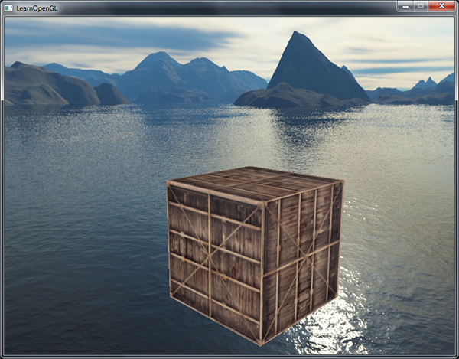

*Try experimenting with different skyboxes and see how they can have an enormous impact on the look and feel of your scene. // важныя аспекты арст //*

### ***An optimization***

*Right now we've rendered the skybox first before we rendered all the other objects in the scene. This works great, but isn't too efficient. If we render the skybox first we're running the fragment shader for each pixel on the screen even though only a small part of the skybox will eventually be visible; fragments that could have easily been discarded using early depth testing saving us valuable bandwidth.*

*So to give us a slight performance boost we're going to render the skybox last. This way, the depth buffer is completely filled with all the objects' depth values so we only have to render the skybox's fragments wherever the early depth test passes, greatly reducing the calls to the fragment shader. The problem is that the skybox will most likely fail to render since it's only a 1x1x1 cube, failing most depth tests. Simply rendering it without depth testing is not a solution since the skybox will then overwrite all the other objects in the scene. We need to trick the depth buffer into believing that the skybox has the maximum depth value of 1.0 so that it fails the depth test wherever there's a different object in front of it.*

*In the*[*coordinate systems*](https://learnopengl.com/#!Getting-started/Coordinate-Systems)*tutorial we said that perspective division is performed after the vertex shader has run, dividing the gl_Position's xyz coordinates by its w component. We also know from the*[*depth testing*](https://learnopengl.com/#!Advanced-OpenGL/Depth-testing)*tutorial that the z component of the resulting division is equal to that vertex's depth value. Using this information we can set the z component of the output position equal to its w component which will result in a z component that is always equal to 1.0, because when the perspective division is applied its z component translates to w / w = 1.0:*

***void*** *main()*

*{*

*TexCoords = aPos;*

*vec4 pos = projection * view * vec4(aPos, 1.0);*

*gl_Position = pos.xyww;*

*}*

*The resulting normalized device coordinates will then always have a z value equal to 1.0: the maximum depth value. The skybox will as a result only be rendered wherever there are no objects visible (only then it will pass the depth test, everything else is in front of the skybox).*

*We do have to change the depth function a little by setting it to GL_LEQUAL instead of the default GL_LESS. The depth buffer will be filled with values of 1.0 for the skybox, so we need to make sure the skybox passes the depth tests with values less than or equal to the depth buffer instead of less than.*

*You can find the more optimized version of the source code*[*here*](https://learnopengl.com/code_viewer_gh.php?code=src/4.advanced_opengl/6.1.cubemaps_skybox/cubemaps_skybox.cpp)*.*

### ***Environment mapping***

*We now have the entire surrounding environment mapped in a single texture object and we could use that information for more than just a skybox. Using a cubemap with an environment, we could give objects reflective or refractive properties. Techniques that use an environment cubemap like this are called environment mapping techniques and the two most popular ones are reflection and refraction.*

#### **Reflection**

*Reflection is the property that an object (or part of an object) reflects its surrounding environment e.g. the object's colors are more or less equal to its environment based on the angle of the viewer. A mirror for example is a reflective object: it reflects its surroundings based on the viewer's angle.*

*The basics of reflection are not that difficult. The following image shows how we can calculate a reflection vector and use that vector to sample from a cubemap:*

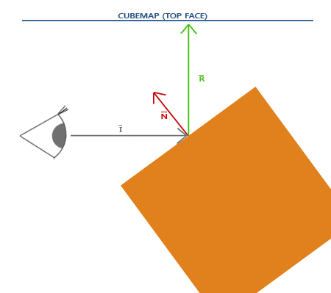

*We calculate a reflection vector R¯ around the object's normal vector N¯ based on the view direction vector I¯. We can calculate this reflection vector using GLSL's built-in reflect function. // структура GLSL // The resulting vector R¯ is then used as a direction vector to index/sample the cubemap returning a color value of the environment. The resulting effect is that the object seems to reflect the skybox.*

*Since we already have a skybox setup in our scene, creating reflections isn't too difficult. We'll change the fragment shader used by the container to give the container reflective properties:*

*#version 330 core*

***out*** *vec4 FragColor;*

***in*** *vec3 Normal;*

***in*** *vec3 Position;*

***uniform*** *vec3 cameraPos;*

***uniform*** *samplerCube skybox;*

***void*** *main()*

*{*

*vec3 I = normalize(Position - cameraPos);*

*vec3 R = reflect(I, normalize(Normal));*

*FragColor = vec4(texture(skybox, R).rgb, 1.0);*

*}*

*We first calculate the view/camera direction vector I and use this to calculate the reflect vector R which we then use to sample from the skybox cubemap. Note that we have the fragment's interpolated Normal and Position variable again so we'll need to adjust the vertex shader as well.*

*#version 330 core*

***layout*** *(location = 0)* ***in*** *vec3 aPos;*

***layout*** *(location = 1)* ***in*** *vec3 aNormal;*

***out*** *vec3 Normal;*

***out*** *vec3 Position;*

***uniform*** *mat4 model;*

***uniform*** *mat4 view;*

***uniform*** *mat4 projection;*

***void*** *main()*

*{*

*Normal = mat3(transpose(inverse(model))) * aNormal;*

*Position = vec3(model * vec4(aPos, 1.0));*

*gl_Position = projection * view * model * vec4(aPos, 1.0);*

*}*

*We're using normal vectors so we'll want to transform them with a normal matrix again. The Position output vector is a world-space position vector. This Position output of the vertex shader is used to calculate the view direction vector in the fragment shader.*

*Because we're using normals you'll want to update the*[*vertex data*](https://learnopengl.com/code_viewer.php?code=lighting/basic_lighting_vertex_data)*and update the attribute pointers as well. Also make sure to set the cameraPos uniform.*

*Then we also want to bind the cubemap texture before rendering the container:*

*glBindVertexArray(cubeVAO);*

*glBindTexture(GL_TEXTURE_CUBE_MAP, skyboxTexture);*

*glDrawArrays(GL_TRIANGLES, 0, 36);*

*Compiling and running your code gives you a container that acts like a perfect mirror. The surrounding skybox is perfectly reflected on the container:*

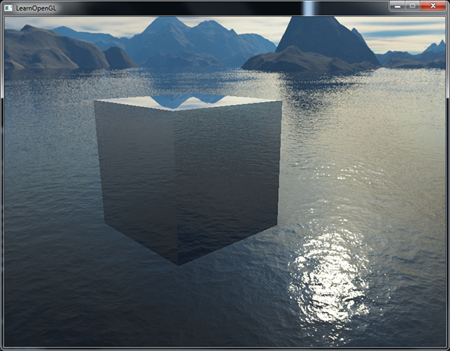

*You can find the full source code*[*here*](https://learnopengl.com/code_viewer_gh.php?code=src/4.advanced_opengl/6.2.cubemaps_environment_mapping/cubemaps_environment_mapping.cpp)*.*

*When reflection is applied to an entire object (like the container) the object looks as if it has a high reflective material like steel or chrome. If we were to load the nanosuit model we used in the*[*model loading*](https://learnopengl.com/#!Model-Loading/Model)*tutorials we'd get the effect that the suit looks to be entirely made out of chrome:*

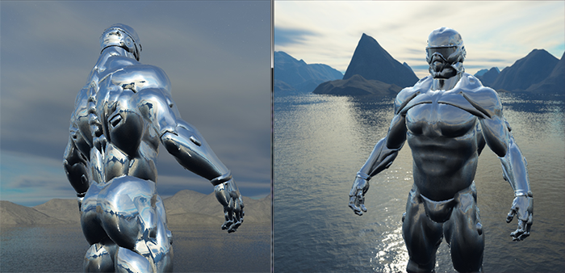

*This looks quite awesome, but in reality most models aren't all completely reflective. We could for example introduce reflection maps that give the models another extra level of detail. Just like diffuse and specular maps, reflection maps are texture images that we can sample to determine the reflectivity of a fragment. Using these reflection maps we can determine which parts of the model show reflection and by what intensity. In the exercise of this tutorial it's up to you to introduce reflection maps in the model loader we created earlier, significantly boosting the detail of the nanosuit model.*

#### **Refraction**

*Another form of environment mapping is called refraction and is similar to reflection. Refraction is the change in direction of light due to the change of the material the light flows through. Refraction is what we commonly see with water-like surfaces where the light doesn't enter straight through, but bends a little. It's like looking at your arm when it's halfway in the water.*

*Refraction is described by*[*Snell's law*](http://en.wikipedia.org/wiki/Snell%27s_law)*that with environment maps looks a bit like this:*

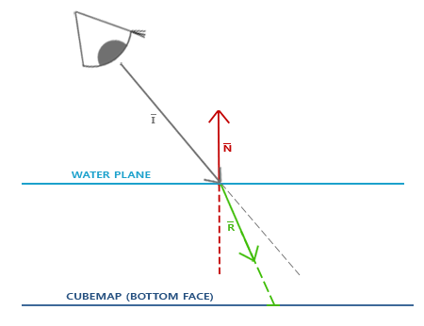

*Again, we have a view vector I¯, a normal vector N¯ and this time a resulting refraction vector R¯. As you can see, the direction of the view vector is slightly bend. This resulting bended vector R¯ is then used to sample from the cubemap.*

*Refraction can easily be implemented by using GLSL's built-in refract function that expects a normal vector, a view direction and a ratio between both materials' refractive indices.*

*The refractive index determines the amount light distorts/bends of a material where each material has its own refractive index. A list of the most common refractive indices are given in the following table:*

|  |  |
| --- | --- |
| ***Material*** | ***Refractive index*** |
| *Air* | *1.00* |
| *Water* | *1.33* |
| *Ice* | *1.309* |
| *Glass* | *1.52* |
| *Diamond* | *2.42* |

*We use these refractive indices to calculate the ratio between both materials the light passes through. In our case, the light/view ray goes from air to glass (if we assume the container is made of glass) so the ratio becomes 1.001.52=0.6581.001.52=0.658.*

*We already have the cubemap bound, supplied the vertex data with normals and set the camera position as a uniform. The only thing we have to change is the fragment shader:*

***void*** *main()*

*{*

***float*** *ratio = 1.00 / 1.52;*

*vec3 I = normalize(Position - cameraPos);*

*vec3 R = refract(I, normalize(Normal), ratio);*

*FragColor = vec4(texture(skybox, R).rgb, 1.0);*

*}*

*// тут, здаецца, не ўлічана магчымасць праламлення святла ў двух паслядоўных шкляных пласцінах //*

*By changing the refractive indices you can create completely different visual results. Compiling the application and running the results is not so interesting though since we're simply using a basic container, which doesn't really show the effect refraction has aside that it acts slightly as a magnifying glass right now. Using the same shaders on the nanosuit model however does show us the effect we're looking for: a glass-like object.*

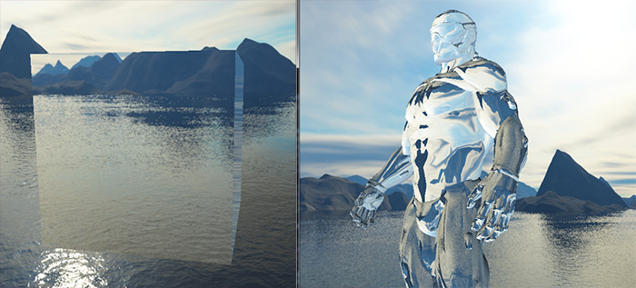

*You can imagine that with the right combination of lighting, reflection, refraction and vertex movement you can create pretty neat water graphics. Do note that for physically accurate results we also should refract the light again when it leaves the object; now we simply used single-side refraction which is fine for most purposes.*

### ***Dynamic environment maps***

*Right now we've been using a static combination of images as the skybox, which looks great, but doesn't include the actual scene with possibly moving objects. We didn't really notice this so far, because we only used a single object. If we had a mirror-like objects with multiple surrounding objects, only the skybox would be visible in the mirror as if it was the only object in the scene.*

*Using framebuffers it is possible to create a texture of the scene for all 6 different angles from the object in question and store those in a cubemap each render iteration. We can then use this (dynamically generated) cubemap to create realistic reflection and refractive surfaces that include all other objects. This is called dynamic environment mapping, because we dynamically create a cubemap of an object's surroundings and use that as its environment map.*

*While it looks great, it has one enormous disadvantage: we have to render the scene 6 times per object using an environment map, which is an enormous performance penalty on your application. Modern applications try to use the skybox as much as possible and where possible pre-compile cubemaps wherever they can to still sort-of create dynamic environment maps. While dynamic environment mapping is a great technique, it requires a lot of clever tricks and hacks to get it working in an actual rendering application without too many performance drops.*

*// праблема вялікая – адлюстраваць усе аб’екты. Для гэтага для зададзенага аб’екта будуецца 6 тэстур у фрэймбуферы. І гэта варта рабіць для кожнага, здольнага адлюстроўваць, аб’екта! Якіх можа быць шмат! Жуць! //*

### ***Exercises***

* *Try to introduce reflection maps into the model loader we created in the*[*model loading*](https://learnopengl.com/#!Model-Loading/Assimp)*tutorials. You can find the upgraded nanosuit model with reflection maps included*[*here*](https://learnopengl.com/objects/nanosuit_reflection.zip)*. There are a few things to note though:*
  + *Assimp doesn't really seem to like reflection maps in most object formats so we cheated a little by storing the reflection maps as ambient maps. You can then load the reflection maps by specifying aiTextureType_AMBIENT as the texture type when loading materials.*
  + *I sort of hastily created reflection map textures from the specular texture images, so the reflection maps won't map exactly to the model in some places :).*
  + *Since the model loader by itself already takes up 3 texture units in the shader, you'll have to bind the skybox to a 4th texture unit since we'll also sample from the skybox in the same shader.*
* *If you did things right it'll look something like*[*this*](https://learnopengl.com/img/advanced/cubemaps_reflection_map.png)*.*

*// не рабіў //*

[*https://learnopengl.com/#!Advanced-OpenGL/Advanced-Data*](https://learnopengl.com/#!Advanced-OpenGL/Advanced-Data)

## ***Advanced Data***

*We've been extensively using buffers in OpenGL to store data for quite some time now. There are more interesting ways to manipulate buffers and also other interesting methods to pass large amounts of data to the shaders via textures. This tutorial we'll discuss some more interesting buffer functions and how we can use texture objects to store large amounts of data (the texture part of the tutorial has not yet been written).*

*A buffer in OpenGL is only an object that manages a certain piece of memory and nothing more. We give a meaning to a buffer when binding it to a specific buffer target. A buffer is only a vertex array buffer when we bind it to GL_ARRAY_BUFFER, but we could just as easily bind it to GL_ELEMENT_ARRAY_BUFFER. OpenGL internally stores a buffer per target and based on the target, processes the buffers differently.*

*So far we've been filling the memory managed by the buffer objects by calling glBufferData which allocates a piece of memory and adds data into this memory. If we were to pass NULL as its data argument, the function would only allocate memory and not fill it. This is useful if we first want to reserve a specific amount of memory and later come back to this buffer to fill it piece by piece.*

*Instead of filling the entire buffer with one function call we can also fill specific regions of the buffer by calling glBufferSubData. This function expects a buffer target, an offset, the size of the data and the actual data as its arguments. What's new with this function is that we can now give an offset that specifies from where we want to fill the buffer. This allows us to insert/update only certain parts of the buffer's memory. Do note that the buffer should have enough allocated memory so a call to glBufferData is necessary before calling glBufferSubData on the buffer.*

*glBufferSubData(GL_ARRAY_BUFFER, 24,* ***sizeof****(data), &data); // Range: [24, 24 + sizeof(data)]*

*Yet another method for getting data into a buffer is to ask for a pointer to the buffer's memory and directly copy the data to the buffer by yourself. By calling glMapBuffer OpenGL returns a pointer to the currently bound buffer's memory for us to operate on:*

***float*** *data[] = {*

*0.5f, 1.0f, -0.35f*

*...*

*};*

*glBindBuffer(GL_ARRAY_BUFFER, buffer);*

*// get pointer*

***void*** *\*ptr = glMapBuffer(GL_ARRAY_BUFFER, GL_WRITE_ONLY);*

*// now copy data into memory*

*memcpy(ptr, data,* ***sizeof****(data));*

*// make sure to tell OpenGL we're done with the pointer*

*glUnmapBuffer(GL_ARRAY_BUFFER);*

*By telling OpenGL we're finished with the pointer operations via glUnmapBuffer OpenGL knows you're done. By unmapping, the pointer becomes invalid and the function returns GL_TRUE if OpenGL was able to map your data successfully to the buffer.*

*Using glMapBuffer is useful to directly map data to a buffer, without first storing it in temporary memory. Think of directly reading data from file and copying into the buffer's memory.*

### ***Batching vertex attributes***

*Using glVertexAttribPointer we were able to specify the attribute layout of the vertex array buffer's content. Within the vertex array buffer we interleaved the attributes; that is, we placed the position, normal and/or texture coordinates next to each other for each vertex. Now that we know a bit more about buffers we could take a different approach.*

*What we could also do is batch all the vector data into large chunks per attribute type instead of interleaving them. Instead of an interleaved layout 123123123123 we take a batched approach 111122223333.*

*When loading vertex data from file you generally retrieve an array of positions, an array of normals and/or an array of texture coordinates. It might cost some effort to combine these arrays into one large array of interleaved data. Taking the batching approach is then an easier solution that we can easily implement using glBufferSubData:*

***float*** *positions[] = { ... };*

***float*** *normals[] = { ... };*

***float*** *tex[] = { ... };*

*// fill buffer*

*glBufferSubData(GL_ARRAY_BUFFER, 0,* ***sizeof****(positions), &positions);*

*glBufferSubData(GL_ARRAY_BUFFER,* ***sizeof****(positions),* ***sizeof****(normals), &normals);*

*glBufferSubData(GL_ARRAY_BUFFER,* ***sizeof****(positions) +* ***sizeof****(normals),* ***sizeof****(tex), &tex);*

*This way we can directly transfer the attribute arrays as a whole into the buffer without first having to process them. We could have also combined them in one large array and fill the buffer right away using glBufferData, but using glBufferSubData lends itself perfectly for tasks like these.*

*We'll also have to update the vertex attribute pointers to reflect these changes:*

*glVertexAttribPointer(0, 3, GL_FLOAT, GL_FALSE, 3 \** ***sizeof****(****float****), 0);*

*glVertexAttribPointer(1, 3, GL_FLOAT, GL_FALSE, 3 \** ***sizeof****(****float****), (****void****\*)(****sizeof****(positions)));*

*glVertexAttribPointer( 2, 2, GL_FLOAT, GL_FALSE, 2 \** ***sizeof****(****float****), (****void****\*)(****sizeof****(positions) +* ***sizeof****(normals)));*

*Note that the stride parameter is equal to the size of the vertex attribute, since the next vertex attribute vector can be found directly after its 3 (or 2) components.*

*This gives us yet another approach of setting and specifying vertex attributes. Using either approach has no immediate benefit to OpenGL, it is mostly a more organized way to set vertex attributes. The approach you want to use is purely based on your preference and the type of application.*

### ***Copying buffers***

*Once your buffers are filled with your data you could want to share that data with other buffers or perhaps copy the buffer's content into another buffer. The function glCopyBufferSubData allows us to copy the data from one buffer to another buffer with relative ease. The function's prototype is as follows:*

***void*** *glCopyBufferSubData(GLenum readtarget, GLenum writetarget, GLintptr readoffset,*

*GLintptr writeoffset, GLsizeiptr size);*

*The readtarget and writetarget parameters expect to give the buffer targets that we want to copy from and to. We could for example copy from a VERTEX_ARRAY_BUFFER buffer to a VERTEX_ELEMENT_ARRAY_BUFFER buffer by specifying those buffer targets as the read and write targets respectively. The buffers currently bound to those buffer targets will then be affected.*

*But what if we wanted to read and write data into two different buffers that are both vertex array buffers? We can't bind two buffers at the same time to the same buffer target. For this reason, and this reason alone, OpenGL gives us two more buffer targets called GL_COPY_READ_BUFFER and GL_COPY_WRITE_BUFFER. We then bind the buffers of our choice to these new buffer targets and set those targets as the readtarget and writetarget argument.*

*glCopyBufferSubData then reads data of a given size from a given readoffset and writes it into the writetargetbuffer at writeoffset. An example of copying the content of two vertex array buffers is shown below:*

***float*** *vertexData[] = { ... };*

*glBindBuffer(GL_COPY_READ_BUFFER, vbo1);*

*glBindBuffer(GL_COPY_WRITE_BUFFER, vbo2);*

*glCopyBufferSubData(GL_COPY_READ_BUFFER, GL_COPY_WRITE_BUFFER, 0, 0,* ***sizeof****(vertexData));*

*We could've also done this by only binding the write target buffer to one of the new buffer target types:*

***float*** *vertexData[] = { ... };*

*glBindBuffer(GL_ARRAY_BUFFER, vbo1);*

*glBindBuffer(GL_COPY_WRITE_BUFFER, vbo2);*

*glCopyBufferSubData(GL_ARRAY_BUFFER, GL_COPY_WRITE_BUFFER, 0, 0,* ***sizeof****(vertexData));*

*With some extra knowledge about how to manipulate buffers we can already use them in more interesting ways. The further you get in OpenGL the more useful these new buffer methods start to become. In the*[*next*](https://learnopengl.com/#!Advanced-OpenGL/Advanced-GLSL)*tutorial where we'll discuss uniform buffer objects we'll make good use of glBufferSubData.*

[*https://learnopengl.com/#!Advanced-OpenGL/Advanced-GLSL*](https://learnopengl.com/#!Advanced-OpenGL/Advanced-GLSL)

## ***Advanced GLSL***

*30/10/2017*

*This tutorial won't really show you super advanced cool new features that give an enormous boost to your scene's visual quality. This tutorial goes more or less into some interesting aspects of GLSL and some nice tricks that might help you in your future endeavors. Basically some good to knows and features that might make your life easier when creating OpenGL applications in combination with GLSL.*

*We'll discuss some interesting built-in variables, new ways to organize shader's input and output and a very useful tool called uniform buffer objects.*

### ***GLSL's built-in variables***

*Shaders are minimal, if we need data from any other source outside the current shader we'll have to pass data around. We learned to do this via vertex attributes, uniforms and samplers. There are however a few extra variables defined by GLSL prefixed with gl_ that give us an extra means to gather and/or write data. We've already seen two of them in the tutorials so far: gl_Position that is the output vector of the vertex shader and the fragment shader's gl_FragCoord.*

*We'll discuss a few interesting built-in input and output variables that are built-in in GLSL and explain how they might benefit us. Note that we won't discuss all built-in variables that exist in GLSL so if you want to see all built-in variables you can check OpenGL's*[*wiki*](http://www.opengl.org/wiki/Built-in_Variable_(GLSL))*.*

#### **Vertex shader variables**

*We've already seen gl_Position which is the clip-space output position vector of the vertex shader. Setting gl_Position in the vertex shader is a strict requirement if you want to render anything on the screen. Nothing we haven't seen before.*

#### **gl_PointSize**

*One of the render primitives we're able to choose from is GL_POINTS in which case each single vertex is a primitive and rendered as a point. It is possible to set the size of the points being rendered via OpenGL's glPointSize function, but we can also influence this value in the vertex shader.*

*An output variable defined by GLSL is called gl_PointSize that is a float variable where you can set the point's width and height in pixels. By describing the point's size in the vertex shader you can influence this point value per vertex.*

*Influencing the point sizes in the vertex shader is disabled by default, but if you want to enable this you'll have to enable OpenGL's GL_PROGRAM_POINT_SIZE:*

*glEnable(GL_PROGRAM_POINT_SIZE);*

*A simple example of influencing the point sizes is by setting the point size equal to the clip-space position's z value which is equal to the vertex's distance to the viewer. The point size should then increase the further we are from the vertices as the viewer.*

***void*** *main()*

*{*

*gl_Position = projection * view * model * vec4(aPos, 1.0);*

*gl_PointSize = gl_Position.z;*

*}*

*The result is that the points we've drawn are rendered larger the more we move away from them:*

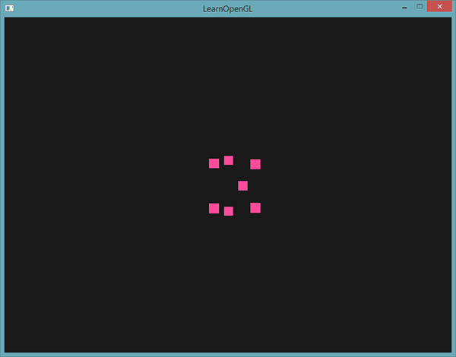

*You can imagine that varying the point size per vertex is interesting for techniques like particle generation.*

#### **gl_VertexID**

*The gl_Position and gl_PointSize are output variables since their value is read as output from the vertex shader; we can influence the result by writing to them. The vertex shader also gives us an interesting input variable, that we can only read from, called gl_VertexID.*

*The integer variable gl_VertexID holds the current ID of the vertex we're drawing. When doing indexed rendering (with glDrawElements) this variable holds the current index of the vertex we're drawing. When drawing without indices (via glDrawArrays) this variable holds the number of the currently processed vertex since the start of the render call.*

*Although not particularly useful right now, it's good to know that we have access to info like this.*

### ***Fragment shader variables***

*Within the fragment shader we also have access to some interesting variables. GLSL gives us two interesting input variables called gl_FragCoord and gl_FrontFacing.*

#### **gl_FragCoord**

*We've seen the gl_FragCoord a couple of times during the discussion of depth testing, because the z component of the gl_FragCoord vector is equal to the depth value of that particular fragment. However, we can also use the x and y component of the vector for some interesting effects.*

*The gl_FragCoord's x and y component are the window-space coordinates of the fragment, originating from the bottom-left of the window. We have specified a window of 800x600 with glViewport so the window-space coordinates of the fragment will have x values between 0 and 800, and y values between 0 and 600.*

*Using the fragment shader we can calculate a different color value based on the window coordinate of the fragment. A common usage for the gl_FragCoord variable is for comparing visual output of different fragment calculations, as usually seen in tech demos. We could for example split the screen in two by rendering one output to the left side of the window and another output to the right side of the window. An example fragment shader that outputs a different color based on the fragment's window coordinates is given below:*

***void*** *main()*

*{*

***if****(gl_FragCoord.x < 400)*

*FragColor = vec4(1.0, 0.0, 0.0, 1.0);*

***else***

*FragColor = vec4(0.0, 1.0, 0.0, 1.0);*

*}*

*Because the width of the window is equal to 800, whenever a pixel's x-coordinate is less than 400 it must be at the left side of the window and thus we give the object a different color.*

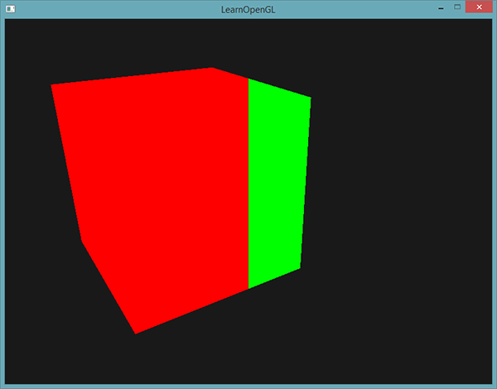

*We can now calculate two completely different fragment shader results and display each of them on a different side of the window. This is great for testing out different lighting techniques for example.*

#### **gl_FrontFacing**

*Another interesting input variable in the fragment shader is the gl_FrontFacing variable. In the*[*face culling*](https://learnopengl.com/#!Advanced-OpenGL/Face-culling)*tutorial we mentioned that OpenGL is able to figure out if a face is a front or back face due to the winding order of the vertices. If we're not using face culling (by enabling GL_FACE_CULL) then the gl_FrontFacing variable tells us if the current fragment is part of a front-facing or a back-facing face. We could then decide to calculate different colors for front faces for example.*

*The gl_FrontFacing variable is a bool that is true if the fragment is part of a front face and else false. We could for example create a cube this way with a different texture on the inside than on the outside:*

*#version 330 core*

***out*** *vec4 FragColor;*

***in*** *vec2 TexCoords;*

***uniform*** *sampler2D frontTexture;*

***uniform*** *sampler2D backTexture;*

***void*** *main()*

*{*

***if****(gl_FrontFacing)*

*FragColor = texture(frontTexture, TexCoords);*

***else***

*FragColor = texture(backTexture, TexCoords);*

*}*

*So if we take a peek inside the container we can now see a different texture being used.*

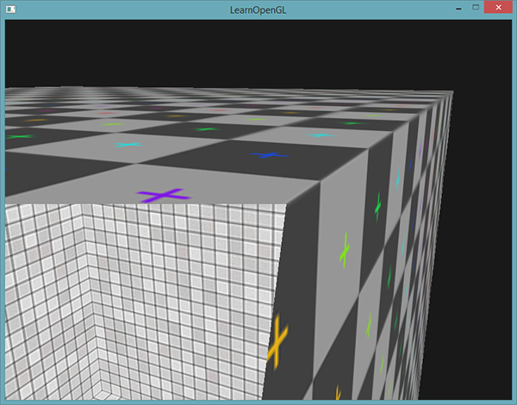

*Note that if you enabled face culling you won't be able to see any faces inside the container and using gl_FrontFacing would then be pointless.*

#### **gl_FragDepth**

*The input variable gl_FragCoord is an input variable that allows us to read window-space coordinates and get the depth value of the current fragment, but it is a read-only variable. We can't influence the window-space coordinates of the fragment, but it is possible to actually set the depth value of the fragment. GLSL gives us an output variable called gl_FragDepth that we can use to set the depth value of the fragment within the shader.*

*To actually set the depth value in the shader we simply write a float value between 0.0 and 1.0 to the output variable:*

*gl_FragDepth = 0.0; // this fragment now has a depth value of 0.0*

*If the shader does not write a value to gl_FragDepth the variable will automatically take its value from gl_FragCoord.z.*

*Setting the depth value by our self has a major disadvantage however, because OpenGL disables all early depth testing (as discussed in the*[*depth testing*](https://learnopengl.com/#!Advanced-OpenGL/Depth-testing)*tutorial) as soon as we write to gl_FragDepth in the fragment shader. It is disabled, because OpenGL cannot know what depth value the fragment will have before we run the fragment shader, since the fragment shader might completely change this depth value.*

*By writing to gl_FragDepth you should take this performance penalty into consideration. From OpenGL 4.2 however, we can still sort of mediate between both sides by redeclaring the gl_FragDepth variable at the top of the fragment shader with a depth condition:*

***layout*** *(depth_<condition>)* ***out******float*** *gl_FragDepth;*

*This condition can take the following values:*

|  |  |
| --- | --- |
| ***Condition*** | ***Description*** |
| *any* | *The default value. Early depth testing is disabled and you lose most performance.* |
| *greater* | *You can only make the depth value larger compared to gl_FragCoord.z.* |
| *less* | *You can only make the depth value smaller compared to gl_FragCoord.z.* |
| *unchanged* | *If you write to gl_FragDepth, you will write exactly gl_FragCoord.z.* |

*By specifying greater or less as the depth condition OpenGL can make the assumption that you'll only write depth values larger or greater than the fragment's depth value. This way OpenGL is still able to do an early depth test in cases where the depth value is smaller than the fragment's depth value.*

*An example of where we increment the depth value in the fragment shader, but still want to preserve some of the early depth testing is shown in the fragment shader below:*

*#version 420 core // note the GLSL version!*

***out*** *vec4 FragColor;*

***layout*** *(depth_greater)* ***out******float*** *gl_FragDepth;*

***void*** *main()*

*{*

*FragColor = vec4(1.0);*

*gl_FragDepth = gl_FragCoord.z + 0.1;*

*}*

*Do note that this feature is only available from OpenGL version 4.2 or higher.*

### ***Interface blocks***

*So far, every time we wanted to send data from the vertex to the fragment shader we declared several matching input/output variables. Declaring these one at a time is the easiest way to send data from one shader to another, but as applications become larger you probably want to send more than a few variables over which may include arrays and/or structs.*

*To help us organize these variables GLSL offers us something called interface blocks that allows us to group together those variables. The declaration of such an interface block looks a lot like a struct declaration, except that it is now declared using an in or out keyword based on the block being an input or an output block.*

*#version 330 core*

***layout*** *(location = 0)* ***in*** *vec3 aPos;*

***layout*** *(location = 1)* ***in*** *vec2 aTexCoords;*

***uniform*** *mat4 model;*

***uniform*** *mat4 view;*

***uniform*** *mat4 projection;*

***out*** *VS_OUT*

*{*

*vec2 TexCoords;*

*} vs_out;*

***void*** *main()*

*{*

*gl_Position = projection * view * model * vec4(aPos, 1.0);*

*vs_out.TexCoords = aTexCoords;*

*}*

*This time we declared an interface block called vs_out that groups together all the output variables we want to send to the next shader. This is kind of a trivial example, but you can imagine that this helps organize your shaders' inputs/outputs. It is also useful when we want to group shader input/output into arrays as we'll see in the*[*next*](https://learnopengl.com/#!Advanced-OpenGL/Geometry-shaders)*tutorial about geometry shaders.*

*Then we also need to declare an input interface block in the next shader which is the fragment shader. The block name(VS_OUT) should be the same in the fragment shader, but the instance name (vs_out as used in the vertex shader) can be anything we like - avoiding confusing names like vs_out that actually contains input variables.*

*#version 330 core*

***out*** *vec4 FragColor;*

***in*** *VS_OUT*

*{*

*vec2 TexCoords;*

*} fs_in;*

***uniform*** *sampler2D texture;*

***void*** *main()*

*{*

*FragColor = texture(texture, fs_in.TexCoords);*

*}*

*As long as both interface block names are equal, their corresponding input and output is matched together. This is another useful feature that helps organize your code and proves useful when crossing between certain shader stages like the geometry shader.*

### ***Uniform buffer objects***

*We've been using OpenGL for quite a while now and learned some pretty cool tricks, but also a few annoyances. For example, when using more than 1 shader we continually have to set uniform variables where most of them are exactly the same for each shader - so why bother to even set them again?*

*OpenGL gives us a tool called uniform buffer objects that allow us to declare a set of global uniform variables that remain the same over several shader programs. When using uniform buffer objects we thus have to set the relevant uniforms only****once****. We do still have to manually set the uniforms that are unique per shader. Creating and configuring a uniform buffer object requires a bit of work though.*

*Because a uniform buffer object is a buffer like any other buffer we can create one via glGenBuffers, bind it to the GL_UNIFORM_BUFFER buffer target and store all the relevant uniform data into the buffer. There are certain rules as to how the data for uniform buffer objects should be stored and we'll get to that later. First, we'll take a simple vertex shader and store our projection and view matrix in a so called uniform block:*

*#version 330 core*

***layout*** *(location = 0)* ***in*** *vec3 aPos;*

***layout*** *(std140)* ***uniform*** *Matrices*

*{*

*mat4 projection;*

*mat4 view;*

*};*

***uniform*** *mat4 model;*

***void*** *main()*

*{*

*gl_Position = projection * view * model * vec4(aPos, 1.0);*

*}*

*In most of our samples we set a projection and view uniform matrix each render iteration for each shader we're using. This is a perfect example of where uniform buffer objects become useful since now we only have to store these matrices once.*

*Here we declared a uniform block called Matrices that stores two 4x4 matrices. Variables in a uniform block can be directly accessed without the block name as a prefix. Then we store these matrix values in a buffer somewhere in the OpenGL code and each shader that declared this uniform block has access to the matrices.*

*You're probably wondering right now what the layout (std140) statement means. What this says is that the currently defined uniform block uses a specific memory layout for its content; this statement sets the uniform block layout.*

#### **Uniform block layout**

*The content of a uniform block is stored in a buffer object which is basically nothing more than a reserved piece of memory. Because this piece of memory holds no information on what kind of data it holds, we need to tell OpenGL what parts of the memory corresponds to which uniform variables in the shader.*

*Imagine the following uniform block in a shader:*

***layout*** *(std140)* ***uniform*** *ExampleBlock*

*{*

***float*** *value;*

*vec3 vector;*

*mat4 matrix;*

***float*** *values[3];*

***bool*** *boolean;*

***int*** *integer;*

*};*

*What we want to know is the size (in bytes) and the offset (from the start of the block) of each of these variables so we can place them in the buffer in their respective order. The size of each of the elements is clearly stated in OpenGL and directly corresponds to C++ data types; vectors and matrices being (large) arrays of floats. What OpenGL doesn't clearly state is the spacing between the variables. This allows the hardware to position variables as it sees fit. Some hardware is able to place a vec3 adjacent to a float for example. Not all hardware can handle this and pads the vec3 to an array of 4 floats before appending the float. A great feature, but inconvenient for us.*

*By default GLSL uses a uniform memory layout called a shared layout - shared because once the offsets are defined by the hardware, they are consistently shared between multiple programs. With a shared layout GLSL is allowed to reposition the uniform variables for optimization as long as the variables' order remains intact. Because we don't know at what offset each uniform variable will be we don't know how to precisely fill our uniform buffer. We can query this information with functions like glGetUniformIndices, but that is out of the scope of this tutorial.*

*While a shared layout gives us some space-saving optimizations, we'd need to query each offset for each uniform variable which translates to a lot of work. The general practice is however to not use the shared layout, but to use the std140 layout. The std140 layout****explicitly****states the memory layout for each variable type by stating their respective offsets governed by a set of rules. Since this is explicitly mentioned we can manually figure out the offsets for each variable.*

*Each variable has a base alignment which is equal to the space a variable takes (including padding) within a uniform block - this base alignment is calculated using the std140 layout rules. Then, for each variable, we calculate its aligned offset which is the byte offset of a variable from the start of the block. The aligned byte offset of a variable****must****be equal to a multiple of its base alignment.*

*The exact layout rules can be found at OpenGL's uniform buffer specification*[*here*](http://www.opengl.org/registry/specs/ARB/uniform_buffer_object.txt)*, but we'll list the most common rules below. Each variable type in GLSL such as int, float and bool are defined to be four-byte quantities with each entity of 4 bytes being represented as N.*

|  |  |
| --- | --- |
| ***Type*** | ***Layout rule*** |
| *Scalar e.g. int or bool* | *Each scalar has a base alignment of N.* |
| *Vector* | *Either 2N or 4N. This means that a vec3 has a base alignment of 4N.* |
| *Array of scalars or vectors* | *Each element has a base alignment equal to that of a vec4.* |
| *Matrices* | *Stored as a large array of column vectors, where each of those vectors has a base alignment of vec4.* |
| *Struct* | *Equal to the computed size of its elements according to the previous rules, but padded to a multiple of the size of a vec4.* |

*Like most of OpenGL's specifications it's easier to understand with an example. We're taking the uniform block called ExampleBlock we introduced earlier and calculate the aligned offset for each of its members using the std140 layout:*

***layout*** *(std140)* ***uniform*** *ExampleBlock*

*{*

*// base alignment // aligned offset*

***float*** *value; // 4 // 0*

*vec3 vector; // 16 // 16 (must be multiple of 16 so 4->16)*

*mat4 matrix; // 16 // 32 (column 0)*

*// 16 // 48 (column 1)*

*// 16 // 64 (column 2)*

*// 16 // 80 (column 3)*

***float*** *values[3]; // 16 // 96 (values[0])*

*// 16 // 112 (values[1])*

*// 16 // 128 (values[2])*

***bool*** *boolean; // 4 // 144*

***int*** *integer; // 4 // 148*

*};*

*As an exercise, try to calculate the offset values yourself and compare them to this table. With the calculated offset values, based on the rules of the std140 layout, we can fill the buffer with the variable data at each offset using functions like glBufferSubData. While not the most efficient, the std140 layout does guarantee us that the memory layout remains the same over each program that declared this uniform block.*

*By adding the statement layout (std140) before the definition of the uniform block we tell OpenGL that this uniform block uses the std140 layout. There are two other layouts to choose from that require us to query each offset before filling the buffers. We've already seen the shared layout and the other remaining layout being packed. When using the packed layout, there is no guarantee that the layout remains the same between programs (not shared) because it allows the compiler to optimize uniform variables away from the uniform block which might differ per shader.*

#### **Using uniform buffers**

*We've discussed defining uniform blocks in the shaders and specifying their memory layout, but we haven't discussed how to actually use them yet.*

*First we need to create a uniform buffer object which is done via glGenBuffers. Once we have a buffer object we bind it to the GL_UNIFORM_BUFFER target and allocate enough memory by calling glBufferData.*

***unsigned******int*** *uboExampleBlock;*

*glGenBuffers(1, &uboExampleBlock);*

*glBindBuffer(GL_UNIFORM_BUFFER, uboExampleBlock);*

*glBufferData(GL_UNIFORM_BUFFER, 152, NULL, GL_STATIC_DRAW); // allocate 150 bytes of memory*

*glBindBuffer(GL_UNIFORM_BUFFER, 0);*

*Now whenever we want to update or insert data into the buffer, we bind to uboExampleBlock and use glBufferSubData to update its memory. We only have to update this uniform buffer once, and all shaders that use this buffer now use its updated data. But, how does OpenGL know what uniform buffers correspond to which uniform blocks?*

*In the OpenGL context there is a number of binding points defined where we can link a uniform buffer to. Once we created a uniform buffer we link it to one of those binding points and we also link the uniform block in the shader to the same binding point, effectively linking those to each other. The following diagram illustrates this:*

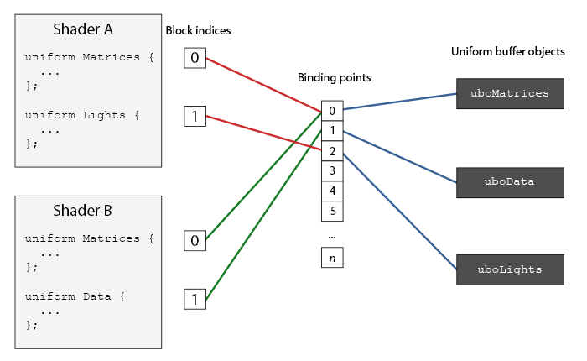

*As you can see we can bind multiple uniform buffers to different binding points. Because shader A and shader B both have a uniform block linked to the same binding point 0 their uniform blocks share the same uniform data found in uboMatrices; a requirement being that both shaders defined the same Matrices uniform block.*

*To set the uniform block to a specific binding point we call glUniformBlockBinding that takes a program object as its first argument, a uniform block index and the binding point to link to. The uniform block index is a location index of the defined uniform block in the shader. This can be retrieved via a call to glGetUniformBlockIndex that accepts a program object and the name of the uniform block. We can set the Lights uniform block from the diagram to binding point 2 as follows:*

***unsigned******int*** *lights_index = glGetUniformBlockIndex(shaderA.ID, "Lights");*

*glUniformBlockBinding(shaderA.ID, lights_index, 2);*

*Note that we have to repeat this process for****each****shader.*

*From OpenGL version 4.2 and onwards it is also possible to store the binding point of a uniform block explicitly in the shader by adding another layout specifier, saving us the calls to glGetUniformBlockIndex and glUniformBlockBinding. The following code sets the binding point of the Lights uniform block explicitly:*

***layout****(std140, binding = 2)* ***uniform*** *Lights { ... };*

*Then we also need to bind the uniform buffer object to the same binding point and this can be accomplished with either glBindBufferBase or glBindBufferRange.*

*glBindBufferBase(GL_UNIFORM_BUFFER, 2, uboExampleBlock);*

*// or*

*glBindBufferRange(GL_UNIFORM_BUFFER, 2, uboExampleBlock, 0, 152);*

*The function glBindbufferBase expects a target, a binding point index and a uniform buffer object as its arguments. This function links uboExampleBlock to binding point 2 and from this point on both sides of the binding point are linked. You can also use the glBindBufferRange function that expects an extra offset and size parameter - this way you can bind only a specific range of the uniform buffer to a binding point. Using glBindBufferRange you could have multiple different uniform blocks linked to a single uniform buffer object.*

*Now that everything is set up, we can start adding data to the uniform buffer. We could add all the data as a single byte array or update parts of the buffer whenever we feel like it using glBufferSubData. To update the uniform variable booleanwe could update the uniform buffer object as follows:*

*glBindBuffer(GL_UNIFORM_BUFFER, uboExampleBlock);*

***int*** *b =* ***true****; // bools in GLSL are represented as 4 bytes, so we store it in an integer*

*glBufferSubData(GL_UNIFORM_BUFFER, 144, 4, &b);*

*glBindBuffer(GL_UNIFORM_BUFFER, 0);*

*And the same procedure applies for all the other uniform variables inside the uniform block, but with different range arguments.*

#### **A simple example**

*So let's demonstrate a real useful example of using uniform buffer objects. If we look back at all the previous code samples we've continually been using 3 matrices: the projection, view and model matrices. Of all those matrices, only the model matrix changes frequently. If we have multiple shaders that use this same set of matrices, we'd probably be better off using uniform buffer objects.*

*We're going to store the projection and view matrix in a uniform block called Matrices. We're not going to store the model matrix in there, since the model matrix tends to change quite frequently between shaders so we wouldn't really benefit from uniform buffer objects then.*

*#version 330 core*

***layout*** *(location = 0)* ***in*** *vec3 aPos;*

***layout*** *(std140)* ***uniform*** *Matrices*

*{*

*mat4 projection;*

*mat4 view;*

*};*

***uniform*** *mat4 model;*

***void*** *main()*

*{*

*gl_Position = projection * view * model * vec4(aPos, 1.0);*

*}*

*Not much special going on here, except that we now use a uniform block with a std140 layout. What we're going to do in our sample application is display 4 cubes where each cube is displayed using a different shader program. Each of the 4 shader programs uses the same vertex shader, but has a different fragment shader that only outputs a single color that differs per shader.*

*First, we set the uniform block of the vertex shaders equal to binding point 0. Note that we have to do this for each shader.*

***unsigned******int*** *uniformBlockIndexRed = glGetUniformBlockIndex(shaderRed.ID, "Matrices");*

***unsigned******int*** *uniformBlockIndexGreen = glGetUniformBlockIndex(shaderGreen.ID, "Matrices");*

***unsigned******int*** *uniformBlockIndexBlue = glGetUniformBlockIndex(shaderBlue.ID, "Matrices");*

***unsigned******int*** *uniformBlockIndexYellow = glGetUniformBlockIndex(shaderYellow.ID, "Matrices");*

*glUniformBlockBinding(shaderRed.ID, uniformBlockIndexRed, 0);*

*glUniformBlockBinding(shaderGreen.ID, uniformBlockIndexGreen, 0);*

*glUniformBlockBinding(shaderBlue.ID, uniformBlockIndexBlue, 0);*

*glUniformBlockBinding(shaderYellow.ID, uniformBlockIndexYellow, 0);*

*Next we create the actual uniform buffer object and also bind the buffer to binding point 0:*

***unsigned******int*** *uboMatrices*

*glGenBuffers(1, &uboMatrices);*

*glBindBuffer(GL_UNIFORM_BUFFER, uboMatrices);*

*glBufferData(GL_UNIFORM_BUFFER, 2 \** ***sizeof****(glm::mat4), NULL, GL_STATIC_DRAW);*

*glBindBuffer(GL_UNIFORM_BUFFER, 0);*

*glBindBufferRange(GL_UNIFORM_BUFFER, 0, uboMatrices, 0, 2 \** ***sizeof****(glm::mat4));*

*First we allocate enough memory for our buffer which is equal to 2 times the size of glm::mat4. The size of GLM's matrix types correspond directly to mat4 in GLSL. Then we link a specific range of the buffer which in this case is the entire buffer, to binding point 0.*

*Now all that's left to do is actually fill the buffer. If we keep the field of view value constant of the projection matrix (so no more camera zoom) we only have to define it once in our application - this means we only have to insert this into the buffer only once as well. Because we already allocated enough memory in the buffer object we can use glBufferSubData to store the projection matrix before we enter the game loop:*

*glm::mat4 projection = glm::perspective(glm::radians(45.0f), (****float****)width/(****float****)height, 0.1f, 100.0f);*

*glBindBuffer(GL_UNIFORM_BUFFER, uboMatrices);*

*glBufferSubData(GL_UNIFORM_BUFFER, 0,* ***sizeof****(glm::mat4), glm::value_ptr(projection));*

*glBindBuffer(GL_UNIFORM_BUFFER, 0);*

*Here we store the first half of the uniform buffer with the projection matrix. Before we draw the objects each render iteration we then update the second half of the buffer with the view matrix:*

*glm::mat4 view = camera.GetViewMatrix();*

*glBindBuffer(GL_UNIFORM_BUFFER, uboMatrices);*

*glBufferSubData(GL_UNIFORM_BUFFER,* ***sizeof****(glm::mat4),* ***sizeof****(glm::mat4), glm::value_ptr(view));*

*glBindBuffer(GL_UNIFORM_BUFFER, 0);*

*And that's it for uniform buffer objects. Each vertex shader that contains a Matrices uniform block will now contain the data stored in uboMatrices. So if we now were to draw 4 cubes using 4 different shaders their projection and view matrix should remain the same:*

*glBindVertexArray(cubeVAO);*

*shaderRed.use();*

*glm::mat4 model;*

*model = glm::translate(model, glm::vec3(-0.75f, 0.75f, 0.0f)); // move top-left*

*shaderRed.setMat4("model", model);*

*glDrawArrays(GL_TRIANGLES, 0, 36);*

*// ... draw Green Cube*

*// ... draw Blue Cube*

*// ... draw Yellow Cube*

*The only uniform we still need to set is the model uniform. Using uniform buffer objects in a scenario like this saves us from quite a few uniform calls per shader. The result looks something like this:*

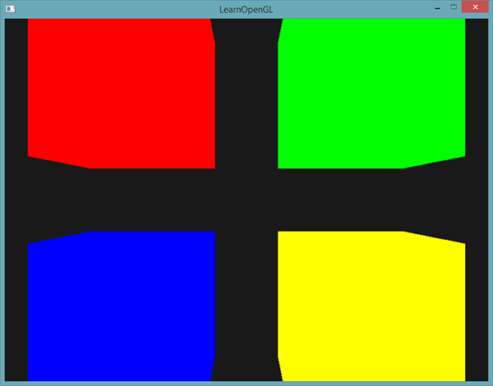

*Each of the cube is moved to one side of the window by altering the model matrix and due to the different fragment shaders their object colors differ. This is a relatively simple scenario of where we might use uniform buffer objects, but any large rendering application could have over hundreds of shader programs active; this is where uniform buffer objects really start to shine.*

*You can find the full source code of the uniform example application*[*here*](https://learnopengl.com/code_viewer_gh.php?code=src/4.advanced_opengl/8.advanced_glsl_ubo/advanced_glsl_ubo.cpp)*.*

*Uniform buffer objects have several advantages over single uniforms. First, setting a lot of uniforms at once is faster than setting multiple uniforms one at a time. Second, if you want to change the same uniform over several shaders, it is much easier to change a uniform once in a uniform buffer. One last advantage that is not immediately apparent is that you can use a lot more uniforms in shaders using uniform buffer objects. OpenGL has a limit to how much uniform data it can handle that can be queried with GL_MAX_VERTEX_UNIFORM_COMPONENTS. When using uniform buffer objects, this limit is much higher. So whenever you reach a maximum number of uniforms (when doing skeletal animation for example) you could always use uniform buffer objects. // абмежаванне тэхналогіі //*

[*https://learnopengl.com/#!Advanced-OpenGL/Geometry-Shader*](https://learnopengl.com/#!Advanced-OpenGL/Geometry-Shader)

## ***Geometry Shader***

*Between the vertex and the fragment shader there is an optional shader stage called the geometry shader. A geometry shader takes as input a set of vertices that form a single primitive e.g. a point or a triangle. The geometry shader can then transform these vertices as it sees fit before sending them to the next shader stage. What makes the geometry shader interesting however is that it is able to transform the (set of) vertices to completely different primitives possibly generating much more vertices than were initially given.*

*We're going to throw you right into the deep by showing you an example of a geometry shader:*

*#version 330 core*

***layout*** *(points)* ***in****;*

***layout*** *(line_strip, max_vertices = 2)* ***out****;*

***void*** *main() {*

*gl_Position = gl_in[0].gl_Position + vec4(-0.1, 0.0, 0.0, 0.0);*

*EmitVertex();*

*gl_Position = gl_in[0].gl_Position + vec4( 0.1, 0.0, 0.0, 0.0);*

*EmitVertex();*

*EndPrimitive();*

*}*

*At the start of every geometry shader we need to declare the type of primitive input we're receiving from the vertex shader. We do this by declaring a layout specifier in front of the in keyword. This input layout qualifier can take any of the following primitive values from a vertex shader:*

* *points: when drawing GL_POINTS primitives (1).*
* *lines: when drawing GL_LINES or GL_LINE_STRIP (2).*
* *lines_adjacency: GL_LINES_ADJACENCY or GL_LINE_STRIP_ADJACENCY (4).*
* *triangles: GL_TRIANGLES, GL_TRIANGLE_STRIP or GL_TRIANGLE_FAN (3).*
* *triangles_adjacency : GL_TRIANGLES_ADJACENCY or GL_TRIANGLE_STRIP_ADJACENCY (6).*

*These are almost all the rendering primitives we're able to give to rendering calls like glDrawArrays. If we'd chosen to draw vertices as GL_TRIANGLES we should set the input qualifier to triangles. The number within the parenthesis represents the minimal number of vertices a single primitive contains.*

*Then we also need to specify a primitive type that the geometry shader will actually output and we do this via a layout specifier in front of the out keyword. Like the input layout qualifier, the output layout qualifier can also take several primitive values:*

* *points*
* *line_strip*
* *triangle_strip*

*With just these 3 output specifiers we can create almost any shape we want from the input primitives. To generate a single triangle for example we'd specify triangle_strip as the output and then output 3 vertices.*

*The geometry shader also expects us to set a maximum number of vertices it outputs (if you exceed this number, OpenGL won't draw the extra vertices) which we can also do within the layout qualifier of the out keyword. In this particular case we're going to output a line_strip with a maximum number of 2 vertices.*

*In case you are wondering what a line strip is: a line strip binds together a set of points to form one continuous line between them with a minimum of 2 points. Each extra point given to the rendering call results in a new line between the new point and the previous point as you can see in the image below where we have 5 point vertices:*

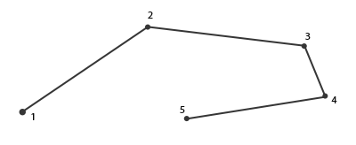

*With the current shader we'll only output a single line since the maximum number of vertices is equal to 2.*

*To generate meaningful results we need some way to retrieve the output from the previous shader stage. GLSL gives us a built-in variable called gl_in that internally (probably) looks something like this:*

***in*** *gl_Vertex*

*{*

*vec4 gl_Position;*

***float*** *gl_PointSize;*

***float*** *gl_ClipDistance[];*

*} gl_in[];*

*Here it is declared as an interface block (as discussed in the*[*previous*](https://learnopengl.com/#!Advanced-OpenGL/Advanced-GLSL)*tutorial) that contains a few interesting variables of which the most interesting one is gl_Position that contains the similar vector we set as the vertex shader's output.*

*Note that it is declared as an array, because most render primitives consist of more than 1 vertex and the geometry shader receives****all****vertices of a primitive as its input.*

*Using the vertex data from the previous vertex shader stage we can start to generate new data which is done via 2 geometry shader functions called EmitVertex and EndPrimitive. The geometry shader expects you to generate/output at least one of the primitives you specified as output. In our case we want to at least generate one line strip primitive.*

***void*** *main() {*

*gl_Position = gl_in[0].gl_Position + vec4(-0.1, 0.0, 0.0, 0.0);*

*EmitVertex();*

*gl_Position = gl_in[0].gl_Position + vec4( 0.1, 0.0, 0.0, 0.0);*

*EmitVertex();*

*EndPrimitive();*

*}*

*Each time we call EmitVertex the vector currently set to gl_Position is added to the primitive. Whenever EndPrimitive is called, all emitted vertices for this primitive are combined into the specified output render primitive. By repeatedly calling EndPrimitive after one or more EmitVertex calls multiple primitives can be generated. This particular case emits two vertices that were translated by a small offset from the original vertex position and then calls EndPrimitive, combining these two vertices into a single line strip of 2 vertices.*

*Now that you (sort of) know how geometry shaders work you can probably guess what this geometry shader does. This geometry shader takes a point primitive as its input and creates a horizontal line primitive with the input point at its center. If we were to render this it looks something like this:*

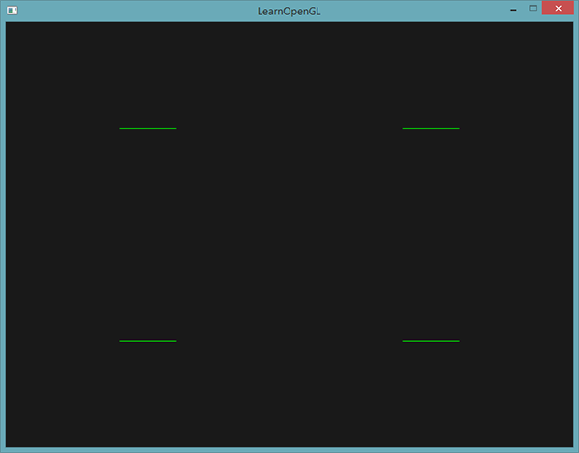

*Not very impressive yet, but it's interesting to consider that this output was generated using just the following render call:*

*glDrawArrays(GL_POINTS, 0, 4);*

*While this is a relatively simple example, it does show you how we can use geometry shaders to (dynamically) generate new shapes on the fly. Later in this tutorial we'll discuss some interesting effects that we can achieve using geometry shaders, but for now we're going to start by creating a simple geometry shader.*

### ***Using geometry shaders***

*To demonstrate the use of a geometry shader we're going to render a really simple scene where we just draw 4 points on the z-plane in normalized device coordinates. The coordinates of the points are:*

***float*** *points[] = {*

*-0.5f, 0.5f, // top-left*

*0.5f, 0.5f, // top-right*

*0.5f, -0.5f, // bottom-right*

*-0.5f, -0.5f // bottom-left*

*};*

*The vertex shader only needs to draw the points on the z-plane so we'll only need a basic vertex shader:*

*#version 330 core*

***layout*** *(location = 0)* ***in*** *vec2 aPos;*

***void*** *main()*

*{*

*gl_Position = vec4(aPos.x, aPos.y, 0.0, 1.0);*

*}*

*And we'll simply output the color green for all points which we hardcode in the fragment shader:*

*#version 330 core*

***out*** *vec4 FragColor;*

***void*** *main()*

*{*

*FragColor = vec4(0.0, 1.0, 0.0, 1.0);*

*}*

*Generate a VAO and a VBO for the points' vertex data and then draw them via glDrawArrays:*

*shader.use();*

*glBindVertexArray(VAO);*

*glDrawArrays(GL_POINTS, 0, 4);*

*The result is a dark scene with 4 (difficult to see) green points:*

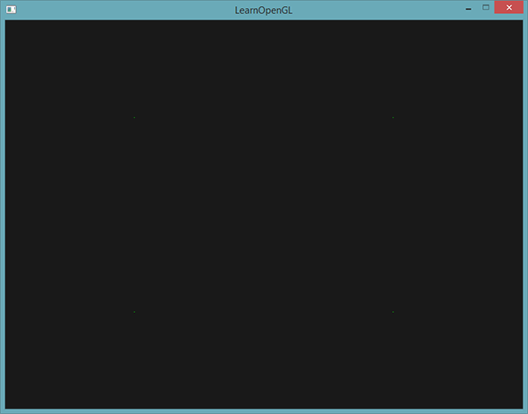

*But didn't we already learn to do all this? Yes, and now we're going to spice this little scene up by adding a geometry shader to the scene.*

*For learning purposes we're going to create what is called a pass-through geometry shader that takes a point primitive as its input and passes it to the next shader unmodified:*

*#version 330 core*

***layout*** *(points)* ***in****;*

***layout*** *(points, max_vertices = 1)* ***out****;*

***void*** *main() {*

*gl_Position = gl_in[0].gl_Position;*

*EmitVertex();*

*EndPrimitive();*

*}*

*By now this geometry shader should be fairly easy to understand. It simply emits the unmodified vertex position it received as input and generates a point primitive.*

*A geometry shader needs to be compiled and linked to a program just like the vertex and fragment shader, but this time we'll create the shader using GL_GEOMETRY_SHADER as the shader type:*

*geometryShader = glCreateShader(GL_GEOMETRY_SHADER);*

*glShaderSource(geometryShader, 1, &gShaderCode, NULL);*

*glCompileShader(geometryShader);*

*...*

*glAttachShader(program, geometryShader);*

*glLinkProgram(program);*

*The shader compilation code is basically the same as the vertex and fragment shader code. Be sure to check for compile or linking errors!*

*If you'd now compile and run you should be looking at a result similar to the following:*

**

*It's exactly the same as without the geometry shader! It's a bit dull, I'll admit that, but the fact that we were still able to draw the points means that the geometry shader works, so now it's time for the more funky stuff!*

#### **Let's build some houses**

*Drawing points and lines isn't that interesting so we're going to get a little creative by using the geometry shader to draw a house for us at the location of each point. We can achieve this by setting the output of the geometry shader to triangle_strip and draw a total of three triangles: two for a square and one for the roof.*

*A triangle strip in OpenGL is a more efficient way to draw triangles using less vertices. After the first triangle is drawn, each subsequent vertex will generate another triangle next to the first triangle: every 3 adjacent vertices will form a triangle. If we have a total of 6 vertices that form a triangle strip we'd get the following triangles: (1,2,3), (2,3,4), (3,4,5) and (4,5,6) forming a total of 4 triangles. A triangle strip needs at least 3 vertices and will generate N-2 triangles; with 6 vertices we created 6-2 = 4 triangles. The following image illustrates this:*

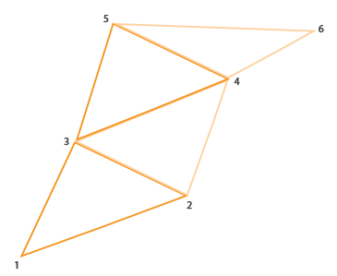

*Using a triangle strip as the output of the geometry shader we can easily create the house shape we're after by generating 3 adjacent triangles in the correct order. The following image shows in what order we need to draw what vertices to get the triangles we need with the blue dot being the input point:*

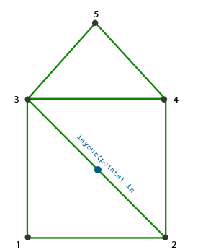

*This translates to the following geometry shader:*

*#version 330 core*

***layout*** *(points)* ***in****;*

***layout*** *(triangle_strip, max_vertices = 5)* ***out****;*

***void*** *build_house(vec4 position)*

*{*

*gl_Position = position + vec4(-0.2, -0.2, 0.0, 0.0); // 1:bottom-left*

*EmitVertex();*

*gl_Position = position + vec4( 0.2, -0.2, 0.0, 0.0); // 2:bottom-right*

*EmitVertex();*

*gl_Position = position + vec4(-0.2, 0.2, 0.0, 0.0); // 3:top-left*

*EmitVertex();*

*gl_Position = position + vec4( 0.2, 0.2, 0.0, 0.0); // 4:top-right*

*EmitVertex();*

*gl_Position = position + vec4( 0.0, 0.4, 0.0, 0.0); // 5:top*

*EmitVertex();*

*EndPrimitive();*

*}*

***void*** *main() {*

*build_house(gl_in[0].gl_Position);*

*}*

*This geometry shader generates 5 vertices, with each vertex being the point's position plus an offset, to form one large triangle strip. The resulting primitive is then rasterized and the fragment shader runs on the entire triangle strip, resulting in a green house for each point we've drawn:*

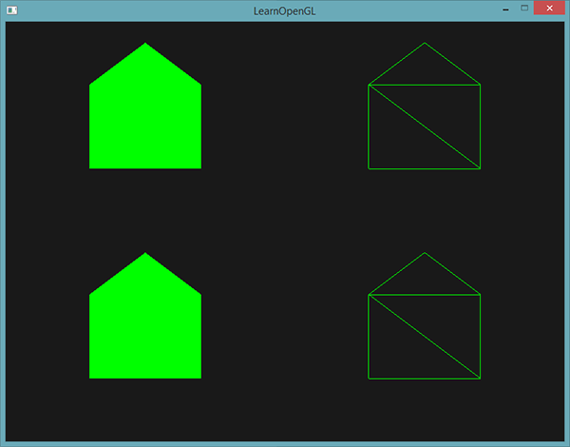

*You can see that each house indeed consists of 3 triangles - all drawn using just a single point in space. The green houses do look a bit boring though so let's liven it up a bit by giving each house a unique color. To do this we're going to add an extra vertex attribute with color information per vertex in the vertex shader, direct it to the geometry shader that further forwards it to the fragment shader.*

*The updated vertex data is given below:*

***float*** *points[] = {*

*-0.5f, 0.5f, 1.0f, 0.0f, 0.0f, // top-left*

*0.5f, 0.5f, 0.0f, 1.0f, 0.0f, // top-right*

*0.5f, -0.5f, 0.0f, 0.0f, 1.0f, // bottom-right*

*-0.5f, -0.5f, 1.0f, 1.0f, 0.0f // bottom-left*

*};*

*Then we update the vertex shader to forward the color attribute to the geometry shader using an interface block:*

*#version 330 core*

***layout*** *(location = 0)* ***in*** *vec2 aPos;*

***layout*** *(location = 1)* ***in*** *vec3 aColor;*

***out*** *VS_OUT {*

*vec3 color;*

*} vs_out;*

***void*** *main()*

*{*

*gl_Position = vec4(aPos.x, aPos.y, 0.0, 1.0);*

*vs_out.color = aColor;*

*}*

*Then we also need to declare the same interface block (with a different interface name) in the geometry shader:*

***in*** *VS_OUT {*

*vec3 color;*

*} gs_in[];*

*Because the geometry shader acts on a set of vertices as its input, its input data from the vertex shader is always represented as arrays of data even though we only have a single vertex right now.*

*We don't necessarily have to use interface blocks to transfer data to the geometry shader. We could have also written it as:*

***in*** *vec3 vColor[];*

*If the vertex shader forwarded the color vector as out vec3 vColor. However, interface blocks are much easier to work with in shaders like the geometry shader. In practice, geometry shader inputs can get quite large and grouping them in one large interface block array makes a lot more sense.*

*Then we should also declare an output color vector for the next fragment shader stage:*

***out*** *vec3 fColor;*

*Because the fragment shader expects only a single (interpolated) color it doesn't make sense to forward multiple colors. The fColor vector is thus not an array, but a single vector. When emitting a vertex, each vertex will store the last stored value in fColor for its fragment shader run. For the houses, we can thus only fill fColor once with the color from the vertex shader before the first vertex is emitted to color the entire house:*

*fColor = gs_in[0].color; // gs_in[0] since there's only one input vertex*

*gl_Position = position + vec4(-0.2, -0.2, 0.0, 0.0); // 1:bottom-left*

*EmitVertex();*

*gl_Position = position + vec4( 0.2, -0.2, 0.0, 0.0); // 2:bottom-right*

*EmitVertex();*

*gl_Position = position + vec4(-0.2, 0.2, 0.0, 0.0); // 3:top-left*

*EmitVertex();*

*gl_Position = position + vec4( 0.2, 0.2, 0.0, 0.0); // 4:top-right*

*EmitVertex();*

*gl_Position = position + vec4( 0.0, 0.4, 0.0, 0.0); // 5:top*

*EmitVertex();*

*EndPrimitive();*

*All the emitted vertices will have the last stored value in fColor embedded into their data that is equal to the vertex's color as we defined in their attributes. All the houses will now have a color of their own:*

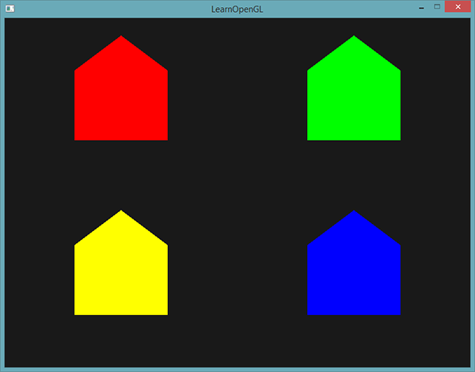

*Just for fun we could also pretend it's winter and give their roofs a little snow by giving the last vertex a color of its own: white.*

*fColor = gs_in[0].color;*

*gl_Position = position + vec4(-0.2, -0.2, 0.0, 0.0); // 1:bottom-left*

*EmitVertex();*

*gl_Position = position + vec4( 0.2, -0.2, 0.0, 0.0); // 2:bottom-right*

*EmitVertex();*

*gl_Position = position + vec4(-0.2, 0.2, 0.0, 0.0); // 3:top-left*

*EmitVertex();*

*gl_Position = position + vec4( 0.2, 0.2, 0.0, 0.0); // 4:top-right*

*EmitVertex();*

*gl_Position = position + vec4( 0.0, 0.4, 0.0, 0.0); // 5:top*

*fColor = vec3(1.0, 1.0, 1.0);*

*EmitVertex();*

*EndPrimitive();*

*The result now looks something like this:*

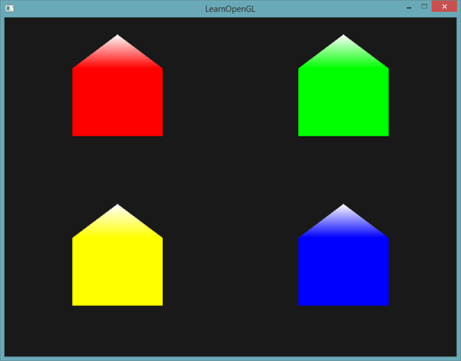

*You can compare your source code with the OpenGL code*[*here*](https://learnopengl.com/code_viewer_gh.php?code=src/4.advanced_opengl/9.1.geometry_shader_houses/geometry_shader_houses.cpp)*.*

*You can see that with geometry shaders you can get pretty creative even with the simplest primitives. Because the shapes are generated dynamically on the ultra-fast hardware of your GPU this is a lot more efficient than defining these shapes yourself within vertex buffers. Geometry buffers are therefore a great tool for optimization on simple often-repeating shapes like cubes in a voxel world or grass leaves on a large outdoor field.*

*04.11.2017*

### ***Exploding objects***

*While drawing houses is fun and all, it's not something we're going to use that much. That's why we're now going to take it up one notch and explode objects! That is something we're also probably not going to use that much either, but it does show you some of the powers of geometry shaders.*

*When we say exploding an object we're not actually going to blow up our precious bundled sets of vertices, but we're going to move each triangle along the direction of their normal vector over a small period of time. The effect is that the entire object's triangles seem to explode along the direction of each of the triangle's normal vectors. The effect of exploding triangles on the nanosuit model looks a bit like this:*

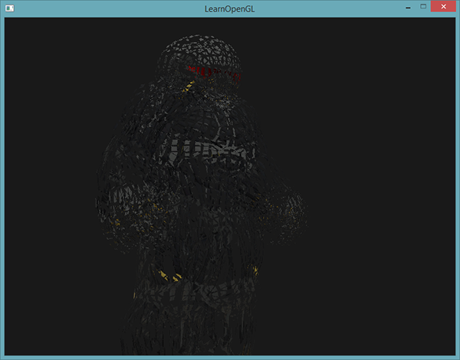

*The great thing about such a geometry shader effect is that it works on all objects, regardless of their complexity.*

*Because we're going to translate each vertex into the direction of the triangle's normal vector we first need to calculate this normal vector. What we need to do is calculate a vector that is perpendicular to the surface of a triangle, using just the 3 vertices we have access to. You might remember from the*[*transformations*](https://learnopengl.com/#!Getting-started/Transformations)*tutorial that we can retrieve a vector perpendicular to two other vectors using the cross product. If we were to retrieve two vectors a and b that are parallel to the surface of the triangle we can retrieve the normal vector by doing a cross product on those vectors. The following geometry shader function does exactly this to retrieve the normal vector using 3 input vertex coordinates:*

*vec3 GetNormal()*

*{*

*vec3 a = vec3(gl_in[0].gl_Position) - vec3(gl_in[1].gl_Position);*

*vec3 b = vec3(gl_in[2].gl_Position) - vec3(gl_in[1].gl_Position);*

***return*** *normalize(cross(a, b));*

*}*

*Here we retrieve two vectors a and b that are parallel to the surface of the triangle using subtraction. Subtracting two vectors from each other results in a vector that is the difference of the two vectors and since all 3 points lie on the triangle plane, subtracting any of its vectors from each other results in a vector parallel to the plane. Do note that if we switched a and b in the cross function we'd get a normal vector that points in the opposite direction - order is important here!*

*Now that we know how to calculate a normal vector we can create an explode function that takes this normal vector along with a vertex position vector. The function returns a new vector that translates the position vector along the direction of the normal vector:*

*vec4 explode(vec4 position, vec3 normal)*

*{*

***float*** *magnitude = 2.0;*

*vec3 direction = normal * ((sin(time) + 1.0) / 2.0) * magnitude;*

***return*** *position + vec4(direction, 0.0);*

*}*

*The function itself shouldn't be too complicated. The sin function receives a time variable as its argument that based on the time returns a value between -1.0 and 1.0. Because we don't want to implode the object we transform the sin values to the [0,1] range. The resulting value is then multiplied by the normal vector and the resulting direction vector is added to the position vector.*

*The complete geometry shader for the explode effect while drawing a model loaded using our*[*model loader*](https://learnopengl.com/#!Model-Loading/Assimp)*then looks like this:*

*#version 330 core*

***layout*** *(triangles)* ***in****;*

***layout*** *(triangle_strip, max_vertices = 3)* ***out****;*

***in*** *VS_OUT {*

*vec2 texCoords;*

*} gs_in[];*

***out*** *vec2 TexCoords;*

***uniform******float*** *time;*

*vec4 explode(vec4 position, vec3 normal) { ... }*

*vec3 GetNormal() { ... }*

***void*** *main() {*

*vec3 normal = GetNormal();*

*gl_Position = explode(gl_in[0].gl_Position, normal);*

*TexCoords = gs_in[0].texCoords;*

*EmitVertex();*

*gl_Position = explode(gl_in[1].gl_Position, normal);*

*TexCoords = gs_in[1].texCoords;*

*EmitVertex();*

*gl_Position = explode(gl_in[2].gl_Position, normal);*

*TexCoords = gs_in[2].texCoords;*

*EmitVertex();*

*EndPrimitive();*

*}*

*Note that we're also outputting the appropriate texture coordinates before emitting a vertex.*

*Also don't forget to actually set the time variable in your OpenGL code:*

*shader.setFloat("time", glfwGetTime());*

*The result is a 3D model that seems to continually explode its vertices over time after which it returns to normal again. Although not exactly super useful, it does show you a more advanced use of the geometry shader. You can compare your source code with the complete source code*[*here*](https://learnopengl.com/code_viewer_gh.php?code=src/4.advanced_opengl/9.2.geometry_shader_exploding/geometry_shader_exploding.cpp)*.*

#### **Visualizing normal vectors**

*In this section we're going to give you an example of using the geometry shader that is actually useful: visualizing the normal vectors of any object. When programming lighting shaders you will eventually run into weird visual outputs of which the cause is hard to determine. A common cause of lighting errors is due to incorrect normal vectors caused by incorrectly loading vertex data, improperly specifying them as vertex attributes or incorrectly managing them in the shaders. What we want is some way to detect if the normal vectors we supplied are correct. A great way to determine if your normal vectors are correct is by visualizing them and it just so happens that the geometry shader is an extremely useful tool for this purpose.*

*The idea is as follows: we first draw the scene as normal without a geometry shader and then we draw the scene a second time, but this time only displaying normal vectors that we generate via a geometry shader. The geometry shader takes as input a triangle primitive and generates 3 lines from those in the direction of the normal vector - one normal vector for each vertex. In pseudocode it'll look something like this:*

*shader.use();*

*DrawScene();*

*normalDisplayShader.use();*

*DrawScene();*

*This time we're creating a geometry shader that uses the vertex normals supplied by the model instead of generating them ourselves. To accommodate for scaling and rotations (due to the view and model matrix) we'll transform the normals first with a normal matrix before transforming it to clip-space coordinates (geometry shader receives its position vectors as clip-space coordinates so we should also transform the normal vectors to the same space). This can all be done in the vertex shader:*

*#version 330 core*

***layout*** *(location = 0)* ***in*** *vec3 aPos;*

***layout*** *(location = 1)* ***in*** *vec3 aNormal;*

***out*** *VS_OUT {*

*vec3 normal;*

*} vs_out;*

***uniform*** *mat4 projection;*

***uniform*** *mat4 view;*

***uniform*** *mat4 model;*

***void*** *main()*

*{*

*gl_Position = projection * view * model * vec4(aPos, 1.0);*

*mat3 normalMatrix = mat3(transpose(inverse(view * model)));*

*vs_out.normal = normalize(vec3(projection * vec4(normalMatrix * aNormal, 1.0)));*

*}*

*The transformed clip-space normal vector is then passed to the next shader stage via an interface block. The geometry shader then takes each vertex (with a position and a normal vector) and draws a normal vector from each position vector:*

*#version 330 core*

***layout*** *(triangles)* ***in****;*

***layout*** *(line_strip, max_vertices = 6)* ***out****;*

***in*** *VS_OUT {*

*vec3 normal;*

*} gs_in[];*

***const******float*** *MAGNITUDE = 0.4;*

***void*** *GenerateLine(****int*** *index)*

*{*

*gl_Position = gl_in[index].gl_Position;*

*EmitVertex();*

*gl_Position = gl_in[index].gl_Position + vec4(gs_in[index].normal, 0.0) * MAGNITUDE;*

*EmitVertex();*

*EndPrimitive();*

*}*

***void*** *main()*

*{*

*GenerateLine(0); // first vertex normal*

*GenerateLine(1); // second vertex normal*

*GenerateLine(2); // third vertex normal*

*}*

*The contents of geometry shaders like these should be self-explanatory by now. Note that we're multiplying the normal vector by a MAGNITUDE vector to restrain the size of the displayed normal vectors (otherwise they'd be a bit too large).*

*Since visualizing normals are mostly used for debugging purposes we can just display them as mono-colored lines (or super-fancy lines if you feel like it) with the help of the fragment shader:*

*#version 330 core*

***out*** *vec4 FragColor;*

***void*** *main()*

*{*

*FragColor = vec4(1.0, 1.0, 0.0, 1.0);*

*}*

*Now rendering your model with normal shaders first and then with the special normal-visualizing shader you'll see something like this:*

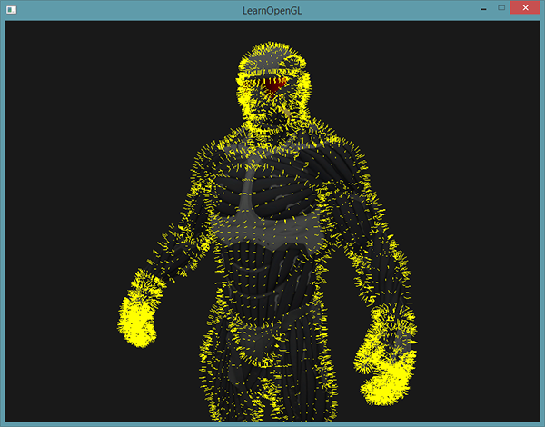

*Apart from the fact that our nanosuit now looks like a hairy guy with kitchen mittens on, it gives us a really useful method for determining if the normal vectors of a model are indeed correct. You can imagine that geometry shaders like this are also frequently used for adding fur to objects. // для дадання меху //*

*You can find the OpenGL's source code*[*here*](https://learnopengl.com/code_viewer_gh.php?code=src/4.advanced_opengl/9.3.geometry_shader_normals/normal_visualization.cpp)*.*

[*https://learnopengl.com/#!Advanced-OpenGL/Instancing*](https://learnopengl.com/#!Advanced-OpenGL/Instancing)

## ***Instancing***

*Say you have a scene where you're drawing a lot of models where most of these models contain the same set of vertex data, but with different world transformations. Think of a scene filled with grass leaves: each grass leave is a small model consisting of only a few triangles. You'll probably want to draw quite a few of them and your scene might end up with thousands or maybe tens of thousands of grass leaves that you need to render each frame. Because each leaf consists of only a few triangles the leaf is rendered almost instantly, but all those thousands of render calls you'll have to make will drastically reduce performance.*

*If we were to actually render such a large amount of objects it will look a bit like this in code:*

***for****(****unsigned******int*** *i = 0; i < amount_of_models_to_draw; i++)*

*{*

*DoSomePreparations(); // bind VAO, bind textures, set uniforms etc.*

*glDrawArrays(GL_TRIANGLES, 0, amount_of_vertices);*

*}*

*When drawing many instances of your model like this you'll quickly reach a performance bottleneck because of the many drawing calls. Compared to rendering the actual vertices, telling the GPU to render your vertex data with functions like glDrawArrays or glDrawElements eats up quite some performance since OpenGL must make necessary preparations before it can draw your vertex data (like telling the GPU which buffer to read data from, where to find vertex attributes and all this over the relatively slow CPU to GPU bus). So even though rendering your vertices is super fast, giving your GPU the commands to render them isn't.*

*It would be much more convenient if we could send some data over to the GPU once and then tell OpenGL to draw multiple objects with a single drawing call using this data. Enter instancing.*

*Instancing is a technique where we draw many objects at once with a single render call, saving us all the CPU -> GPU communications each time we need to render an object; this only has to be done once. To render using instancing all we need to do is change the render calls glDrawArrays and glDrawElements to glDrawArraysInstanced and glDrawElementsInstanced respectively. These instanced versions of the classic rendering functions take an extra parameter called the instance count that sets the number of instances we want to render. We thus sent all the required data to the GPU only once, and then tell the GPU how it should draw all these instances with a single call. The GPU then renders all these instances without having to continually communicate with the CPU.*

*By itself this function is a bit useless. Rendering the same object a thousand times is of no use to us since each of the rendered objects are rendered exactly the same and thus also at the same location; we would only see one object! For this reason GLSL embedded another built-in variable in the vertex shader called gl_InstanceID.*

*When drawing via one of the instanced rendering calls, gl_InstanceID is incremented for each instance being rendered starting from 0. If we were to render the 43th instance for example, gl_InstanceID would have the value 42 in the vertex shader. Having a unique value per instance means we could now for example index into a large array of position values to position each instance at a different location in the world.*

*To get a feel for instanced drawing we're going to demonstrate a simple example that renders a hundred 2D quads in normalized device coordinates with just one render call. We accomplish this by adding a small offset to each instanced quad by indexing a uniform array of 100 offset vectors. The result is a neatly organized grid of quads that fill the entire window:*

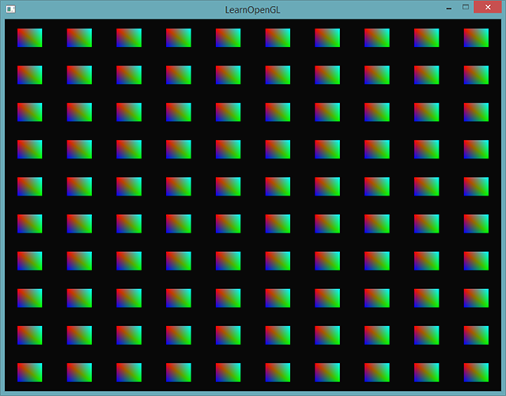

*Each quad consists of 2 triangles with a total of 6 vertices. Each vertex contains a 2D NDC position vector and a color vector. Below is the vertex data used for this example - the triangles are quite small to properly fit the screen in large quantities:*

***float*** *quadVertices[] = {*

*// positions // colors*

*-0.05f, 0.05f, 1.0f, 0.0f, 0.0f,*

*0.05f, -0.05f, 0.0f, 1.0f, 0.0f,*

*-0.05f, -0.05f, 0.0f, 0.0f, 1.0f,*

*-0.05f, 0.05f, 1.0f, 0.0f, 0.0f,*

*0.05f, -0.05f, 0.0f, 1.0f, 0.0f,*

*0.05f, 0.05f, 0.0f, 1.0f, 1.0f*

*};*

*The colors of the quads are accomplished with the fragment shader that receives a forwarded color vector from the vertex shader and sets it as its color output:*

*#version 330 core*

***out*** *vec4 FragColor;*

***in*** *vec3 fColor;*

***void*** *main()*

*{*

*FragColor = vec4(fColor, 1.0);*

*}*

*Nothing new so far, but at the vertex shader it's starting to get interesting:*

*#version 330 core*

***layout*** *(location = 0)* ***in*** *vec2 aPos;*

***layout*** *(location = 1)* ***in*** *vec3 aColor;*

***out*** *vec3 fColor;*

***uniform*** *vec2 offsets[100];*

***void*** *main()*

*{*

*vec2 offset = offsets[gl_InstanceID];*

*gl_Position = vec4(aPos + offset, 0.0, 1.0);*

*fColor = aColor;*

*}*

*Here we defined a uniform array called offsets that contain a total of 100 offset vectors. Within the vertex shader we then retrieve an offset vector for each instance by indexing the offsets array using gl_InstanceID. If we were to draw 100 quads using instanced drawing we'd get 100 quads located at different positions with just this vertex shader.*

*We do need to actually set the offset positions that we calculate in a nested for-loop before we enter the game loop:*

*glm::vec2 translations[100];*

***int*** *index = 0;*

***float*** *offset = 0.1f;*

***for****(****int*** *y = -10; y < 10; y += 2)*

*{*

***for****(****int*** *x = -10; x < 10; x += 2)*

*{*

*glm::vec2 translation;*

*translation.x = (****float****)x / 10.0f + offset;*

*translation.y = (****float****)y / 10.0f + offset;*

*translations[index++] = translation;*

*}*

*}*

*Here we create a set of 100 translation vectors that contains a translation vector for all positions in a 10x10 grid. Aside from generating the translations array we'd also need to transfer the data to the vertex shader's uniform array:*

*shader.use();*

***for****(****unsigned******int*** *i = 0; i < 100; i++)*

*{*

*stringstream ss;*

*string index;*

*ss << i;*

*index = ss.str();*

*shader.setVec2(("offsets[" + index + "]").c_str(), translations[i]);*

*}*

*Within this snippet of code we transform the for-loop counter i to a string that we then use to dynamically create a location string for querying the uniform location. For each item in the offsets uniform array we then set the corresponding translation vector.*

*Now that all the preparations are finished we can start rendering the quads. To draw via instanced rendering we call glDrawArraysInstanced or glDrawElementsInstanced. Since we're not using an element index buffer we're going to call the glDrawArrays version:*

*glBindVertexArray(quadVAO);*

*glDrawArraysInstanced(GL_TRIANGLES, 0, 6, 100);*

*The parameters of glDrawArraysInstanced are exactly the same as glDrawArrays except the last parameter that sets the number of instances we want to draw. Since we want to display 100 quads in a 10x10 grid we set it equal to 100. Running the code should now give you the familiar image of 100 colorful quads.*

### ***Instanced arrays***

*While the previous implementation works fine for this specific use case, whenever we are rendering a lot more than 100 instances (which is quite common) we will eventually hit a*[*limit*](http://www.opengl.org/wiki/Uniform_(GLSL)#Implementation_limits)*on the amount of uniform data we can send to the shaders. Another alternative is called instanced arrays that is defined as a vertex attribute (allowing us to store much more data) that is only updated whenever the vertex shader renders a new instance.*

*With vertex attributes, each run of the vertex shader will cause GLSL to retrieve the next set of vertex attributes that belong to the current vertex. When defining a vertex attribute as an instanced array however, the vertex shader only updates the content of the vertex attribute per instance instead of per vertex. This allows us to use the standard vertex attributes for data per vertex and use the instanced array for storing data that is unique per instance.*

*To give you an example of an instanced array we're going to take the previous example and represent the offset uniform array as an instanced array. We'll have to update the vertex shader by adding another vertex attribute:*

*#version 330 core*

***layout*** *(location = 0)* ***in*** *vec2 aPos;*

***layout*** *(location = 1)* ***in*** *vec3 aColor;*

***layout*** *(location = 2)* ***in*** *vec2 aOffset;*

***out*** *vec3 fColor;*

***void*** *main()*

*{*

*gl_Position = vec4(aPos + aOffset, 0.0, 1.0);*

*fColor = aColor;*

*}*

*We no longer use gl_InstanceID and can directly use the offset attribute without first indexing into a large uniform array.*

*Because an instanced array is a vertex attribute, just like the position and color variables, we also need to store its content in a vertex buffer object and configure its attribute pointer. We're first going to store the translations array (from the previous section) in a new buffer object:*

***unsigned******int*** *instanceVBO;*

*glGenBuffers(1, &instanceVBO);*

*glBindBuffer(GL_ARRAY_BUFFER, instanceVBO);*

*glBufferData(GL_ARRAY_BUFFER,* ***sizeof****(glm::vec2) * 100, &translations[0], GL_STATIC_DRAW);*

*glBindBuffer(GL_ARRAY_BUFFER, 0);*

*Then we also need to set its vertex attribute pointer and enable the vertex attribute:*

*glEnableVertexAttribArray(2);*

*glBindBuffer(GL_ARRAY_BUFFER, instanceVBO);*

*glVertexAttribPointer(2, 2, GL_FLOAT, GL_FALSE, 2 \** ***sizeof****(****float****), (****void****\*)0);*

*glBindBuffer(GL_ARRAY_BUFFER, 0);*

*glVertexAttribDivisor(2, 1);*

*What makes this code interesting is the last line where we call glVertexAttribDivisor. This function tells OpenGL****when*** *to update the content of a vertex attribute to the next element. Its first parameter is the vertex attribute in question and the second parameter the attribute divisor. By default the attribute divisor is 0 which tells OpenGL to update the content of the vertex attribute each iteration of the vertex shader. By setting this attribute to 1 we're telling OpenGL that we want to update the content of the vertex attribute when we start to render a new instance. By setting it to 2 we'd update the content every 2 instances and so on. By setting the attribute divisor to 1 we're effectively telling OpenGL that the vertex attribute at attribute location 2 is an instanced array. // калі я задам 2, то ў мяне палова квадратаў ніжэй не намалюецца? // // так менавіта яно і ёсць. Праверана. //*

*If we now were to render the quads again using glDrawArraysInstanced we'd get the following output:*

**

*This is exactly the same as the previous example, but this time accomplished using instanced arrays, which allows us to pass a lot more data (as much as memory allows us to) to the vertex shader for instanced drawing.*

*For fun we could also slowly downscale each quad from top-right to bottom-left using gl_InstanceID again, because why not?*

***void*** *main()*

*{*

*vec2 pos = aPos * (gl_InstanceID / 100.0);*

*gl_Position = vec4(pos + aOffset, 0.0, 1.0);*

*fColor = aColor;*

*}*

*The result is that the first instances of the quads are drawn extremely small and the further we're in the process of drawing the instances, the closer gl_InstanceID gets to 100 and thus the more the quads regain their original size. It's perfectly legal to use instanced arrays together with gl_InstanceID like this.*

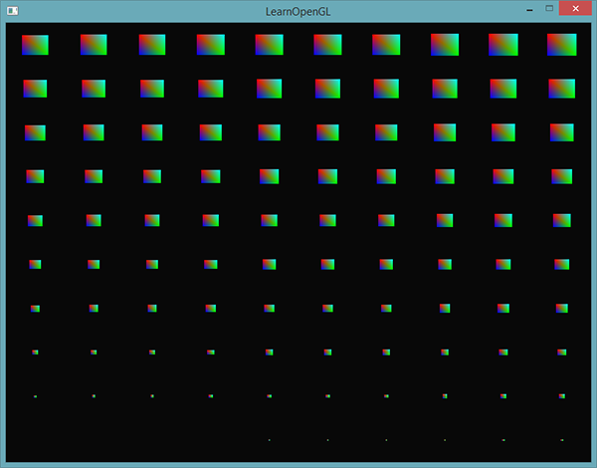

*If you're still a bit unsure about how instanced rendering works or want to see how everything fits together you can find the full source code of the application*[*here*](https://learnopengl.com/code_viewer_gh.php?code=src/4.advanced_opengl/10.1.instancing_quads/instancing_quads.cpp)*.*

*While fun and all, these examples aren't really good examples of instancing. Yes, they do give you an easy overview of how instancing works, but instancing is extremely useful when drawing an enormous amount of similar objects which we haven't really been doing so far. For that reason we're going to venture into space in the next section to see the real power of instanced rendering.*

### ***An asteroid field***

*Imagine a scene where we have one large planet that's at the center of a large asteroid ring. Such an asteroid ring could contain thousands or tens of thousands of rock formations and quickly becomes un-renderable on any decent graphics card. This scenario proves itself particularly useful for instanced rendering, since all the asteroids can be represented using a single model. Each single asteroid then contains minor variations using a transformation matrix unique to each asteroid.*

*To demonstrate the impact of instanced rendering we're first going to render a scene of asteroids flying around a planet without instanced rendering. The scene will contain a large planet model that can be downloaded from*[*here*](https://learnopengl.com/data/models/planet.rar)*and a large set of asteroid rocks that we properly position around the planet. The asteroid rock model can be downloaded*[*here*](https://learnopengl.com/data/models/rock.rar)*.*

*Within the code samples we load the models using the model loader we've previously defined in the*[*model loading*](https://learnopengl.com/#!Model-Loading/Assimp)*tutorials.*

*To achieve the effect we're looking for we'll be generating a transformation matrix for each asteroid that we'll use as their model matrix. The transformation matrix is created by first translating the rock somewhere in the asteroid ring - we'll also add a small random displacement value to this offset to make the ring look more natural. Then we apply a random scale and a random rotation around a rotation vector. The result is a transformation matrix that transforms each asteroid somewhere around the planet while also giving it a more natural and unique look compared to other asteroids. The result is a ring full of asteroids where each asteroid looks different to the other.*

***unsigned******int*** *amount = 1000;*

*glm::mat4 *modelMatrices;*

*modelMatrices =* ***new*** *glm::mat4[amount];*

*srand(glfwGetTime()); // initialize random seed*

***float*** *radius = 50.0;*

***float*** *offset = 2.5f;*

***for****(****unsigned******int*** *i = 0; i < amount; i++)*

*{*

*glm::mat4 model;*

*// 1. translation: displace along circle with 'radius' in range [-offset, offset]*

***float*** *angle = (****float****)i / (****float****)amount * 360.0f;*

***float*** *displacement = (rand() % (****int****)(2 * offset * 100)) / 100.0f - offset;*

***float*** *x = sin(angle) * radius + displacement;*

*displacement = (rand() % (****int****)(2 * offset * 100)) / 100.0f - offset;*

***float*** *y = displacement * 0.4f; // keep height of field smaller compared to width of x and z*

*displacement = (rand() % (****int****)(2 * offset * 100)) / 100.0f - offset;*

***float*** *z = cos(angle) * radius + displacement;*

*model = glm::translate(model, glm::vec3(x, y, z));*

*// 2. scale: Scale between 0.05 and 0.25f*

***float*** *scale = (rand() % 20) / 100.0f + 0.05;*

*model = glm::scale(model, glm::vec3(scale));*

*// 3. rotation: add random rotation around a (semi)randomly picked rotation axis vector*

***float*** *rotAngle = (rand() % 360);*

*model = glm::rotate(model, rotAngle, glm::vec3(0.4f, 0.6f, 0.8f));*

*// 4. now add to list of matrices*

*modelMatrices[i] = model;*

*}*

*This piece of code might look a little daunting, but we basically transform the x and z position of the asteroid along a circle with a radius defined by radius and randomly displace each asteroid a little around the circle by -offset and offset. We give the y displacement less of an impact to create a more flat asteroid ring. Then we apply scale and rotation transformations and store the resulting transformation matrix in modelMatrices that is of size amount. Here we generate a total of 1000 model matrices, one per asteroid.*

*After loading the planet and rock models and compiling a set of shaders, the rendering code then looks a bit like this:*

*// draw Planet*

*shader.use();*

*glm::mat4 model;*

*model = glm::translate(model, glm::vec3(0.0f, -3.0f, 0.0f));*

*model = glm::scale(model, glm::vec3(4.0f, 4.0f, 4.0f));*

*shader.setMat4("model", model);*

*planet.Draw(shader);*

*// draw meteorites*

***for****(****unsigned******int*** *i = 0; i < amount; i++)*

*{*

*shader.setMat4("model", modelMatrices[i]);*

*rock.Draw(shader);*

*}*

*First we draw the planet model that we translate and scale a bit to accommodate to the scene and then we draw a number of rock models equal to the amount of transformations we calculated. Before we draw each rock however, we first set the corresponding model transformation matrix within the shader.*

*The result is then a space-like scene where we can see a natural-looking asteroid ring around a planet:*

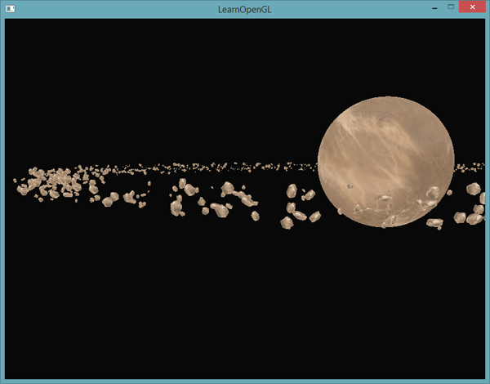

*This scene contains a total of 1001 rendering calls per frame of which 1000 are of the rock model. You can find the source code for this scene*[*here*](https://learnopengl.com/code_viewer_gh.php?code=src/4.advanced_opengl/10.2.asteroids/asteroids.cpp)*.*

*As soon as we start to increase this number we will quickly notice that the scene stops running smoothly and the number of frames we're able to render per second reduces drastically. As soon as we set amount to 2000 the scene already becomes so slow, it's difficult to move around.*

*Let's now try to render the same scene, but this time using instanced rendering. We first need to adapt the vertex shader a little:*

*#version 330 core*

***layout*** *(location = 0)* ***in*** *vec3 aPos;*

***layout*** *(location = 2)* ***in*** *vec2 aTexCoords;*

***layout*** *(location = 3)* ***in*** *mat4 instanceMatrix;*

***out*** *vec2 TexCoords;*

***uniform*** *mat4 projection;*

***uniform*** *mat4 view;*

***void*** *main()*

*{*

*gl_Position = projection * view * instanceMatrix * vec4(aPos, 1.0);*

*TexCoords = aTexCoords;*

*}*

*We're no longer using a model uniform variable, but instead declare a mat4 as a vertex attribute so we can store an instanced array of transformation matrices. However, when we declare a datatype as a vertex attribute that is greater than a vec4 things work a bit differently. The maximum amount of data allowed as a vertex attribute is equal to a vec4. Because a mat4 is basically 4 vec4s, we have to reserve 4 vertex attributes for this specific matrix. Because we assigned it a location of 3, the columns of the matrix will have vertex attribute locations of 3, 4, 5 and 6.*

*We then have to set each of the attribute pointers of those 4 vertex attributes and configure them as instanced arrays:*

*// vertex Buffer Object*

***unsigned******int*** *buffer;*

*glGenBuffers(1, &buffer);*

*glBindBuffer(GL_ARRAY_BUFFER, buffer);*

*glBufferData(GL_ARRAY_BUFFER, amount \** ***sizeof****(glm::mat4), &modelMatrices[0], GL_STATIC_DRAW);*

***for****(****unsigned******int*** *i = 0; i < rock.meshes.size(); i++)*

*{*

***unsigned******int*** *VAO = rock.meshes[i].VAO;*

*glBindVertexArray(VAO);*

*// vertex Attributes*

***GLsizei*** *vec4Size =* ***sizeof****(glm::vec4);*

*glEnableVertexAttribArray(3);*

*glVertexAttribPointer(3, 4, GL_FLOAT, GL_FALSE, 4 * vec4Size, (****void****\*)0);*

*glEnableVertexAttribArray(4);*

*glVertexAttribPointer(4, 4, GL_FLOAT, GL_FALSE, 4 * vec4Size, (****void****\*)(vec4Size));*

*glEnableVertexAttribArray(5);*

*glVertexAttribPointer(5, 4, GL_FLOAT, GL_FALSE, 4 * vec4Size, (****void****\*)(2 * vec4Size));*

*glEnableVertexAttribArray(6);*

*glVertexAttribPointer(6, 4, GL_FLOAT, GL_FALSE, 4 * vec4Size, (****void****\*)(3 * vec4Size));*

*glVertexAttribDivisor(3, 1);*

*glVertexAttribDivisor(4, 1);*

*glVertexAttribDivisor(5, 1);*

*glVertexAttribDivisor(6, 1);*

*glBindVertexArray(0);*

*}*

*Note that we cheated a little by declaring the VAO variable of the Mesh as a public variable instead of a private variable so we could access its vertex array object. This is not the cleanest solution, but just a simple modification to suit this tutorial. Aside from the little hack, this code should be clear. We're basically declaring how OpenGL should interpret the buffer for each of the matrix's vertex attributes and that each of those vertex attributes is an instanced array.*

*Next we take the VAO of the mesh(es) again and this time draw using glDrawElementsInstanced:*

*// draw meteorites*

*instanceShader.use();*

***for****(****unsigned******int*** *i = 0; i < rock.meshes.size(); i++)*

*{*

*glBindVertexArray(rock.meshes[i].VAO);*

*glDrawElementsInstanced(*

*GL_TRIANGLES, rock.meshes[i].indices.size(), GL_UNSIGNED_INT, 0, amount*

*);*

*}*

*Here we draw the same amount of asteroids as the earlier example, but this time using instanced rendering. The results should be similar, but you'll start to really see the effect of instanced rendering when we start to increase this amountvariable. Without instanced rendering we were able to smoothly render around 1000 to 1500 asteroids. With instanced rendering we can now set this value to 100000 that, with the rock model having 576 vertices, equals around 57 million vertices drawn each frame without any performance drops!*

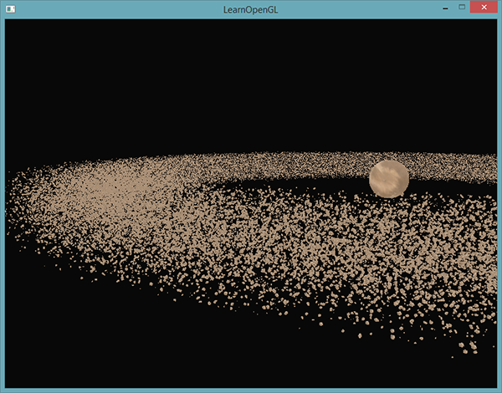

*This image was rendered with 100000 asteroids with a radius of 150.0f and an offset equal to 25.0f. You can find the source code of the instanced rendering demo*[*here*](https://learnopengl.com/code_viewer_gh.php?code=src/4.advanced_opengl/10.3.asteroids_instanced/asteroids_instanced.cpp)*.*

*On different machines an asteroid count of 100000 might be a bit too high, so try tweaking the values till you reach an acceptable framerate. // у мяне на 100000 і на 50000 на ноутбуку глючыла, а вось на 10000 – цудоўна. //*

*As you can see, with the right type of environments instanced rendering can make an enormous difference to the rendering capabilities of your graphics card. For this reason, instanced rendering is commonly used for grass, flora, particles and scenes like this - basically any scene with many repeating shapes can benefit from instanced rendering. // кантэкст выкарыстання паняцця //*

[*https://learnopengl.com/#!Advanced-OpenGL/Anti-Aliasing*](https://learnopengl.com/#!Advanced-OpenGL/Anti-Aliasing)

## ***Anti Aliasing***

*05.11.2017*

*Somewhere in your adventurous rendering journey you probably came across some jagged saw-like patterns along the edges of your models. The reason these jagged edges appear is due to how the rasterizer transforms the vertex data into actual fragments behind the scene. An example of what these jagged edges look like can already be seen when drawing a simple cube:*

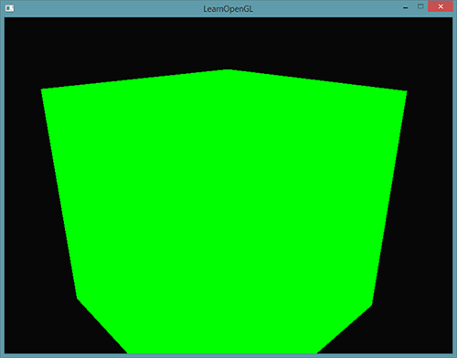

*While not immediately visible, if you take a closer look at the edges of the cube you'll see a jagged pattern. If we zoom in you'd see the following:*

**

*This is clearly not something we want in a final version of an application. This effect, of clearly seeing the pixel formations an edge is composed of, is called aliasing. There are quite a few techniques out there called anti-aliasing techniques that fight exactly this aliasing behavior to produce more smooth edges.*

*At first we had a technique called super sample anti-aliasing (SSAA) that temporarily used a much higher resolution to render the scene in (super sampling) and when the visual output is updated in the framebuffer, the resolution was downsampled back to the normal resolution. This extra resolution was used to prevent these jagged edges. While it did provide us with a solution to the aliasing problem, it came with a major performance drawback since we had to draw a lot more fragments than usual. This technique therefore only had a short glory moment.*

*This technique did gave birth to a more modern technique called multisample anti-aliasing or MSAA that borrows from the concepts behind SSAA while implementing a much more efficient approach. In this tutorial we'll be extensively discussing this MSAA technique that is built-in in OpenGL.*

#### **Multisampling**

*To understand what multisampling is and how it works into solving the aliasing problem we first need to delve a bit further into the inner workings of OpenGL's rasterizer.*

*The rasterizer is the combination of all algorithms and processes that sit between your final processed vertices and the fragment shader. The rasterizer takes all vertices belonging to a single primitive and transforms this to a set of fragments. Vertex coordinates can theoretically have any coordinate, but fragments can't since they are bound by the resolution of your window. There will almost never be a one-on-one mapping between vertex coordinates and fragments, so the rasterizer has to determine in some way at what fragment/screen-coordinate each specific vertex will end up at.*

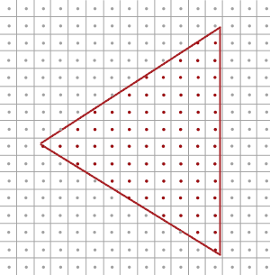

*Here we see a grid of screen pixels where the center of each pixel contains a sample point that is used to determine if a pixel is covered by the triangle. The red sample points are covered by the triangle and a fragment will be generated for that covered pixel. Even though some parts of the triangle edges still enter certain screen pixels, the pixel's sample point is not covered by the inside of the triangle so this pixel won't be influenced by any fragment shader.*

*You can probably already figure out the origin of aliasing right now. The complete rendered version of the triangle would look like this on your screen:*

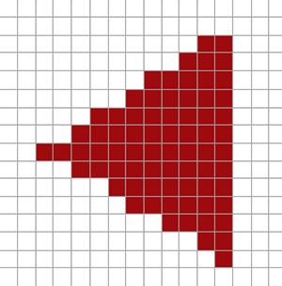

*Due to the limited amount of screen pixels, some pixels will be rendered along an edge and some won't. The result is that we're rendering primitives with non-smooth edges giving rise to the jagged edges we've seen before.*

*What multisampling does is not use a single sampling point for determining coverage of the triangle, but use multiple sample points (guess where it got its name from). Instead of a single sample point at the center of each pixel we're going to place 4 subsamples in a general pattern and use those to determine pixel coverage. This does mean that the size of the color buffer is also increased by the number of subsamples we're using per pixel.*

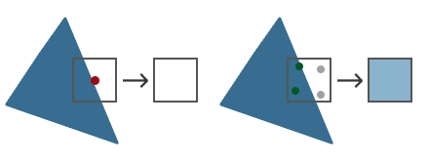

*The left side of the image shows how we would normally determine the coverage of a triangle. This specific pixel won't run a fragment shader (and thus remains blank) since its sample point wasn't covered by the triangle. The right side of the image shows a multisampled version where each pixel contains 4 sample points. Here we can see that only 2 of the sample points cover the triangle.*

*The amount of sample points can be any number we'd like with more samples giving us better coverage precision.*

*This is where multisampling becomes interesting. We determined that 2 subsamples were covered by the triangle so the next step is to determine a color for this specific pixel. Our initial guess would be that we run the fragment shader for each covered subsample and later average the colors of each subsample per pixel. In this case we'd run the fragment shader twice on the interpolated vertex data at each subsample and store the resulting color in those sample points. This is (fortunately)****not****how it works, because this basically means we need to run a lot more fragment shaders than without multisampling, drastically reducing performance.*

*How MSAA really works is that the fragment shader is only run****once****per pixel (for each primitive) regardless of how many subsamples the triangle covers. The fragment shader is run with the vertex data interpolated to the****center****of the pixel and the resulting color is then stored inside each of the covered subsamples. Once the color buffer's subsamples are filled with all the colors of the primitives we've rendered, all these colors are then averaged per pixel resulting in a single color per pixel. Because only two of the 4 samples were covered in the previous image, the color of the pixel was averaged with the triangle's color and the color stored at the other 2 sample points (in this case: the clear color) resulting in a light blue-ish color.*

*The result is a color buffer where all the primitive edges now produce a smoother pattern. Let's see what multisampling looks like when we again determine the coverage of the earlier triangle:*

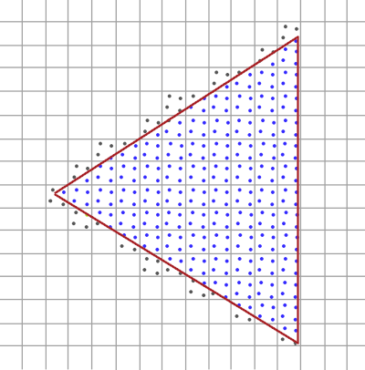

*Here each pixel contains 4 subsamples (the irrelevant samples were hidden) where the blue subsamples are covered by the triangle and the gray sample points aren't. Within the inner region of the triangle all pixels will run the fragment shader once where its color output it is stored in all 4 subsamples. At the edges of the triangle not all subsamples will be covered so the result of the fragment shader is only stored at some subsamples. Based on the amount of subsamples covered, the resulting pixel color is determined by the triangle color and the other subsample's stored colors.*

*Basically, the more sample points are covered by the triangle, the more the eventual pixel color is that of the triangle. If we then fill the pixel colors just like we did earlier with the non-multisampled triangle we get the following image:*

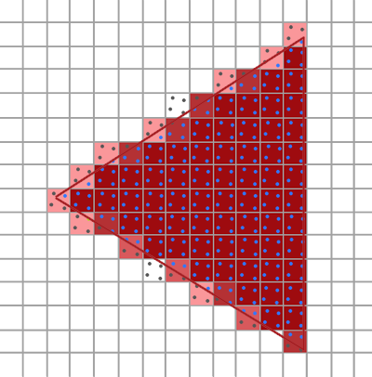

*For each pixel, the less subsamples are part of the triangle, the less it takes the color of the triangle as you can see in the image. The hard edges of the triangle are now surrounded by colors slightly lighter than the actual edge color, which causes the edge to appear smooth when viewed from a distance.*

*Not only color values are affected by the multisampling, but also the depth and stencil test now make use of the multiple sample points. For depth testing, the vertex's depth value is interpolated to each subsample before running the depth test and for stencil testing we store stencil values per subsample, instead of per pixel. This does mean that the size of the depth and stencil buffer are now also increased by the amount of subsamples per pixel.*

*What we've discussed so far is a basic overview of how multisampled anti-aliasing works behind the scenes. The actual logic behind the rasterizer is a bit more complicated than we've discussed here, but you should be able to understand the concept and logic behind multisampled anti-aliasing now.*

***MSAA in OpenGL***

*If we want to use MSAA in OpenGL we need to use a color buffer that is able to store more than one color value per pixel (since multisampling requires us to store a color per sample point). We thus need a new type of buffer that can store a given amount of multisamples and this is called a multisample buffer.*

*Most windowing systems are able to provide us a multisample buffer instead of a default color buffer. GLFW also gives us this functionality and all we need to do is hint GLFW that we'd like to use a multisample buffer with N samples instead of a normal color buffer by calling glfwWindowHint before creating the window:*

*glfwWindowHint(GLFW_SAMPLES, 4);*

*When we now call glfwCreateWindow the rendering window is created, this time with a color buffer containing 4 subsamples per screen coordinate. GLFW also automatically creates a depth and stencil buffer with 4 subsamples per pixel. This does mean that the size of all the buffers is increased by 4.*

*Now that we asked GLFW for multisampled buffers we need to enable multisampling by calling glEnable and enabling GL_MULTISAMPLE. On most OpenGL drivers, multisampling is enabled by default so this call is then a bit redundant, but it's usually a good idea to enable it anyways. This way all OpenGL implementations have multisampling enabled.*

*glEnable(GL_MULTISAMPLE);*

*Once the default framebuffer has multisampled buffer attachments, all we need to do to enable multisampling is just call glEnable and we're done. Because the actual multisampling algorithms are implemented in the rasterizer in your OpenGL drivers there's not much else we need to do. If we now were to render the green cube from the start of this tutorial we should see much smoother edges:*

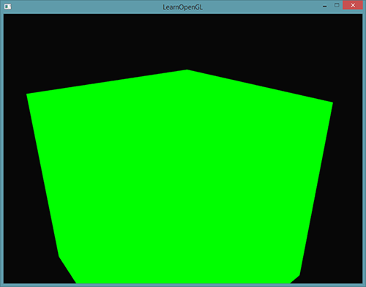

*This container does indeed look a lot smoother and the same will apply for any other object you're drawing in your scene. You can find the source code for this simple example*[*here*](https://learnopengl.com/code_viewer.php?code=advanced/anti_aliasing_multisampling)*.*

### ***Off-screen MSAA***

*Because GLFW takes care of creating the multisampled buffers, enabling MSAA is quite easy. If we want to use our own framebuffers however, for some off-screen rendering, we have to generate the multisampled buffers ourselves; now we do need to take care of creating multisampled buffers.*

*There are two ways we can create multisampled buffers to act as attachments for framebuffers: texture attachments and renderbuffer attachments, similar to normal attachments like we've discussed in the*[*framebuffers*](https://learnopengl.com/#!Advanced-OpenGL/Framebuffers)*tutorial.*

#### **Multisampled texture attachments**

*To create a texture that supports storage of multiple sample points we use glTexImage2DMultisample instead of glTexImage2D that accepts GL_TEXTURE_2D_MULTISAPLE as its texture target:*

*glBindTexture(GL_TEXTURE_2D_MULTISAMPLE, tex);*

*glTexImage2DMultisample(GL_TEXTURE_2D_MULTISAMPLE, samples, GL_RGB, width, height, GL_TRUE);*

*glBindTexture(GL_TEXTURE_2D_MULTISAMPLE, 0);*

*The second argument now sets the number of samples we'd like the texture to have. If the last argument is equal to GL_TRUE the image will use identical sample locations and the same number of subsamples for each texel.*

*To attach a multisampled texture to a framebuffer we use glFramebufferTexture2D, but this time with GL_TEXTURE_2D_MULTISAMPLE as the texture type:*

*glFramebufferTexture2D(GL_FRAMEBUFFER, GL_COLOR_ATTACHMENT0, GL_TEXTURE_2D_MULTISAMPLE, tex, 0);*

*The currently bound framebuffer now has a multisampled color buffer in the form of a texture image.*

#### **Multisampled renderbuffer objects**

*Like textures, creating a multisampled renderbuffer object isn't difficult. It is even quite easy since all we need to change is the call to glRenderbufferStorage that is now glRenderbufferStorageMultisample when we specify the (currently bound) renderbuffer's memory storage:*

*glRenderbufferStorageMultisample(GL_RENDERBUFFER, 4, GL_DEPTH24_STENCIL8, width, height);*

*The one thing that changed here is the extra parameter after the renderbuffer target where we set the amount of samples we'd like to have which is 4 in this particular case.*

#### **Render to multisampled framebuffer**

*Rendering to a multisampled framebuffer object goes automatically. Whenever we draw anything while the framebuffer object is bound, the rasterizer will take care of all the multisample operations. We then end up with a multisampled color buffer and/or depth and stencil buffer. Because a multisampled buffer is a bit special we can't directly use their buffer images for other operations like sampling them in a shader.*

*A multisampled image contains much more information than a normal image so what we need to do is downscale or resolve the image. Resolving a multisampled framebuffer is generally done via glBlitFramebuffer that copies a region from one framebuffer to the other while also resolving any multisampled buffers.*

*glBlitFramebuffer transfers a given source region defined by 4 screen-space coordinates to a given target region also defined by 4 screen-space coordinates. You might remember from the*[*framebuffers*](https://learnopengl.com/#!Advanced-OpenGL/Framebuffers)*tutorial that if we bind to GL_FRAMEBUFFER we're binding to both the read and draw framebuffer targets. We could also bind to those targets individually by binding the framebuffers to GL_READ_FRAMEBUFFER and GL_DRAW_FRAMEBUFFER respectively. The glBlitFramebuffer function reads from those two targets to determine which is the source and which is the target framebuffer. We could then transfer the multisampled framebuffer output to the actual screen by blitting the image to the default framebuffer like so:*

*glBindFramebuffer(GL_READ_FRAMEBUFFER, multisampledFBO);*

*glBindFramebuffer(GL_DRAW_FRAMEBUFFER, 0);*

*glBlitFramebuffer(0, 0, width, height, 0, 0, width, height, GL_COLOR_BUFFER_BIT, GL_NEAREST);*

*If we then were to render the application we'd get the same output as without a framebuffer: a lime-green cube that is displayed using MSAA and thus shows significantly less jagged edges:*

**

*You can find the source code*[*here*](https://learnopengl.com/code_viewer_gh.php?code=src/4.advanced_opengl/11.anti_aliasing_offscreen/anti_aliasing_offscreen.cpp)*.*

*But what if we wanted to use the texture result of a multisampled framebuffer to do stuff like post-processing? We can't directly use the multisampled texture(s) in the fragment shader. What we could do is blit the multisampled buffer(s) to a different FBO with a non-multisampled texture attachment. We then use this ordinary color attachment texture for post-processing, effectively post-processing an image rendered via multisampling. This does mean we have to generate a new FBO that acts solely as an intermediate framebuffer object to resolve the multisampled buffer into a normal 2D texture we can use in the fragment shader. This process looks a bit like this in pseudocode:*

***unsigned******int*** *msFBO = CreateFBOWithMultiSampledAttachments();*

*// then create another FBO with a normal texture color attachment*

*...*

*glFramebufferTexture2D(GL_FRAMEBUFFER, GL_COLOR_ATTACHMENT0, GL_TEXTURE_2D, screenTexture, 0);*

*...*

***while****(!glfwWindowShouldClose(window))*

*{*

*...*

*glBindFramebuffer(msFBO);*

*ClearFrameBuffer();*

*DrawScene();*

*// now resolve multisampled buffer(s) into intermediate FBO*

*glBindFramebuffer(GL_READ_FRAMEBUFFER, msFBO);*

*glBindFramebuffer(GL_DRAW_FRAMEBUFFER, intermediateFBO);*

*glBlitFramebuffer(0, 0, width, height, 0, 0, width, height, GL_COLOR_BUFFER_BIT, GL_NEAREST);*

*// now scene is stored as 2D texture image, so use that image for post-processing*

*glBindFramebuffer(GL_FRAMEBUFFER, 0);*

*ClearFramebuffer();*

*glBindTexture(GL_TEXTURE_2D, screenTexture);*

*DrawPostProcessingQuad();*

*...*

*}*

*If we'd then implement this into the post-processing code of the*[*framebuffers*](https://learnopengl.com/#!Advanced-OpenGL/Framebuffers)*tutorial we're able to create all kinds of cool post-processing effects on a texture of a scene with (almost) no jagged edges. With the blur kernel filter applied it'll look something like this:*

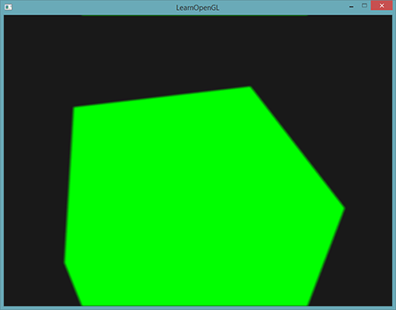

*Because the screen texture is a normal texture again with just a single sample point, some post-processing filters like edge-detection will introduce jagged edges again. To accommodate for this you could blur the texture afterwards or create your own anti-aliasing algorithm.*

*You can see that when we want to combine multisampling with off-screen rendering we'd need to take care of some extra details. All the details are worth the extra effort though since multisampling significantly boosts the visual quality of your scene. Do note that enabling multisampling can noticeably reduce performance of your application the more samples you use. As of this writing, using MSAA with 4 samples is commonly preferred.*

### ***Custom Anti-Aliasing algorithm***

*It is also possible to directly pass a multisampled texture image to the shaders instead of first resolving them. GLSL then gives us the option to sample the texture images per subsample so we can create our own anti-aliasing algorithms which is commonly done by large graphics applications.*

*To retrieve the color value per subsample you'd have to define the texture uniform sampler as a sampler2DMS instead of the usual sampler2D:*

***uniform*** *sampler2DMS screenTextureMS;*

*Using the texelFetch function it is then possible to retrieve the color value per sample:*

*vec4 colorSample = texelFetch(screenTextureMS, TexCoords, 3); // 4th subsample*

*We won't go into the details of creating custom anti-aliasing techniques, but merely provided some pointers as to how you might implement a feature like this.*

# *Advanced Lightning*

[*https://learnopengl.com/#!Advanced-Lighting/Advanced-Lighting*](https://learnopengl.com/#!Advanced-Lighting/Advanced-Lighting)

## ***Advanced Lighting***

*In the*[*lighting*](https://learnopengl.com/#!Lighting/Basic-Lighting)*tutorials we briefly introduced the Phong lighting model to bring a basic amount of realism into our scenes. The Phong model looks quite nice, but has a few nuances we'll focus on in this tutorial.*

### ***Blinn-Phong***

*Phong lighting is a great and very efficient approximation of lighting, but its specular reflections break down in certain conditions, specifically when the shininess property is low resulting in a large (rough) specular area. The image below shows what happens when we use a specular shininess exponent of 1.0 on a flat textured plane:*

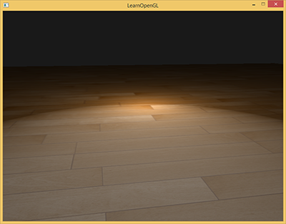

*You can see at the edges that the specular area is immediately cut off. The reason this happens is that the angle between the view vector and the reflection vector is not allowed to go higher than 90 degrees. If the angle is larger than 90 degrees the resulting dot product becomes negative and this results in specular exponents of 0.0. You're probably thinking this won't be a problem since we shouldn't get any light with angles higher than 90 degrees anyways, right?*

*Wrong, this only applies to the diffuse component where an angle higher than 90 degrees between the normal and light source means the light source is below the lighted surface and thus the light's diffuse contribution should equal 0.0. However, with specular lighting we're not measuring the angle between the light source and the normal, but between the view and reflection direction vector. Take a look at the following two images:*

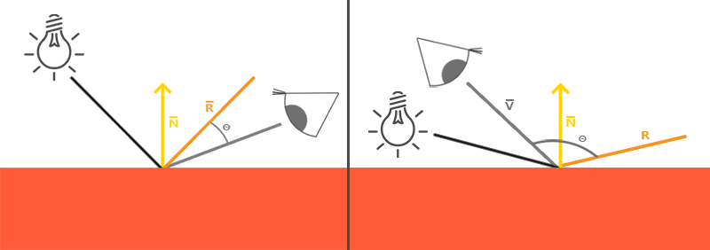

*Here the issue should become apparent. The left image shows Phong reflections as familiar with θ being less than 90 degrees. In the right image we can see that the angle θ between the view and reflection direction is larger than 90 degrees and as a result nullifies the specular contribution. This generally isn't a problem since the view direction is far from the reflection direction, but if we use a low specular exponent the specular radius is large enough to have a contribution under these conditions. In that case we're nullifying this contribution at angles larger than 90 degrees (as seen in the first image).*

*In 1977 the Blinn-Phong shading model was introduced by James F. Blinn as an extension to the Phong shading we've used so far. The Blinn-Phong model is largely similar, but approaches the specular model slightly different which as a result overcomes our problem. Instead of relying on a reflection vector we're using a so called halfway vector that is a unit vector exactly halfway between the view direction and the light direction. The closer this halfway vector aligns with the surface's normal vector, the higher the specular contribution.*

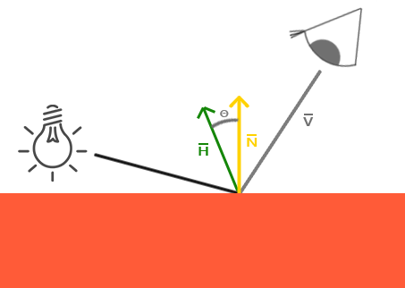

*When the view direction is perfectly aligned with the (now imaginary) reflection vector, the halfway vector aligns perfectly with the normal vector. Thus the closer the viewer looks in the original reflection direction, the stronger the specular highlight becomes.*

*Here you can see that whatever direction the viewer is look from, the angle between the halfway vector and the surface normal never exceeds 90 degrees (unless the light is far below the surface of course). This produces slightly different results compared to Phong reflections, but mostly looks slightly more visually plausible, especially with low specular exponents. The Blinn-Phong shading model is also the exact shading model used in the earlier fixed function pipeline of OpenGL.*

*Getting the halfway vector is easy, we add the light's direction vector and view vector together and normalize the result:*

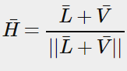

*This translates to GLSL code as follows:*

*vec3 lightDir = normalize(lightPos - FragPos);*

*vec3 viewDir = normalize(viewPos - FragPos);*

*vec3 halfwayDir = normalize(lightDir + viewDir);*

*Then the actual calculation of the specular term basically becomes a clamped dot product between the surface normal and the halfway vector to get the cosine angle between them that we again raise to a specular shininess exponent:*

***float*** *spec = pow(max(dot(normal, halfwayDir), 0.0), shininess);*

*vec3 specular = lightColor * spec;*

*And there is nothing more to Blinn-Phong than what we just described. The only difference between Blinn-Phong and Phong specular reflection is that we now measure the angle between the normal and the halfway vector compared to the angle between the view direction and the reflection vector.*

*With the introduction of the halfway vector for calculating the specular highlights we should no longer have the specular cutoff issue of Phong shading. The image below shows the specular area of both methods with a specular exponent of 0.5:*

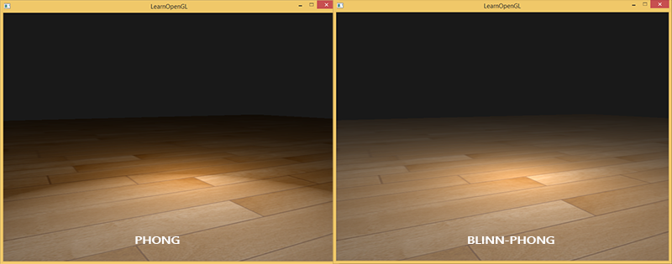

*Another subtle difference between Phong and Blinn-Phong shading is that the angle between the halfway vector and the surface normal is often shorter than the angle between the view and reflection vector. As a result, to get similar results to Phong shading the specular shininess exponent has to be set a bit higher. A general rule of thumb is to set it between 2 and 4 times the Phong shininess exponent.*

*Below is a comparison between both specular reflection models with the Phong exponent set to 8.0 and the Blinn-Phong component set to 32.0:*

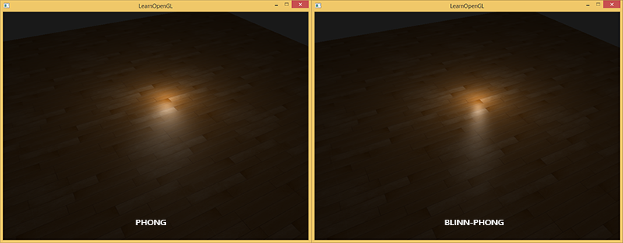

*You can see that the Blinn-Phong specular exponent is bit sharper compared to Phong. It usually requires a bit of tweaking to get similar results as to what you previously had set with Phong shading, but the Blinn-Phong shading gives generally a bit more plausible results compared to default Phong shading.*

*Here we used a simple fragment shader that switches between regular Phong reflections and Blinn-Phong reflections:*

***void*** *main()*

*{*

*[...]*

***float*** *spec = 0.0;*

***if****(blinn)*

*{*

*vec3 halfwayDir = normalize(lightDir + viewDir);*

*spec = pow(max(dot(normal, halfwayDir), 0.0), 16.0);*

*}*

***else***

*{*

*vec3 reflectDir = reflect(-lightDir, normal);*

*spec = pow(max(dot(viewDir, reflectDir), 0.0), 8.0);*

*}*

*You can find the source code for the simple demo*[*here*](https://learnopengl.com/code_viewer_gh.php?code=src/5.advanced_lighting/1.advanced_lighting/advanced_lighting.cpp)*. By pressing the b key the demo switches from Phong to Blinn-Phong lighting and vica versa.*

[*https://learnopengl.com/#!Advanced-Lighting/Gamma-Correction*](https://learnopengl.com/#!Advanced-Lighting/Gamma-Correction)

## ***Gamma Correction***

*// //*

*06.11.2017*

*As soon as we computed all the final pixel colors of the scene we will have to display them on a monitor. In the old days of digital imaging most monitors were cathode-ray tube (CRT) monitors. These monitors had the physical property that twice the input voltage did not result in twice the amount of brightness. Doubling the input voltage resulted in a brightness equal to a power relationship of roughly 2.2 also known as the gamma of a monitor. This happens to (coincidently) also closely match how human beings measure brightness as brightness is also displayed with a similar (inverse) power relationship. To better understand what this all means take a look at the following illustration:*

**

*The top line looks like the correct brightness scale to the human eye, doubling the brightness (from 0.1 to 0.2 for example) does indeed look like it's twice as bright with nice consistent differences. However, when we're talking about the physical brightness of light e.g. amount of photons leaving a light source the bottom scale actually displays the correct brightness. At the bottom scale, doubling the brightness returns the correct physical brightness, but since our eyes perceive brightness differently (more susceptible to changes in dark colors) it looks weird.*

*Because the human eyes prefer to see brightness colors according to the top scale, monitors (still today) use a power relationship for displaying output colors so that the original physical brightness colors are mapped to the non-linear brightness colors in the top scale; basically because it looks better.*

*This non-linear mapping of monitors does indeed make the brightness look better in our eyes, but when it comes to rendering graphics there is one issue: all the color and brightness options we configure in our applications are based on what we perceive from the monitor and thus all the options are actually non-linear brightness/color options. Take a look at the graph below:*

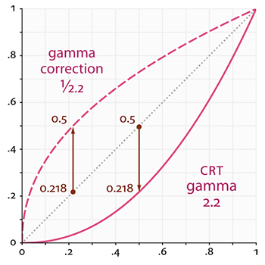

*The dotted line represents color/light values in linear space and the solid line represents the color space that monitors the display. If we double a color in linear space, its result is indeed double the value. For instance, take a light's color vector L¯=(0.5,0.0,0.0) which represents a semi-dark red light. If we would double this light in linear space it would become (1.0,0.0,0.0) as you can see in the graph. However, because the colors we defined still have to output to the monitor display, the color gets displayed on the monitor as (0.218,0.0,0.0) as you can see from the graph. Here's where the issues start to rise: once we double the dark-red light in linear space, it actually becomes more than 4.5 times as bright on the monitor! // вось зараз мне гэта нелінейнасць зразумела //*

*Up until this tutorial we have assumed we were working in linear space, but we've been actually working in the color space defined by the monitor's output color space so all colors and lighting variables we configured weren't physically correct, but merely looked just right on our monitor. For this reason, we (and artists) generally set lighting values way brighter than they should be (since the monitor darkens them) which as a result makes most linear-space calculations incorrect. Also note that the monitor graph and the linear graph both start and end up at the same position; it is the intermediate colors that get darkened by the display.*

*Because colors are configured based on the monitor's display all intermediate (lighting) calculations in linear-space are physically incorrect. This becomes more and more obvious as more advanced lighting algorithms are used, as you can see in the image below:*

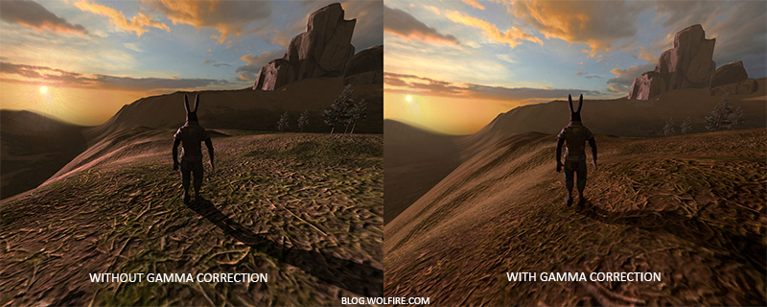

*You can see that with gamma correction, the (updated) color values work more nicely together and the darker areas are less dark and thus show more details. Overall, a much better image quality with only small modifications.*

*Without properly correcting this monitor gamma the lighting just looks wrong and artists will have a hard time getting realistic and good-looking results. The solution is to apply gamma correction.*

### ***Gamma correction***

*The idea of gamma correction is to apply the inverse of the monitor's gamma to the final output color before displaying to the monitor. Looking back at the gamma curve graph earlier this section we see another dashed line that is the inverse of the monitor's gamma curve. We multiply each of the linear output colors by this inverse gamma curve (making them brighter) and as soon as the colors are displayed on the monitor, the monitor's gamma curve is applied and the resulting colors become linear. Basically we make the intermediate colors brighter so that as soon as the monitor darkens them, it balances all out.*

*Let's give another example. Say we again have the dark-red color (0.5,0.0,0.0). Before displaying this color to the monitor we first apply the gamma correction curve to the color value. Linear colors displayed by a monitor are roughly scaled to a power of 2.2 so the inverse requires scaling the colors by a power of 1/2.2. The gamma-corrected dark-red color thus becomes (0.5,0.0,0.0)1/2.2=(0.5,0.0,0.0)0.45=(0.73,0.0,0.0). The corrected colors are then fed to the monitor and as a result the color is displayed as (0.73,0.0,0.0)2.2=(0.5,0.0,0.0). You can see that by using gamma-correction, the monitor now finally displays the colors as we linearly set them in the application.*

*A gamma value of 2.2 is a default gamma value that roughly estimates the average gamma of most displays. The color space as a result of this gamma of 2.2 is called the sRGB color space. Each monitor has their own gamma curves, but a gamma value of 2.2 gives good results on most monitors. For this reason, games often allow players to change the game's gamma setting as it varies slightly per monitor.*

*There are two ways to apply gamma correction to your scenes:*

* *By using OpenGL's built-in sRGB framebuffer support.*
* *Or by doing the gamma correction ourselves in the fragment shaders.*

*The first option is probably the easiest, but also gives you less control. By enabling GL_FRAMEBUFFER_SRGB you tell OpenGL that each subsequent drawing commands should first gamma correct colors from the sRGB color space before storing them in color buffer(s). The sRGB is a color space that roughly corresponds to a gamma of 2.2 and a standard for most home devices. After enabling GL_FRAMEBUFFER_SRGB OpenGL will automatically perform gamma correction after each fragment shader run to all subsequent framebuffers, including the default framebuffer.*

*Enabling GL_FRAMEBUFFER_SRGB is as simple as calling glEnable:*

*glEnable(GL_FRAMEBUFFER_SRGB);*

*From now on your rendered images will be gamma corrected and as this is done by the hardware it is completely free. Something you should keep in mind with this approach (and the other approach) is that gamma correction (also) transforms the colors from linear space to non-linear space so it is very important you only do gamma correction at the last and final step. If you gamma-correct your colors before the final output, all subsequent operations on those colors will operate on incorrect values. For instance, if you use multiple framebuffers you probably want intermediate results passed in between framebuffers to remain in linear-space and only have the last framebuffer apply gamma correction before being sent to the monitor.*

*The second approach requires a bit more work, but also gives us complete control over the gamma operations. We apply gamma correction at the end of each relevant fragment shader run so the final colors end up gamma corrected before being sent out to the monitor:*

***void*** *main()*

*{*

*// do super fancy lighting*

*[...]*

*// apply gamma correction*

***float*** *gamma = 2.2;*

*FragColor.rgb = pow(fragColor.rgb, vec3(1.0/gamma));*

*}*

*The last line of code effectively raises each individual color component of fragColor to 1.0/gamma correcting the output color of this fragment shader run.*

*An issue with this approach is that in order to be consistent you have to apply gamma correction to each fragment shader that contributes to the final output so if you have a dozen fragment shaders for multiple objects, you have to add the gamma correction code to each of these shaders. An easier solution would be to introduce a post-processing stage in your render loop and apply gamma correction on the post-processed quad as a final step which you'd only have to do once. // важная задача пост-працэсінга //*

*These one-liners represent the technical implementation of gamma correction. Not all too impressive, but there are a few extra things you have to consider when doing gamma correction.*

### ***sRGB textures***

*Because monitors always display colors with gamma applied in sRGB space, whenever you draw, edit or paint a picture on your computer you are picking colors based on what you see on the monitor. This effectively means all the pictures you create or edit are not in linear space, but in sRGB space e.g. doubling a dark-red color on your screen based on your perceived brightness, does not equal double the red component.*

*As a result, texture artists create all your textures in sRGB space so if we use those textures as they are in our rendering application we have to take this into account. Before we applied gamma correction this was not an issue, because the textures looked good in sRGB space and without gamma correction we also worked in sRGB space so the textures were displayed exactly as they are which was fine. However, now that we're displaying everything in linear space the texture colors will be off as the following image shows:*

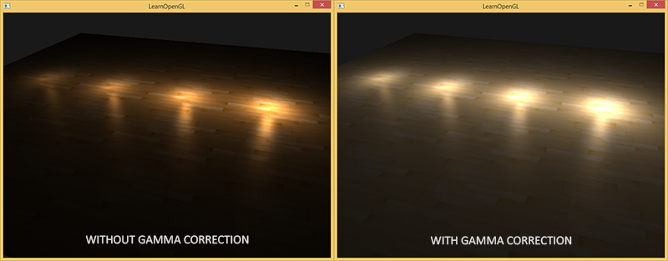

*The texture images are way too bright and this happens because they are actually gamma corrected twice! Think about it, when we create an image based on what we see on the monitor, we effectively gamma correct the color values of an image so that it looks right on the monitor. Because we then again gamma correct in the renderer, the images will be way too bright.*

*To fix this issue we have to make sure texture artists work in linear space. However, since most texture artists don't even know what gamma correction is and it's easier to work in sRGB space this is probably not the preferred solution.*

*The other solution is to re-correct or transform these sRGB textures back to linear space before doing any calculations on their color values. We can do this as follows:*

***float*** *gamma = 2.2;*

*vec3 diffuseColor = pow(texture(diffuse, texCoords).rgb, vec3(gamma));*

*To do this for each texture in sRGB space is quite troublesome though. Luckily OpenGL gives us yet another solution to our problems by giving us the GL_SRGB and GL_SRGB_ALPHA internal texture formats.*

*If we create a texture in OpenGL with any of these two sRGB texture formats specified, OpenGL will automatically correct the colors to linear-space as soon as we use them, allowing us to properly work in linear space with all color values extracted. We can specify a texture as an sRGB texture as follows:*

*glTexImage2D(GL_TEXTURE_2D, 0, GL_SRGB, width, height, 0, GL_RGB, GL_UNSIGNED_BYTE, image);*

*If you also want to include alpha components in your texture you'll have to specify the texture's internal format as GL_SRGB_ALPHA.*

*You should be careful when specifying your textures in sRGB space as not all textures will actually be in sRGB space. Textures used for coloring objects like diffuse textures are almost always in sRGB space. Textures used for retrieving lighting parameters like*[*specular maps*](https://learnopengl.com/#!Lighting/Lighting-maps)*and*[*normal maps*](https://learnopengl.com/#!Advanced-Lighting/Normal-Mapping)*are almost always in linear space so if you were to configure these as sRGB textures as well, the lighting will break down. Be careful in which textures you specify as sRGB. // важны момант і рэкамендацыя //*

*With our diffuse textures specified as sRGB textures you get the visual output you'd expect again, but this time everything is gamma corrected only once.*

### ***Attenuation***

*Another thing that will be different with gamma correction is lighting attenuation. In the real physical world, lighting attenuates closely inversely proportional to the squared distance from a light source. In normal English it simply means that the light strength is reduced over the distance to the light source squared like below:*

***float*** *attenuation = 1.0 / (distance * distance);*

*However, when using this attenuation equation the attenuation effect is always way too strong, giving lights a small radius that didn't look physically right. For that reason other attenuation functions were used like we discussed in the*[*basic_lighting*](https://learnopengl.com/#!Basic-Lighting/Basic-Lighting) *tutorials that give much more control, or the linear equivalent is used:*

***float*** *attenuation = 1.0 / distance;*

*The linear equivalent gives much more plausible results than its quadratic variant without gamma correction, but when we enable gamma correction the linear attenuation looks too weak and the physically correct quadratic attenuation suddenly gives the better results. The image below shows the differences:*

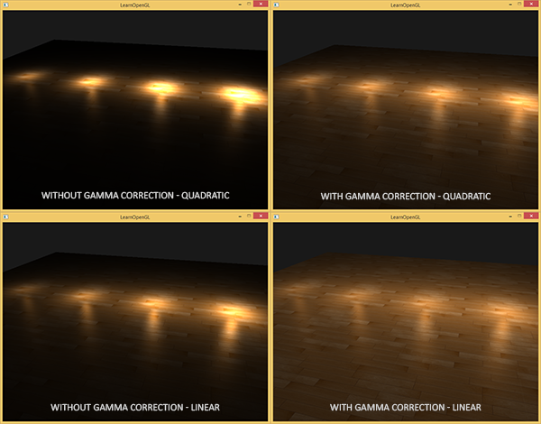

*The cause of this difference is that light attenuation functions change brightness, and as we weren't visualizing our scene in linear space, we chose the attenuation functions that looked best on our monitor, but weren't physically correct. Think of the squared attenuation function, if we were to use this function without gamma correction the attenuation function effectively becomes: (1.0/distance2)2.2 displayed on a monitor. This creates a much larger attenuation effect without gamma correction. This also explains why the linear equivalent makes much more sense without gamma correction as this effectively becomes (1.0/distance)2.2=1.0/distance2.2 which resembles its physical equivalent a lot more.*

*The more advanced attenuation function we discussed in the*[*basic lighting*](https://learnopengl.com/#!Lighting/Basic-Lighting)*is still useful in gamma corrected scenes as it gives much more control over the exact attenuation (but of course requires different parameters in a gamma corrected scene).*

*I created a simple demo scene of which you can find its source code*[*here*](https://learnopengl.com/code_viewer_gh.php?code=src/5.advanced_lighting/2.gamma_correction/gamma_correction.cpp)*. By pressing the spacebar we switch between a gamma corrected and un-corrected scene with both scenes using their texture and attenuation equivalents. It's not the most impressive demo, but it does show how to actually apply all techniques. // я не глядзеў гэта //*

*To summarize, gamma correction allows you to work/visualize your renders in linear space. Because linear space makes sense in the physical world, most physical equations now actually give good results like real light attenuation. The more advanced your lighting becomes, the easier it is to get good looking (and realistic) results with gamma correction. That is also why it's advised to only really tweak your lighting parameters as soon as you have gamma correction in place.*

### ***Additional resources***

* [*What every coder should know about gamma*](http://blog.johnnovak.net/2016/09/21/what-every-coder-should-know-about-gamma/)*: a well written in-depth article by John Novak about gamma correction.*
* [*www.cambridgeincolour.com*](http://www.cambridgeincolour.com/tutorials/gamma-correction.htm)*: more about gamma and gamma correction.*
* [*blog.wolfire.com*](http://blog.wolfire.com/2010/02/Gamma-correct-lighting)*: blog post by David Rosen about the benefit of gamma correction in graphics rendering.*
* [*renderwonk.com*](http://renderwonk.com/blog/index.php/archive/adventures-with-gamma-correct-rendering/)*: some extra practical considerations.*

[*https://learnopengl.com/#!Advanced-Lighting/Shadows/Shadow-Mapping*](https://learnopengl.com/#!Advanced-Lighting/Shadows/Shadow-Mapping)

## ***Shadow Mapping***

*Shadows are a result of the absence of light due to occlusion; when a light source's light rays do not hit an object because it gets occluded by some other object the object is in shadow. Shadows add a great deal of realism to a lighted scene and make it easier for a viewer to observe spatial relationships between objects. They give a greater sense of depth to our scene and objects. For example, take a look at the following image of a scene with and without shadows:*

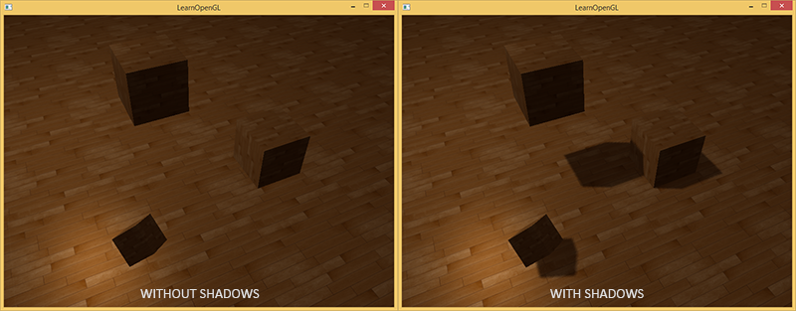

*You can see that with shadows it becomes much more obvious how the objects relate to each other. For instance, the fact that one of the cubes is floating above the others is much more noticeable when we have shadows.*

*Shadows are a bit tricky to implement though, specifically because in current real-time research a perfect shadow algorithm hasn't been developed yet. There are several good shadow approximation techniques, but they all have their little quirks and annoyances which we have to take into account.*

*One technique used by most videogames that gives decent results and is relatively easy to implement is shadow mapping. Shadow mapping is not too difficult to understand, doesn't cost too much in performance and is quite easily extended into more advanced algorithms (like*[*Omnidirectional Shadow Maps*](https://learnopengl.com/#!Advanced-Lighting/Shadows/Point-Shadows)*and*[*Cascaded Shadow Maps*](https://learnopengl.com/#!Advanced-Lighting/Shadows/CSM)*).*

### ***Shadow mapping***

*The idea behind shadow mapping is quite simple: we render the scene from the light's point of view and everything we see from the light's perspective is lit and everything we can't see must be in shadow. Imagine a floor section with a large box between itself and a light source. Since the light source will see this box and not the floor section when looking in its direction that specific floor section should be in shadow.*

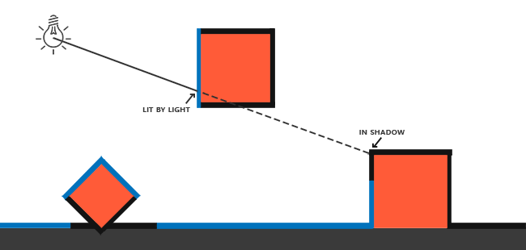

*Here all the blue lines represent the fragments that the light source can see. The occluded fragments are shown as black lines: these are rendered as being shadowed. If we were to draw a line or ray from the light source to a fragment on the right-most box we can see the ray first hits the floating container before hitting the right-most container. As a result, the floating container's fragment is lit and the right-most container's fragment is not lit and thus in shadow.*

*We want to get a point on the ray where it first hit an object and compare this closest point to other points on this ray. We then do a basic test to see if a test point's ray position is further down the ray than the closest point and if so, the test point must be in shadow. Iterating through possibly thousands of light rays from such a light source is an extremely inefficient approach and doesn't lend itself too well for real-time rendering. We can do something similar, but without casting light rays. Instead, we use something we're quite familiar with: the depth buffer.*

*You probably remember from the*[*depth testing*](https://learnopengl.com/#!Advanced-OpenGL/Depth-testing)*tutorial that a value in the depth buffer corresponds to the depth of a fragment clamped to [0,1] from the camera's point of view. What if we were to render the scene from the light's perspective and store the resulting depth values in a texture? This way we can sample the closest depth values as seen from the light's perspective. After all, the depth values show the first fragment visible from the light's perspective. We store all these depth values in a texture that we call a depth map or shadow map.*

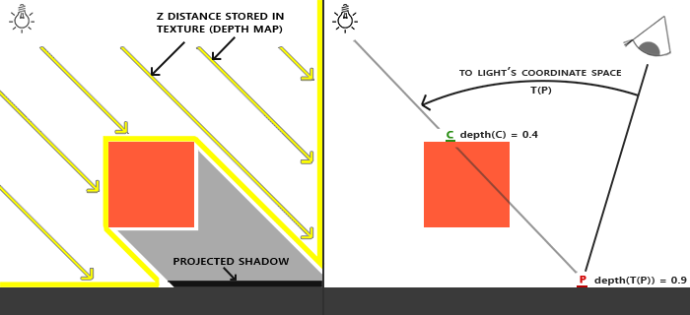

*The left image shows a directional light source (all light rays are parallel) casting a shadow on the surface below the cube. Using the depth values stored in the depth map we find the closest point and use that to determine whether fragments are in shadow. We create the depth map by rendering the scene (from the light's perspective) using a view and projection matrix specific to that light source. This projection and view matrix together form a transformation T that transforms any 3D position to the light's visible coordinate space.*

*A directional light doesn't have a position as it's modelled to be infinitely far away. However, for the sake of shadow mapping we need to render the scene from a light's perspective and thus render the scene from a position somewhere along the lines of the light direction.*

*In the right image we see the same directional light and the viewer. We render a fragment at point P¯ for which we have to determine whether it is in shadow. To do this, we first transform point P¯ to the light's coordinate space using T. Since point P¯ is now as seen from the light's perspective, its z coordinate corresponds to its depth which in this example is 0.9. Using point P¯ we can also index the depth map to obtain the closest visible depth from the light's perspective which is at point C with a sampled depth of 0.4. Since indexing the depth map returned a depth smaller than the depth at point P¯ we can conclude point P¯ is occluded and thus in shadow.*

*Shadow mapping consists of two passes: first we render the depth map and in the second pass we render the scene as normal and use the generated depth map to calculate whether fragments are in shadow. It might sound a bit complicated, but as soon as we walk through the technique step-by-step it'll likely start to make sense.*

### ***The depth map***

*The first pass requires us to generate a depth map. The depth map is the depth texture as rendered from the light's perspective that we'll be using for calculating shadows. Because we need to store the rendered result of a scene into a texture we're going to need*[*framebuffers*](https://learnopengl.com/#!Advanced-OpenGL/Framebuffers)*again.*

*First we'll create a framebuffer object for rendering the depth map:*

***unsigned******int*** *depthMapFBO;*

*glGenFramebuffers(1, &depthMapFBO);*

*Next we create a 2D texture that we'll use as the framebuffer's depth buffer:*

***const******unsigned******int*** *SHADOW_WIDTH = 1024, SHADOW_HEIGHT = 1024;*

***unsigned******int*** *depthMap;*

*glGenTextures(1, &depthMap);*

*glBindTexture(GL_TEXTURE_2D, depthMap);*

*glTexImage2D(GL_TEXTURE_2D, 0, GL_DEPTH_COMPONENT,*

*SHADOW_WIDTH, SHADOW_HEIGHT, 0, GL_DEPTH_COMPONENT, GL_FLOAT, NULL);*

*glTexParameteri(GL_TEXTURE_2D, GL_TEXTURE_MIN_FILTER, GL_NEAREST);*

*glTexParameteri(GL_TEXTURE_2D, GL_TEXTURE_MAG_FILTER, GL_NEAREST);*

*glTexParameteri(GL_TEXTURE_2D, GL_TEXTURE_WRAP_S, GL_REPEAT);*

*glTexParameteri(GL_TEXTURE_2D, GL_TEXTURE_WRAP_T, GL_REPEAT);*

*Generating the depth map shouldn't look too complicated. Because we only care about depth values we specify the texture's formats as GL_DEPTH_COMPONENT. We also give the texture a width and height of 1024: this is the resolution of the depth map.*

*With the generated depth texture we can attach it as the framebuffer's depth buffer:*

*glBindFramebuffer(GL_FRAMEBUFFER, depthMapFBO);*

*glFramebufferTexture2D(GL_FRAMEBUFFER, GL_DEPTH_ATTACHMENT, GL_TEXTURE_2D, depthMap, 0);*

*glDrawBuffer(GL_NONE);*

*glReadBuffer(GL_NONE);*

*glBindFramebuffer(GL_FRAMEBUFFER, 0);*

*// зараз тэкстура змяшчае глыбіні //*

*We only need the depth information when rendering the scene from the light's perspective so there is no need for a color buffer. A framebuffer object however is not complete without a color buffer so we need to explicitly tell OpenGL we're not going to render any color data. We do this by setting both the read and draw buffer to GL_NONE with glDrawBuffer and glReadbuffer.*

*With a properly configured framebuffer that renders depth values to a texture we can start the first pass: generating the depth map. The complete rendering stage of both passes will looks a bit like this:*

*// 1. first render to depth map*

*glViewport(0, 0, SHADOW_WIDTH, SHADOW_HEIGHT);*

*glBindFramebuffer(GL_FRAMEBUFFER, depthMapFBO);*

*glClear(GL_DEPTH_BUFFER_BIT);*

*ConfigureShaderAndMatrices();*

*RenderScene();*

*glBindFramebuffer(GL_FRAMEBUFFER, 0);*

*// 2. then render scene as normal with shadow mapping (using depth map)*

*glViewport(0, 0, SCR_WIDTH, SCR_HEIGHT);*

*glClear(GL_COLOR_BUFFER_BIT | GL_DEPTH_BUFFER_BIT);*

*ConfigureShaderAndMatrices();*

*glBindTexture(GL_TEXTURE_2D, depthMap);*

*RenderScene();*

*This code left out some details, but it'll give you the general idea of shadow mapping. What is important to note here are the calls to glViewport. Because shadow maps often have a different resolution compared to what we originally render the scene in (usually the window resolution) we need to change the viewport parameters to accommodate for the size of the shadow map. If we forget to update the viewport parameters, the resulting depth map will be either incomplete or too small.*

### ***Light space transform***

*An unknown in the previous snippet of code is the ConfigureShaderAndMatrices function. In the second pass this is business as usual: make sure proper projection and view matrices are set and the relevant model matrices per object. However, in the first pass we use a different projection and view matrix to render the scene from the light's point of view.*

*Because we're modelling a directional light source all its light rays are parallel. For this reason we're going to use an orthographic projection matrix for the light source where there is no perspective deform:*

***float*** *near_plane = 1.0f, far_plane = 7.5f;*

*glm::mat4 lightProjection = glm::ortho(-10.0f, 10.0f, -10.0f, 10.0f, near_plane, far_plane);*

*Here is an example orthographic projection matrix as used in this tutorial's demo scene. Because a projection matrix indirectly determines the range of what is visible e.g. what is not clipped you want to make sure the size of the projection frustum correctly contains the objects you want to be in the depth map. When objects or fragments are not in the depth map they will not produce shadows.*

*To create a view matrix to transform each object so they're visible from the light's point of view we're going to use the infamous glm::lookAt function; this time with the light source's position looking at the scene's center.*

*glm::mat4 lightView = glm::lookAt(glm::vec3(-2.0f, 4.0f, -1.0f),*

*glm::vec3( 0.0f, 0.0f, 0.0f),*

*glm::vec3( 0.0f, 1.0f, 0.0f));*

*Combining these two gives us a light space transformation matrix that transforms each world-space vector into the space as visible from the light source; exactly what we need to render the depth map.*

*glm::mat4 lightSpaceMatrix = lightProjection * lightView;*

*This lightSpaceMatrix is the transformation matrix that we earlier denoted as T. With this lightSpaceMatrix we can render the scene as usual as long as we give the shader the light-space equivalents of the projection and view matrices. However, we only care about depth values and not all the expensive fragment calculations in our main shader. To save performance we're going to use a different, but much simpler shader for rendering to the depth map.*

### ***Render to depth map***

*When we render the scene from the light's perspective we'd much rather use a simple shader that only transforms the vertices to light space and not much more. For such a simple shader called simpleDepthShader we'll use the following vertex shader:*

*#version 330 core*

***layout*** *(location = 0)* ***in*** *vec3 aPos;*

***uniform*** *mat4 lightSpaceMatrix;*

***uniform*** *mat4 model;*

***void*** *main()*

*{*

*gl_Position = lightSpaceMatrix * model * vec4(aPos, 1.0);*

*}*

*This vertex shader takes a per-object model, a vertex and transforms all vertices to light space using lightSpaceMatrix.*

*Since we have no color buffer the resulting fragments do not require any processing, so we can simply use an empty fragment shader:*

*#version 330 core*

***void*** *main()*

*{*

*// gl_FragDepth = gl_FragCoord.z;*

*}*

*The empty fragment shader does no processing whatsoever and at the end of its run the depth buffer is updated. We could explicitly set the depth by uncommenting its one line, but this is effectively what happens behind the scene anyways.*

*Rendering the depth buffer now effectively becomes:*

*simpleDepthShader.use();*

*glUniformMatrix4fv(lightSpaceMatrixLocation, 1, GL_FALSE, glm::value_ptr(lightSpaceMatrix));*

*glViewport(0, 0, SHADOW_WIDTH, SHADOW_HEIGHT);*

*glBindFramebuffer(GL_FRAMEBUFFER, depthMapFBO);*

*glClear(GL_DEPTH_BUFFER_BIT);*

*RenderScene(simpleDepthShader);*

*glBindFramebuffer(GL_FRAMEBUFFER, 0);*

*Here the RenderScene function takes a shader program, calls all relevant drawing functions and sets the corresponding model matrices where necessary.*

*The result is a nicely filled depth buffer holding the closest depth of each visible fragment from the light's perspective. By projecting this texture onto a 2D quad that fills the screen (similar to what we did in the post-processing section at the end of the*[*framebuffers*](https://learnopengl.com/#!Advanced-OpenGL/Framebuffers)*tutorial) we get something like this:*

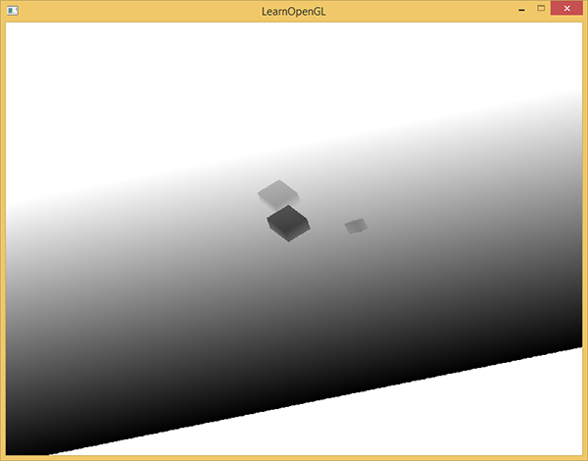

*For rendering the depth map onto a quad we used the following fragment shader:*

*#version 330 core*

***out*** *vec4 FragColor;*

***in*** *vec2 TexCoords;*

***uniform*** *sampler2D depthMap;*

***void*** *main()*

*{*

***float*** *depthValue = texture(depthMap, TexCoords).r;*

*FragColor = vec4(vec3(depthValue), 1.0);*

*}*

*Note that there are some subtle changes when displaying depth using a perspective projection matrix instead of an orthographic projection matrix as depth is non-linear when using perspective projection. At the end of this tutorial we'll discuss some of these subtle differences.*

*You can find the source code for rendering a scene to a depth map*[*here*](https://learnopengl.com/code_viewer_gh.php?code=src/5.advanced_lighting/3.1.1.shadow_mapping_depth/shadow_mapping_depth.cpp)*.*

### ***Rendering shadows***

*With a properly generated depth map we can start generating the actual shadows. The code to check if a fragment is in shadow is (quite obviously) executed in the fragment shader, but we do the light-space transformation in the vertex shader:*

*#version 330 core*

***layout*** *(location = 0)* ***in*** *vec3 aPos;*

***layout*** *(location = 1)* ***in*** *vec3 aNormal;*

***layout*** *(location = 2)* ***in*** *vec2 aTexCoords;*

***out*** *VS_OUT {*

*vec3 FragPos;*

*vec3 Normal;*

*vec2 TexCoords;*

*vec4 FragPosLightSpace;*

*} vs_out;*

***uniform*** *mat4 projection;*

***uniform*** *mat4 view;*

***uniform*** *mat4 model;*

***uniform*** *mat4 lightSpaceMatrix;*

***void*** *main()*

*{*

*vs_out.FragPos = vec3(model * vec4(aPos, 1.0));*

*vs_out.Normal = transpose(inverse(mat3(model))) * aNormal;*

*vs_out.TexCoords = aTexCoords;*

*vs_out.FragPosLightSpace = lightSpaceMatrix * vec4(vs_out.FragPos, 1.0);*

*gl_Position = projection * view * model * vec4(aPos, 1.0);*

*}*

*What is new here is the extra output vector FragPosLightSpace. We take the same lightSpaceMatrix (used to transform vertices to light space in the depth map stage) and transform the world-space vertex position to light space. The vertex shader passes a normally transformed world-space vertex position vs_out.FragPos and a light-space transformed vs_out.FragPosLightSpace to the fragment shader.*

*The fragment shader we'll use to render the scene uses the Blinn-Phong lighting model. Within the fragment shader we then calculate a shadow value that is either 1.0 when the fragment is in shadow or 0.0 when not in shadow. The resulting diffuse and specular colors are then multiplied by this shadow component. Because shadows are rarely completely dark due to light scattering we leave the ambient color out of the shadow multiplications.*

*#version 330 core*

***out*** *vec4 FragColor;*

***in*** *VS_OUT {*

*vec3 FragPos;*

*vec3 Normal;*

*vec2 TexCoords;*

*vec4 FragPosLightSpace;*

*} fs_in;*

***uniform*** *sampler2D diffuseTexture;*

***uniform*** *sampler2D shadowMap;*

***uniform*** *vec3 lightPos;*

***uniform*** *vec3 viewPos;*

***float*** *ShadowCalculation(vec4 fragPosLightSpace)*

*{*

*[...]*

*}*

***void*** *main()*

*{*

*vec3 color = texture(diffuseTexture, fs_in.TexCoords).rgb;*

*vec3 normal = normalize(fs_in.Normal);*

*vec3 lightColor = vec3(1.0);*

*// ambient*

*vec3 ambient = 0.15 * color;*

*// diffuse*

*vec3 lightDir = normalize(lightPos - fs_in.FragPos);*

***float*** *diff = max(dot(lightDir, normal), 0.0);*

*vec3 diffuse = diff * lightColor;*

*// specular*

*vec3 viewDir = normalize(viewPos - fs_in.FragPos);*

***float*** *spec = 0.0;*

*vec3 halfwayDir = normalize(lightDir + viewDir);*

*spec = pow(max(dot(normal, halfwayDir), 0.0), 64.0);*

*vec3 specular = spec * lightColor;*

*// calculate shadow*

***float*** *shadow = ShadowCalculation(fs_in.FragPosLightSpace);*

*vec3 lighting = (ambient + (1.0 - shadow) * (diffuse + specular)) * color;*

*FragColor = vec4(lighting, 1.0);*

*}*

*The fragment shader is largely a copy of what we used in the*[*advanced lighting*](https://learnopengl.com/#!Advanced-Lighting/Advanced-Lighting)*tutorial, but with an added shadow calculation. We declared a function ShadowCalculation that does most of the shadow work. At the end of the fragment shader we multiply the diffuse and specular contributions by the inverse of the shadow component e.g. how much the fragment is not in shadow. This fragment shader takes as extra input the light-space fragment position and the depth map generated from the first render pass.*

*The first thing to do to check whether a fragment is in shadow is transform the light-space fragment position in clip-space to normalized device coordinates. When we output a clip-space vertex position to gl_Position in the vertex shader, OpenGL automatically does a perspective divide e.g. transform clip-space coordinates in the range [-w,w] to [-1,1] by dividing the x, y and z component by the vector's w component. As the clip-space FragPosLightSpace is not passed to the fragment shader via gl_Position we have to do this perspective divide ourselves:*

***float*** *ShadowCalculation(vec4 fragPosLightSpace)*

*{*

*// perform perspective divide*

*vec3 projCoords = fragPosLightSpace.xyz / fragPosLightSpace.w; // вось з гэтым кампанентнам варта разабрацца лепей //*

*[...]*

*}*

*This returns the fragment's light-space position in the range [-1,1].*

*When using an orthographic projection matrix the w component of a vertex remains untouched so this step is actually quite meaningless. However, it is necessary when using perspective projection so keeping this line ensures it works with both projection matrices.*

*Because the depth from the depth map is in the range [0,1] and we also want to use projCoords to sample from the depth map so we transform the NDC coordinates to the range [0,1]:*

*projCoords = projCoords * 0.5 + 0.5;*

*With these projected coordinates we can sample the depth map as the resulting [0,1] coordinates from projCoordsdirectly correspond to the transformed NDC coordinates from the first render pass. This gives us the closest depth from the light's point of view:*

***float*** *closestDepth = texture(shadowMap, projCoords.xy).r;*

*To get the current depth at the fragment we simply retrieve the projected vector's z coordinate which equals the depth of the fragment from the light's perspective.*

***float*** *currentDepth = projCoords.z;*

*The actual comparison is then simply a check whether currentDepth is higher than closestDepth and if so, the fragment is in shadow.*

***float*** *shadow = currentDepth > closestDepth ? 1.0 : 0.0;*

*The complete ShadowCalculation function then becomes:*

***float*** *ShadowCalculation(vec4 fragPosLightSpace)*

*{*

*// perform perspective divide*

*vec3 projCoords = fragPosLightSpace.xyz / fragPosLightSpace.w;*

*// transform to [0,1] range*

*projCoords = projCoords * 0.5 + 0.5;*

*// get closest depth value from light's perspective (using [0,1] range fragPosLight as coords)*

***float*** *closestDepth = texture(shadowMap, projCoords.xy).r;*

*// get depth of current fragment from light's perspective*

***float*** *currentDepth = projCoords.z;*

*// check whether current frag pos is in shadow*

***float*** *shadow = currentDepth > closestDepth ? 1.0 : 0.0;*

***return*** *shadow;*

*}*

*Activating this shader, binding the proper textures and activating the default projection and view matrices in the second render pass should give you a result similar to the image below:*

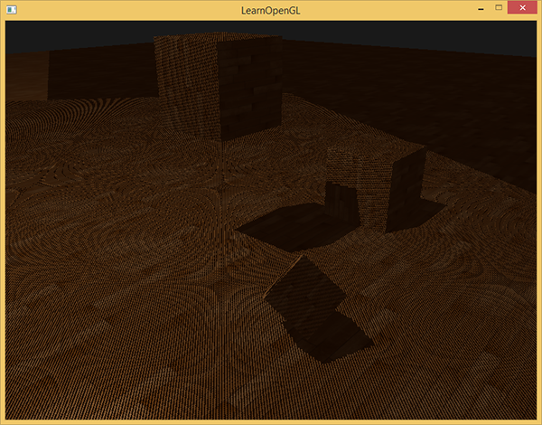

*If you did things right you should indeed see (albeit with quite a few artifacts) shadows on the floor and the cubes. You can find the source code of the demo application*[*here*](https://learnopengl.com/code_viewer_gh.php?code=src/5.advanced_lighting/3.1.2.shadow_mapping_base/shadow_mapping_base.cpp)*.*

*// усё атрымалася – і дадзеныя поласы таксама ёсць //*

#### **Improving shadow maps**

*We managed to get the basics of shadow mapping working, but as you can see there are still a few artifacts related to shadow mapping that we'd like to fix for better results, which we'll focus on in the next sections.*

#### **Shadow acne**

*It is obvious something is wrong from the previous image. A closer zoom shows us a very obvious Moiré-like pattern:*

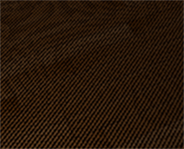

*We can see a large part of the floor quad rendered with obvious black lines in an alternating fashion. This shadow mapping artifact is called shadow acne and can be explained by a simple image:*

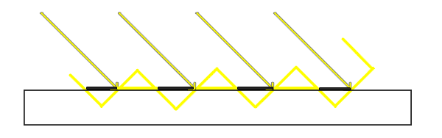

*Because the shadow map is limited by resolution, multiple fragments can sample the same value from the depth map when they're relatively far away from the light source. The image shows the floor where each tilted panel represents a single texel of the depth map. As you can see, several fragments sample the same depth sample.*

*While this is generally okay it becomes an issue when the light source looks at an angle towards the surface as in that case the depth map is also rendered from an angle. Several fragments then access the same tilted depth texel while some are above and some below the floor; we get a shadow discrepancy. Because of this some fragments are deemed in shadow and some are not, giving the striped pattern from the image.*

*We can solve this issue with a small little hack called a shadow bias where we simply offset the depth of the surface (or the shadow map) by a small bias amount such that fragments are not incorrectly considered below the surface.*

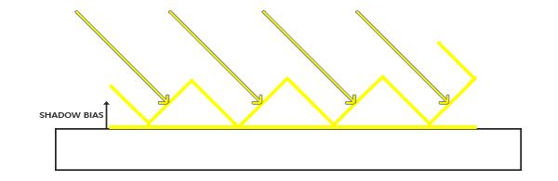

*With the bias applied all the samples get a depth smaller than the surface's depth and thus the entire surface is correctly lit without any shadows. We can implement such a bias as follows:*

***float*** *bias = 0.005;*

***float*** *shadow = currentDepth - bias > closestDepth ? 1.0 : 0.0;*

*A shadow bias of 0.005 solves the issues of our scene by a large extent, but some surfaces that have a steep angle to the light source might still produce shadow acne. A more solid approach would be to change the amount of bias based on the surface angle towards the light: something we can solve with the dot product:*

***float*** *bias = max(0.05 * (1.0 - dot(normal, lightDir)), 0.005);*

*Here we have a maximum bias of 0.05 and a minimum of 0.005 based on the surface's normal and light direction. This way surfaces like the floor that are almost perpendicular to the light source get a small bias, while surfaces like the cube's side-faces get a much larger bias. The following image shows the same scene but now with a shadow bias: much better results.*

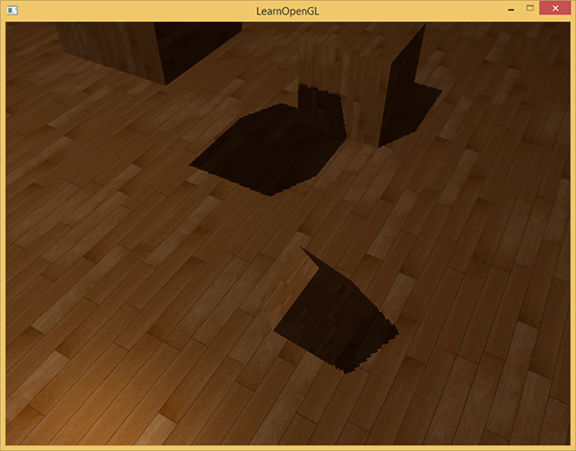

*Choosing the correct bias value(s) requires some tweaking as this will be different in each scene, but most of the time it's simply a matter of incrementing the bias until all acne is removed. // усё атрымалася //*

#### **Peter panning**

*A disadvantage of using a shadow bias is that you're applying an offset to the actual depth of objects. As a result the bias might become large enough to see a visible offset of shadows compared to the actual object locations as you can see below (with an exaggerated bias value):*

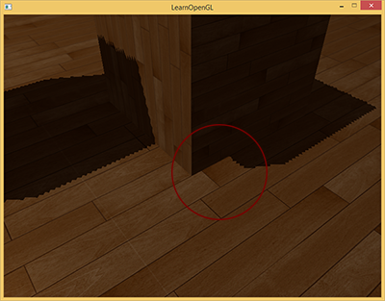

*This shadow artifact is called peter panning since objects seem slightly detached from their shadows. We can use a little trick to solve most of the peter panning issue by using front face culling when rendering the depth map. You might remember from the*[*face culling*](https://learnopengl.com/#!Advanced-OpenGL/Face-Culling)*tutorial that OpenGL by default culls back-faces. By telling OpenGL we want to cull front faces we're switching that order around.*

*Because we only need depth values for the depth map it shouldn't matter for solid objects whether we take the depth of their front faces or their back faces. Using their back face depths doesn't give wrong results as it doesn't matter if we have shadows inside objects; we can't see there anyways.*

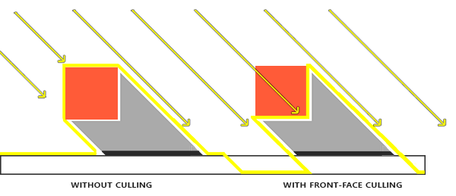

*To mostly fix peter panning we cull front faces. Note that you need to enable GL_CULL_FACE first.*

*glCullFace(GL_FRONT);*

*RenderSceneToDepthMap();*

*glCullFace(GL_BACK); // don't forget to reset original culling face*

*This effectively solves the peter panning issues, but****only for solid****objects that actually have an inside without openings. In our scene for example, this works perfectly fine on the cubes, but won't work on the floor as culling the front face completely removes the floor from the equation. The floor is a single plane and would thus completely be culled. If one wants to solve peter panning with this trick care has to be taken to only cull the front faces of objects where it makes sense.*

*Another consideration is that objects that are close to the shadow receiver (like the distant cube) might still give incorrect results. Care should be taken to use front face culling on objects where it makes sense. However, with normal bias values one can generally avoid peter panning.*

*// лепей зразумець прыроду і сутнасць гэтага эфекта //*

#### **Over sampling**

*Another visual discrepancy which you might like or dislike is that some regions outside the light's visible frustum are considered to be in shadow while they're not. This happens because projected coordinates outside the light's frustum are higher than 1.0 and will thus sample the depth texture outside its default range of [0,1]. Based on the texture's wrapping method we will get incorrect depth results not based on the real depth values from the light source. // не зразумеў я гэты артэфакт… А… зразумела… Тут у цені ўсё, што знаходзіцца далёка ад скрыняў //*

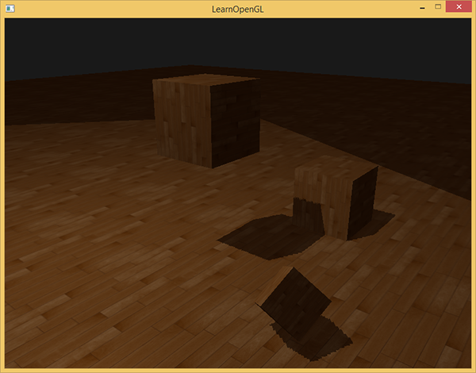

*You can see in the image that there is some sort of imaginary region of light and a large part outside this area is in shadow; this area represents the size of the depth map projected onto the floor. The reason this happens is that we earlier set the depth map's wrapping options to GL_REPEAT.*

*What we'd rather have is that all coordinates outside the depth map's range have a depth of 1.0 which as a result means these coordinates will never be in shadow (as no object will have a depth larger than 1.0). We can achieve this by storing a border color and set the depth map's texture wrap options to GL_CLAMP_TO_BORDER:*

*glTexParameteri(GL_TEXTURE_2D, GL_TEXTURE_WRAP_S, GL_CLAMP_TO_BORDER);*

*glTexParameteri(GL_TEXTURE_2D, GL_TEXTURE_WRAP_T, GL_CLAMP_TO_BORDER);*

***float*** *borderColor[] = { 1.0f, 1.0f, 1.0f, 1.0f };*

*glTexParameterfv(GL_TEXTURE_2D, GL_TEXTURE_BORDER_COLOR, borderColor);*

*Now whenever we sample outside the depth map's [0,1] coordinate range the texture function will always return a depth of 1.0, returning a shadow value of 0.0. The result now looks a lot more plausible:*

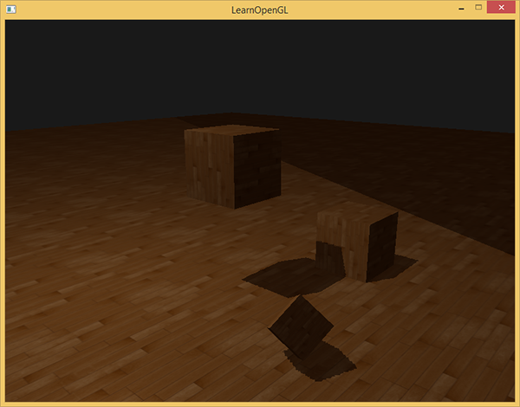

*There still seems to be one part still showing a dark region. Those are the coordinates outside the far plane of the light's orthographic frustum. You can see that this dark region always occurs at the far end of the light source's frustum by looking at the shadow directions.*

*A projected coordinate is further than the light's far plane when its z coordinate is larger than 1.0. In that case the GL_CLAMP_TO_BORDER wrapping method doesn't work anymore as we compare the coordinate's z component with the depth map values; this always returns true for z larger than 1.0.*

*The fix for this is also relatively easy as we simply force the shadow value to 0.0 whenever the projected vector's z coordinate is larger than 1.0:*

***float*** *ShadowCalculation(vec4 fragPosLightSpace)*

*{*

*[...]*

***if****(projCoords.z > 1.0)*

*shadow = 0.0;*

***return*** *shadow;*

*}*

*// гэта ясна… а чаму праекцыйная каардыната можа быць больш за адзінку? //*

*Checking the far plane and clamping the depth map to a manually specified border color solves the over-sampling of the depth map and finally gives us the result we are looking for:*

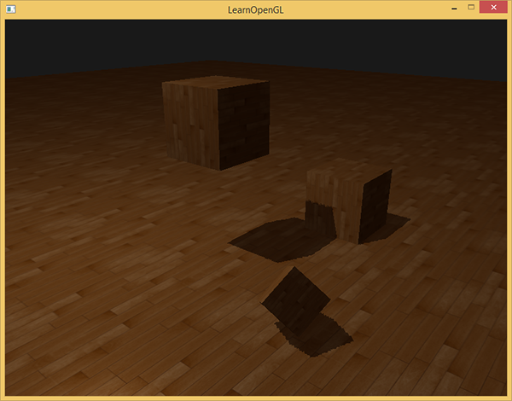

*The result of all this does mean that we only have shadows where the projected fragment coordinates sit inside the depth map range so anything outside this range will have no visible shadows. As games usually make sure this only occurs in the distance it is a much more plausible effect than the obvious black regions we had before.*

#### **PCF**

*The shadows right now are a nice addition to the scenery, but it's still not exactly what we want. If you were to zoom in on the shadows the resolution dependency of shadow mapping quickly becomes apparent.*

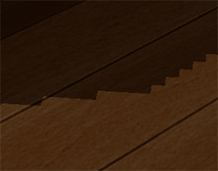

*Because the depth map has a fixed resolution the depth frequently spans more than one fragment per texel. As a result multiple fragments sample the same depth value from the depth map and come to the same shadow conclusions, which produces these jagged blocky edges. // я так разумею, шмат фрагментаў праецыруюцца ў аднолькувую каардынату на ценевым мапе //*

*You can reduce these blocky shadows by increasing the depth map resolution or by trying to fit the light frustum as closely to the scene as possible.*

*Another (partial) solution to these jagged edges is called PCF or percentage-closer filtering which is a term that hosts many different filtering functions that produce softer shadows, making them appear less blocky or hard. The idea is to sample more than once from the depth map, each time with slightly different texture coordinates. For each individual sample we check whether it is in shadow or not. All the sub-results are then combined and averaged and we get a nice soft looking shadow.*

*One simple implementation of PCF is to simply sample the surrounding texels of the depth map and average the results:*

***float*** *shadow = 0.0;*

*vec2 texelSize = 1.0 / textureSize(shadowMap, 0);*

***for****(****int*** *x = -1; x <= 1; ++x)*

*{*

***for****(****int*** *y = -1; y <= 1; ++y)*

*{*

***float*** *pcfDepth = texture(shadowMap, projCoords.xy + vec2(x, y) * texelSize).r;*

*shadow += currentDepth - bias > pcfDepth ? 1.0 : 0.0;*

*}*

*}*

*shadow /= 9.0;*

*Here textureSize returns a vec2 of the width and height of the given sampler texture at mipmap level 0. Divided over 1 this returns the size of a single texel that we use to offset the texture coordinates, making sure each new sample samples a different depth value. Here we sample 9 values around the projected coordinate's x and y value, test for shadow occlusion and finally average the results by the total number of samples taken.*

*By using more samples and/or varying the texelSize variable you can increase the quality of the soft shadows. Below you can see the shadows with simple PCF applied:*

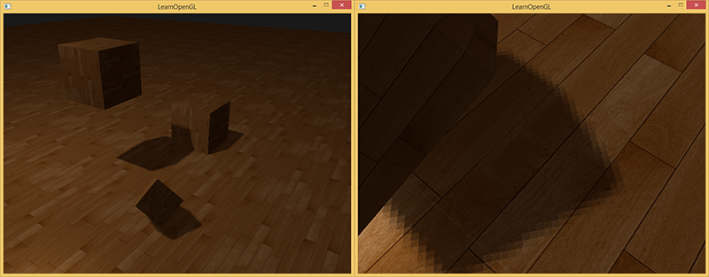

*From a distance the shadows look a lot better and less hard. If you zoom in you can still see the resolution artifacts of shadow mapping, but in general this gives good results for most applications.*

*You can find the complete source code of the example*[*here*](https://learnopengl.com/code_viewer_gh.php?code=src/5.advanced_lighting/3.1.3.shadow_mapping/shadow_mapping.cpp)*.*

*There is actually much more to PCF and quite a few techniques to considerably improve the quality of soft shadows, but for the sake of this tutorial's length we'll leave that for a later discussion.*

#### **Orthographic vs projection**

*There is a difference between rendering the depth map with an orthographic or a projection matrix. An orthographic projection matrix does not deform the scene with perspective so all view/light rays are parallel which makes it a great projection matrix for directional lights. A perspective projection matrix however does deform all vertices based on perspective which gives different results. The following image shows the different shadow regions of both projection methods:*

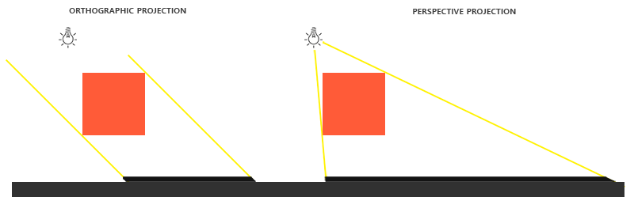

*Perspective projections make more sense for light sources that have actual locations unlike directional lights. Perspective projections are thus most often used with spotlights and point lights while orthographic projections are used for directional lights.*

*Another subtle difference with using a perspective projection matrix is that visualizing the depth buffer will often give an almost completely white result. This happens because with perspective projection the depth is transformed to non-linear depth values with most of its noticeable range close to the near plane. // intbu // To be able to properly view the depth values as we did with the orthographic projection you first want to transform the non-linear depth values to linear as we discussed in the*[*depth testing*](https://learnopengl.com/#!Advanced-OpenGL/Depth-testing)*tutorial. // remind //*

*#version 330 core*

***out*** *vec4 FragColor;*

***in*** *vec2 TexCoords;*

***uniform*** *sampler2D depthMap;*

***uniform******float*** *near_plane;*

***uniform******float*** *far_plane;*

***float*** *LinearizeDepth(****float*** *depth)*

*{*

***float*** *z = depth * 2.0 - 1.0; // Back to NDC*

***return*** *(2.0 * near_plane * far_plane) / (far_plane + near_plane - z * (far_plane - near_plane));*

*}*

***void*** *main()*

*{*

***float*** *depthValue = texture(depthMap, TexCoords).r;*

*FragColor = vec4(vec3(LinearizeDepth(depthValue) / far_plane), 1.0); // perspective*

*// FragColor = vec4(vec3(depthValue), 1.0); // orthographic*

*}*

*This shows depth values similar to what we've seen with orthographic projection. Note that this is only useful for debugging; the depth checks remain the same with orthographic or projection matrices as the relative depths do not change.*

***Additional resources***

* [*Tutorial 16 : Shadow mapping*](http://www.opengl-tutorial.org/intermediate-tutorials/tutorial-16-shadow-mapping/)*: similar shadow mapping tutorial by opengl-tutorial.org with a few extra notes.*
* [*Shadow Mapping - Part 1*](http://ogldev.atspace.co.uk/www/tutorial23/tutorial23.html)*: another shadow mapping tutorial by ogldev.*
* [*How Shadow Mapping Works*](https://www.youtube.com/watch?v=EsccgeUpdsM)*: a 3-part YouTube tutorial by TheBennyBox on shadow mapping and its implementation.*
* [*Common Techniques to Improve Shadow Depth Maps*](https://msdn.microsoft.com/en-us/library/windows/desktop/ee416324%28v=vs.85%29.aspx)*: a great article by Microsoft listing a large number of techniques to improve the quality of shadow maps.*

[*http://www.opengl-tutorial.org/intermediate-tutorials/tutorial-16-shadow-mapping/*](http://www.opengl-tutorial.org/intermediate-tutorials/tutorial-16-shadow-mapping/)

*адхілюся і засвою вось гэты цьютарал, бо тэму засвоіў не вельмі добра.*

*In Tutorial 15 we learnt how to create lightmaps, which encompasses static lighting. While it produces very nice shadows, it doesn’t deal with animated models.*

*Shadow maps are the current (as of 2016) way to make dynamic shadows. The great thing about them is that it’s fairly easy to get to work. The bad thing is that it’s terribly difficult to get to work right.*

*In this tutorial, we’ll first introduce the basic algorithm, see its shortcomings, and then implement some techniques to get better results. Since at time of writing (2012) shadow maps are still a heavily researched topic, we’ll give you some directions to further improve your own shadowmap, depending on your needs.*

### *Basic shadowmap*

*The basic shadowmap algorithm consists in two passes. First, the scene is rendered from the point of view of the light. Only the depth of each fragment is computed. Next, the scene is rendered as usual, but with an extra test to see it the current fragment is in the shadow.*

*The “being in the shadow” test is actually quite simple. If the current sample is further from the light than the shadowmap at the same point, this means that the scene contains an object that is closer to the light. In other words, the current fragment is in the shadow.*

*The following image might help you understand the principle :*

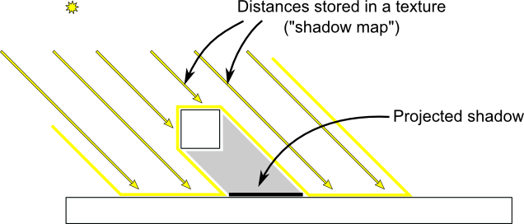

#### Rendering the shadow map

*In this tutorial, we’ll only consider directional lights - lights that are so far away that all the light rays can be considered parallel. As such, rendering the shadow map is done with an orthographic projection matrix. An orthographic matrix is just like a usual perspective projection matrix, except that no perspective is taken into account - an object will look the same whether it’s far or near the camera.*

#### Setting up the rendertarget and the MVP matrix

*Since Tutorial 14, you know how to render the scene into a texture in order to access it later from a shader.*

*Here we use a 1024x1024 16-bit depth texture to contain the shadow map. 16 bits are usually enough for a shadow map. Feel free to experiment with these values. Note that we use a depth texture, not a depth renderbuffer, since we’ll need to sample it later.*

*// The framebuffer, which regroups 0, 1, or more textures, and 0 or 1 depth buffer.*

*GLuint FramebufferName* ***=*** *0;*

*glGenFramebuffers(1,* ***&****FramebufferName);*

*glBindFramebuffer(GL_FRAMEBUFFER, FramebufferName);*

*// Depth texture. Slower than a depth buffer, but you can sample it later in your shader*

*GLuint depthTexture;*

*glGenTextures(1,* ***&****depthTexture);*

*glBindTexture(GL_TEXTURE_2D, depthTexture);*

*glTexImage2D(GL_TEXTURE_2D, 0,GL_DEPTH_COMPONENT16, 1024, 1024, 0,GL_DEPTH_COMPONENT, GL_FLOAT, 0);*

*glTexParameteri(GL_TEXTURE_2D, GL_TEXTURE_MAG_FILTER, GL_NEAREST);*

*glTexParameteri(GL_TEXTURE_2D, GL_TEXTURE_MIN_FILTER, GL_NEAREST);*

*glTexParameteri(GL_TEXTURE_2D, GL_TEXTURE_WRAP_S, GL_CLAMP_TO_EDGE);*

*glTexParameteri(GL_TEXTURE_2D, GL_TEXTURE_WRAP_T, GL_CLAMP_TO_EDGE);*

*glFramebufferTexture(GL_FRAMEBUFFER, GL_DEPTH_ATTACHMENT, depthTexture, 0);*

*glDrawBuffer(GL_NONE); // No color buffer is drawn to.*

*// Always check that our framebuffer is ok*

***if****(glCheckFramebufferStatus(GL_FRAMEBUFFER)* ***!=*** *GL_FRAMEBUFFER_COMPLETE)*

***return*** *false;*

*The MVP matrix used to render the scene from the light’s point of view is computed as follows :*

* *The Projection matrix is an orthographic matrix which will encompass everything in the axis-aligned box (-10,10),(-10,10),(-10,20) on the X,Y and Z axes respectively. These values are made so that our entire *visible *scene is always visible; more on this in the Going Further section.*
* *The View matrix rotates the world so that in camera space, the light direction is -Z (would you like to re-read*[*Tutorial 3*](http://www.opengl-tutorial.org/beginners-tutorials/tutorial-3-matrices/)*?)*
* *The Model matrix is whatever you want.*

*glm****::****vec3 lightInvDir* ***=*** *glm****::****vec3(0.5f,2,2);*

*// Compute the MVP matrix from the light's point of view*

*glm****::****mat4 depthProjectionMatrix* ***=*** *glm****::****ortho****<float>****(****-****10,10,****-****10,10,****-****10,20);*

*glm****::****mat4 depthViewMatrix* ***=*** *glm****::****lookAt(lightInvDir, glm****::****vec3(0,0,0), glm****::****vec3(0,1,0));*

*glm****::****mat4 depthModelMatrix* ***=*** *glm****::****mat4(1.0);*

*glm****::****mat4 depthMVP* ***=*** *depthProjectionMatrix* ***\**** *depthViewMatrix* ***\**** *depthModelMatrix;*

*// Send our transformation to the currently bound shader,*

*// in the "MVP" uniform*

*glUniformMatrix4fv(depthMatrixID, 1, GL_FALSE,* ***&****depthMVP[0][0])*

#### The shaders

*The shaders used during this pass are very simple. The vertex shader is a pass-through shader which simply compute the vertex’ position in homogeneous coordinates:*

***#version 330 core***

*// Input vertex data, different for all executions of this shader.*

***layout****(location* ***=*** *0)* ***in******vec3*** *vertexPosition_modelspace;*

*// Values that stay constant for the whole mesh.*

***uniform******mat4*** *depthMVP;*

***void*** *main(){*

*gl_Position* ***=*** *depthMVP* ***\*******vec4****(vertexPosition_modelspace,1);*

*}*

*The fragment shader is just as simple : it simply writes the depth of the fragment at location 0 (i.e. in our depth texture).*

***#version 330 core***

*// Ouput data*

***layout****(location* ***=*** *0)* ***out******float*** *fragmentdepth;*

***void*** *main(){*

*// Not really needed, OpenGL does it anyway*

*fragmentdepth* ***=*** *gl_FragCoord.z;*

*}*

*Rendering a shadow map is usually more than twice as fast as the normal render, because only low precision depth is written, instead of both the depth and the color; Memory bandwidth is often the biggest performance issue on GPUs.*

*Result*

*The resulting texture looks like this :*

**

*A dark colour means a small z ; hence, the upper-right corner of the wall is near the camera. At the opposite, white means z=1 (in homogeneous coordinates), so this is very far.*

#### Using the shadow map

*Basic shader*

*Now we go back to our usual shader. For each fragment that we compute, we must test whether it is “behind” the shadow map or not.*

*To do this, we need to compute the current fragment’s position in the same space that the one we used when creating the shadowmap. So we need to transform it once with the usual MVP matrix, and another time with the depthMVP matrix.*

*There is a little trick, though. Multiplying the vertex’ position by depthMVP will give homogeneous coordinates, which are in [-1,1] ; but texture sampling must be done in [0,1].*

*For instance, a fragment in the middle of the screen will be in (0,0) in homogeneous coordinates ; but since it will have to sample the middle of the texture, the UVs will have to be (0.5, 0.5).*

*This can be fixed by tweaking the fetch coordinates directly in the fragment shader but it’s more efficient to multiply the homogeneous coordinates by the following matrix, which simply divides coordinates by 2 (the diagonal: [-1,1] -> [-0.5, 0.5] ) and translates them (the lower row: [-0.5, 0.5] -> [0,1] ).*

*glm****::****mat4 biasMatrix(*

*0.5, 0.0, 0.0, 0.0,*

*0.0, 0.5, 0.0, 0.0,*

*0.0, 0.0, 0.5, 0.0,*

*0.5, 0.5, 0.5, 1.0*

*);*

*glm****::****mat4 depthBiasMVP* ***=*** *biasMatrix****\*****depthMVP;*

*We can now write our vertex shader. It’s the same as before, but we output 2 positions instead of 1:*

* *gl_Position is the position of the vertex as seen from the current camera*
* *ShadowCoord is the position of the vertex as seen from the last camera (the light)*

*// Output position of the vertex, in clip space : MVP * position*

*gl_Position* ***=*** *MVP* ***\*******vec4****(vertexPosition_modelspace,1);*

*// Same, but with the light's view matrix*

*ShadowCoord* ***=*** *DepthBiasMVP* ***\*******vec4****(vertexPosition_modelspace,1);*

*The fragment shader is then very simple:*

* *texture( shadowMap, ShadowCoord.xy ).z is the distance between the light and the nearest occluder*
* *ShadowCoord.z is the distance between the light and the current fragment*

*… so if the current fragment is further than the nearest occluder, this means we are in the shadow (of said nearest occluder) :*

***float*** *visibility* ***=*** *1.0;*

***if*** *( texture( shadowMap, ShadowCoord.xy ).z* ***<*** *ShadowCoord.z){*

*visibility* ***=*** *0.5;*

*}*

*We just have to use this knowledge to modify our shading. Of course, the ambient colour isn’t modified, since its purpose in life is to fake some incoming light even when we’re in the shadow (or everything would be pure black)*

*color* ***=***

*// Ambient : simulates indirect lighting*

*MaterialAmbientColor* ***+***

*// Diffuse : "color" of the object*

*visibility* ***\**** *MaterialDiffuseColor* ***\**** *LightColor* ***\**** *LightPower* ***\**** *cosTheta****+***

*// Specular : reflective highlight, like a mirror*

*visibility* ***\**** *MaterialSpecularColor* ***\**** *LightColor* ***\**** *LightPower* ***\**** *pow(cosAlpha,5);*

#### Result - Shadow acne

*Here’s the result of the current code. Obviously, the global idea it there, but the quality is unacceptable.*

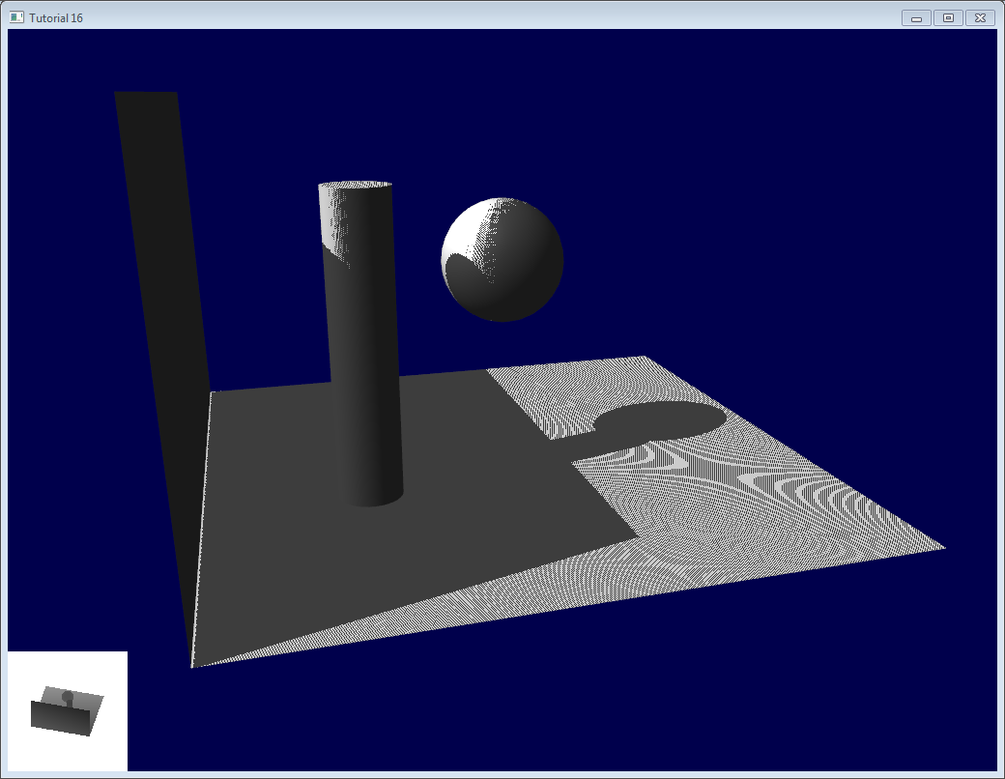

*Let’s look at each problem in this image. The code has 2 projects : shadowmaps and shadowmaps_simple; start with whichever you like best. The simple version is just as ugly as the image above, but is simpler to understand.*

#### Problems

##### *Shadow acne*

*The most obvious problem is called shadow acne :*

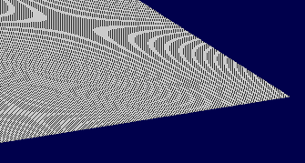

*This phenomenon is easily explained with a simple image :*

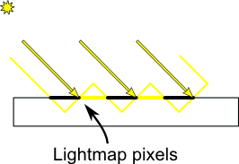

*The usual “fix” for this is to add an error margin : we only shade if the current fragment’s depth (again, in light space) is really far away from the lightmap value. We do this by adding a bias :*

***float*** *bias* ***=*** *0.005;*

***float*** *visibility* ***=*** *1.0;*

***if*** *( texture( shadowMap, ShadowCoord.xy ).z* ***<*** *ShadowCoord.z****-****bias){*

*visibility* ***=*** *0.5;*

*}*

*The result is already much nicer :*

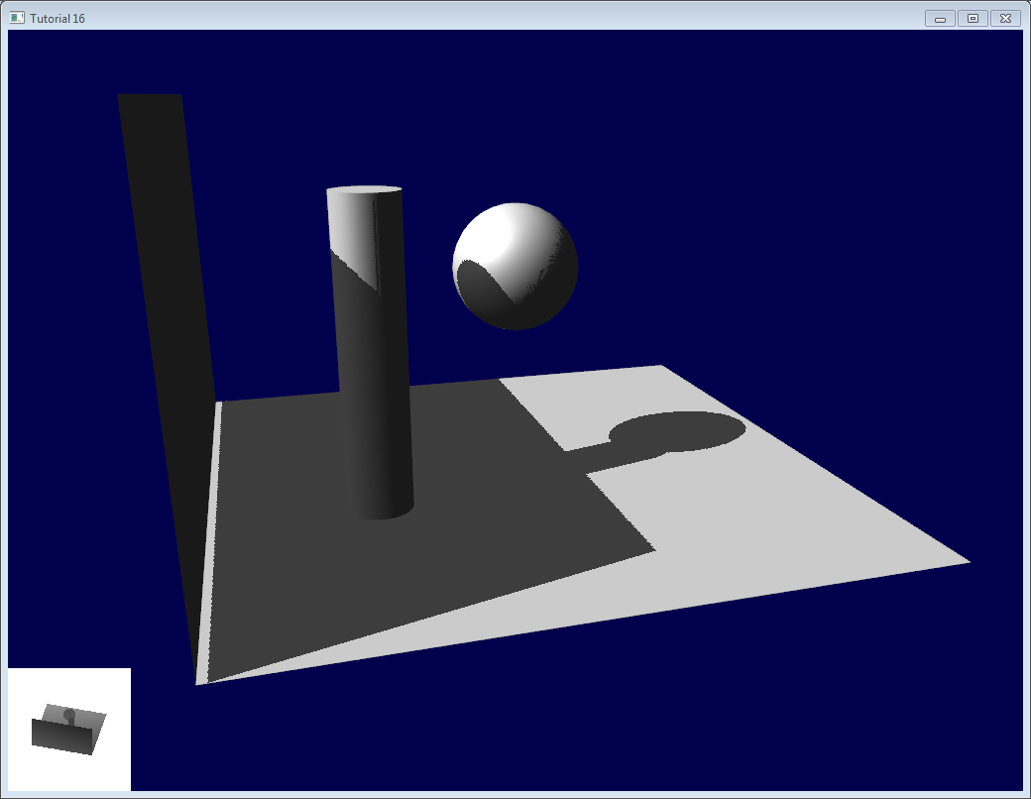

*However, you can notice that because of our bias, the artefact between the ground and the wall has gone worse. What’s more, a bias of 0.005 seems too much on the ground, but not enough on curved surface: some artefacts remain on the cylinder and on the sphere.*

*A common approach is to modify the bias according to the slope :*

***float*** *bias* ***=*** *0.005****\*****tan(acos(cosTheta)); // cosTheta is dot( n,l ), clamped between 0 and 1*

*bias* ***=*** *clamp(bias, 0,0.01);*

*Shadow acne is now gone, even on curved surfaces.*

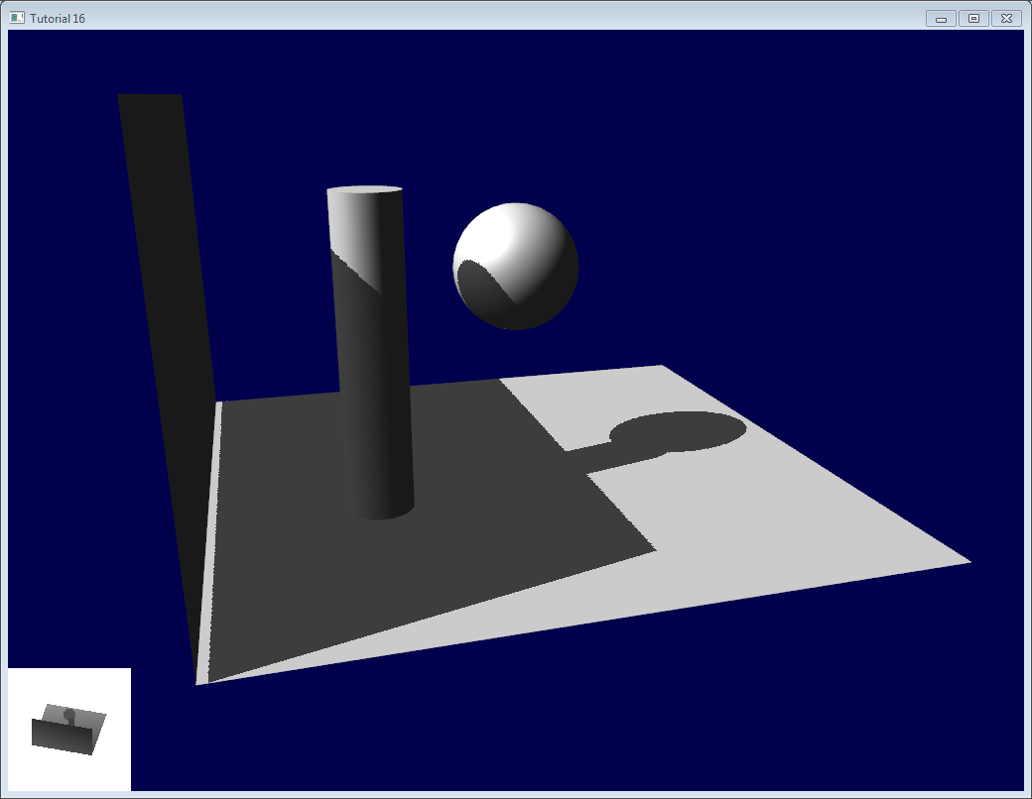

*Another trick, which may or may not work depending on your geometry, is to render only the back faces in the shadow map. This forces us to have a special geometry ( see next section - Peter Panning ) with thick walls, but at least, the acne will be on surfaces which are in the shadow :*

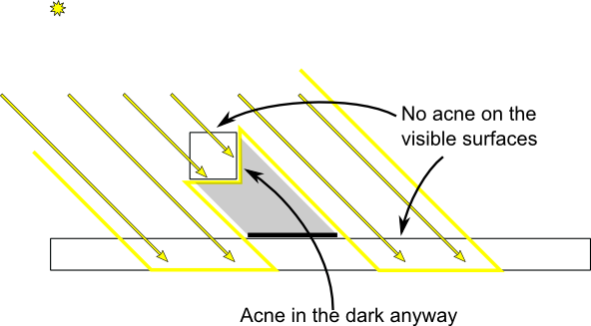

*When rendering the shadow map, cull front-facing triangles :*

*// We don't use bias in the shader, but instead we draw back faces,*

*// which are already separated from the front faces by a small distance*

*// (if your geometry is made this way)*

*glCullFace(GL_FRONT); // Cull front-facing triangles -> draw only back-facing triangles*

*And when rendering the scene, render normally (backface culling)*

*glCullFace(GL_BACK); // Cull back-facing triangles -> draw only front-facing triangles*

*This method is used in the code, in addition to the bias.*

##### *Peter Panning*

*We have no shadow acne anymore, but we still have this wrong shading of the ground, making the wall to look as if it’s flying (hence the term “Peter Panning”). In fact, adding the bias made it worse.*

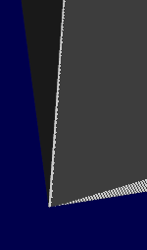

*This one is very easy to fix : simply avoid thin geometry. This has two advantages :*

* *First, it solves Peter Panning : it the geometry is more deep than your bias, you’re all set.*
* *Second, you can turn on backface culling when rendering the lightmap, because now, there is a polygon of the wall which is facing the light, which will occlude the other side, which wouldn’t be rendered with backface culling.*

*The drawback is that you have more triangles to render ( two times per frame ! )*

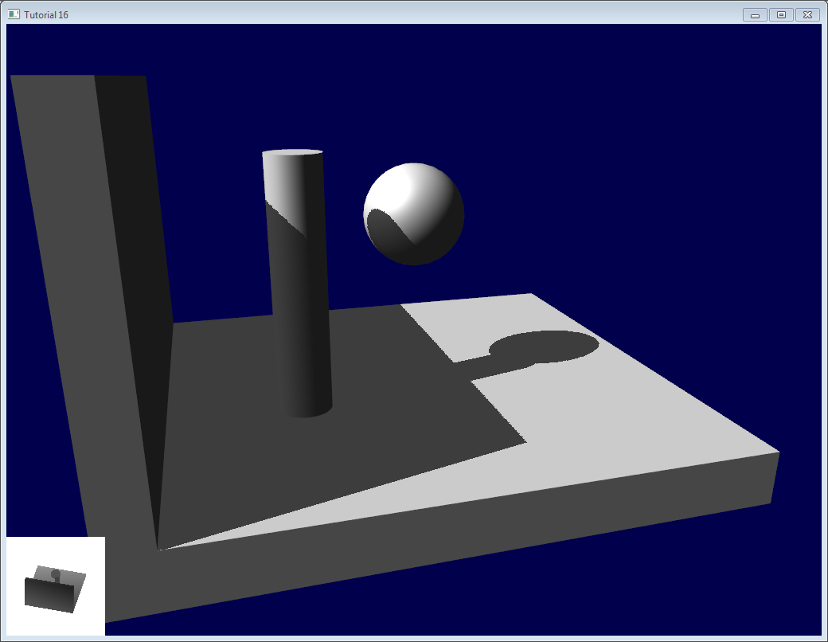

##### *Aliasing*

*Even with these two tricks, you’ll notice that there is still aliasing on the border of the shadow. In other words, one pixel is white, and the next is black, without a smooth transition inbetween.*

**

###### *PCF*

*The easiest way to improve this is to change the shadowmap’s sampler type to sampler2DShadow. The consequence is that when you sample the shadowmap once, the hardware will in fact also sample the neighboring texels, do the comparison for all of them, and return a float in [0,1] with a bilinear filtering of the comparison results.*

*For instance, 0.5 means that 2 samples are in the shadow, and 2 samples are in the light.*

*Note that it’s not the same than a single sampling of a filtered depth map ! A comparison always returns true or false; PCF gives a interpolation of 4 “true or false”.*

**

*As you can see, shadow borders are smooth, but shadowmap’s texels are still visible.*

###### *Poisson Sampling*

*An easy way to deal with this is to sample the shadowmap N times instead of once. Used in combination with PCF, this can give very good results, even with a small N. Here’s the code for 4 samples :*

***for*** *(****int*** *i****=****0;i****<****4;i****++****){*

***if*** *( texture( shadowMap, ShadowCoord.xy* ***+*** *poissonDisk[i]****/****700.0 ).z* ***<*** *ShadowCoord.z****-****bias ){*

*visibility****-=****0.2;*

*}*

*}*

*poissonDisk is a constant array defines for instance as follows :*

***vec2*** *poissonDisk[4]* ***=******vec2****[](*

***vec2****(* ***-****0.94201624,* ***-****0.39906216 ),*

***vec2****( 0.94558609,* ***-****0.76890725 ),*

***vec2****(* ***-****0.094184101,* ***-****0.92938870 ),*

***vec2****( 0.34495938, 0.29387760 )*

*);*

*This way, depending on how many shadowmap samples will pass, the generated fragment will be more or less dark :*

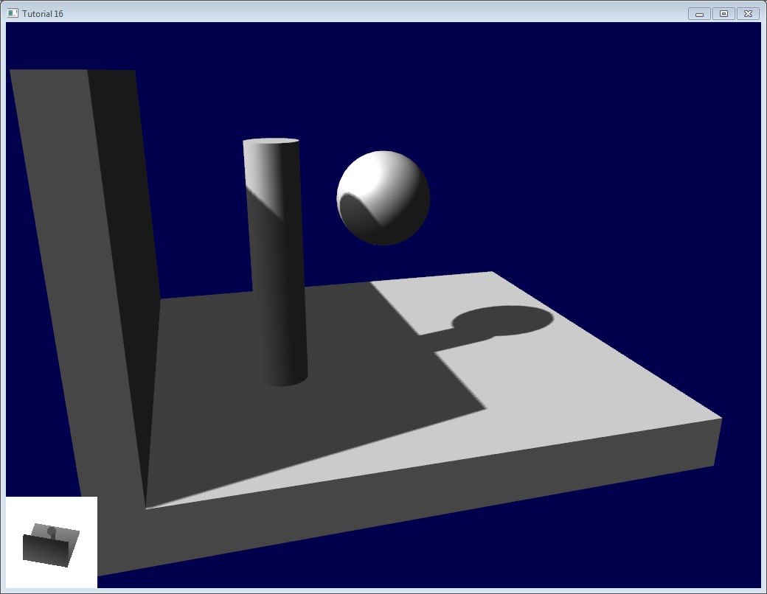

*The 700.0 constant defines how much the samples are “spread”. Spread them too little, and you’ll get aliasing again; too much, and you’ll get this :* banding (this screenshot doesn’t use PCF for a more dramatic effect, but uses 16 samples instead) \**

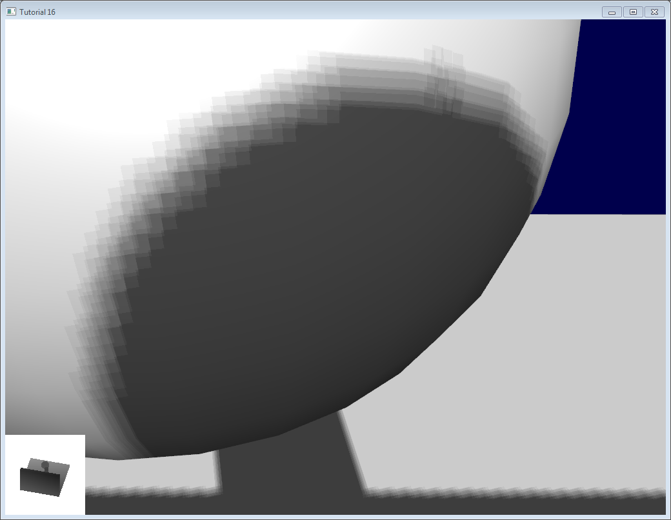

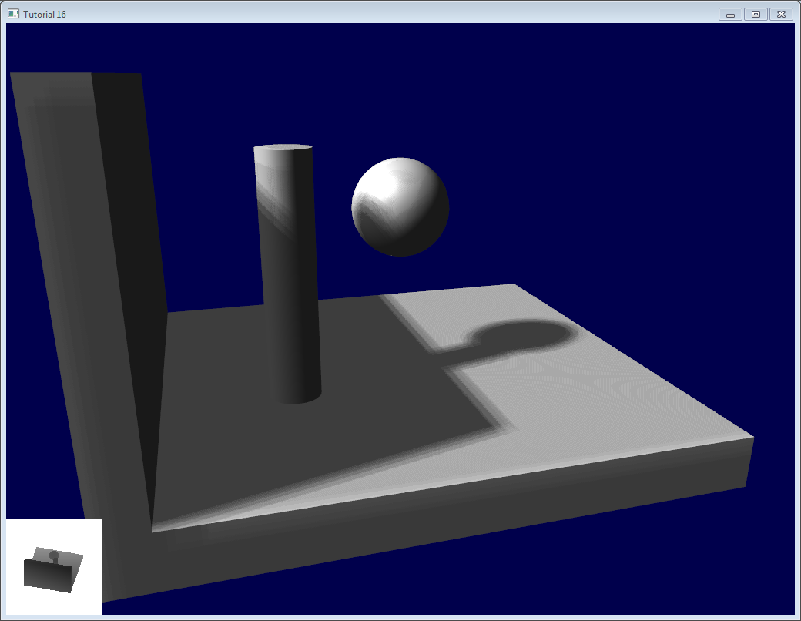

Stratified Poisson Sampling

*We can remove this banding by choosing different samples for each pixel. There are two main methods : Stratified Poisson or Rotated Poisson. Stratified chooses different samples; Rotated always use the same, but with a random rotation so that they look different. In this tutorial I will only explain the stratified version.*

*The only difference with the previous version is that we index poissonDisk with a random index :*

***for*** *(****int*** *i****=****0;i****<****4;i****++****){*

***int*** *index* ***=*** *// A random number between 0 and 15, different for each pixel (and each i !)*

*visibility* ***-=*** *0.2****\*****(1.0****-****texture( shadowMap,* ***vec3****(ShadowCoord.xy* ***+*** *poissonDisk[index]****/****700.0, (ShadowCoord.z****-****bias)****/****ShadowCoord.w) ));*

*}*

*We can generate a random number with a code like this, which returns a random number in [0,1[ :*

***float*** *dot_product* ***=*** *dot(seed4,* ***vec4****(12.9898,78.233,45.164,94.673));*

***return*** *fract(sin(dot_product)* ***\**** *43758.5453);*

*In our case, seed4 will be the combination of i (so that we sample at 4 different locations) and … something else. We can use gl_FragCoord ( the pixel’s location on the screen ), or Position_worldspace :*

*// - A random sample, based on the pixel's screen location.*

*// No banding, but the shadow moves with the camera, which looks weird.*

***int*** *index* ***=******int****(16.0****\*****random(gl_FragCoord.xyy, i))****%****16;*

*// - A random sample, based on the pixel's position in world space.*

*// The position is rounded to the millimeter to avoid too much aliasing*

*//int index = int(16.0*random(floor(Position_worldspace.xyz*1000.0), i))%16;*

*This will make patterns such as in the picture above disappear, at the expense of visual noise. Still, a well-done noise is often less objectionable than these patterns.*

**

*See*[*tutorial16/ShadowMapping.fragmentshader*](https://github.com/opengl-tutorials/ogl/blob/master/tutorial16_shadowmaps/ShadowMapping.fragmentshader)*for three example implementions.*

*Going further*

*Even with all these tricks, there are many, many ways in which our shadows could be improved. Here are the most common :*

*// далей яшчэ не чытаў… слаба разумею. Застаўся маленькі фрагмент. Засвою потым… вяртаюся да ранейшага цьютарала //*

[*https://learnopengl.com/#!Advanced-Lighting/Shadows/Point-Shadows*](https://learnopengl.com/#!Advanced-Lighting/Shadows/Point-Shadows)

## ***Point Shadows***

*In the last tutorial we learned to create dynamic shadows with shadow mapping. It works great, but it's only suited for directional lights as the shadows are only generated in a single direction of the light source. It is therefore also known as directional shadow mapping as the depth (or shadow) map is generated from just the direction the light is looking at.*

*What this tutorial will focus on is the generation of dynamic shadows in all surrounding directions. The technique we're using is perfect for point lights as a real point light would cast shadows in all directions. This technique is known as point (light) shadows or more formerly as omnidirectional shadow maps.*

*This tutorial builds upon the previous*[*shadow mapping tutorial*](https://learnopengl.com/#!Advanced-Lighting/Shadows/Shadow-Mapping)*so unless you're familiar with traditional shadow mapping it is advised to read the shadow mapping tutorial first.*

*The algorithm remains mostly the same to directional shadow mapping: we generate a depth map from the light's perspective(s), sample the depth map based on the current fragment position and compare each fragment with the stored depth value to see whether it is in shadow. The main difference between directional shadow mapping and omnidirectional shadow mapping is the depth map used.*

*The depth map we need requires rendering a scene from all surrounding directions of a point light and as such a normal 2D depth map won't work; what if we were to use a*[*cubemap*](https://learnopengl.com/#!Advanced-OpenGL/Cubemaps)*instead? Because a cubemap can store environment data with only 6 faces it is possible to render the entire scene to each of the faces of a cubemap and sample these as the point light's surrounding depth values.*

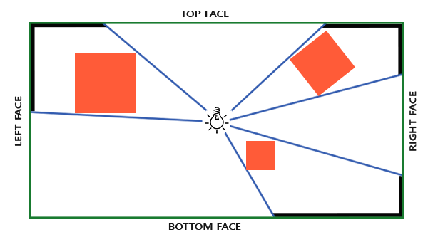

*The generated depth cubemap is then passed to the lighting fragment shader that samples the cubemap with a direction vector to obtain the depth (from the light's perspective) at that fragment. Most of the complicated stuff we already discussed in the shadow mapping tutorial. What makes this algorithm slightly more difficult is the depth cubemap generation.*

***Generating the depth cubemap***

*To create a cubemap of a light's surrounding depth values we have to render the scene 6 times: once for each face. One (quite obvious) way to do this is render the scene 6 times with 6 different view matrices, each time attaching a different cubemap face to a framebuffer object. This would look something like this:*

***for****(****unsigned******int*** *i = 0; i < 6; i++)*

*{*

*GLenum face = GL_TEXTURE_CUBE_MAP_POSITIVE_X + i;*

*glFramebufferTexture2D(GL_FRAMEBUFFER, GL_DEPTH_ATTACHMENT, face, depthCubemap, 0);*

*BindViewMatrix(lightViewMatrices[i]);*

*RenderScene();*

*}*

*This can be quite expensive though as a lot of render calls are necessary for just a single depth map. In this tutorial we're going to use an alternative (more organized) approach using a little trick in the geometry shader that allows us to build the depth cubemap with just a single render pass.*

*First, we'll need to create a cubemap:*

***unsigned******int*** *depthCubemap;*

*glGenTextures(1, &depthCubemap);*

*And generate each of the single cubemap faces as 2D depth-valued texture images:*

***const******unsigned******int*** *SHADOW_WIDTH = 1024, SHADOW_HEIGHT = 1024;*

*glBindTexture(GL_TEXTURE_CUBE_MAP, depthCubemap);*

***for*** *(****unsigned******int*** *i = 0; i < 6; ++i)*

*glTexImage2D(GL_TEXTURE_CUBE_MAP_POSITIVE_X + i, 0, GL_DEPTH_COMPONENT,*

*SHADOW_WIDTH, SHADOW_HEIGHT, 0, GL_DEPTH_COMPONENT, GL_FLOAT, NULL);*

*Also don't forget to set the suitable texture parameters:*

*glTexParameteri(GL_TEXTURE_CUBE_MAP, GL_TEXTURE_MAG_FILTER, GL_NEAREST);*

*glTexParameteri(GL_TEXTURE_CUBE_MAP, GL_TEXTURE_MIN_FILTER, GL_NEAREST);*

*glTexParameteri(GL_TEXTURE_CUBE_MAP, GL_TEXTURE_WRAP_S, GL_CLAMP_TO_EDGE);*

*glTexParameteri(GL_TEXTURE_CUBE_MAP, GL_TEXTURE_WRAP_T, GL_CLAMP_TO_EDGE);*

*glTexParameteri(GL_TEXTURE_CUBE_MAP, GL_TEXTURE_WRAP_R, GL_CLAMP_TO_EDGE);*

*Normally we'd attach a single face of a cubemap texture to the framebuffer object and render the scene 6 times, each time switching the depth buffer target of the framebuffer to a different cubemap face. Since we're going to use a geometry shader that allows us to render to all faces in a single pass we can directly attach the cubemap as a framebuffer's depth attachment using glFramebufferTexture:*

*glBindFramebuffer(GL_FRAMEBUFFER, depthMapFBO);*

*glFramebufferTexture(GL_FRAMEBUFFER, GL_DEPTH_ATTACHMENT, depthCubemap, 0);*

*glDrawBuffer(GL_NONE);*

*glReadBuffer(GL_NONE);*

*glBindFramebuffer(GL_FRAMEBUFFER, 0);*

*Again, note the call to glDrawBuffer and glReadBuffer: we only care about depth values when generating a depth cubemap so we have to explicitly tell OpenGL this framebuffer object does not render to a color buffer.*

*With omnidirectional shadow maps we have two render passes: first we generate the depth map and second, we use the depth map in the normal render pass to create shadows in the scene. With the framebuffer object and the cubemap this process looks a bit like this:*

*// 1. first render to depth cubemap*

*glViewport(0, 0, SHADOW_WIDTH, SHADOW_HEIGHT);*

*glBindFramebuffer(GL_FRAMEBUFFER, depthMapFBO);*

*glClear(GL_DEPTH_BUFFER_BIT);*

*ConfigureShaderAndMatrices();*

*RenderScene();*

*glBindFramebuffer(GL_FRAMEBUFFER, 0);*

*// 2. then render scene as normal with shadow mapping (using depth cubemap)*

*glViewport(0, 0, SCR_WIDTH, SCR_HEIGHT);*

*glClear(GL_COLOR_BUFFER_BIT | GL_DEPTH_BUFFER_BIT);*

*ConfigureShaderAndMatrices();*

*glBindTexture(GL_TEXTURE_CUBE_MAP, depthCubemap);*

*RenderScene();*

*The process is exactly the same as with default shadow mapping, although this time we render to and use a cubemap depth texture compared to a 2D depth texture. Before we actually render the scene from all of the light's viewing directions we first have to calculate the proper transformation matrices.*

***Light space transform***

*With the framebuffer and cubemap set we need some way to transform all the scene's geometry to the relevant light spaces in all 6 directions of the light. Similar to the*[*shadow mapping*](https://learnopengl.com/#!Advanced-Lighting/Shadows/Shadow-Mapping)*tutorial we're going to need a light space transformation matrix TT, but this time one for each face.*

*Each light space transformation matrix contains both a projection and a view matrix. For the projection matrix we're going to use a perspective projection matrix; the light source represents a point in space so perspective projection makes most sense. Each light space transformation matrix uses the same projection matrix:*

***float*** *aspect = (****float****)SHADOW_WIDTH/(****float****)SHADOW_HEIGHT;*

***float*** *near = 1.0f;*

***float*** *far = 25.0f;*

*glm::mat4 shadowProj = glm::perspective(glm::radians(90.0f), aspect, near, far);*

*Important to note here is the field of view parameter of glm::perspective that we set to 90 degrees. By setting this to 90 degrees we make sure the viewing field is exactly large enough to properly fill a single face of the cubemap such that all faces align correctly to each other at the edges.*

*As the projection matrix does not change per direction we can re-use it for each of the 6 transformation matrices. We do need a different view matrix per direction. With glm::lookAt we create 6 view directions, each looking at a single direction of the cubemap in the order: right, left, top, bottom, near and far.*

*std::vector<glm::mat4> shadowTransforms;*

*shadowTransforms.push_back(shadowProj \**

*glm::lookAt(lightPos, lightPos + glm::vec3( 1.0, 0.0, 0.0), glm::vec3(0.0,-1.0, 0.0));*

*shadowTransforms.push_back(shadowProj \**

*glm::lookAt(lightPos, lightPos + glm::vec3(-1.0, 0.0, 0.0), glm::vec3(0.0,-1.0, 0.0));*

*shadowTransforms.push_back(shadowProj \**

*glm::lookAt(lightPos, lightPos + glm::vec3( 0.0, 1.0, 0.0), glm::vec3(0.0, 0.0, 1.0));*

*shadowTransforms.push_back(shadowProj \**

*glm::lookAt(lightPos, lightPos + glm::vec3( 0.0,-1.0, 0.0), glm::vec3(0.0, 0.0,-1.0));*

*shadowTransforms.push_back(shadowProj \**

*glm::lookAt(lightPos, lightPos + glm::vec3( 0.0, 0.0, 1.0), glm::vec3(0.0,-1.0, 0.0));*

*shadowTransforms.push_back(shadowProj \**

*glm::lookAt(lightPos, lightPos + glm::vec3( 0.0, 0.0,-1.0), glm::vec3(0.0,-1.0, 0.0));*

*Here we create 6 view matrices and multiply them with the projection matrix to get a total of 6 different light space transformation matrices. The target parameter of glm::lookAt each looks into the direction of a single cubemap face.*

*These transformation matrices are send to the shaders that render the depth into the cubemap.*

***Depth shaders***

*To render depth values to a depth cubemap we're going to need a total of three shaders: a vertex and fragment shader and a*[*geometry shader*](https://learnopengl.com/#!Advanced-OpenGL/Geometry-Shader)*in between.*

*The geometry shader will be the shader responsible for transforming all world-space vertices to 6 different light spaces. Therefore the vertex shader simply transforms vertices to world-space and directs them to the geometry shader:*

*#version 330 core*

***layout*** *(location = 0)* ***in*** *vec3 aPos;*

***uniform*** *mat4 model;*

***void*** *main()*

*{*

*gl_Position = model * vec4(aPos, 1.0);*

*}*

*The geometry shader then takes as input 3 triangle vertices and a uniform array of light space transformation matrices. The geometry shader is then responsible for transforming the vertices to the light spaces; this is also where it gets interesting.*

*The geometry shader has a built-in variable called gl_Layer that specifies which cubemap face to emit a primitive to. When left alone the geometry shader just sends its primitives further down the pipeline as usual, but when we update this variable we can control to which cubemap face we render to for each primitive. This of course only works when we have a cubemap texture attached to the active framebuffer.*

*#version 330 core*

***layout*** *(triangles)* ***in****;*

***layout*** *(triangle_strip, max_vertices=18)* ***out****;*

***uniform*** *mat4 shadowMatrices[6];*

***out*** *vec4 FragPos; // FragPos from GS (output per emitvertex)*

***void*** *main()*

*{*

***for****(****int*** *face = 0; face < 6; ++face)*

*{*

*gl_Layer = face; // built-in variable that specifies to which face we render.*

***for****(****int*** *i = 0; i < 3; ++i) // for each triangle's vertices*

*{*

*FragPos = gl_in[i].gl_Position;*

*gl_Position = shadowMatrices[face] * FragPos;*

*EmitVertex();*

*}*

*EndPrimitive();*

*}*

*}*

*This geometry shader should be relatively straightforward. We take as input a triangle and output a total of 6 triangles (6 * 3 vertices each equals 18 vertices). In the main function we iterate over 6 cubemap faces where we specify each face as the output face by storing the face integer into gl_Layer. Then we generate each triangle by transforming each world-space vertex to the relevant light space by multiplying FragPos with the face's light-space transformation matrix. Note that we also sent the resulting FragPos variable to the fragment shader that we'll need to calculate a depth value.*

*In the last tutorial we used an empty fragment shader and let OpenGL figure out the depth values of the depth map. This time we're going to calculate our own (linear) depth as the linear distance between each fragment position and the light source's position. Calculating our own depth values makes the later shadow calculations a bit more intuitive.*

*#version 330 core*

***in*** *vec4 FragPos;*

***uniform*** *vec3 lightPos;*

***uniform******float*** *far_plane;*

***void*** *main()*

*{*

*// get distance between fragment and light source*

***float*** *lightDistance = length(FragPos.xyz - lightPos);*

*// map to [0;1] range by dividing by far_plane*

*lightDistance = lightDistance / far_plane;*

*// write this as modified depth*

*gl_FragDepth = lightDistance;*

*}*

*The fragment shader takes as input the FragPos from the geometry shader, the light's position vector and the frustum's far plane value. Here we take the distance between the fragment and the light source, map it to the [0,1] range and write it as the fragment's depth value.*

*Rendering the scene with these shaders and the cubemap-attached framebuffer object active should give you a completely filled depth cubemap for the second pass's shadow calculations.*

***Omnidirectional shadow maps***

*With everything set up it is time to render the actual omnidirectional shadows. The procedure is similar to the directional shadow mapping tutorial although this time we bind a cubemap texture instead of a 2D texture as the depth map and also pass the light projection's far plane variable to the shaders.*

*glViewport(0, 0, SCR_WIDTH, SCR_HEIGHT);*

*glClear(GL_COLOR_BUFFER_BIT | GL_DEPTH_BUFFER_BIT);*

*shader.use();*

*// ... send uniforms to shader (including light's far_plane value)*

*glActiveTexture(GL_TEXTURE0);*

*glBindTexture(GL_TEXTURE_CUBE_MAP, depthCubemap);*

*// ... bind other textures*

*RenderScene();*

*Here the renderScene function renders some cubes in a large cube room scattered around a light source at the center of the scene.*

*The vertex shader and fragment shader are largely similar to the original shadow mapping shaders: the differences being that the fragment shader no longer requires a fragment position in light space as we can now sample the depth values using a direction vector.*

*Because of this the vertex shader no longer needs to transform its position vectors to light space so we can exclude the FragPosLightSpace variable:*

*#version 330 core*

***layout*** *(location = 0)* ***in*** *vec3 aPos;*

***layout*** *(location = 1)* ***in*** *vec3 aNormal;*

***layout*** *(location = 2)* ***in*** *vec2 aTexCoords;*

***out*** *vec2 TexCoords;*

***out*** *VS_OUT {*

*vec3 FragPos;*

*vec3 Normal;*

*vec2 TexCoords;*

*} vs_out;*

***uniform*** *mat4 projection;*

***uniform*** *mat4 view;*

***uniform*** *mat4 model;*

***void*** *main()*

*{*

*vs_out.FragPos = vec3(model * vec4(aPos, 1.0));*

*vs_out.Normal = transpose(inverse(mat3(model))) * aNormal;*

*vs_out.TexCoords = aTexCoords;*

*gl_Position = projection * view * model * vec4(aPos, 1.0);*

*}*

*The fragment shader's Blinn-Phong lighting code is exactly the same as we had before with a shadow multiplication at the end:*

*#version 330 core*

***out*** *vec4 FragColor;*

***in*** *VS_OUT {*

*vec3 FragPos;*

*vec3 Normal;*

*vec2 TexCoords;*

*} fs_in;*

***uniform*** *sampler2D diffuseTexture;*

***uniform*** *samplerCube depthMap;*

***uniform*** *vec3 lightPos;*

***uniform*** *vec3 viewPos;*

***uniform******float*** *far_plane;*

***float*** *ShadowCalculation(vec3 fragPos)*

*{*

*[...]*

*}*

***void*** *main()*

*{*

*vec3 color = texture(diffuseTexture, fs_in.TexCoords).rgb;*

*vec3 normal = normalize(fs_in.Normal);*

*vec3 lightColor = vec3(0.3);*

*// ambient*

*vec3 ambient = 0.3 * color;*

*// diffuse*

*vec3 lightDir = normalize(lightPos - fs_in.FragPos);*

***float*** *diff = max(dot(lightDir, normal), 0.0);*

*vec3 diffuse = diff * lightColor;*

*// specular*

*vec3 viewDir = normalize(viewPos - fs_in.FragPos);*

*vec3 reflectDir = reflect(-lightDir, normal);*

***float*** *spec = 0.0;*

*vec3 halfwayDir = normalize(lightDir + viewDir);*

*spec = pow(max(dot(normal, halfwayDir), 0.0), 64.0);*

*vec3 specular = spec * lightColor;*

*// calculate shadow*

***float*** *shadow = ShadowCalculation(fs_in.FragPos);*

*vec3 lighting = (ambient + (1.0 - shadow) * (diffuse + specular)) * color;*

*FragColor = vec4(lighting, 1.0);*

*}*

*There are a few subtle differences: the lighting code is the same, but we now have a samplerCube uniform and the ShadowCalculation function takes the fragment's position as its parameter instead of the fragment position in light space. We now also include the light frustum's far_plane value that we'll later need. At the end of the fragment shader run we calculate the shadow component which is 1.0 when the fragment is in shadow or 0.0 when it's not. We use the calculated shadow component to influence the lighting's diffuse and specular components.*

*What is largely different is the content of the ShadowCalculation function that now samples depth values from a cubemap instead of a 2D texture. Let's discuss its content step by step.*

*The first thing we have to do is retrieve the depth of the cubemap. As you might remember from the cubemap section of this tutorial is that we stored the depth as the linear distance between a fragment and the light position; we're taking a similar approach here:*

***float*** *ShadowCalculation(vec3 fragPos)*

*{*

*vec3 fragToLight = fragPos - lightPos;*

***float*** *closestDepth = texture(depthMap, fragToLight).r;*

*}*

*Here we take the difference vector between the fragment's position and the light's position and use that vector as a direction vector to sample the cubemap. The direction vector doesn't need to be a unit vector to sample from a cubemap so there's no need to normalize it. The resulting closestDepth is the normalized depth value between the light source and its closest visible fragment.*

*The closestDepth value is currently in the range [0,1] so we first transform it back to [0,far_plane] by multiplying it with far_plane.*

*closestDepth *= far_plane;*

*Next we retrieve the depth value between the current fragment and the light source which we can easily obtain by taking the length of fragToLight due to how we calculated depth values in the cubemap:*

***float*** *currentDepth = length(fragToLight);*

*This returns a depth value in the same (or larger) range as closestDepth.*

*Now we can compare both depth values to see which is closer than the other and determine whether the current fragment is in shadow. We also include a shadow bias so we don't get shadow acne as discussed in the*[*previous*](https://learnopengl.com/#!Advanced-Lighting/Shadows/Shadow-Mapping)*tutorial.*

***float*** *bias = 0.05;*

***float*** *shadow = currentDepth - bias > closestDepth ? 1.0 : 0.0;*

*The complete ShadowCalculation then becomes:*

***float*** *ShadowCalculation(vec3 fragPos)*

*{*

*// get vector between fragment position and light position*

*vec3 fragToLight = fragPos - lightPos;*

*// use the light to fragment vector to sample from the depth map*

***float*** *closestDepth = texture(depthMap, fragToLight).r;*

*// it is currently in linear range between [0,1]. Re-transform back to original value*

*closestDepth *= far_plane;*

*// now get current linear depth as the length between the fragment and light position*

***float*** *currentDepth = length(fragToLight);*

*// now test for shadows*

***float*** *bias = 0.05;*

***float*** *shadow = currentDepth - bias > closestDepth ? 1.0 : 0.0;*

***return*** *shadow;*

*}*

*With these shaders we already get pretty good shadows and this time in all surrounding directions from a point light. With a point light positioned at the center of a simple scene it'll look a bit like this:*

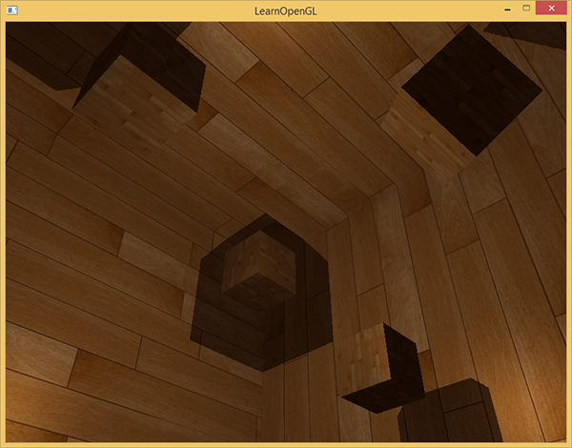

*You can find the source code of this demo*[*here*](https://learnopengl.com/code_viewer_gh.php?code=src/5.advanced_lighting/3.2.1.point_shadows/point_shadows.cpp)*.*

***Visualizing cubemap depth buffer***

*If you're somewhat like me you probably didn't get this right on the first try so it makes sense to do some debugging with one of the obvious checks being validating whether the depth map was built correctly. Because we don't have a 2D depth map texture anymore visualizing the depth map becomes a bit less obvious.*

*A simple trick to visualize the depth buffer is to take the normalized (in the range [0,1]) closestDepth variable in the ShadowCalculation function and display that variable as:*

*FragColor = vec4(vec3(closestDepth / far_plane), 1.0);*

*The result is a grayed out scene where each color represents the linear depth values of the scene:*

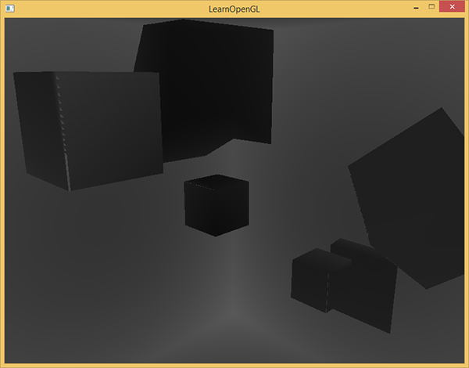

*You can also see the to-be shadowed regions on the outside wall. If it looks somewhat similar you know the depth cubemap was properly generated. Otherwise you probably did something wrong or used the closestDepth still in the [0,far_plane] range.*

***PCF***

*Since omnidirectional shadow maps are based on the same principles of traditional shadow mapping it also has the same resolution dependent artifacts. If you zoom in closely you can again see jagged edges. Percentage-closer filtering or PCF allows us to smooth out these jagged edges by filtering multiple samples around the fragment position and average the results.*

*If we take the same simple PCF filter of the previous tutorial and add a third dimension (because we need 3D direction vectors to sample from a cubemap) we get:*

***float*** *shadow = 0.0;*

***float*** *bias = 0.05;*

***float*** *samples = 4.0;*

***float*** *offset = 0.1;*

***for****(****float*** *x = -offset; x < offset; x += offset / (samples * 0.5))*

*{*

***for****(****float*** *y = -offset; y < offset; y += offset / (samples * 0.5))*

*{*

***for****(****float*** *z = -offset; z < offset; z += offset / (samples * 0.5))*

*{*

***float*** *closestDepth = texture(depthMap, fragToLight + vec3(x, y, z)).r;*

*closestDepth *= far_plane; // Undo mapping [0;1]*

***if****(currentDepth - bias > closestDepth)*

*shadow += 1.0;*

*}*

*}*

*}*

*shadow /= (samples * samples * samples);*

*The code isn't too different from what we had in traditional shadow mapping. Here we calculate the texture offsets dynamically based on the number of samples we'd like to take in each axis and take 3 times sample the amount of sub-samples that we then average at the end.*

*The shadows now look a lot more soft and smooth and gives much more plausible results.*

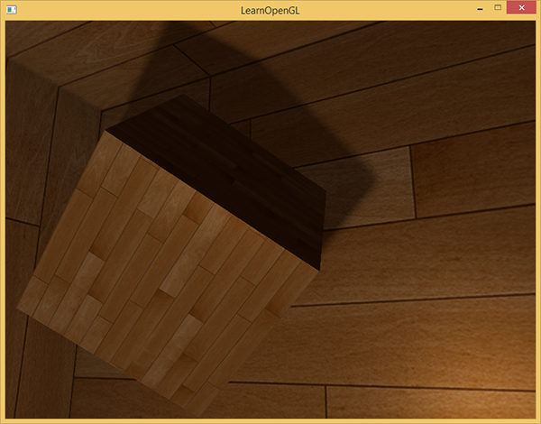

*However, with samples set to 4.0 we take a total of 64 samples each fragment which is a lot!*

*As most of these samples are redundant in that they sample close to the original direction vector it might make more sense to only sample in perpendicular directions of the sample direction vector. However as there is no (easy) way to figure out which sub-directions are redundant this becomes difficult. One trick we can use is to take an array of offset directions that are all roughly separable e.g. each of them points in completely different directions, reducing the number of sub-directions that are close together. Below we have such an array of a maximum of 20 offset directions:*

*vec3 sampleOffsetDirections[20] = vec3[]*

*(*

*vec3( 1, 1, 1), vec3( 1, -1, 1), vec3(-1, -1, 1), vec3(-1, 1, 1),*

*vec3( 1, 1, -1), vec3( 1, -1, -1), vec3(-1, -1, -1), vec3(-1, 1, -1),*

*vec3( 1, 1, 0), vec3( 1, -1, 0), vec3(-1, -1, 0), vec3(-1, 1, 0),*

*vec3( 1, 0, 1), vec3(-1, 0, 1), vec3( 1, 0, -1), vec3(-1, 0, -1),*

*vec3( 0, 1, 1), vec3( 0, -1, 1), vec3( 0, -1, -1), vec3( 0, 1, -1)*

*);*

*Then we can adapt the PCF algorithm to take a fixed amount of samples from sampleOffsetDirections and use these to sample the cubemap. The advantage is that we need a lot less samples to get visually similar results to the first PCF algorithm.*

***float*** *shadow = 0.0;*

***float*** *bias = 0.15;*

***int*** *samples = 20;*

***float*** *viewDistance = length(viewPos - fragPos);*

***float*** *diskRadius = 0.05;*

***for****(****int*** *i = 0; i < samples; ++i)*

*{*

***float*** *closestDepth = texture(depthMap, fragToLight + sampleOffsetDirections[i] * diskRadius).r;*

*closestDepth *= far_plane; // Undo mapping [0;1]*

***if****(currentDepth - bias > closestDepth)*

*shadow += 1.0;*

*}*

*shadow /=* ***float****(samples);*

*Here we add offsets to a specific diskRadius around the original fragToLight direction vector to sample from the cubemap.*

*Another interesting trick we can apply here is that we can change the diskRadius based on how far the viewer is away from a fragment; this way we can increase the offset radius by the distance to the viewer, making the shadows softer when far away and sharper when close by.*

***float*** *diskRadius = (1.0 + (viewDistance / far_plane)) / 25.0;*

*The results of this PCF algorithm gives just as good, if not better, results of soft shadows:*

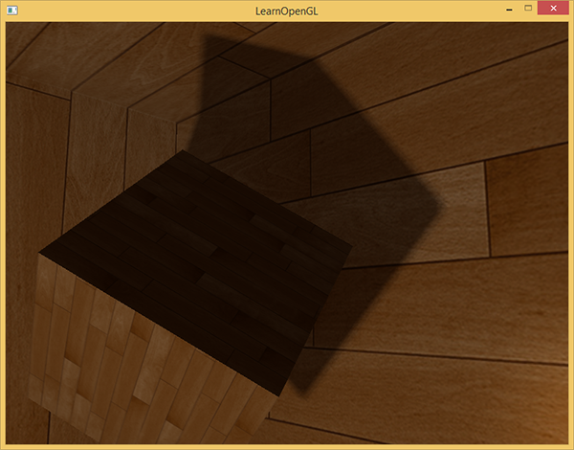

*Of course, the bias we add to each sample is highly based on context and will always require tweaking based on the scene you're working with. Play around with all the values and see how they affect the scene.*

*You can find the final code here:*[*here*](https://learnopengl.com/code_viewer_gh.php?code=src/5.advanced_lighting/3.2.2.point_shadows_soft/point_shadows_soft.cpp)*.*

*I should mention that using geometry shaders to generate a depth map isn't necessarily faster than rendering the scene 6 times for each face. Using a geometry shader like this has its own performance penalties that might outweigh the performance gain of using one in the first place. This of course depends on the type of environment, the specific video card drivers and more so if you really care about performance, make sure to profile both methods and select the more efficient one for your scene. I personally prefer using geometry shaders for shadow mapping, simply because I find them more intuitive to use.*

***Additional resources***

* [*Shadow Mapping for point light sources in OpenGL*](http://www.sunandblackcat.com/tipFullView.php?l=eng&topicid=36)*: omnidirectional shadow mapping tutorial by sunandblackcat.*
* [*Multipass Shadow Mapping With Point Lights*](http://ogldev.atspace.co.uk/www/tutorial43/tutorial43.html)*: omnidirectional shadow mapping tutorial by ogldev.*
* [*Omni-directional Shadows*](http://www.cg.tuwien.ac.at/~husky/RTR/OmnidirShadows-whyCaps.pdf)*: a nice set of slides about omnidirectional shadow mapping by Peter Houska.*

*// //*